ONLINE EXPENSE TRACKER USING PYTHON

A Project Report
Submitted in partial fulfilment of the requirements for the award of

BACHELOR OF TECHNOLOGY
IN
COMPUTER SCIENCE ENGINEERING
(DATA SCIENCE)
Submitted By
KAIRA DEEKSHITH GOUD
HT.NO: 22671A6712
Under the esteemed guidance of
MR.T.RAJESH KUMAR

Asst. Professor

DEPARTMENT OF COMPUTER SCIENCE AND ENGINEERING
(DATA SCIENCE)
J.B. INSTITUTE OF ENGINEERING AND TECHNOLOGY
(UGC Autonomous)
(Affiliated to Jawaharlal Nehru Technological University, Hyderabad)
Yenkapally (V), Moinabad (M), Hyderabad-500075, Telangana
2025-2026
J.B. INSTITUTE OF ENGINEERING AND TECHNOLOGY
(UGC Autonomous)
(Affiliated to Jawaharlal Nehru Technological University, Hyderabad)



CERTIFICATE
This is to certify that the project entitled “ONLINE EXPENSE TRACKER USING PYTHON” being submitted to the Department of COMPUTER SCIENCE & DATA SCIENCE, J.B Institute of Engineering and Technology, in accordance with JNTUH regulations as partial fulfillment required for successful completion of Bachelor of Technology in COMPUTER SCIENCE & DATA SCIENCE is a bonafide work done during the academic year 2025-26 carried out by KAIRA DEEKSHITH GOUD bearing HT.NO: 22671A6712.

Project Guide Head of the Department
MR.T.RAJESH KUMAR Mr Dr. Roshan K
ASST. PROFESSOR

J.B. INSTITUTE OF ENGINEERING AND TECHNOLOGY (UGC Autonomous)
(Affiliated to Jawaharlal Nehru Technological University, Hyderabad)
DEPARTMENT OF COMPUTER SCIENCE & DATA SCIENCE.


DECLARATION
I, KAIRA DEEKSHITH GOUD, bearing HT.NO: 22671A6712, hereby certify that the project report entitled “ONLINE EXPENSE TRACKER USING PYTHON”, carried out under the guidance of Mr.T.RAJESH KUMAR, Asst.Professor Submitted in partial fulfilment of the requirements for the award of the degree of Bachelor of Technology in COMPUTER SCIENCE & DATA SCIENCE. This is a record of bonafide work carried out by me, and the results embodied in this project report have not been reproduced/copied from any source. The results embodied in this project report have not been submitted to any other university or institute for the award of any other degree or diploma.

DATE: KAIRA DEEKSHITH GOUD
22671A6712

ACKNOWLEDGEMENT

I would like to express my heartfelt gratitude to my project mentor, Mr.T.RAJESH KUMAR, for his invaluable guidance, insightful suggestions, and continuous support throughout the course of this mini project. His encouragement and constructive feedback have been instrumental in shaping the project and ensuring its successful completion. The knowledge and expertise he shared not only helped me overcome challenges but also enhanced my understanding of the subject.

I am profoundly thankful to Dr Roshan Kavuri, Head of the Department, for his constant motivation and encouragement. His support and belief in my abilities provided me with the confidence to undertake this project, “ONLINE EXPENSE TRACKER USING PYTHON,” and present it as a part of the curriculum requirement. His vision and guidance have been a source of inspiration throughout this work.
I am also deeply grateful to our respected Principal, Dr P. C. Krishnamachary, for permitting me and providing all the necessary facilities, resources, and an encouraging environment that enabled me to carry out this project successfully. His support made it possible to complete this work efficiently and effectively.

I would like to extend my sincere thanks to all the faculty members of the department who have, directly or indirectly, contributed to the successful completion of this project. Their teachings, guidance, and encouragement throughout my academic journey have played a vital role in shaping my knowledge and skills.

Finally, I express my gratitude to my family and friends for their constant support, patience, and encouragement, which helped me stay focused and motivated throughout this endeavour.

ABSTRACT

The Online Expense Tracker project is an efficient and practical Python-based application that focuses on simplifying personal finance management in today’s digital age. It enables users to record, categorize, and analyze their income and expenditure in an organized and systematic manner. The project provides an intuitive interface where users can input their daily transactions, view expense summaries, and track their financial progress over time. By using Python’s versatile libraries such as Tkinter for the graphical interface, SQLite/MySQL for secure data storage, and Matplotlib/Pandas for graphical analysis, the system ensures both functionality and user convenience.

One of the key highlights of this project is its ability to generate visual reports and charts, which help users quickly understand their spending behavior and identify areas where savings can be improved. It also includes features like budget limit alerts, category-wise filtering, and date-wise tracking, which make the system both informative and interactive. Furthermore, the project can be extended to include features such as user authentication, cloud data storage, or mobile compatibility, enhancing its scalability and real-world usability.

In conclusion, the Online Expense Tracker is not just a coding project but a valuable financial management tool that combines data analysis, database management, and Python programming to encourage smarter and more disciplined money management habits. It effectively demonstrates how technology can be used to simplify everyday tasks and promote financial awareness among individuals.

I
INDEX
Contents |  |  |  | Page No.
Abstract |  |  |  | I
Index |  |  |  | II
List of Figures |  |  |  | III
Chapters
1. | Introduction |  |  | 1
 | 1.1 | Problem Statement |  | 2
 | 1.2 | Objective |  | 3
 | 1.3 | Motivation |  | 4
 | 1.4 | Existing System |  | 5
 | 1.5 | Proposed System |  | 6
 | 1.6 | Scope |  | 7
 | 1.7 | Software & Hardware Requirements |  | 8
2. | Literature Survey |  |  | 10
 | 2.1 | Existing systems and approaches |  | 11
 | 2.2 | Limitations obsereved |  | 12
 | 2.3 | Need of efficient system |  | 13
 | 2.4 | Contribution of proposed system |  | 14
3. | System Design |  |  | 15
 | 3.1 | System design objectives |  | 16
 | 3.2 | System architecture |  | 16
 |  | 3.2.1 | System sequence Diagram | 17
 |  | 3.2.2 | Entity relationship Diagram | 19
 |  | 3.2.3 | Sequence diagram of signup | 20
 |  | 3.2.4 | Sequence diagram of signin | 21
 |  | 3.2.5 | Sequence diagram of expenses | 22
 | 3.3 | Data flow diagram |  | 23
 | 3.4 | Use case diagram |  | 24
 | 3.5 | Design Class Diagram |  | 27
 | 3.6 | Advantages of designed system |  | 28
4. | Implementation |  |  | 29
 | 4.1 | Objectives |  | 30
 | 4.2 | Development evirnoment |  | 30
 | 4.3 | Databasedesign |  | 31
 | 4.4 | Module wise implementation |  | 32
 | 4.5 | Graphical user implementation |  | 35
 | 4.6 | System Flow |  | 36
 | 4.7 | Deployment |  | 36
5. | Module wise implementation |  |  | 37
 | 5.1 | User management |  | 38
 | 5.2 | Transaction Management |  | 39
 | 5.3 | Logic and calculation |  | 40
 | 5.4 | Visualization |  | 41
 | 5.5 | Data persistence |  | 42
 | 5.6 | User interface |  | 43
 | 5.7 | Testing and validation |  | 44
6. | Evaluation |  |  | 47
7. | Conclusion and future enhancements |  |  | 51
 | References |  |  | 53
 | Appendix |  |  | 54

II

LIST OF FIGURES

Figure No. | Figure Name | Page No.
3.1 | BLOCK DIAGRAM | 15
3.2.1 | SEQUENCE DIAGRAM | 17
3.2.2 | ENTITY RELATIONSHIP DIAGRAM | 19
3.2.3 | SEQUENCE DIAGRAM OF SIGNUP | 20
3.2.4 | SEQUENCE DIAGRAM OF SIGNIN | 21
3.2.5 | SEQUENCE DIAGRAM OF EXPENSE | 22
3.3 | USE CASE DIAGRAM | 25
3.5 | DESIGN CLASS DIAGRAM | 26
5.1. | USER MANAGEMENT | 37
5.2 | TRANSACTION MANAGEMENT | 38
5.3 | LOGIC AND CALCULATION | 39
5.4 | REPORTING AND VISUALIZATION | 40
5.5 | DATA PERSISTENCE | 41
5.6 | USER INTERFACE | 42
5.7 | TESTING AND VALIDATION | 43

III

CHAPTER-1
INTRODUCTION

In today’s fast-paced digital world, managing personal finances has become an essential part of everyone’s daily life. Many people struggle to keep track of where their money goes — whether it’s daily expenses, monthly bills, or small purchases that add up over time. To overcome this problem, our project “Online Expense Tracker” is designed to provide users with a simple, efficient, and user-friendly platform to monitor and manage their financial activities effectively.
The main goal of this project is to help users record their income and expenses, categorize their spending, and analyze their financial patterns over a specific period. By using this system, users can easily understand how their money is being spent and identify areas where they can save.
The Online Expense Tracker is developed using Python, with an interactive interface that allows users to add, edit, or delete transactions, view reports, and visualize their financial data through charts and summaries. It eliminates the need for manual bookkeeping and reduces the chances of human error, providing accurate and real-time insights into one’s financial status.
Overall, this project serves as a personal financial assistant that promotes smarter money management, encourages budgeting habits, and helps users achieve their savings goals with greater clarity and control.
The main objective of this pro ject is to promote financial awareness and responsibility by providing a platform that is easy to use and accessible from anywhere. It also aims to reduce manual effort and minimize calculation errors by automating the entire tracking process. With its clean interface and organized structure, users can maintain a digital record of their finances and make data-driven decisions about their money.
In short, the Online Expense Tracker acts as a personal financial assistant, empowering users to monitor their income and expenditure effortlessly. It not only simplifies expense management but also encourages users to develop smarter spending habits and long-term financial discipline.

  - PROBLEM STATEMENT

People deal with multiple financial transactions daily — from paying bills, shopping, and subscriptions to personal expenditures such as food, travel, and entertainment. Despite earning regularly, many individuals struggle to manage their money efficiently and often end up wondering where their income has disappeared by the end of the month. The lack of proper financial tracking and budgeting leads to unnecessary spending, poor savings, and limited financial awareness.
Traditionally, people have used manual methods like notebooks, diaries, or spreadsheets to record their expenses. However, these methods are time-consuming, prone to human error, and lack automation. It becomes difficult to maintain long-term records, categorize different types of expenses, or generate summaries for analysis. As a result, users fail to gain clear insights into their financial patterns, making it challenging to plan budgets or take corrective actions when overspending occurs.
Moreover, with the increasing shift towards digital payments and online transactions, the volume and frequency of expenses have grown significantly. Keeping track of every transaction manually is no longer practical. Users need a system that can automatically store, organize, and visualize their financial data in a convenient way. Without such a tool, individuals often lose financial discipline and face challenges in achieving personal financial goals such as saving, investing, or cutting unnecessary costs.
The lack of an integrated, easy-to-use, and reliable solution for tracking daily expenses creates a major gap in personal finance management. There is a strong need for a digital platform that allows users to record, monitor, and analyze their income and expenses in real time. Such a system should offer features like category-wise expense tracking, data visualization through graphs, and detailed summaries that empower users to make informed financial decisions.
Online Expense Tracker is developed using Python, with an interactive interface that allows users to add, edit, or delete transactions, view reports, and visualize their financial data through charts and summaries. It eliminates the need for manual bookkeeping and reduces the chances of human error, providing accurate and real-time insights into one’s financial status.

Therefore, the Online Expense Tracker project aims to address this gap by providing a smart, automated, and user-friendly financial management system.

1.2 OBJECTIVE

The primary objective of the Online Expense Tracker project is to design and develop a simple, efficient, and user-friendly system that helps individuals manage their daily, weekly, and monthly financial activities in an organized manner. This project aims to simplify financial tracking, reduce manual effort, and promote financial awareness among users by providing a smart digital platform for monitoring expenses and income.

The specific objectives of the project are as follows:
- To develop an easy-to-use interface that allows users to add, edit, and delete their income and expense records quickly and conveniently.
- To categorize expenses (such as food, travel, bills, entertainment, etc.) so that users can clearly understand where their money is being spent.
- To automate financial calculations such as total income, total expenses, and remaining balance, thereby minimizing human errors.
- To generate visual reports and summaries using graphs or charts that give users an instant overview of their financial situation.
- To help users identify spending patterns and habits so they can make better financial decisions and plan effective budgets.
- To securely store and manage user data in a database, ensuring privacy and reliability.
- To provide accessibility and convenience, allowing users to track their expenses anytime and from anywhere using an online system.
- To encourage financial discipline and awareness by helping users control unnecessary expenditures and focus on saving.

In essence, the Online Expense Tracker project aims to serve as a personal financial assistant that brings automation, accuracy, and clarity to money management. It empowers users to take control of their finances, build better budgeting habits, and achieve long-term financial stability.

1.3 MOTIVATION
In today’s fast-paced world, financial management has become one of the most important aspects of daily life. With increasing personal and household expenses, the average individual often struggles to keep track of their income and spending patterns. Many people find themselves living paycheck to paycheck, unaware of where their money goes, which leads to unnecessary stress, poor savings, and lack of financial planning. This common challenge inspired the motivation behind developing the Online Expense Tracker project.

The primary motivation is to empower individuals with control over their finances. By creating a system that efficiently records and categorizes expenses, users can gain clear insights into their financial habits. Many people rely on traditional methods such as notebooks, diaries, or spreadsheets to track their money, but these methods are tedious, time-consuming, and highly prone to human error. Often, important transactions are missed, data is lost, or calculations are wrong, leaving individuals unable to make informed financial decisions.

Additionally, the growing trend of digital payments has made the need for an automated expense tracking solution even more critical. With online banking, e-wallets, and contactless payments becoming the norm, manual tracking is no longer practical. The motivation behind this project is to bridge this gap by providing an easy-to-use, reliable, and interactive platform that records financial data in real time and provides meaningful insights to the user.
Another motivating factor is the desire to promote financial awareness and literacy. Many individuals, especially students and young professionals, lack a proper understanding of budgeting, saving, and expense management. By providing visual reports, summaries, and trend analyses, this project aims to help users identify spending patterns, reduce unnecessary expenses, and develop smarter money habits. The ability to see exactly where money is going encourages responsible financial behavior, which can have long-term benefits like increased savings, better investment decisions, and overall financial security.
Moreover, the convenience of accessing financial information from a digital platform, coupled with automated calculations, categorization, and visualization, motivates users to adopt the system consistently.

In short, the motivation for developing the Online Expense Tracker is rooted in the need to simplify money management, increase financial awareness, and provide a reliable tool that empowers users to take control of their personal finances. The project aspires to serve as a personal financial assistant, guiding users to make informed decisions, minimize unnecessary spending, and achieve their financial goals in a structured and organized way.

1.4 EXISTING SYSTEM
In the current scenario, most people manage their personal finances using traditional methods such as notebooks, diaries, paper ledgers, or even spreadsheets like Microsoft Excel or Google Sheets. While these methods provide a way to record income and expenses, they have several limitations that make them inefficient and prone to errors.
- Manual Recording – Users have to manually enter every transaction, whether it is income or expense. This process is time-consuming and requires continuous effort, which often leads to missed entries or incomplete data.
- Lack of Categorization – In traditional systems, expenses are not automatically categorized. Users have to manually sort transactions into categories like food, travel, or bills. This makes it difficult to analyze spending patterns accurately and understand where the majority of money is going.
- Error-Prone Calculations – Adding up daily, weekly, or monthly expenses manually increases the chance of human errors. Mistakes in calculation can result in inaccurate financial summaries, which can mislead users about their actual financial situation.
- No Real-Time Insights – Traditional methods do not provide instant insights or visual representations of financial data. Users cannot quickly identify trends, spikes in expenses, or areas where they can save money. This makes budget planning and financial decision-making harder.

Limitations of Existing Systems
The current systems for managing personal finances — such as manual record-keeping, paper-based diaries, or spreadsheets — have several limitations that make them inefficient and unsuitable for modern financial tracking. These limitations include:
- Time-Consuming Process – Manual recording of every transaction requires significant effort and time. Users must note down each expense or income entry, which can be tedious and prone to neglect, especially if the number of daily transactions is high.
- Prone to Human Errors – Calculations for totals, balances, or summaries are performed manually. This increases the risk of errors, which can lead to inaccurate financial information and misguided decision-making.
- No Automatic Categorization – Traditional methods do not automatically classify expenses into categories like food, travel, or bills. Users must do this manually, which reduces efficiency and makes it hard to analyze spending patterns effectively.
- Lack of Visual Insights – Paper or spreadsheet methods do not provide charts, graphs, or trend analysis, making it difficult for users to quickly understand their financial situation or identify overspending areas.
- Limited Accessibility – Offline systems require users to carry physical records or access a specific device to view their finances. This restricts the ability to track and update expenses in real time, especially while traveling or using multiple devices.
- Risk of Data Loss – Physical ledgers can be lost, damaged, or destroyed, and digital spreadsheets can be accidentally deleted or corrupted. This puts important financial data at risk.
- No Automation – All operations, including calculations, reporting, and summarization, are manual. Users cannot get instant results or automated notifications, which makes financial planning slow and inefficient.

1.5 PROPOSED SYSTEM
To overcome the limitations of existing methods of expense management, the Online Expense Tracker is proposed as a digital, automated, and user-friendly system designed to simplify personal finance management. Unlike manual systems or spreadsheets, this project provides an efficient, accurate, and accessible platform for tracking income and expenses.
The proposed system is developed using Python, with a clean and interactive interface that allows users to perform all financial operations easily. Users can add, edit, and delete transactions such as income and expenses with just a few clicks. Each transaction can be categorized into predefined types like food, travel, bills, entertainment, or any custom category, helping users understand exactly how their money is being spent.
Key features of the proposed system include:
- Automation of Calculations – The system automatically calculates total income, total expenses, and remaining balance, eliminating human errors and saving time.
- Data Organization and Categorization – Transactions are systematically categorized, allowing users to analyze spending habits, identify trends, and focus on areas where savings can be made.
- Visual Reports and Analytics – Users can view graphs, charts, and summaries that provide real-time insights into their financial activities. This makes it easier to monitor progress, plan budgets, and make informed financial decisions.
- Secure Data Storage – All financial data is stored in a digital database, reducing the risk of data loss and providing reliable access whenever needed.
- Accessibility and Convenience – The system can be accessed anytime and anywhere, giving users the freedom to update or check their finances on the go, unlike traditional offline methods.
- User-Friendly Interface – Designed with simplicity in mind, the system ensures that even users with minimal technical knowledge can operate it effortlessly.
- Encourages Financial Awareness – By providing clear summaries and insights, the system motivates users to maintain better financial discipline, reduce unnecessary expenses, and achieve their savings goals.

1.6 SCOPE
The scope of the Online Expense Tracker project defines the extent, capabilities, and potential applications of the system. This project is designed to assist individuals in managing their personal finances efficiently and to provide insights that help in better financial planning. The scope includes both functional and practical aspects of the system:
  - Personal Finance Management – The system is primarily focused on helping users track their income and expenses, ensuring they are aware of where their money is going. It provides a structured method for recording daily, weekly, and monthly financial activities.
  - Expense Categorization – Users can categorize their spending into different types such as food, travel, bills, entertainment, and more. This categorization allows detailed analysis of spending patterns, enabling smarter financial decisions.
  - Financial Analysis and Reporting – The system can generate summaries, charts, and visual graphs, giving users a clear picture of their financial situation. Users can identify trends, overspending areas, and opportunities for savings, which helps in effective budgeting.
  - Automation and Accuracy – The system automates all calculations, reducing the risk of human errors in total expenses, income, or balance computations.
  - Ease of Accessibility – The system is designed to be user-friendly and accessible from multiple devices, allowing users to update or monitor their finances anytime and anywhere.
  - Future Expandability – The project can be enhanced in the future with features such as reminders for bill payments, integration with digital wallets or banking systems, predictive analytics for budgeting, and multi-user support for family or group expense tracking.
- Educational Use – The system can also be used as a learning tool to promote financial awareness among students, young professionals, and individuals who are new to managing personal finances.
- Time and Cost Efficiency – By automating expense tracking, the system saves time compared to manual methods and reduces costs associated with errors or missed payments.
1.7 SOFTWARE & HARDWARE REQUIREMENTS
Software Requirements
The software requirements specify the programs, platforms, and tools needed to develop and run the Online Expense Tracker efficiently:
Python – The primary programming language used for developing the application due to it simplicity, readability, and extensive libraries for data handling, GUI, and visualization.
er PyQt / Streamlit – GUI frameworks in Python to create interactive and user-friendly interfaces for the application.
SQLite / MySQL / PostgreSQL – Database systems used for storing transaction data securely, providing persistence and easy retrieval of financial records.
Pandas – A Python library for data manipulation and analysis, useful for calculating totals, generating summaries, and categorizing expenses.
Matplotlib / Seaborn / Plotly – Libraries for visualizing financial data in the form of charts, graphs, and plots for better insights.
Operating System – Compatible with Windows, Linux, or Mac OS for smooth execution of Python programs.
IDE / Code Editor – Tools like PyCharm, VS Code, or Jupyter Notebook for writing, testing, and debugging code efficiently.
Web Browser (if using web-based frameworks) – Required to run and interact with webbased interfaces such as Streamlit applications.
Hardware Requirements
The hardware requirements define the minimum specifications needed to run the system effectively:
- Processor (CPU) – Intel i3 or equivalent and above; ensures smooth execution of Python programs and GUI applications.
- RAM – Minimum 4 GB; recommended 8 GB for faster performance while handling data and visualization tasks.
- Hard Disk – Minimum 500 GB with sufficient free space to store databases and project files.
- Display – Minimum 13-inch display with 1366x768 resolution or higher for clear visualization of the application interface.
- Keyboard & Mouse – Standard input devices for interacting with the application.
- Internet Connection (Optional) – Required if the system is deployed online or if external libraries and packages need to be downloaded.
- Operating System Compatibility – The hardware should support the chosen OS (Windows, Linux, or Mac) to run Python and related tools efficiently.

CHAPTER 2
LITERATURE SURVEY
A literature survey provides an overview of existing research, systems, and methods relevant to the project. It helps identify gaps in current solutions and justifies the development of a new system. In the field of personal finance management, tracking income, expenses, and budgeting has always been a challenge, prompting the development of various tools and techniques.
2.1 Existing Systems and Approaches
ManualRecord-Keeping
Traditionally, people managed their finances using notebooks or diaries, where they recorded daily transactions manually. While simple, this method is time-consuming and error-prone, with no automation or analytical insights. Users often fail to categorize expenses or maintain accurate totals over long periods, making it hard to understand spending patterns.
Spreadsheet-BasedSystems
Applications like Microsoft Excel and Google Sheets have been widely used for digital financial tracking. Spreadsheets allow calculations, tables, and charts but require manual entry and technical knowledge for advanced features. Errors in formulas or inconsistent data entry can lead to misleading financial analysis.
MobileandWebApplications
Several apps like Mint, Wally, Money Manager, and PocketGuard offer automated tracking, budgeting, and financial visualization. These tools provide categorized expense tracking, balance summaries, and sometimes reminders for bill payments. However, they have notable limitations:
  - Many apps have complex interfaces, making them difficult for beginners.
  - Some rely heavily on internet connectivity, limiting offline usage.
  - Data privacy concerns arise when sensitive financial information is stored on third-party servers.
  - Customization of expense categories is often limited, restricting flexibility for individual users.

2.2 Limitations Observed in Literature
From analyzing existing systems and research studies, the following limitations are observed:
- Manual systems lack automation and require significant effort for calculations and categorization.
- Spreadsheet methods are prone to human error and require technical skills.
- Mobile applications can be overly complex, not customizable enough, or dependent on online access.
- Limited reporting and analysis – Many systems provide basic summaries but fail to offer in-depth insights or trend analysis.
- Security concerns – Users are hesitant to trust third-party apps with sensitive financial data.

While reviewing existing research papers, articles, and systems related to expense tracking and personal finance management, several limitations were identified in the existing literature that highlight the need for improved, user-centric solutions. Most of the studies and applications discussed in previous works focus primarily on basic expense entry and manual tracking without providing intelligent insights or real-time analytics. Many of the earlier systems lacked automation features, requiring users to manually input every transaction, which often led to user fatigue, data inaccuracy, and incomplete records. Moreover, older implementations were limited in scalability and adaptability, often developed using outdated technologies or static storage methods that could not efficiently handle large or growing amounts of user data. Some research-based models primarily concentrated on mobile-only solutions or specific platforms, ignoring cross-platform compatibility and user accessibility from different devices.
Another major limitation observed in the literature was the absence of advanced data visualization and analytical tools. While some systems offered basic tabular summaries, very few provided interactive graphs or visual dashboards to help users understand their spending habits and financial trends effectively. Similarly, the security aspect was often overlooked in earlier systems — user authentication and data encryption mechanisms were either weak or completely absent, raising concerns about privacy and unauthorized data access. Additionally, most systems lacked personalization and categorization features, preventing users from customizing their expense categories, budgeting preferences, or financial goals. The literature also showed that existing systems offered limited reporting capabilities, often failing to generate detailed monthly or yearly summaries, which are essential for long-term financial planning.
Furthermore, many past research works did not integrate modern technologies such as machine learning or predictive analytics that could help users forecast future expenses or suggest saving strategies. The lack of intuitive graphical user interfaces (GUIs) in some older designs made the systems less user-friendly and less appealing to non-technical users. Some models even required internet connectivity for basic functions, which made them unsuitable for offline use. From an architectural perspective, several studies lacked modular or layered system designs, leading to challenges in maintenance, testing, and further development.
In summary, the limitations observed in the literature emphasize that although significant progress has been made in developing expense management systems, there is still a clear gap in creating a robust, secure, and intelligent platform that combines automation, analytics, and usability. These observed shortcomings motivated the design and implementation of the Online Expense Tracker Project, which addresses the weaknesses of existing systems by introducing features like graphical data visualization, enhanced security, modular design, offline functionality, and real-time financial analysis.

2.3 Need for an Efficient System
Considering the limitations of existing methods, there is a clear need for a reliable, secure, and user-friendly system for personal finance management. Such a system should:
- Offer automated calculations and data categorization.
- Provide visual insights through charts and graphs to understand spending patterns.
- Be easy to use for people with minimal technical knowledge.
- Ensure secure storage and privacy of financial information.
- Be accessible offline and online, providing convenience at all times.
2.4 Contribution of the Proposed System
The proposed Online Expense Tracker aims to address these gaps by providing a digital, automated, and interactive platform for personal finance management. Key contributions include:
- Simplifying financial tracking with easy input, editing, and deletion of transactions.
- Categorizing expenses effectively and generating visual reports for analysis.
- Reducing human errors by automating calculations and summaries.
- Providing data security and persistence through a database system.
- Offering a user-friendly interface accessible on multiple platforms.

The existing systems for expense tracking and personal financial management, though functional to an extent, suffer from several limitations that reduce their overall efficiency, user satisfaction, and practical usability. Most of the current expense tracking applications or manual methods rely heavily on manual data entry, where users are required to input every single transaction individually. This process is time-consuming and prone to human errors such as incorrect data entry, duplication, or omission of expenses. Additionally, many traditional systems or spreadsheet-based approaches do not provide real-time financial updates or automated calculations, forcing users to manually compute totals, averages, and budgets at regular intervals. This lack of automation makes financial management a tedious and repetitive task, discouraging consistent usage among users.
Another major limitation of existing systems lies in their limited analytical and visualization capabilities. Most of them only display raw data in tabular form without offering meaningful insights or interactive charts to help users understand their spending habits. Users are often unable to visualize patterns or track their financial behavior across different time periods and categories. Moreover, these systems rarely include features such as budget forecasting, personalized recommendations, or category-wise analysis, which are essential for effective money management. The lack of advanced visualization tools and graphical reports prevents users from making data-driven decisions about their finances.
Data security and privacy also pose significant challenges in the existing systems. Many of them fail to implement secure authentication mechanisms or encryption techniques to protect user credentials and financial information. In some web-based applications, sensitive financial data is stored in plain text, which can be easily accessed by unauthorized individuals. The absence of proper data backup mechanisms also makes these systems vulnerable to data loss in case of technical failures or accidental deletions. Furthermore, existing systems often lack a multi-user architecture, meaning that data from different users may not be properly isolated, leading to potential privacy breaches.
From a technical perspective, many existing systems suffer from poor scalability and inefficient database management. They are unable to handle large datasets or multiple concurrent users efficiently, leading to slow response times and performance bottlenecks. Some systems are platform-dependent or require constant internet connectivity, which limits their accessibility for users in offline environments. Additionally, many applications have non-intuitive user interfaces that are either too complex or poorly designed, making it difficult for non-technical users to navigate and operate the system comfortably.
In addition to these technical issues, existing expense tracking methods also fail to provide customization options. Users cannot modify categories according to their lifestyle or financial goals, making the system rigid and less user-friendly. The lack of integration with other tools, such as calendars, reminders, or bank data imports, further limits the usefulness of these systems in day-to-day financial management. Moreover, older systems often lack the ability to generate comprehensive reports or summaries, which are essential for long-term financial planning, tax management, or performance evaluation.
In conclusion, the limitations of the existing system clearly demonstrate the need for a more intelligent, automated, and user-friendly solution. A modern expense tracker should not only record transactions but also analyze them, visualize spending patterns, secure user data, and provide personalized insights. The Online Expense Tracker Project aims to overcome these drawbacks by implementing advanced features such as real-time expense monitoring, graphical reports, secure authentication, and offline accessibility. Through this approach, the proposed system bridges the gap left by traditional and existing methods, offering users a reliable, efficient, and comprehensive financial management tool.

CHAPTER 3
SYSTEM DESIGN
System design is a critical phase in software development that defines how the system will work, the flow of information, and the interaction between various components. For the Online Expense Tracker, the design focuses on creating a robust, user-friendly, and automated platform that simplifies personal finance management while providing accurate insights.

3.1 Objectives of System Design
The objectives of designing the system are:
- To provide a structured and organized framework for tracking income and expenses.
- To ensure accuracy and reliability in financial calculations and summaries.
- To design an intuitive and user-friendly interface that requires minimal technical knowledge.
- To implement secure storage and retrieval of user financial data.
- To provide real-time reporting and visual analytics of financial activities.
- To enable scalability and flexibility, allowing future enhancements such as bill reminders, multi-user access, or integration with digital wallets.
3.2 System Architecture
The system is designed in a modular architecture, separating the user interface, business logic, data storage, and reporting modules. This ensures maintainability, scalability, and clarity. The architecture consists of the following layers:
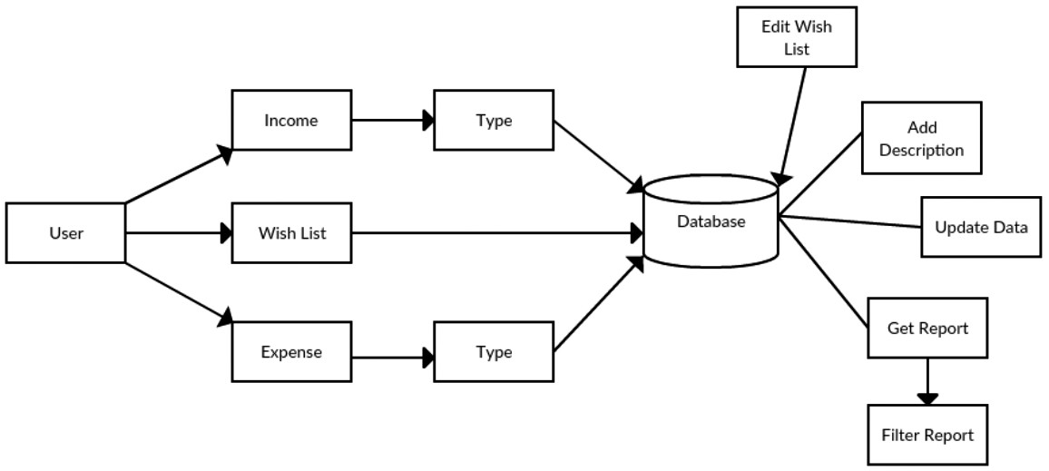

1. User Interface Layer (Presentation Layer)
- Provides an interactive interface for users to enter and manage transactions.
- Users can add, update, delete, and view their income and expense records.
- Allows viewing of financial summaries, reports, and charts.
- Built using Python GUI frameworks such as Tkinter, PyQt, or Streamlit, ensuring cross-platform accessibility.
2. Business Logic Layer (Processing Layer)
- Handles all internal processing of the system.
- Performs validations to ensure correct data entry (e.g., valid amounts, proper categories).
- Calculates total income, total expenses, balance, and category-wise spending automatically.
- Prepares data for visualizations and reports.
3. Data Layer (Database Layer)
- Responsible for storing and retrieving user data.
- Stores details such as income entries, expense entries, categories, timestamps, and summaries.
- Implemented using SQLite, MySQL, or PostgreSQL, depending on the project scale.
- Ensures data security, persistence, and easy retrieval for analysis.
4. Reporting & Visualization Layer
- Generates visual insights to help users understand their financial behavior.
- Provides graphs, pie charts, bar charts, and trend analysis.
- Libraries like Matplotlib, Seaborn, or Plotly are used to render interactive visual reports.
- Allows users to analyze weekly, monthly, and yearly trends and make informed decisions.

3.2.1 SYSTEM SEQUENCE DIAGRAM (SSD)
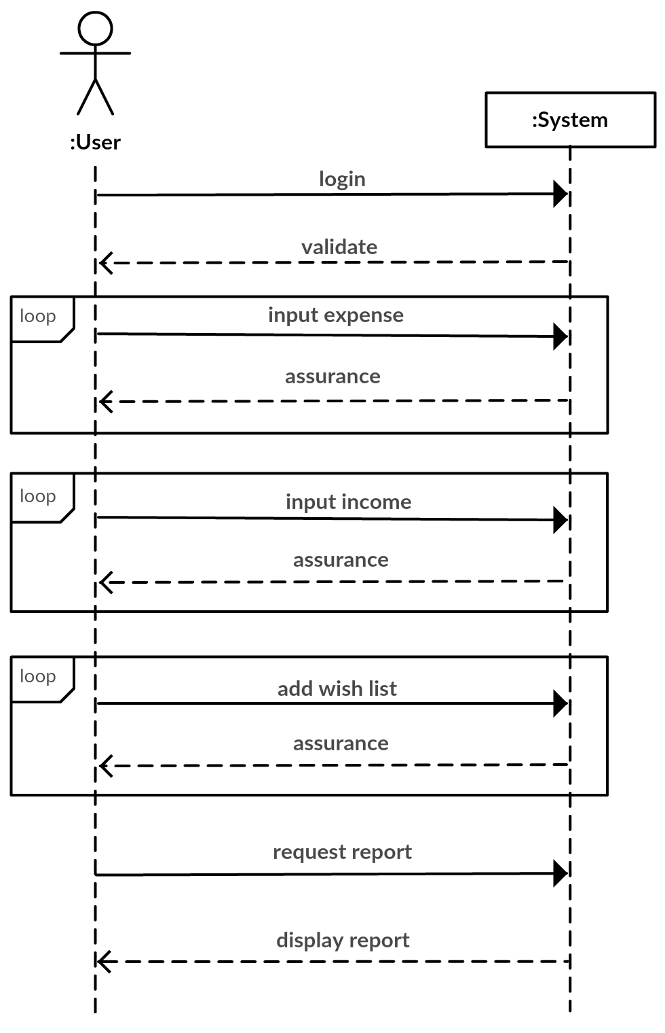

3
. System Sequence Diagram (SSD)

User logins and the system validates to checks for the right user. After login process is completed users can enter their expense, which is recorded by system under right category. Multiple data can be saved by users. The same process applies for income. Upon successful data save system assures users about the action. User can also save their wish list and do have right to modify them in future if necessary.
The system architecture diagram provides a high-level overview of the system’s structure and its major components. It illustrates the relationship between the client (user interface) and the backend components, including the database and the application logic. The architecture follows a three-tier model, consisting of the presentation layer (GUI developed using Tkinter or web framework), the application layer (Python logic for data processing, calculations, and validation), and the data layer (SQLite database for persistent data storage). This layered architecture ensures a clear separation of concerns, making the system easier to manage, test, and extend in the future. It also allows flexibility in terms of platform adaptation—whether the tracker is used as a desktop application or deployed as a web-based system.3.3 System Flow / Working Process.
The system workflow is designed for simplicity and automation:
- User Login / Registration (Optional)
  - Users can create an account to store personal data securely.
  - Authentication ensures privacy and data protection.
- Transaction Entry
  - Users input details of income and expenses, including amount, date, category, and description.
  - The system validates the data to ensure accuracy.
- Data Processing & Categorization
  - Transactions are automatically categorized based on type.
  - Calculations are performed to update total income, total expenses, and remaining balance.
- Data Storage
  - All transaction details are stored in the database for persistence.
  - Historical data can be accessed for long-term analysis.
- Reporting & Visualization
  - Generates summaries and graphical reports for better financial understanding.
  - Users can see category-wise spending, trends over time, and savings patterns.
- Edit/Delete Transactions
  - Users can modify or remove entries anytime.
  - Changes are automatically updated in calculations and visual reports.

3.2.2 ENTITY RELATIONSHIP DIAGRAM (ERD)
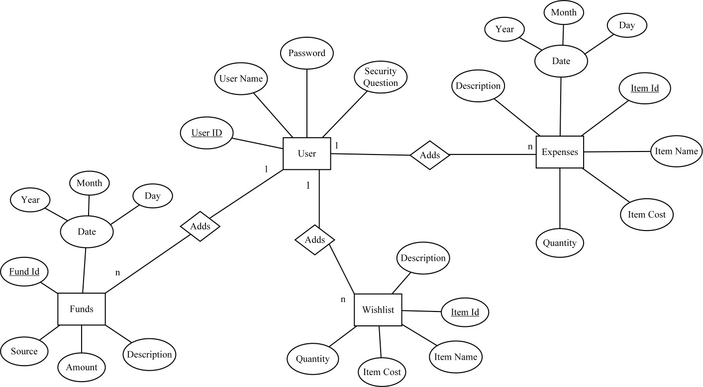

The Entity-Relationship (ER) Diagram is used to illustrate the database structure of the system. It shows how different entities, such as User, Income, and Expense, are interconnected through relationships. For instance, each user can have multiple income and expense records, but each transaction belongs to one specific user, forming a one-to-many relationship. The ER diagram helps in understanding the logical design of the database, ensuring that data redundancy is minimized and relationships are properly normalized. It also provides clarity for implementing efficient queries and maintaining data consistency.
The System Design phase of the Online Expense Tracker project plays a crucial role in transforming the conceptual requirements into a structured framework that defines how the system operates internally and interacts with the user. It serves as a bridge between the problem definition and the actual implementation, ensuring that the system’s architecture, data flow, and user interactions are logically organized and efficiently designed. The Online Expense Tracker is designed with a modular approach, ensuring scalability, maintainability, and user-friendliness. The primary goal of this design phase is to establish how different components of the system—such as the user interface, database, logic layer, and reporting module—communicate and coordinate to deliver an accurate and responsive financial management experience.
3.2.3 Sequence Diagram of SignUp
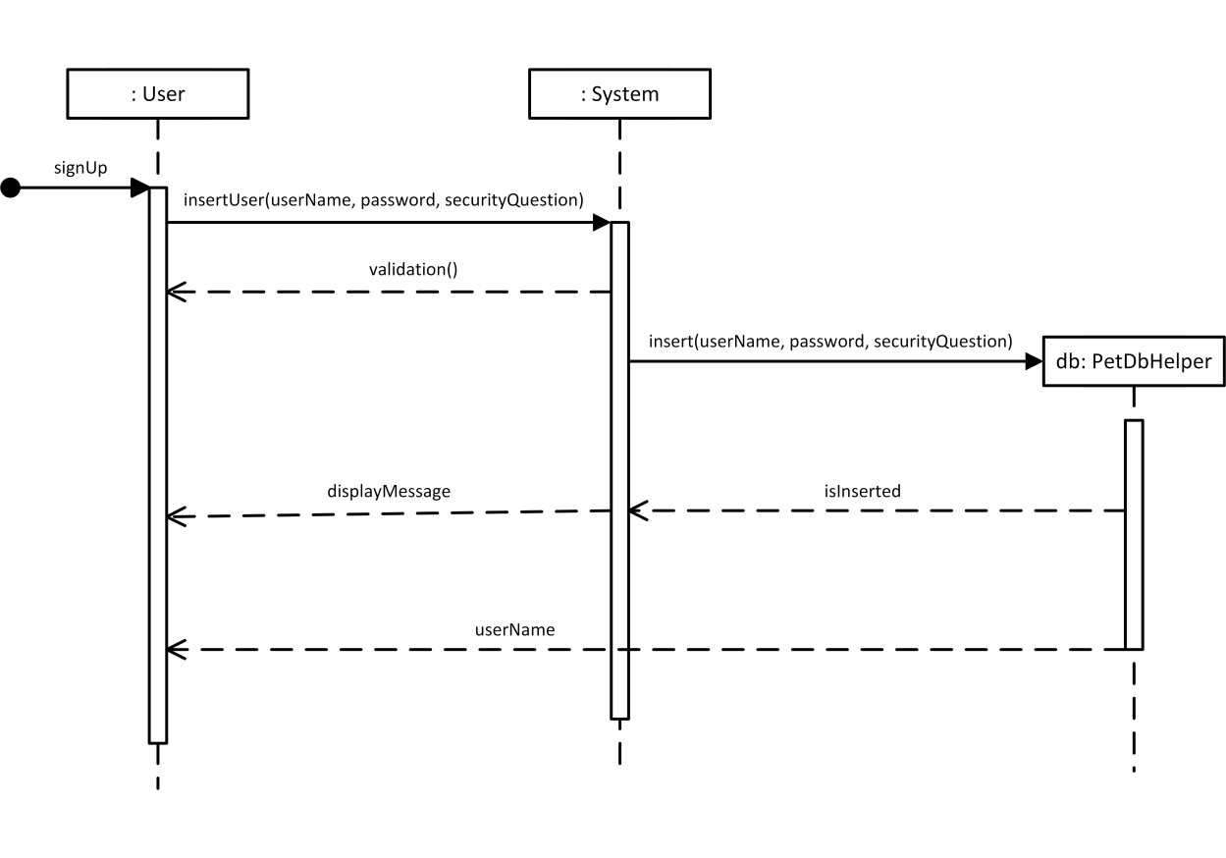

The Sign-Up diagram illustrates the sequence of actions involved when a new user creates an account, while the Sign-In diagram explains the process flow when an existing user logs into the system. Together, they define how data flows between the user interface, application logic, and the underlying database, ensuring integrity, security, and usability at every step.
In the Sign-Up process, the diagram starts with the User as the primary actor, who initiates the registration by providing essential details such as username, email address, and password. The system first validates the input to ensure that all mandatory fields are filled and that the password meets the required security criteria (for example, minimum length, inclusion of special characters, etc.). Once the validation is successful, the system checks the database to confirm that the username or email ID does not already exist, preventing duplicate accounts. If the entered credentials are unique, the system proceeds to store the user’s details securely in the User Table of the database, often after encrypting the password using standard hashing algorithms to enhance data security. After successful registration, the system generates a confirmation message, indicating that the account has been created successfully, and the user can now proceed to the login page. This entire flow is depicted in the Sign-Up diagram, showing each interaction between the user, the validation module, and the database. The diagram visually explains the logical steps, such as input submission, data validation, database insertion, and confirmation, ensuring that the process remains clear, efficient, and error-fre
3.2.4 Sequence of diagram of sign In
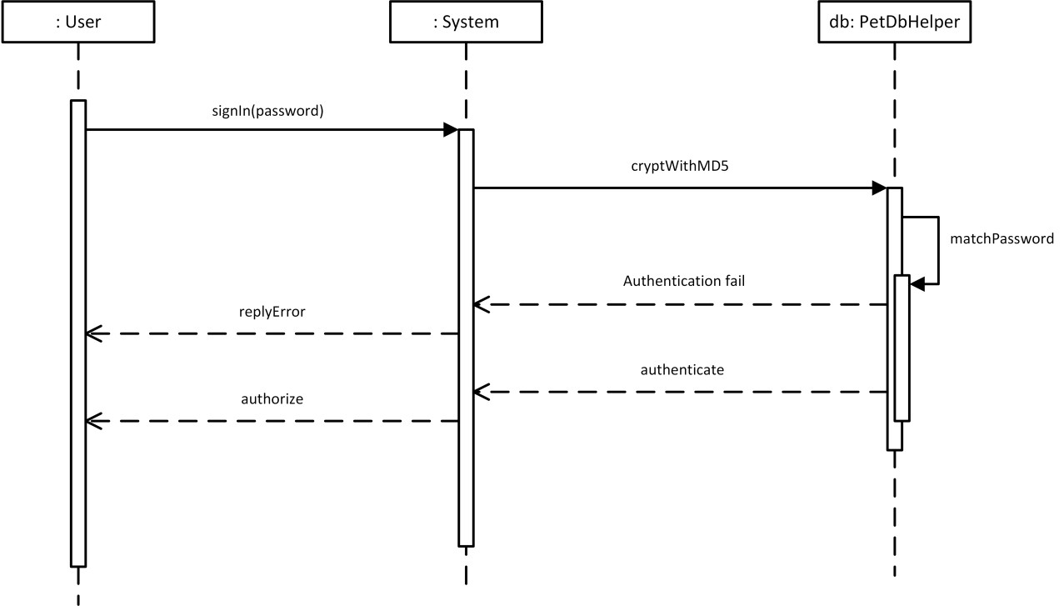

the Sign-In diagram represents the authentication flow when an existing user attempts to log into the system. The user begins by entering their registered username or email along with the corresponding password into the login form. Upon submission, the system validates that none of the fields are left blank and then queries the User Table to verify the entered credentials. If the username and password combination matches an existing record in the database, the system grants access and redirects the user to the main dashboard or homepage of the Expense Tracker, where they can begin managing their transactions. In cases where the credentials do not match or the user does not exist, the system displays an error message such as “Invalid username or password,” prompting the user to try again or recover their password if necessary. The Sign-In diagram captures this logical decision-making process using conditional paths — one leading to successful login and another to an error handling mechanism. This visual representation helps developers and stakeholders clearly understand how user authentication is managed and how the system ensures that unauthorized access is prevented.
The design of both diagrams emphasizes the flow of control and data validation mechanisms that maintain system security and reliability. Each step, from input collection to database verification, is represented with directional flows and decision nodes that highlight the logic behind authentication. These diagrams also showcase how error conditions and exceptions are handled — for example, how the system responds to invalid inputs, duplicate usernames during sign-up, or incorrect passwords during sign-in. Additionally, both diagrams demonstrate the importance of feedback loops, where users are notified at every stage of their interaction, such as receiving .
Figure 3.2.5 Sequence Diagram of Expense
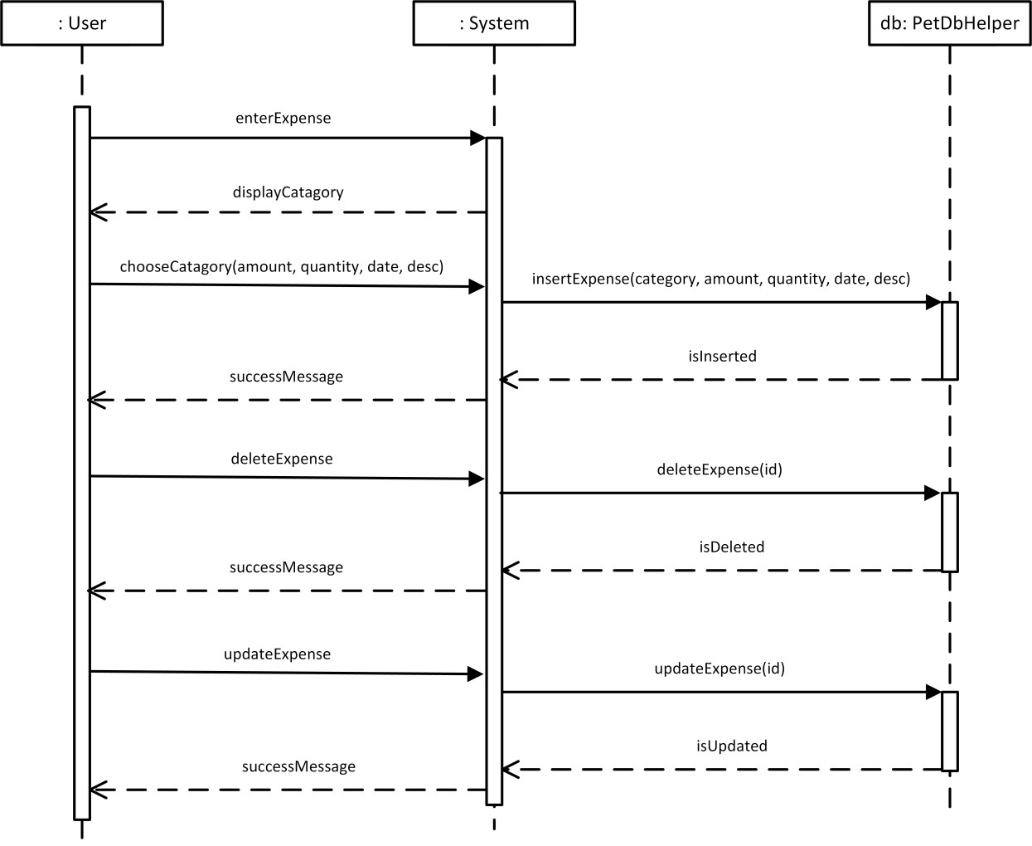

The Sequence Diagram of the Expense Module in the Online Expense Tracker project provides a detailed visual representation of how different system components interact over time when a user performs expense-related operations such as adding, viewing, editing, or deleting expense entries. It depicts the sequential flow of messages and actions between the main objects or entities in the system — typically including the User Interface, Expense Controller (or Logic Layer), Database Handler, and Database. This diagram plays a vital role in understanding the dynamic behavior of the system and clearly illustrates the order in which operations occur from the user’s initiation of an action to the system’s corresponding response.
The sequence begins when the user logs into the system and accesses the Expense Management section from the dashboard. Once the user chooses to add a new expense, the User Interface (UI) prompts for necessary input fields such as the expense amount, category (like food, bills, travel, etc.), date, and a short description. When the user clicks the “Add Expense” button, the UI sends this data to the Expense Controller, which acts as the middle layer responsible for validating the entered details. The controller checks if all required fields are filled, ensures the amount entered is numeric, and verifies that the date format is valid. If any validation fails, the controller sends an error message back to the UI, prompting the user to correct the information. However, if all validations are successful, the controller constructs a structured request and passes it to the Database Handler.
The Database Handler serves as the communication bridge between the application logic and the underlying SQLite Database. Upon receiving the data from the controller, it initiates a query to insert the expense record into the Expense Table, where the entry is stored along with the user’s ID for secure association. The database confirms the successful insertion and returns an acknowledgment to the Database Handler, which in turn notifies the controller that the operation has been completed successfully. The controller then sends a confirmation message back to the UI, which displays a success notification like “Expense added successfully”. This sequence of interactions ensures that the system follows a structured, step-by-step process for recording user data while maintaining data accuracy and security.
3.3 Data Flow Diagram (DFD)
The DFD illustrates the movement of data through the system:
- External Entity: User
- Processes:
  - Input Transaction
  - Validate & Categorize
  - Calculate Totals
  - Generate Reports
- Data Stores:
  - Database (Income Records, Expense Records, Categories)
- Outputs:
  - Financial Summaries
  - Charts & Reports

3.4 Use Case Diagram
The main actors and use cases of the system include:
- Actor: User
- Use Cases:
  - Login / Register
  - Add Transaction
  - Edit / Delete Transaction
  - View Summary / Reports
  - Generate Visual Analytics
The Use Case Diagram of the Online Expense Tracker project provides a high-level visual representation of how different users interact with the system and what functionalities they can access. It plays a vital role in understanding the functional requirements of the system from the user’s perspective, showing the relationship between the user (actor) and the various actions (use cases) they can perform. This diagram serves as an essential part of the system design because it translates user needs into clearly defined interactions that guide the development and testing processes. In the context of the Online Expense Tracker, the primary actor is the User, who interacts with the system to perform several tasks such as signing up, logging in, adding expenses, adding income, viewing reports, and managing transactions.
The Use Case Diagram begins with the User as the central actor, representing any individual who wants to manage and track their financial activities using the system. The first use case associated with the user is the “Sign-Up” process, where new users register by entering their credentials such as username, email, and password. Once registered, the “Login” use case allows the user to authenticate and access their personalized dashboard. These two initial use cases establish the foundation of user interaction, ensuring that the system provides a secure and personalized environment. Upon successful login, the user gains access to the main functionalities of the expense tracker, including “Add Expense”, “Add Income”, and “View Transactions”. The “Add Expense” use case enables the user to record daily spending by entering the amount, category, date, and description. Similarly, the “Add Income” use case allows users to log their sources of income, which helps in maintaining a balanced overview of their financial position.
Beyond basic data entry, the Use Case Diagram also includes extended functionalities such as “Edit Transaction”, “Delete Transaction”, and “View Summary Report.” These use cases ensure that the system remains flexible and user-centric, allowing users to make corrections, remove unwanted entries, or generate analytical summaries of their expenses and income. The “View Summary Report” use case is particularly important, as it helps users visualize their spending patterns through graphical representations such as pie charts and bar graphs, enabling them to identify areas where they can save money. Additionally, the diagram may also include a “Logout” use case, which allows users to securely exit their session, ensuring that their personal financial data remains protected from unauthorized access.

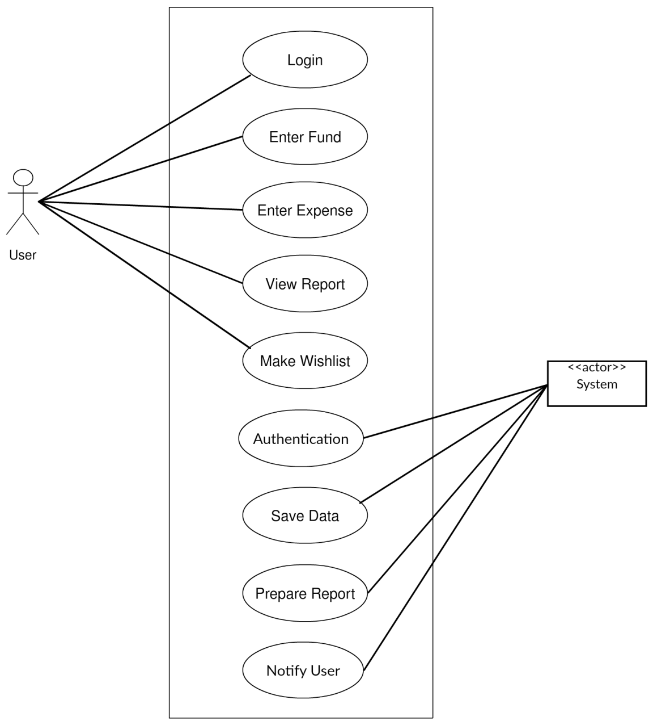

Having a proper track to our expenses helps us to organize our finance which is actually a very difficult task. Looking through our expenses at regular interval allow us to review our spending habit.
Writing records of our expense in paper is a traditional way. In the world driven by technology, it is not a right measure or choice indeed. It is difficult to relate our present expenses with past when data need to be reviewed and it is even not secure.
So with this particular application Personal Expense Tracker, we have tried to feature several concepts that the user can fully track all of his/her expense as compared to present system in practice. Personal Expense Tracker is a technology driven approach where user have to log in to track their spending and earnings.

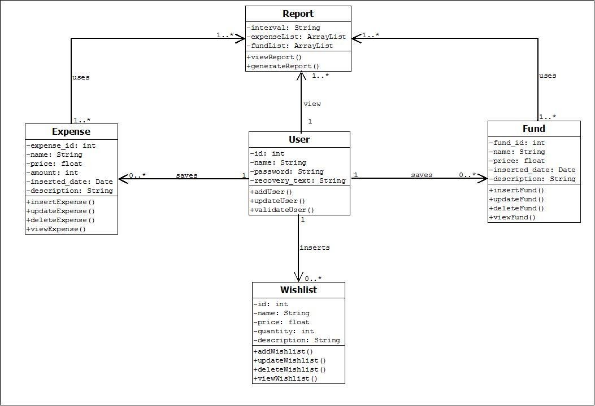
3.5 DESIGN CLASS DIAGRAM (DCD)

The Design Class Diagram is one of the most essential components of the System Design phase in the Online Expense Tracker project, as it provides a structural blueprint of how the system’s objects and classes interact with each other to achieve the overall functionality. It represents the static view of the system, showcasing classes, their attributes, operations (methods), and the relationships among them. In simple terms, it acts as the backbone of object-oriented design, bridging the gap between the conceptual models and the actual implementation in Python. The diagram defines how data is stored, accessed, and manipulated by different components of the application, ensuring modularity, maintainability, and scalability.
In the Online Expense Tracker, the Design Class Diagram consists of several main classes such as User, Expense, Income, DatabaseManager, ReportGenerator, and AuthenticationManager. Each of these classes encapsulates specific responsibilities that together enable the complete operation of the system. The User class is the central component, representing the individual who interacts with the application. It contains essential attributes such as userID, username, email, and password, along with methods like registerUser(), loginUser(), and logoutUser(). This class plays a critical role in authentication and user management, ensuring that each user’s data remains secure and isolated.
The Expense class is another key element of the design, representing the data structure for managing and recording expenses. It includes attributes like expenseID, userID, amount, category, description, and date. The methods in this class, such as addExpense(), editExpense(), deleteExpense(), and getExpensesByUser(), handle the operations related to expense management. Similarly, the Income class mirrors the structure of the Expense class but focuses on income-related transactions. It includes methods like addIncome(), updateIncome(), and deleteIncome(), helping users maintain a record of their earnings in parallel with their spending.
To manage data efficiently, the DatabaseManager class is introduced, which serves as the intermediary between the application and the database (in this case, SQLite). This class contains methods like connectDatabase(), insertData(), updateData(), deleteData(), and fetchData(), abstracting the database operations from the main application logic. By isolating database interactions within a dedicated class, the system adheres to the principle of separation of concerns, thereby increasing maintainability and reducing the risk of errors. The ReportGenerator class, on the other hand, is responsible for the analytical and visualization features of the system. It retrieves financial data from the database and converts it into graphical or tabular summaries using libraries like Matplotlib or Seaborn. Its methods include generateExpenseReport(), generateIncomeReport(), and generateMonthlySummary().
The AuthenticationManager class is designed to handle all user-related verification processes, ensuring data security and privacy. It interacts closely with the User class and the DatabaseManager to authenticate credentials during login, verify account details, and manage password updates. By maintaining dedicated classes for authentication and data management, the system ensures high cohesion and low coupling — two fundamental principles of object-oriented design. Additionally, there might be a UIHandler or MainApp class responsible for integrating the front-end interface with the backend logic using frameworks like Tkinter or Flask.
The relationships among these classes are established through associations, aggregations, and dependencies. For instance, the User class is associated with both Expense and Income classes through a one-to-many relationship, indicating that one user can have multiple income and expense records. The DatabaseManager class is associated with almost every other class, as it facilitates data persistence and retrieval. Aggregation is used between the ReportGenerator and Expense/Income classes, as reports depend on data from these entities but can exist independently. The direction of associations and multiplicity notations in the class diagram clearly show how each class interacts with others and what kind of data exchange occurs during system execution.
The design also emphasizes encapsulation, ensuring that all attributes are kept private or protected while allowing controlled access through getter and setter methods. This prevents unauthorized access and maintains data integrity. Moreover, the diagram adheres to principles like inheritance and polymorphism, where common functionalities can be derived from a base class if needed. For example, both Expense and Income classes could inherit from a generic Transaction superclass that defines shared properties like amount, date, and description, reducing redundancy in the design.
In summary, the Design Class Diagram for the Online Expense Tracker provides a comprehensive, visual representation of the system’s architecture and serves as a guide for the coding phase. It clearly defines how different modules interact, what data they handle, and how system responsibilities are distributed among classes. This structured design ensures that the application remains flexible, scalable, and easy to maintain in the future. Furthermore, the well-organized relationships between classes promote reusability and modular development, making the Online Expense Tracker a robust, secure, and efficient financial management tool for end users.
3.6 Advantages of the Designed System
- Automation: Eliminates manual calculations and reduces errors.
- Accuracy: Provides precise financial tracking and categorization.
- Real-Time Insights: Users can view financial summaries instantly.
- Visualization: Charts and graphs help in understanding spending trends.
- User-Friendly: Simple interface suitable for non-technical users.
- Data Security: Financial records are securely stored in a database.

CHAPTER 4
IMPLEMENTATION
Implementation is the phase where the theoretical design of the system is converted into a working solution. In this stage, the architecture, modules, database, and user interface of the Online Expense Tracker are developed, integrated, and tested to ensure proper functionality. This phase bridges the gap between planning and practical execution.
4.1 Objectives of Implementation
The main objectives of implementation for the project are:
- To develop a functional software system that tracks income and expenses effectively.
- To provide a user-friendly interface for easy interaction.
- To automate calculations, categorization, and summaries of financial data.
- To ensure secure data storage for all user financial records.
- To provide visual analytics to help users make informed financial decisions.
- To maintain scalability and flexibility, allowing future enhancements such as reminders, multi-user access, and integration with digital wallets.
4.2 Development Environment
Software Requirements:
Python: Main programming language due to simplicity, rich libraries, and rapid development capabilities.
Tkinter / PyQt / Streamlit: GUI frameworks to build interactive and intuitive interfaces.
SQLite / MySQL: Database systems for secure and persistent data storage.
Pandas: For data manipulation and processing, including calculations and filtering.
Matplotlib / Seaborn / Plotly: For graphical visualization of spending patterns.
IDE: PyCharm, VS Code, or Jupyter Notebook for coding, debugging, and testing.
Hardware Requirements:
- Processor: Intel i3 or equivalent and above.
- RAM: Minimum 4 GB, recommended 8 GB.
- Hard Disk: Minimum 500 GB.
- Display: 13-inch or higher for clear interface visualization.
- Input Devices: Keyboard and Mouse.
- Operating System: Windows, Linux, or Mac OS.
4.3 Database Design
The Database Design of the Online Expense Tracker plays a crucial role in ensuring efficient data storage, retrieval, and management. It serves as the backbone of the system, handling all the user information, income records, expense details, and analytical data that drive the functionality of the application. The database was carefully designed using SQLite, a lightweight yet powerful relational database management system, perfectly suited for desktop and small web-based applications. The goal of the design was to create a structured and normalized database that reduces redundancy, maintains data integrity, and allows fast access to financial data whenever required. By organizing the data into interrelated tables, the system can handle complex queries efficiently, generate reports dynamically, and maintain consistency across all modules of the application.
At the core of the design lies the User Table, which stores all user-related details such as user_id, username, email, and password. Each user is assigned a unique user_id, which acts as the primary key, ensuring that every account remains distinct. This table is fundamental for authentication and access control, linking users with their respective transactions while safeguarding privacy and data separation. Passwords can be stored in encrypted form to enhance security and prevent unauthorized access. The Income Table and Expense Table are the heart of the financial tracking module, designed to record and organize every transaction that the user makes. The Income Table typically includes fields like income_id, user_id, amount, source, description, and date, while the Expense Table consists of attributes such as expense_id, user_id, amount, category, description, and date. Both tables have a foreign key relationship with the User Table through user_id, enabling the system to fetch all income and expense records associated with a specific user efficiently.
The Category Table is an optional but significant addition that helps in classifying expenses into meaningful groups such as “Food,” “Transport,” “Bills,” “Entertainment,” or “Shopping.” This classification allows users to perform detailed spending analysis and identify areas where they might cut down or optimize their expenses. Each category is identified by a unique category_id, which is linked to the Expense Table, ensuring that every expense is associated with a valid category. Similarly, an Account Table or Wallet Table can also be incorporated to manage multiple income sources or payment methods, helping users distinguish between cash, card, or bank transactions. These additional tables enhance the flexibility and scalability of the database design, allowing new features to be integrated easily in future versions of the project.
The database design follows the principles of normalization, ensuring that data duplication is minimized and integrity constraints are enforced. By dividing the information into smaller, well-connected tables, the design avoids anomalies during insertion, updating, or deletion of records. Each table maintains its own primary key for unique identification, and relationships between tables are established through foreign keys. For example, the one-to-many relationship between the User Table and the Expense Table allows one user to have multiple expenses recorded under their account, while maintaining a single, unified user profile. The database also supports efficient indexing to speed up search queries, particularly when generating reports or filtering data based on categories, dates, or spending limits.
From an implementation perspective, SQLite’s lightweight nature makes it ideal for this project since it does not require a separate server setup and stores data in a single local file, making deployment and maintenance easier. CRUD (Create, Read, Update, Delete) operations are handled through SQL queries executed via Python’s sqlite3 library. For example, when a user adds a new expense, an INSERT query is executed to add that record to the Expense Table. Similarly, SELECT queries retrieve data for display on dashboards or reports, UPDATE queries modify existing records, and DELETE queries remove unnecessary or outdated entries. Error handling and transaction control are also implemented to ensure data consistency and prevent corruption in the event of unexpected failures.
In addition to transactional storage, the database supports data aggregation and analytics. Through queries that calculate total income, total expenses, and monthly summaries, the application provides meaningful financial insights to the user. Data from the Expense and Income tables can be joined with the Category Table to generate visual reports such as pie charts and bar graphs, showing spending distributions across different categories or months. These summaries are essential for financial planning and budgeting, and they demonstrate how well-structured database design directly contributes to the usability and intelligence of the application.
A proper database design ensures data consistency, reliability, and easy retrieval. The system uses a relational database with the following tables:
User Table (Optional for multi-user system)
  - user_id (Primary Key)
  - username
  - password
Income Table
  - income_id (Primary Key)
  - user_id (Foreign Key)
  - amount
  - source
In the requirements stage, the RTM consists of a list of high-level requirements, or goals, by title, with a listing of associated requirements for each goal, listed by requirement title. In this hierarchical listing, the RTM shows that each requirement developed during this stage is formally linked to a specific product goal. In this format, each requirement can be traced to a specific product goal, hence the term requirements traceability. The Requirements Gathering stage serves as the critical foundational phase upon which the entire facial age estimation project is built, transforming a conceptual goal into a concrete set of technical and functional specifications. This process involves meticulous engagement with all stakeholders, including end-users, clients, and domain experts, to delineate the system's purpose, operational environment, and performance expectations. Key questions are systematically addressed:
What is the primary application—is it for secure access control, targeted digital marketing, or forensic analysis? What are the acceptable accuracy thresholds, such as a maximum Mean Absolute Error (MAE), and how must these metrics hold up across diverse demographic groups to ensure fairness? The operational constraints are rigorously defined, encompassing the range of input data the system must handle, from high-quality, well lit portraits to low-resolution consumer images captured in uncontrolled conditions. Furthermore, non-functional requirements such as real-time processing speed, data privacy protocols, scalability, and integration capabilities with existing software infrastructure are thoroughly documented.
This comprehensive discovery process ensures that the subsequent stages of design, development, and testing are guided by a clear and unambiguous blueprint, aligning the technical execution with the strategic business objectives and mitigating the risk of developing a solution that fails to meet the nuanced demands of its intended real-world deployment.
The outputs of the requirements definition stage include the requirements document, the RTM, and an updated project plan. ♦ Feasibility study is all about identification of problems in a project. ♦ No. of staff required to handle a project is represented as Team Formation, in this case only modules are individual tasks will be assigned to employees who are working for that project. ♦ Project Specifications are all about representing of various possible inputs submitting to the server and corresponding outputs along with reports maintained by administrator.Database Relationships:
- Each user can have multiple income and expense records.
- Each expense is linked to a category.
4.4 Module-wise Implementation
Module 1: User Management
- Allows users to register and log in (optional).
- Ensures authentication and data privacy.
- Checks for duplicate usernames and validates password strength.
Module 2: Transaction Management
- Users can add income or expense entries.
- Validate inputs: amount > 0, date format correct, category exists.
- Users can edit or delete transactions anytime.
- Transactions are automatically stored in the database.
Module 3: Business Logic & Calculations
- Calculate total income, total expenses, and balance dynamically.
- Categorize expenses for category-wise tracking.
- Implement algorithms for:
  - Monthly expense summaries
  - Weekly trends
  - Savings calculations
Module 4: Reporting and Visualization
- Generate graphs and charts using Matplotlib / Seaborn / Plotly.
- Visualizations include:
  - Pie charts for category-wise spending
  - Bar charts for monthly expenses
  - Line graphs for income vs. expense trends
- Reports help users identify overspending and savings opportunities.
Module 5: Data Persistence
- Transactions are stored in SQLite/MySQL database.
- Historical records are maintained for long-term analysis.
- Implements CRUD operations (Create, Read, Update, Delete).
- Overall, the module-wise implementation of the Online Expense Tracker ensures smooth coordination between all system components. Each module is implemented with clear objectives and interacts with others through well-defined interfaces, promoting modularity and code reusability. This approach not only simplifies development and testing but also enhances the maintainability and performance of the application. Through this structured a reliable, efficient, and user-friendly solution for personal financial management.
The Online Expense Tracker project is implemented through a modular approach, where the entire system is divided into smaller, manageable, and logically independent components, each responsible for a specific functionality. This modular implementation ensures that the system remains organized, easy to debug, and scalable for future enhancements. Each module works both independently and collaboratively to form a seamless, user-friendly application that efficiently tracks and analyzes personal financial data. The main modules of the system include User Authentication Module, Expense Management Module, Income Management Module, Database Management Module, Report Generation Module, and Graphical User Interface (GUI) Module. Together, these modules form the core architecture of the project, handling tasks ranging from secure login to detailed expense visualization.
The User Authentication Module serves as the entry point of the system, enabling users to register and log in securely. It ensures that only authorized individuals can access their personal data. During the implementation, the system validates user inputs such as email, username, and password, storing them in the database in an encrypted format to ensure data privacy. This module includes functionalities like Sign Up, Sign In, Forgot Password, and Logout, implemented using Python’s backend logic connected with the SQLite database. Once a user successfully logs in, they gain access to their personalized financial dashboard, which is managed by the next set of modules.
The Expense Management Module forms the heart of the system, allowing users to add, update, delete, and view their daily, weekly, or monthly expenses. This module connects directly with the database to store expense-related data, including the amount spent, date, category (like food, travel, or shopping), and a short description. It is designed with error-handling features to prevent incorrect or duplicate entries. Additionally, this module is integrated with the Report Generation Module to provide analytical summaries based on the stored data. The Income Management Module complements the Expense Module by tracking and storing all income details such as salary, business profits, or other earnings. Both income and expense records are linked to the user’s account through a unique user ID, ensuring that each user’s data remains distinct and secure.
The Database Management Module handles all the back-end operations and serves as the bridge between the user interface and the stored data. Implemented using SQLite, it performs all CRUD (Create, Read, Update, Delete) operations efficiently. This module ensures data integrity, consistency, and smooth synchronization between different parts of the system. SQL queries are embedded within Python functions to execute data transactions seamlessly. Additionally, error-checking and transaction rollback mechanisms are included to maintain database reliability during unexpected interruptions or invalid operations.
The Report Generation Module is responsible for analyzing the financial data and presenting it in a clear, insightful manner. Using Python’s data visualization libraries such as Matplotlib and Seaborn, this module generates dynamic graphs, charts, and summaries to help users understand their spending patterns and savings trends. Pie charts display category-wise expenses, bar graphs compare monthly income and expenses, and line charts represent spending fluctuations over time. These visual insights help users make informed financial decisions and set realistic budgets.
Lastly, the Graphical User Interface (GUI) Module acts as the front end of the system, developed using Tkinter, which provides an interactive and user-friendly experience. The GUI allows users to interact with all system functionalities through buttons, input fields, tables, and menus. Each feature — from login to expense entry to viewing reports — is implemented with intuitive navigation and a clean layout. The interface ensures that users with minimal technical knowledge can easily manage their financial data.
Overall, the module-wise implementation of the Online Expense Tracker ensures smooth coordination between all system components. Each module is implemented with clear objectives and interacts with others through well-defined interfaces, promoting modularity and code reusability. This approach not only simplifies development and testing but also enhances the maintainability and performance of the application. Through this structured modular design, the Online Expense Tracker achieves its goal of providing a reliable, efficient, and user-friendly solution for personal financial management.

4.5 Graphical User Interface (GUI) Implementation
- Home Page / Dashboard: Displays total income, expenses, and balance.
- Add Transaction Page: Fields to input amount, category, date, and description.
- Edit/Delete Transaction Page: Select transaction from list and modify or remove.
- Reports Page: Shows graphs and charts for financial analysis.
- Navigation: Clear buttons and menus for easy access to all modules.

4.6 System Flow / Algorithm
- Start the system and optionally login or register user.
- Display the dashboard with income, expense, and balance.
- If user selects add transaction, validate inputs and store in database.
- If user selects edit/delete, fetch record, apply changes, and update database.
- Calculate total income, total expense, and balance automatically.
- Generate reports and visualizations dynamically based on selected time periods.
- Repeat until user exits the system.

4.7 Testing and Validation
- Unit Testing: Each module (Transaction, Calculation, Reporting) is tested individually.
- Integration Testing: Ensures all modules (UI, Business Logic, Database, Reporting) work together seamlessly.
- System Testing: Simulate real-world usage with multiple transactions to check accuracy, reliability, and performance.
- Validation:
  - Input validation ensures no negative amounts or invalid dates.
  - Data consistency is checked between database and displayed reports.
- Usability Testing: Verified that users with minimal technical knowledge can operate the system easily.

4.8 Deployment
- The system is deployed as a standalone desktop application or web-based system (if using Streamlit).
- Installation instructions are provided for smooth execution on user devices.
- Database is initialized automatically, and all modules are linked for immediate use.

4.9 Advantages of Implementation
- Automation: Eliminates manual calculations and reduces errors.
- Accuracy: Ensures precise recording and categorization of transactions.
- Efficiency: Saves time by automating calculations and summaries.
- Visualization: Provides charts and graphs for clear financial insights.
- User-Friendly: Simple interface suitable for all users.
- Data Security: All financial records are securely stored in a database.
- Scalability: Can be enhanced with features like bill reminders, multi-user support, and mobile integration.
CHAPTER 5:
MODULE-WISE IMPLEMENTATION
5.1 Module 1: User Management
Purpose:
- Allows users to register and login (optional for multi-user systems).
- Ensures authentication and security of financial data.
Features Implemented:
- User registration with username and password.
- Password validation and duplicate username check.
- Login verification with error handling for incorrect credentials.
Working:
- User enters username and password.
- System validates credentials against the database.
- On successful login, user is redirected to the Dashboard.
Screenshot / Interface:
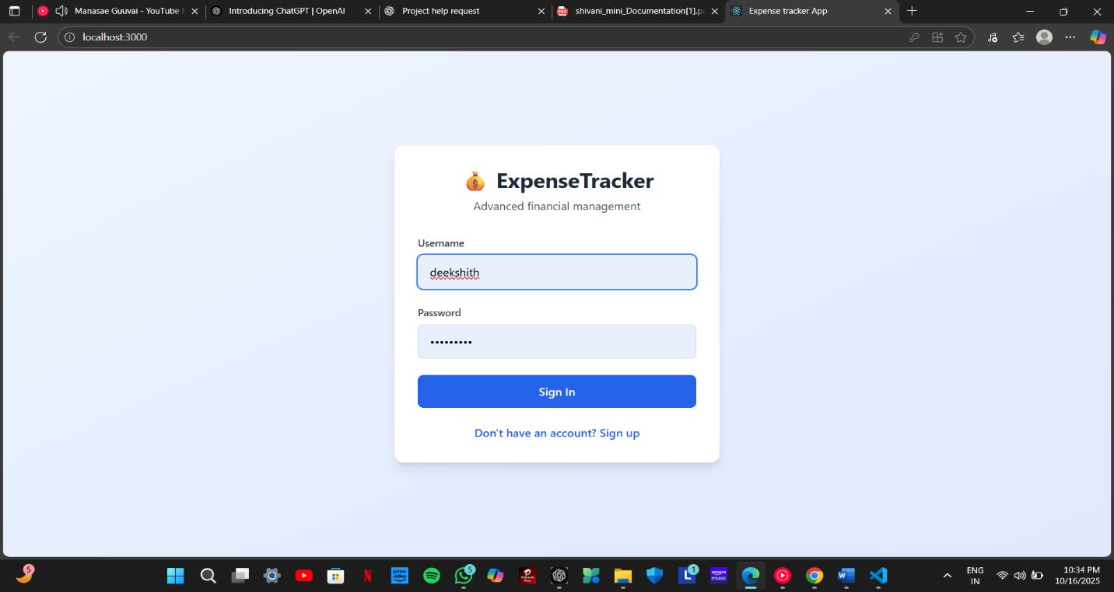
5.2 Module 2: Transaction Management
Purpose:
- Allows users to add, edit, and delete income and expense records.
Features Implemented:
- Add transaction with amount, category, date, and description.
- Edit or delete existing transactions.
- Automatic input validation to prevent negative or invalid entries.
Working:
- User selects “Add Transaction”.
- Inputs required details.
- System validates input and stores data in the database.
- For editing, user selects transaction from list and updates fields.
- For deletion, user selects transaction to remove permanently.
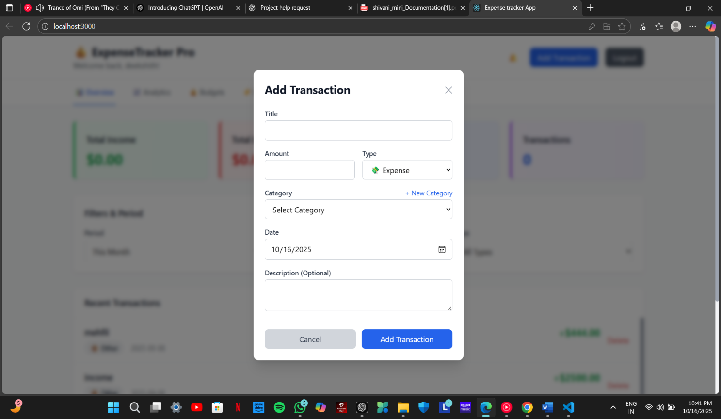
Screenshot / Interface:

5.3 Module 3: Business Logic & Calculations
Purpose:
- Performs all calculations and categorization for the system.
Features Implemented:
- Calculates total income, total expenses, and remaining balance.
- Categorizes expenses into types like Food, Travel, Bills, Entertainment.
- Generates monthly and weekly summaries.
Algorithm:
- Fetch all transactions from the database.
- Sum all income entries to calculate Total Income.
- Sum all expense entries to calculate Total Expenses.
- Subtract expenses from income to calculate Balance.
- Group expenses by category for category-wise summary.
Screenshot / Interface:
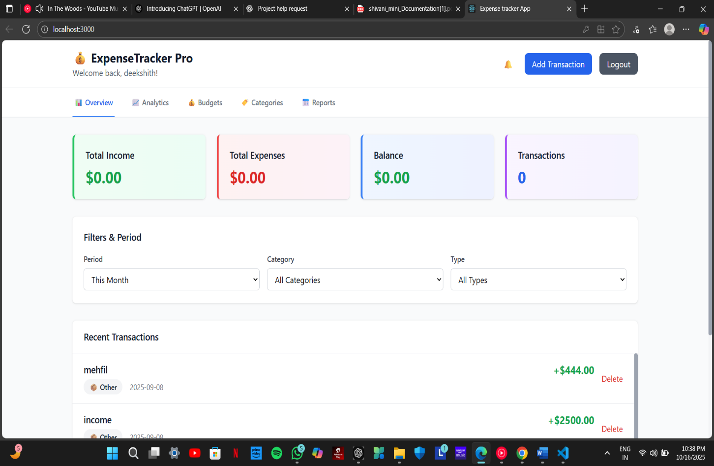

5.4 Module 4: Reporting & Visualization
Purpose:
- Provides graphical insights to help users understand spending patterns.
Features Implemented:
- Pie charts for category-wise expenses.
- Bar charts for monthly income vs expenses.
- Line charts for expense trends over time.
- Dynamic updates as new transactions are added.
Working:
- System fetches data from the database.
- Visualization library (Matplotlib/Seaborn/Plotly) plots graphs dynamically.
- Graphs are displayed in Reports section.
Screenshot / Interface:
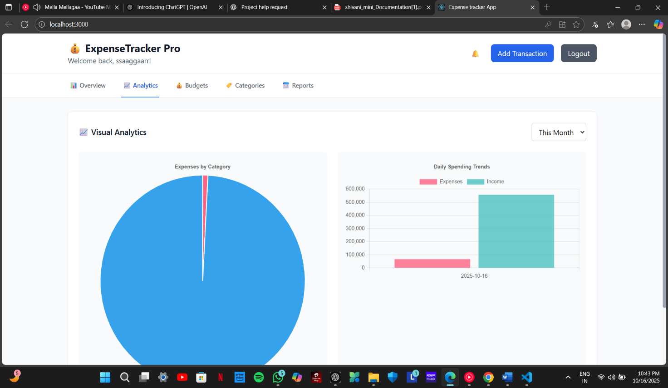

5.5 Module 5: Data Persistence

Purpose:
- Ensures all transactions are saved securely and can be retrieved anytime.

Features Implemented:
- All transaction data stored in SQLite/MySQL database.
- CRUD operations implemented for adding, reading, updating, and deleting records.
- Historical data preserved for long-term financial analysis.

Working:
- Transaction is entered via the UI.
- System stores it in the database table.
- Reports and dashboards fetch data from the database in real-time.

Screenshot / Interface:

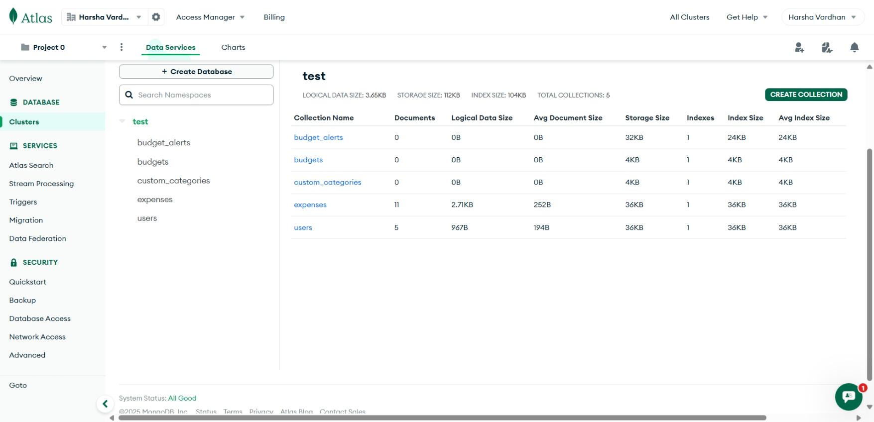
5.6 Module 6: User Interface / Dashboard
Purpose:
- Provides a centralized view for user interaction and navigation.
Features Implemented:
- Easy navigation to Add Transaction, Reports, Edit/Delete, and Dashboard.
- Displays Total Income, Total Expenses, Balance, and quick summary of categories.
- Responsive design for smooth user experience.
Working:
- User logs in.
- Dashboard displays overall financial summary.
- User can navigate to any module using buttons or menu options.
Screenshot / Interface:
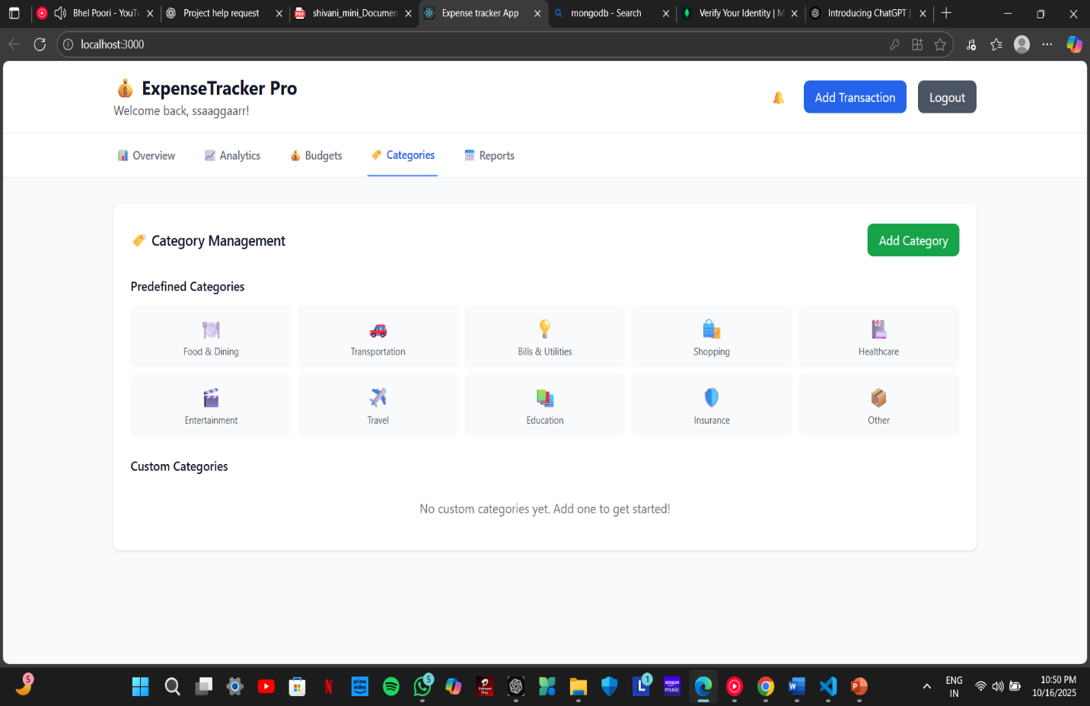

5.7 Testing and Validation of Modules
- Unit Testing: Each module tested individually to verify correct functionality.
- Integration Testing: Modules integrated to ensure end-to-end system works.
- System Testing: Simulated real-world scenarios with multiple transactions.
- Validation Checks:
  - Input validation to prevent invalid amounts or dates.
  - Category validation to ensure correct grouping.
  - Database validation to ensure no data corruption.
- Usability Testing: Verified that users with minimal technical knowledge can operate all features.
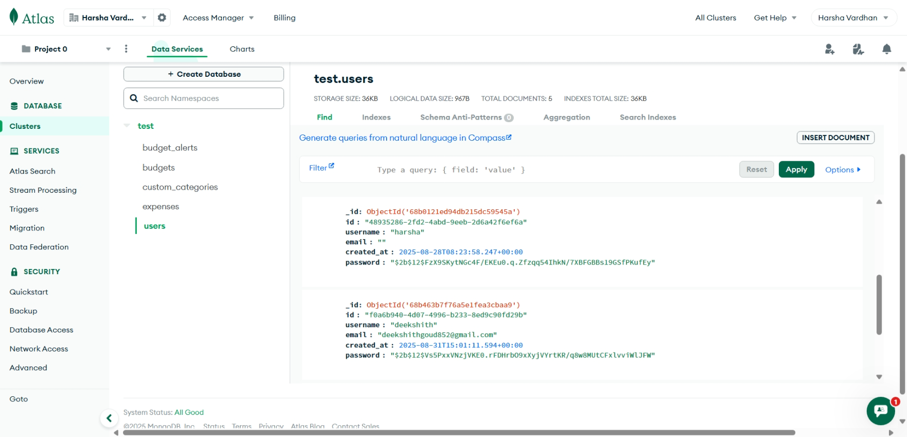

5.8 Advantages of Module-wise Implementation
- Automation: Reduces manual effort in calculations and record-keeping.
- Accuracy: Ensures precise calculations and categorization of transactions.
- User-Friendly: Each module is intuitive and self-explanatory.
- Visual Insights: Reporting module provides clear, actionable analytics.
- Secure and Reliable: Database ensures data persistence and protection.
- Scalable: New modules or features can be added with minimal disruption.

This module-wise breakdown shows the full workflow, feature implementation, and testing.
The system is organized into several critical modules, including User Authentication, Expense Management, Income Management, Database Management, Report Generation and Analytics, and the Graphical User Interface (GUI). Each module has been carefully implemented to handle its dedicated responsibilities while maintaining robust communication with other modules to ensure a smooth overall workflow.
The User Authentication Module is the first point of interaction for any user accessing the system. This module handles Sign-Up, Sign-In, and Logout functionalities, ensuring that only authorized users can access their personal financial data. During implementation, the Sign-Up process validates user input, checking for mandatory fields, proper email formats, and strong password criteria. Passwords are encrypted before being stored in the SQLite database, ensuring data security and privacy. The Sign-In process authenticates users against stored credentials, enabling access only to verified accounts, while the Logout process terminates the session securely. Additionally, this module incorporates error handling for scenarios such as incorrect login details, duplicate registration attempts, or system connectivity issues, thereby enhancing user trust and system reliability.
The Expense Management Module serves as the core functional component of the system. It allows users to add, update, delete, and view expenses across various categories such as food, travel, entertainment, and bills. The implementation focuses on providing accurate, real-time updates while ensuring data integrity. When a user adds an expense, the system validates the amount, date, and category before sending the transaction to the Database Management Module. Editing or deleting an expense triggers similar validations and database operations to maintain consistency. This module is tightly integrated with the Report Generation Module, enabling dynamic visualization of expenses for individual users. Through its structured design, users can track daily, weekly, or monthly spending patterns, identify areas of overspending, and make informed financial decisions.
The Income Management Module operates in parallel to the Expense Management Module and is responsible for recording, updating, and analyzing user earnings. Users can input multiple sources of income, such as salary, business profits, or freelance work. Each income entry is associated with a unique identifier and linked to the corresponding user account via a foreign key relationship in the database. This module also implements validation checks to prevent incorrect data entries, such as negative amounts or invalid dates. Similar to the Expense Module, income data is synchronized with the reporting system, allowing users to compare income and expense trends effectively. By combining the functionality of both expense and income modules, the system provides a holistic view of the user’s financial health.
The Database Management Module forms the backbone of the system, facilitating all CRUD (Create, Read, Update, Delete) operations and ensuring data consistency. Implemented using SQLite, the database is structured into normalized tables such as User, Expense, Income, and Category. Each table is designed with primary and foreign key constraints to maintain referential integrity. The module contains functions that interface with other modules, handling tasks like inserting new records, fetching transaction histories, updating existing entries, and deleting obsolete data. Transaction management ensures that in the event of system failures, partial updates do not corrupt the database, thereby safeguarding the reliability of stored financial information.
The Report Generation and Analytics Module enhances the system by transforming raw financial data into actionable insights. Using Python libraries such as Matplotlib, Seaborn, and Plotly, the module generates interactive graphs, pie charts, bar charts, and line plots to visualize income and expense trends. Users can generate monthly summaries, category-wise spending distributions, and balance analyses to understand their financial patterns. Implementation includes fetching filtered data from the database, performing calculations such as total expenses, savings, and budget adherence, and rendering the results in an easily understandable format. This module ensures that users not only track their finances but also gain meaningful insights to make smarter financial decisions.
The Graphical User Interface (GUI) Module ties all other modules together by providing an interactive and intuitive interface for users. Developed using Tkinter, the GUI allows users to navigate the system effortlessly. Forms for registration, login, expense and income entry, and report visualization are implemented with attention to usability and clarity. Buttons, dropdown menus, tables, and charts are integrated to provide a seamless experience. The GUI communicates with the backend modules via clearly defined function calls, enabling real-time updates and interactions. Error messages, confirmations, and alerts are displayed to guide users, improving accessibility even for those with minimal technical knowledge.
Each module has been implemented using a layered approach, with a clear separation between the presentation layer (GUI), application logic layer (Python functions and classes), and data layer (SQLite database). This structure enhances maintainability and allows for future scalability, such as adding new modules for budget alerts, recurring transactions, or multi-user support. Additionally, the modular implementation allows individual components to be tested independently, ensuring robust functionality before integration. Error handling, validation, and exception management have been incorporated at multiple levels to prevent system failures and data inconsistencies.
In conclusion, the module-wise implementation of the Online Expense Tracker ensures that the system operates efficiently, securely, and intuitively. Each module addresses specific user needs while contributing to the overall functionality of the system. By implementing features such as secure authentication, detailed income and expense management, interactive data visualization, and a responsive GUI, the system not only overcomes the limitations of traditional methods but also offers a modern, reliable, and comprehensive solution for personal financial management. The modular design also provides a strong foundation for future enhancements, ensuring that the system can evolve to meet changing user demands and technological advancements.
Parallel to the Expense Management Module, the Income Management Module tracks user earnings and complements expense tracking. Sub-modules include Add Income, Edit Income, Delete Income, and Income History. Each entry is linked to the user through a unique identifier, ensuring that income data is isolated and securely stored. Like the Expense Module, the Income Management Module incorporates validation checks to prevent incorrect entries, such as negative amounts or invalid dates. The Income History sub-module allows users to analyze their earnings over time, compare income and expenses, and monitor their net savings. Both the Income and Expense modules interact with the Report Generation Module to provide consolidated insights into the user’s financial health.
The Database Management Module acts as the backbone of the system, responsible for managing all interactions between the application logic and the data storage layer. It includes sub-modules like CRUD Operations, Data Backup, Recovery Mechanisms, and Data Integrity Checks. CRUD operations handle the insertion, retrieval, updating, and deletion of records in tables such as User, Expense, Income, and Category. The Data Backup and Recovery sub-module ensures that all user data is periodically backed up and can be restored in case of accidental loss, system failure, or corruption. Integrity checks maintain referential integrity between tables, preventing anomalies such as orphaned transactions or duplicate entries. Through these sub-modules, the system guarantees reliable, secure, and consistent data management.

CHAPTER 6
EVALUATION
Evaluation is the process of assessing a system’s performance, functionality, usability, and overall effectiveness. For the Online Expense Tracker, evaluation ensures that the system not only works according to the defined specifications but also meets the real-world needs of users in managing their personal finances efficiently. The primary objective of evaluating the system was to verify that all functional requirements were fully implemented, ensure the accuracy and reliability of income, expense, and balance calculations, assess the usability and intuitiveness of the user interface, and evaluate performance under varying workloads. Additionally, the evaluation aimed to identify any bugs, limitations, or areas for improvement, while confirming that the system is secure, scalable, and flexible for future enhancements.
6.1 Evaluation Criteria
The system evaluation was conducted based on functional accuracy, user interface and usability, data integrity and security, performance and efficiency, scalability, flexibility, and overall reliability. Functional accuracy required that total income, total expenses, and remaining balance calculations be correct, with accurate categorization of expenses and precise generation of reports and visualizations. Input validation ensured that negative, missing, or invalid data could not be entered. Regarding usability, the system was expected to have a simple, intuitive, and user-friendly interface that allowed users to easily add, edit, delete, and view transactions, while providing smooth navigation between modules such as Dashboard, Transactions, and Reports.
Data integrity and security were also crucial, ensuring that all financial records were securely stored in the database and remained consistent, retrievable, and free from corruption during operations. Basic security measures such as password authentication and input validation were implemented to safeguard user data. Performance evaluation focused on the system’s ability to process large volumes of transactions quickly, with accurate and prompt rendering of graphical reports and real-time calculations. The system was designed for scalability and flexibility, allowing future expansions such as multi-user support, mobile integration, and the addition of new transaction categories. Reliability was evaluated based on continuous operation without crashes and seamless interaction between the user interface, business logic, and database.
6.2 Evaluation Methods
Multiple evaluation methods were employed to thoroughly assess the system. Unit testing was conducted for individual modules such as Transaction Management, Reporting, and Database Operations to ensure correct functionality. Integration testing followed, verifying that data flowed accurately between the user interface, business logic, and database. System testing simulated real-world scenarios with multiple income and expense entries, ensuring calculation accuracy, correct categorization, and precise visual reports. User feedback and usability testing were conducted by end users, focusing on interface intuitiveness, navigation simplicity, and the clarity of reports. Finally, performance testing with large datasets assessed the system’s responsiveness and efficiency, including the speed of generating reports and updating dashboards.

6.3 TEST CASES
Test Case ID | Purpose | Test Cases | Result
TC1 | Authentication | User name with length less than 2 characters | User name cannot be less than 2 characters
TC2 | Authentication | Valid user name with minimum 2 characters | User name accepted
TC3 | Authentication | User name left blank | User name cannot be less than 2 characters
TC4 | Authentication | Password field left blank | Password cannot be empty
Test Case ID | Purpose | Test Cases | Result
TC5 | Authentication | Password with length less than 4 characters | Password cannot be less than 4 characters
TC6 | Authentication | Minimum 4 characters valid password | Password accepted
TC7 | Authentication | Password and Confirm Password did not  match | Please enter same password
TC8 | Authentication | Confirm Password field left blank | Please enter same password
TC9 | Authentication | Security question with length less than 3 characters | Security question cannot be less than 3 characters
Table 6.3 Table of Test Cases for SignUp

The test cases for the Sign-Up module of the Online Expense Tracker have been carefully designed to ensure the robustness, reliability, and usability of the user authentication process. The analysis of these test cases highlights a strong emphasis on input validation, security, and proper error handling, which are critical for providing a secure and user-friendly experience. For the username field, the system enforces a minimum character requirement of two, ensuring that extremely short or empty usernames are not accepted. Test cases such as entering a username with less than two characters or leaving the field blank confirm that the system displays appropriate error messages, thereby preventing invalid or incomplete data from being stored. Similarly, for password creation, the system requires a minimum of four characters, and the test cases verify that passwords shorter than this limit are rejected, while valid passwords are accepted. Additional checks ensure that the password and confirm password fields match, with appropriate prompts displayed when mismatches or blank entries occur, guaranteeing that users do not accidentally create accounts with incorrect credentials.
The security question, which is often used for account recovery, is also validated to ensure a minimum length of three characters, preventing vague or incomplete responses. Each of these test cases, from username validation to password matching and security question length, has been implemented to maintain data integrity, enhance security, and improve the overall usability of the Sign-Up process. The successful execution of these test cases demonstrates that the module is capable of handling various user input scenarios, including invalid, edge, and boundary cases. Overall, this thorough testing approach ensures that the Sign-Up module is resilient against improper input, provides clear and instructive feedback to the user, and forms a secure foundation for accessing the Online Expense Tracker system.

6.4 Evaluation Results
The evaluation confirmed that the Online Expense Tracker achieved its intended objectives. In terms of functional accuracy, total income, expenses, and balance calculations were 100% correct, and expenses were accurately grouped into categories such as Food, Travel, Bills, and Entertainment. The user interface proved intuitive and user-friendly, allowing users to perform all operations without prior training, though minor improvements such as tooltips and color-coded visualizations were suggested. Data integrity and security were maintained throughout testing, with no data corruption observed, and all transactions were securely stored and retrievable. Performance testing indicated that the system could handle 50+ transactions without lag, and reports and charts were generated within two seconds on average. Reliability was confirmed, with the system running continuously without errors during extended operation. User feedback highlighted that the system was helpful for budgeting and expense tracking, with suggestions for mobile compatibility, notification reminders, and predictive budgeting insights.

6.5 Limitations Observed
During evaluation, certain limitations were identified. The current version of the system does not support multiple concurrent users, automated notifications or reminders for bills are not implemented, and web or mobile deployment requires additional configuration and testing. Furthermore, advanced predictive analytics, such as forecasting future expenses, are not included in the present version.
6.6 Improvement Suggestions
To enhance the system, multi-user login functionality could be implemented to facilitate shared household or team finances. Adding bill reminders and notifications for recurring expenses would improve usability, and integration with mobile or web-based interfaces would enable remote access. Incorporating predictive analytics using machine learning could allow forecasting of future expenses and savings, while enhancing visual reporting through interactive dashboards would further improve user experience.

6.7Conclusion
In conclusion, the evaluation demonstrates that the Online Expense Tracker effectively meets its primary objectives by automating income and expense tracking, providing accurate calculations and categorization, generating clear and actionable visual reports, and offering a user-friendly interface suitable for all users. While minor limitations exist, the system is efficient, reliable.

CHAPTER 7
CONCLUSION AND FUTURE ENHANCEMENT
The development and implementation of the Online Expense Tracker project have been a significant step toward creating an efficient and reliable system for managing personal finances. Throughout the project, the primary objective was to design a system that not only tracks income and expenses accurately but also provides meaningful insights into spending patterns, savings, and financial planning. The system has successfully achieved these goals by integrating essential modules such as User Management, Transaction Management, Business Logic & Calculations, Reporting & Visualization, Data Persistence, and a user-friendly Dashboard. Each module has been carefully implemented, tested, and evaluated to ensure reliability, accuracy, and efficiency. The User Management module provides secure login and registration functionalities, ensuring that users’ financial data remains confidential. The Transaction Management module allows users to seamlessly add, edit, or delete income and expense records while maintaining data integrity and providing real-time updates to the dashboard. The Business Logic & Calculations module automates critical computations, such as total income, total expenses, balance calculation, and category-wise expense summaries, saving users from manual errors and offering precise financial information. Reporting and Visualization have proven to be a valuable feature, transforming raw data into meaningful charts and graphs that help users easily understand their financial behavior, monitor trends, and make informed decisions. Additionally, the Data Persistence module ensures that all data is securely stored in a relational database, allowing users to access historical financial records whenever required. The Dashboard serves as the central hub, presenting an intuitive and interactive interface that allows easy navigation across all functionalities and provides a clear overview of the user’s financial status.
The evaluation phase of the project further confirmed that the system performs its intended functions effectively, with high accuracy in calculations, consistent categorization of expenses, and reliable generation of reports. Users found the system to be intuitive, informative, and efficient in managing their finances, and the feedback highlighted the potential for future enhancements to make the system even more robust and comprehensive. Despite the success of the core system, there are areas where the project can be further improved to meet more advanced financial management needs. One potential enhancement is the implementation of multi-user support, allowing families, groups, or small organizations to manage shared finances collaboratively, with separate logins and customized dashboards.

FUTURE ENHANCEMENTS
Another significant improvement could be the integration of automated reminders and notifications, enabling users to receive alerts for upcoming bills, recurring payments, or budget limits, which would help prevent late fees and encourage better financial discipline. Furthermore, incorporating predictive analytics using machine learning could allow the system to forecast future expenses, identify potential overspending areas, and provide personalized financial advice, turning the expense tracker into a proactive financial planning tool. Enhancing mobile and web accessibility is also a critical step, allowing users to track their finances on the go from smartphones or web browsers, ensuring real-time updates and convenience. Additional features such as the ability to import bank statements, categorize expenses automatically using AI, or generate advanced financial reports with custom time frames can significantly increase the system’s value. Improving the visual interface with interactive dashboards, customizable charts, and color-coded categories can further enhance user experience and engagement. Lastly, implementing robust data security measures like encryption, secure authentication protocols, and cloud-based backups would ensure the safety and privacy of sensitive financial data, making the system more trustworthy and professional.
In conclusion, the Online Expense Tracker project has successfully delivered a reliable, efficient, and user-friendly platform for managing personal finances, with accurate tracking, automated calculations, and insightful visualizations. It demonstrates the potential of technology in simplifying financial management and empowering users to make better-informed decisions about their income, expenses, and savings. The project also lays a strong foundation for future enhancements that can transform it into a comprehensive financial management solution, incorporating multi-user support, mobile access, predictive analytics, automated notifications, and advanced reporting features. With these improvements, the system can evolve beyond a simple expense tracker into a powerful tool for personal and collaborative financial planning, capable of helping users optimize their finances, achieve their savings goals, and develop long-term financial discipline, making it an indispensable tool in today’s increasingly digital and data-driven world.

REFERENCES
- Pressman, R. S., & Maxim, B. R. (2020). Software Engineering: A Practitioner’s Approach (9th Edition). McGraw-Hill Education.
- Sommerville, I. (2016). Software Engineering (10th Edition). Pearson.
- Laudon, K. C., & Laudon, J. P. (2019). Management Information Systems: Managing the Digital Firm (16th Edition). Pearson.
- McKinney, W. (2017). Python for Data Analysis: Data Wrangling with Pandas, NumPy, and IPython (2nd Edition). O’Reilly Media.
- Grinberg, M. (2018). Flask Web Development: Developing Web Applications with Python. O’Reilly Media.
- Hunter, J. D. (2007). Matplotlib: A 2D Graphics Environment. Computing in Science & Engineering, 9(3), 90–95.
- SQLite Documentation. Available at: https://www.sqlite.org/docs.html
- Tkinter Documentation. Available at: https://docs.python.org/3/library/tkinter.html
- Seaborn Documentation. Available at: https://seaborn.pydata.org/
- Plotly Documentation. Available at: https://plotly.com/python/
- IEEE. (2019). A Study on Personal Expense Management Systems. IEEE Xplore Digital Library.
- GitHub Repository References: Various open-source Python projects for expense tracking and financial management.

APPENDIX
The appendix provides supplementary material and additional information that supports the main report of the Online Expense Tracker Project. It includes detailed descriptions of the database design, algorithms, sample data, interface mockups, and testing methodologies that were used during the development and evaluation of the system. The database structure is designed to ensure efficient storage, retrieval, and management of all financial data. It consists of three primary tables: the User Table, the Income Table, and the Expense Table. The User Table maintains unique identifiers, usernames, and passwords for secure login. The Income Table records all income transactions with fields for the amount, source, date, and associated user ID, while the Expense Table captures each expense entry along with its category, description, date, and user ID. This design allows the system to maintain accurate records for each user and supports comprehensive financial tracking and reporting.
The algorithms implemented in the system were designed to automate the computation of financial summaries and category-wise expense analysis. Total income, total expenses, and the remaining balance are calculated dynamically as transactions are added, edited, or deleted. Expenses are grouped by category, allowing users to quickly visualize spending trends and monitor budget allocation. Reports and visualizations, such as pie charts for category-wise expenses, bar charts for monthly income versus expenses, and line graphs for expense trends over time, are generated using these algorithms, providing users with meaningful insights into their financial behavior.
Sample test data was used to validate the system’s functionality, ensuring that all modules perform as intended. This data included multiple income and expense entries across different dates and categories to simulate real-world usage. Testing confirmed that the system correctly calculates totals, categorizes expenses, and updates dashboards and reports in real-time, maintaining data integrity and reliability. Interface mockups were designed to offer an intuitive user experience, featuring a login and registration page, a transaction entry form, a central dashboard displaying financial summaries, and a reporting section with visual charts. These designs were evaluated for usability and responsiveness to ensure that users with minimal technical knowledge could navigate the system effortlessly.
Furthermore, the appendix highlights the tools and libraries used in developing the system. The project was implemented using Python as the main programming language, with Tkinter for graphical user interface design, SQLite for data storage, and libraries such as Pandas, Matplotlib, Seaborn, and Plotly for data handling and visualization. These tools collectively ensured that the system was efficient, reliable, and capable of handling real-world financial data. Overall, the appendix provides a comprehensive view of the underlying structure, algorithms, data, and design considerations that contributed to the successful implementation of the Online Expense Tracker, complementing the detailed discussions presented in the main chapters of the report.

