CS 278 Study Guide #4: Computer Architecture

NAME: DUE: Oct 4 Received: .
GRADE:

EXERCISES:
CATEGORY | POINTS
EX04_01 |  | 20
EX04_02 |  | 10
EX04_03 |  | 10
EX04_04 |  | 10
EX04_05 |  | 10
EX04_06 |  | 10
EX04_07 |  | 10
EX04_08 |  | 10
EX04_09 |  | 10
TOTAL |  | 100

EX04_01 – Answer Questions 1 - 8 given in this document. Type or write out your answers and attach them to this worksheet.

EX04_02 – Answer all the EVEN section review questions for 3.1.11 on page 63

2. no
4. 30 MOD (3*4) + (3-1) / 2 = 20
6. no
8. 247 characters

EX04_03 – Answer ALL the section review questions for 3.2.4 on page 70. NOTE: The first question in the section review is wrong. It should read: “In the AddTwo program, what is the meaning of the ENDP directive?”

- The ENDP directive signals the end of a procedure (typically main)
- The .CODE directive declares the program’s entry point
- CODE and STACK
- The EAX
- INVOKE ExitProcess, 0

EX04_04 – Answer ALL the section review questions for 3.2.4 on page 73

- Listing files (.lst) and object files (.obj)
- True
- True
- The loader
- Executable files (.exe)

EX04_05 – Answer ALL the section review questions for 3.4.13 on pages 83 & 84

- var SWORD ?
- var BYTE ?
- var SBYTE ?
- var QWORD ?
- SDWORD

EX04_06 – Answer ALL the section review questions for 3.5.5 on page 88
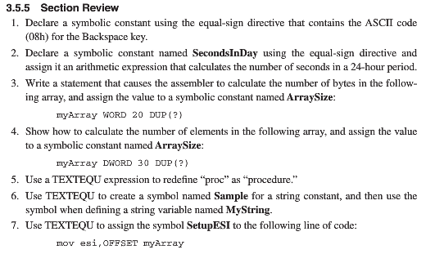

- BACKSPACE = 08h
- SecondsInDay = 60 * 60 * 24
- ArraySize = ($ - myArray)
- ArraySize = ($ - myArray) / 4
- PROCEDURE TEXTEQU <PROC>
- Sample TEXTEQU <”This is my sample string”>
MyString BYTE Sample
- SetupESI TEXTEQU <move esi, OFFSET myArray>

EX04_07 – Do programming problem on page 1 on page 94
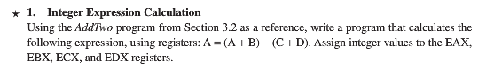

EX04_08 – Do programming problem on page 2 on page 94
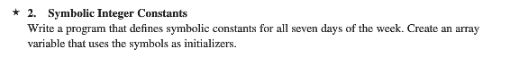

EX04_09 – Do programming problem on page 4 on page 94

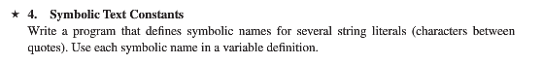

CS278 Study Guide 4: Data Representation

Reading Assignment for Next Class Period
- Read Chapter 3.1 to 3.3 of Irvine

Background Material for this Session
- Chapter 2.1-2.5 of Irvine

Learning Goals for this Study Guide
- Understand Data Representation

Understanding Computer Architecture

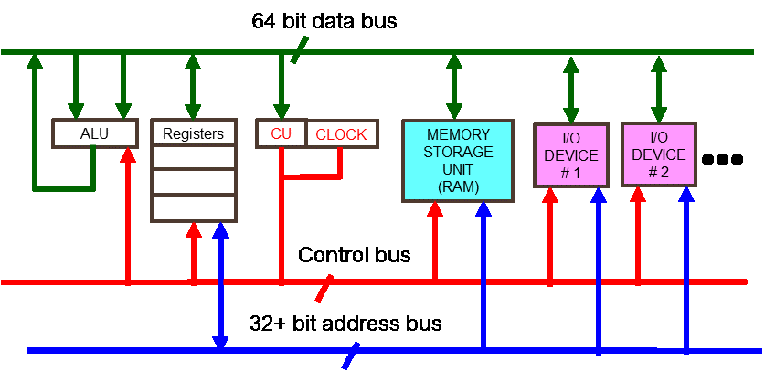

Type out your answers to the follow questions. Save this document in your folder on CS1.

Question 1: What is the Fetch, Decode, Execute Cycle, and what happens in each phase of the cycle?
- Fetch: Retrieve the program’s instructions from memory (Program Counter Register)
- Decode: Computer Determines what the instructions mean they are supposed to do. (It goes to the control unit to do so)
- Execute: Complete the task that the decoded instructions outline (control unit tells ALU to do so)

Question 2: The Intel Extreme 2 Dual Core Processor has a clock frequency of 2.67 Giga Hertz. Approximately how many machine instructions can it perform in 1 second?
- 2.67 billion per second

Question 3: What is the performance bottleneck in modern computers?
- Memory is the performance bottleneck because it takes “so long” to read from memory

Question 4: What is the purpose of cache and branch prediction?
- The purpose is to make things easier (and thus quicker) to access because they are “more local” than the memory. Both cache and branch prediction work together to make the process more efficient.

Question 5: A CPU contains registers and what other elements?
- The CPU contains registers, CU, CLOCK, and ALU

Question 6: What busses connect the CPU to the rest of the computer system?
- The Control Bus, the 32+ bit address bus, and the 64 bit data bus connect the CPU to the rest of the system

Question 7: In this class we will focus on Protected Mode operation of the x86 processors. What are the features of protected mode?
- Protected mode is 4GB Memory Addressable
- Has 32+ address bits depending on the machine
- It also has a native mode for Windows and Linux
- It can run multiple programs at the same time
- Each program can be assigned its own memory area
- Programs cannot accidentally access each other’s data

