HOSPITAL MANAGEMENT SYSTEM
A DBMS Mini Project Report submitted in partial fulfillment of the requirements for the award of the degree of
BACHELOR OF TECHNOLOGY
in

ARTIFICIAL INTELLIGENCE AND MACHINE LEARNING
Submitted By
B. BHANU PRAKASH – 25B11AI102 M. GANESH REDDY – 25B11AI772

T. SANTOSH REDDY – 25B11AIC08 G. SIVA RAMA SWAMY – 25B11AI382

Under the esteemed guidance of

Mrs. G. L. Narasamba Vanguri


DEPARTMENT OF ARTIFICIAL INTELLIGENCE AND MACHINE LEARNING ADITYA UNIVERSITY
(Formerly Aditya Engineering College (A))
Aditya Nagar, ADB Road, Surampalem, Andhra Pradesh, India

2026 – 2027


Aditya Nagar, ADB Road, Surampalem, Andhra Pradesh, India

DEPARTMENT OF ARTIFICIAL INTELLIGENCE AND MACHINE LEARNING

CERTIFICATE
This is to certify that the DBMS Mini Project report entitled “Hospital Management System” is being submitted by B. Bhanu Prakash (Roll No. 25B11AI102), M. Ganesh Reddy (Roll No. 25B11AI772), T. Santosh Reddy (Roll No. 25B11AIC08) and G. Siva Rama Swamy (Roll No. 25B11AI382) in partial fulfillment of the requirements for the award of the B.Tech. degree in Artificial Intelligence and Machine Learning. The work documented in this report was carried out as part of the Mini Project for the course Database Management Systems (DBMS) during the academic year 2026–2027, and records the database design, implementation, and documentation undertaken by the team.
Project Guide Mrs. G. L. Narasamba Vanguri | Head of the Department  Dr. K. Naga Bhargavi, M. Tech, Ph.D.  Associate Professor & HOD

External Examiner

DECLARATION
We hereby declare that the DBMS Mini Project entitled “Hospital Management System” is a genuine work carried out by us. The database design, SQL implementation, queries and documentation presented in this report are our own work, completed under the guidance of Mrs. G. L. Narasamba Vanguri, Department of Artificial Intelligence and Machine Learning, Aditya University, Surampalem. We further declare that this work has not been submitted, in full or in part, for the award of any degree of this or any other educational institution.
Project Associates
B. BHANU PRAKASH (25B11AI102)
M. GANESH REDDY (25B11AI772)
T. SANTOSH REDDY (25B11AIC08)
G. SIVA RAMA SWAMY (25B11AI382)

Date: 05/10/26
Place: Surampalem

ACKNOWLEDGEMENT
It is with immense pleasure that we express our indebted gratitude to our project guide Mrs. G. L. Narasamba Vanguri, Department of Artificial Intelligence and Machine Learning, who guided us throughout the mini project. We are thankful for the constant encouragement and valuable suggestions received at every review stage.
We are grateful to Dr. K. Naga Bhargavi, Head of the Department, for inspiring us and for arranging the facilities and resources needed for this project.
We extend our sincere thanks to the Management, Dr. M. Sreenivasa Reddy, Deputy Pro-Chancellor, Dr. M. B. Srinivas, Vice-Chancellor, and Dr. A. Ramesh, Pro Vice-Chancellor (Engineering & Sciences), for providing an excellent academic environment.
Not to forget, we thank the Teaching and Non-Teaching Staff, our parents and our friends, who have directly or indirectly supported us in completing this project on time.
Project Associates
B. BHANU PRAKASH (25B11AI102)
M. GANESH REDDY (25B11AI772)
T. SANTOSH REDDY (25B11AIC08)
G. SIVA RAMA SWAMY (25B11AI382)

ADITYA UNIVERSITY
Surampalem
Department of Artificial Intelligence and Machine Learning

DBMS MINI PROJECT

Project Documentation Report

Project Title: Hospital Management System

Submitted by:
S.No | Student Name | Roll Number
1 | B. BHANU PRAKASH | 25B11AI102
2 | M. GANESH REDDY | 25B11AI772
3 | T. SANTOSH REDDY | 25B11AIC08
4 | G. SIVA RAMA SWAMY | 25B11AI382

Course: Database Management System (DBMS) Course Code: DBMS
Project Guide: Mrs. G. L. Narasamba Vanguri
Academic Year: 2026–27 Date of Submission: 05/10/2026
GitHub Repository Link: —

1. ABSTRACT
The Hospital Management System (HMS) is a relational database project designed to automate core hospital operations such as patient registration, doctor and staff management, appointments, billing, pharmacy and prescriptions through one centralized database.
The system consists of eight main entities: Patient, Doctor, Department, Appointment, Billing, Staff, Medicine, and Prescription, connected through foreign-key relationships to maintain data consistency across hospital departments.
Built using SQL and normalized up to Third Normal Form (3NF), the system uses PRIMARY KEY, FOREIGN KEY, NOT NULL, UNIQUE, and CHECK constraints to maintain accurate and valid data. The system supports patient care, doctor scheduling, billing and medicine stock management. It reduces paperwork, improves operational efficiency, provides secure role-based data storage in a single centralized database, and enables better and faster patient care. SQL queries demonstrate CRUD operations, filtering, joins, and aggregate functions on the hospital data.

TABLE OF CONTENTS
Chapter | Title | Page No.
 | Certificate | i
 | Declaration | ii
 | Acknowledgement | iii
 | Project Documentation Report | iv
1 | ABSTRACT | v
 | List of Figures | vii
 | List of Tables | vii
2 | INTRODUCTION | 1
 | 2.1 Background | 1
 | 2.2 Purpose of the Database | 1
3 | PROBLEM STATEMENT | 1
4 | OBJECTIVES | 1
5 | TOOLS & TECHNOLOGIES USED | 2
6 | DATABASE DESIGN | 2
 | 6.1 Identified Entities | 2
 | 6.2 Entity Attributes | 2
 | 6.3 ER Diagram | 5
 | 6.4 Relationships & Cardinality | 5
 | 6.5 Primary Keys & Foreign Keys | 6
 | 6.6 Relational Database Schema | 6
 | 6.7 Normalization | 8
7 | DATABASE IMPLEMENTATION | 7
 | 7.1 DDL — Database and Table Creation | 9
 | 7.2 Sample Data — DML | 10
 | 7.3 Constraints & Data Integrity | 14
 | 7.4 SQL Operations & Queries | 14
 | 7.5 Sample Outputs / Screenshots | 15
8 | MODULES & FUNCTIONALITIES | 13
 | 8.1 System Architecture | 16
 | 8.2 Modules | 17
9 | ADVANTAGES OF THE SYSTEM | 14
10 | GITHUB REPOSITORY & TEAM RESPONSIBILITIES | 14
11 | ENHANCEMENTS & FUTURE IMPROVEMENTS | 14
12 | CONCLUSION | 15
13 | REFERENCES | 15
 | APPENDIX | 20
 | A. Complete SQL Script | 16
 | B. Additional Screenshots / Outputs | 16
LIST OF FIGURES
Figure No. | Title of the Figure | Page No.
6.3 | ER Diagram | 5
Figure 1 | SQL queries and database operations (DDL, DML, DQL) | 12
Figure 2 | CRUD operations and other useful SQL queries | 15
Figure 3 | Data integrity and validation | 16
Figure 4 | System architecture (three-layer model) | 17
Figure 5 | Project documentation overview | 20
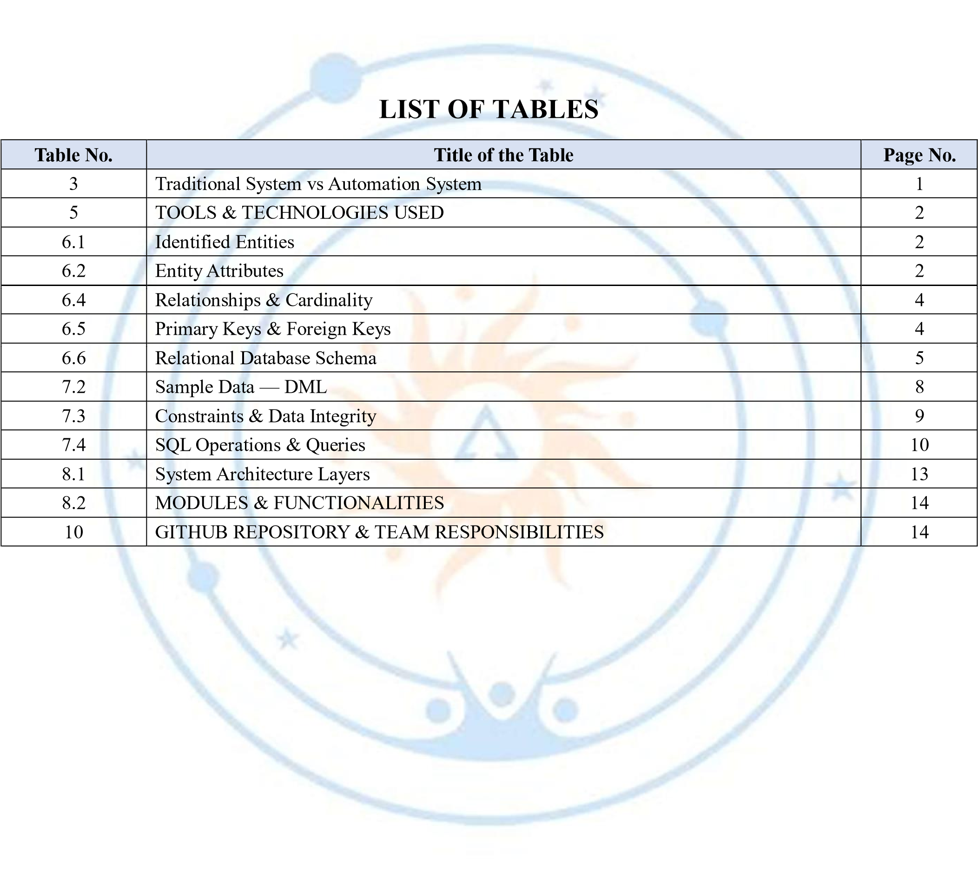

2. INTRODUCTION

2.1 Background
Hospitals handle large amounts of structured information related to patients, doctors, departments, appointments, billing, staff, medicines and prescriptions. When this information is kept in paper registers and separate files, retrieval is slow, the same data is stored several times, and a patient’s history is difficult to trace. A relational database is required to store this information consistently and to maintain the relationships between the different records. In this project, the hospital domain is represented using eight related tables: Patient, Doctor, Department, Appointment, Billing, Staff, Medicine, and Prescription. The schema separates data into appropriate entities and uses keys and constraints to reduce duplication and protect data integrity. SQL queries are then used to insert, retrieve, update, aggregate, and analyse the stored information.

2.2 Purpose of the Database

The database provides a centralized structure for managing patient registration details, doctor and department information, appointment schedules, billing records, staff details, medicine stock, and prescriptions. It can support doctors, receptionists, staff and administrators who need to retrieve patient history, schedule appointments, generate bills, prescribe medicines and monitor medicine stock. The relationships between the tables allow related information to be accessed through SQL joins and subqueries instead of maintaining disconnected records in different departments.

3. PROBLEM STATEMENT
Traditional paper-based hospital record keeping leads to manual paperwork, data redundancy, appointment conflicts, billing errors, slow history retrieval and no centralized records.
For example, a patient visits the hospital multiple times, but their previous records are stored in different registers. Staff may create another record instead of finding the existing one, making medical history difficult to retrieve.
The proposed system centralizes patient, doctor, department, appointment, billing, staff, medicine and prescription information into a single relational database. The system provides structured data management, referential integrity, validation and SQL-based reporting for efficient hospital operations.
Table 3: Traditional System vs Automation System
Traditional System | Automation System
Paper registers — registers and files consume time and space | Relational database
Duplicate entries — same patient recorded many times | Normalized data
Manual billing — manual calculation mistakes | Automated billing
Slow retrieval — past records are hard to trace | Instant search
Data loss risk — departments work in isolation | Backup & security

4. OBJECTIVES
- Objective 1: Automate hospital operations through a hospital management database.
- Objective 2: Maintain a centralized database for patients, doctors, departments, appointments, billing, staff, medicines and prescriptions.
- Objective 3: Improve inter-department communication and patient care.
- Objective 4: Provide efficient appointment scheduling and digital billing.
- Objective 5: Reduce paperwork and secure medical records.
- Objective 6: Generate reports and demonstrate SQL operations (CRUD, joins, aggregate functions) with integrity constraints.
- Objective 7: Document the database design, implementation, sample data, queries, and team responsibilities.

5. TOOLS & TECHNOLOGIES USED
Category | Tool / Technology Used
Database Server | SQL-based relational database management system (RDBMS)
Query Language | SQL — DDL, DML and DQL
Query / Admin Tool | SQL client / SQL environment
System Architecture | Three-layer model: Users Layer, Application Layer, Database Layer
Front-end (if any) | Not specified in the project presentation
Operating System | Not specified in the project presentation
Version Control | GitHub

6. DATABASE DESIGN

6.1 Identified Entities
S.No | Entity Name | Description
1 | Patient | Stores patient identity, age, gender, contact details, address, and blood group.
2 | Doctor | Stores doctor details, specialization, experience, contact number, and department assignment.
3 | Department | Stores hospital department names and the floor on which each department is located.
4 | Appointment | Stores appointments linking patients with doctors, along with date, time, and status.
5 | Billing | Stores patient bills, amounts, payment modes, and billing dates.
6 | Staff | Stores hospital staff details, position, and salary.
7 | Medicine | Stores medicine names, prices, and available stock.
8 | Prescription | Stores medicines prescribed against appointments, along with the dosage.

6.2 Entity Attributes
Entity | Attribute | Data Type | Key (PK/FK/—) | Attribute Type
Patient | Patient_ID | INTEGER | PK | Simple
Patient | Name | VARCHAR(50) | — | Simple
Patient | Age | INTEGER | — | Simple
Patient | Gender | CHAR(1) | — | Simple
Patient | Phone | VARCHAR(10) | — | Simple
Patient | Address | VARCHAR(100) | — | Simple
Patient | Blood_Group | VARCHAR(5) | — | Simple
Doctor | Doctor_ID | INTEGER | PK | Simple
Doctor | Name | VARCHAR(50) | — | Simple
Doctor | Specialization | VARCHAR(50) | — | Simple
Doctor | Experience | INTEGER | — | Simple
Entity | Attribute | Data Type | Key (PK/FK/—) | Attribute Type
Doctor | Phone | VARCHAR(10) | — | Simple
Doctor | Department_ID | INTEGER | FK | Simple
Department | Department_ID | INTEGER | PK | Simple
Department | Department_Name | VARCHAR(50) | — | Simple
Department | Floor | INTEGER | — | Simple
Appointment | Appointment_ID | INTEGER | PK | Simple
Appointment | Patient_ID | INTEGER | FK | Simple
Appointment | Doctor_ID | INTEGER | FK | Simple
Appointment | Appointment_Date | DATE | — | Simple
Appointment | Appointment_Time | TIME | — | Simple
Appointment | Status | VARCHAR(15) | — | Simple
Billing | Bill_ID | INTEGER | PK | Simple
Billing | Patient_ID | INTEGER | FK | Simple
Billing | Amount | DECIMAL(10,2) | — | Simple
Billing | Payment_Mode | VARCHAR(20) | — | Simple
Billing | Bill_Date | DATE | — | Simple
Staff | Staff_ID | INTEGER | PK | Simple
Staff | Name | VARCHAR(50) | — | Simple
Staff | Position | VARCHAR(30) | — | Simple
Staff | Salary | DECIMAL(10,2) | — | Simple
Medicine | Medicine_ID | INTEGER | PK | Simple
Medicine | Medicine_Name | VARCHAR(50) | — | Simple
Medicine | Price | DECIMAL(8,2) | — | Simple
Medicine | Stock | INTEGER | — | Simple
Prescription | Prescription_ID | INTEGER | PK | Simple
Prescription | Appointment_ID | INTEGER | FK | Simple
Prescription | Medicine_ID | INTEGER | FK | Simple
Prescription | Dosage | VARCHAR(50) | — | Simple

6.3 ER Diagram
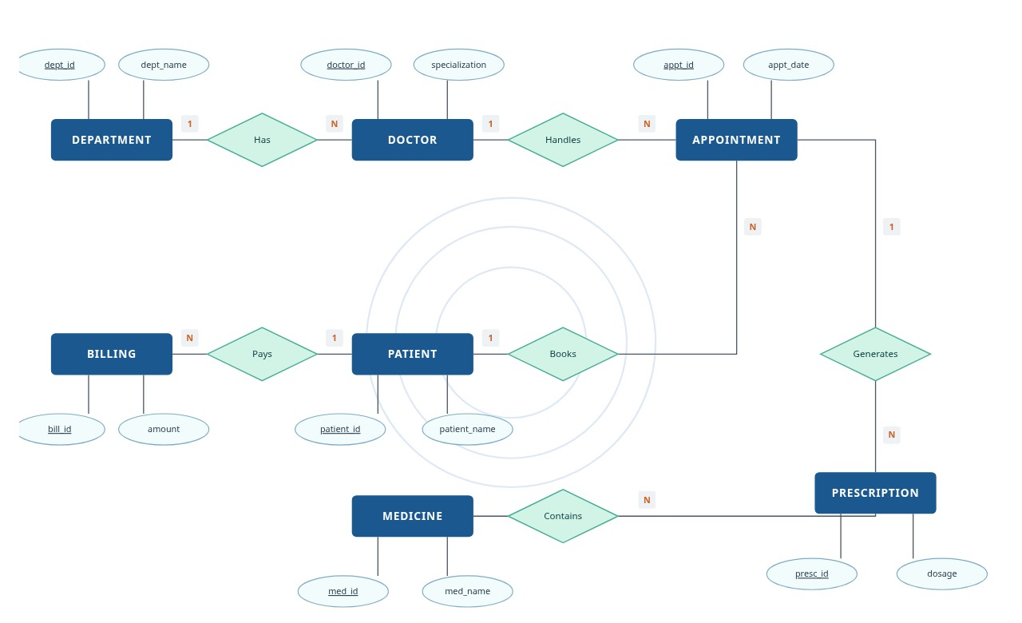
Figure 6.3: ER Diagram of the Hospital Management System
The ER diagram shows the eight entities of the system and their relationships: a Department has many Doctors, a
Doctor handles many Appointments, a Patient books many Appointments, a Patient pays many Bills, an Appointment generates Prescriptions, and a Medicine is contained in Prescriptions. Primary key attributes are underlined, and the cardinality of each relationship is marked on the connecting lines. The Staff entity stores independent employee records and does not take part in a foreign-key relationship.

6.4 Relationships & Cardinality
Entity 1 | Relationship | Entity 2 | Cardinality (1:1 / 1:N / M:N)
Department | has | Doctor | 1:N
Doctor | handles | Appointment | 1:N
Patient | books | Appointment | 1:N
Patient | pays | Billing | 1:N
Appointment | generates | Prescription | 1:N
Medicine | contains | Prescription | 1:N

6.5 Primary Keys & Foreign Keys
Entity | Primary Key | Foreign Key (References)
Patient | Patient_ID | —
Doctor | Doctor_ID | Department_ID → Department
Department | Department_ID | —
Appointment | Appointment_ID | Patient_ID → Patient, Doctor_ID → Doctor
Billing | Bill_ID | Patient_ID → Patient
Entity | Primary Key | Foreign Key (References)
Staff | Staff_ID | —
Medicine | Medicine_ID | —
Prescription | Prescription_ID | Appointment_ID → Appointment, Medicine_ID → Medicine
Referential integrity: every foreign key value must exist in the referenced primary key column.

6.6 Relational Database Schema
Table Name | Column Name | Data Type | PK/FK/— | Constraints
Patient | Patient_ID | INTEGER | PK | PRIMARY KEY
Patient | Name | VARCHAR(50) | — | NOT NULL
Patient | Age | INTEGER | — | CHECK Age > 0
Patient | Gender | CHAR(1) | — | CHECK M / F / O
Patient | Phone | VARCHAR(10) | — | NOT NULL, UNIQUE
Patient | Address | VARCHAR(100) | — | NULL allowed
Patient | Blood_Group | VARCHAR(5) | — | NULL allowed
Doctor | Doctor_ID | INTEGER | PK | PRIMARY KEY
Doctor | Name | VARCHAR(50) | — | NOT NULL
Doctor | Specialization | VARCHAR(50) | — | NOT NULL
Doctor | Experience | INTEGER | — | CHECK Experience >= 0
Doctor | Phone | VARCHAR(10) | — | NOT NULL, UNIQUE
Doctor | Department_ID | INTEGER | FK | NOT NULL, FOREIGN KEY →  Department
Department | Department_ID | INTEGER | PK | PRIMARY KEY
Department | Department_Name | VARCHAR(50) | — | NOT NULL
Department | Floor | INTEGER | — | CHECK Floor >= 0
Appointment | Appointment_ID | INTEGER | PK | PRIMARY KEY
Appointment | Patient_ID | INTEGER | FK | NOT NULL, FOREIGN KEY → Patient
Appointment | Doctor_ID | INTEGER | FK | NOT NULL, FOREIGN KEY → Doctor
Appointment | Appointment_Date | DATE | — | NOT NULL
Appointment | Appointment_Time | TIME | — | NOT NULL
Appointment | Status | VARCHAR(15) | — | NOT NULL, DEFAULT 'Scheduled', CHECK allowed statuses
Billing | Bill_ID | INTEGER | PK | PRIMARY KEY
Billing | Patient_ID | INTEGER | FK | NOT NULL, FOREIGN KEY → Patient
Billing | Amount | DECIMAL(10,2) | — | NOT NULL, CHECK Amount > 0 AND Amount <= 100000
Billing | Payment_Mode | VARCHAR(20) | — | NOT NULL, CHECK Cash / Card / UPI
Billing | Bill_Date | DATE | — | DEFAULT CURRENT_DATE
Staff | Staff_ID | INTEGER | PK | PRIMARY KEY
Staff | Name | VARCHAR(50) | — | NOT NULL
Staff | Position | VARCHAR(30) | — | NOT NULL
Staff | Salary | DECIMAL(10,2) | — | NOT NULL, CHECK Salary >= 0
Medicine | Medicine_ID | INTEGER | PK | PRIMARY KEY
Medicine | Medicine_Name | VARCHAR(50) | — | NOT NULL, UNIQUE
Medicine | Price | DECIMAL(8,2) | — | NOT NULL, CHECK Price >= 0
Medicine | Stock | INTEGER | — | NOT NULL, DEFAULT 0, CHECK  Stock >= 0
Table Name | Column Name | Data Type | PK/FK/— | Constraints
Prescription | Prescription_ID | INTEGER | PK | PRIMARY KEY
Prescription | Appointment_ID | INTEGER | FK | NOT NULL, FOREIGN KEY →  Appointment
Prescription | Medicine_ID | INTEGER | FK | NOT NULL, FOREIGN KEY →  Medicine
Prescription | Dosage | VARCHAR(50) | — | NOT NULL
6.7 Normalization

UNF → 1NF → 2NF → 3NF
UNF: Hospital information could be represented as one large combined record containing patient, doctor, department, appointment, bill, and medicine details, with the same patient and doctor details repeated for every visit.
1NF: The design separates repeating groups and keeps attributes atomic. For example, the medicines prescribed in one visit are stored as separate Prescription records instead of a list inside the appointment record, and each attribute such as Phone or Blood_Group holds a single value.
2NF: Each entity is separated into its own table with a primary key (Patient_ID, Doctor_ID, Appointment_ID, Bill_ID, and so on), so non-key attributes depend on the complete key.
3NF: Relationships are represented using foreign keys. For example, Department_Name and Floor are stored once in the Department table and referenced from Doctor through Department_ID, removing transitive dependency. Patient, doctor, appointment, billing, medicine and prescription facts are stored in their appropriate tables rather than being repeatedly duplicated. This reduces update, insertion, and deletion anomalies.

7. DATABASE IMPLEMENTATION

7.1 DDL — Database and Table Creation
-- 8. PRESCRIPTION TABLE
CREATE TABLE Prescription (
Prescription_ID INTEGER PRIMARY KEY,
Appointment_ID INTEGER NOT NULL,
Medicine_ID INTEGER NOT NULL,
Dosage VARCHAR(50) NOT NULL,
FOREIGN KEY (Appointment_ID) REFERENCES Appointment(Appointment_ID),
FOREIGN KEY (Medicine_ID) REFERENCES Medicine(Medicine_ID)
);
-- 7. BILLING TABLE
CREATE TABLE Billing (
Bill_ID INTEGER PRIMARY KEY,
Patient_ID INTEGER NOT NULL,
Amount DECIMAL(10, 2) NOT NULL CHECK (Amount > 0 AND Amount <= 100000),
Payment_Mode VARCHAR(20) NOT NULL CHECK (Payment_Mode IN ('Cash', 'Card', 'UPI')),
Bill_Date DATE DEFAULT CURRENT_DATE,
FOREIGN KEY (Patient_ID) REFERENCES Patient(Patient_ID)
);
-- 6. APPOINTMENT TABLE
CREATE TABLE Appointment (
Appointment_ID INTEGER PRIMARY KEY,
Patient_ID INTEGER NOT NULL,
Doctor_ID INTEGER NOT NULL,
Appointment_Date DATE NOT NULL,
Appointment_Time TIME NOT NULL,
Status VARCHAR(15) NOT NULL DEFAULT 'Scheduled',
CHECK (Status IN ('Scheduled', 'Completed', 'Cancelled')),
FOREIGN KEY (Patient_ID) REFERENCES Patient(Patient_ID),
FOREIGN KEY (Doctor_ID) REFERENCES Doctor(Doctor_ID),
CONSTRAINT uq_doctor_slot UNIQUE (Doctor_ID, Appointment_Date, Appointment_Time)
);
-- 5. MEDICINE TABLE
CREATE TABLE Medicine (
Medicine_ID INTEGER PRIMARY KEY,
Medicine_Name VARCHAR(50) NOT NULL UNIQUE,
Price DECIMAL(8, 2) NOT NULL CHECK (Price >= 0),
Stock INTEGER NOT NULL DEFAULT 0 CHECK (Stock >= 0)
);
-- 4. STAFF TABLE
CREATE TABLE Staff (
Staff_ID INTEGER PRIMARY KEY,
Name VARCHAR(50) NOT NULL,
Position VARCHAR(30) NOT NULL,
Salary DECIMAL(10, 2) NOT NULL CHECK (Salary >= 0)
);
-- 3. DOCTOR TABLE
CREATE TABLE Doctor (
Doctor_ID INTEGER PRIMARY KEY,
Name VARCHAR(50) NOT NULL,
Specialization VARCHAR(50) NOT NULL,
Experience INTEGER CHECK (Experience >= 0),
Phone VARCHAR(10) NOT NULL UNIQUE,
Department_ID INTEGER NOT NULL,
FOREIGN KEY (Department_ID) REFERENCES Department(Department_ID)
);
-- 2. PATIENT TABLE
CREATE TABLE Patient (
Patient_ID INTEGER PRIMARY KEY,
Name VARCHAR(50) NOT NULL,
Age INTEGER CHECK (Age > 0),
Gender CHAR(1) CHECK (Gender IN ('M', 'F', 'O')),
Phone VARCHAR(10) NOT NULL UNIQUE,
Address VARCHAR(100),
Blood_Group VARCHAR(5)
);
-- 1. DEPARTMENT TABLE
CREATE TABLE Department (
Department_ID INTEGER PRIMARY KEY,
Department_Name VARCHAR(50) NOT NULL,
Floor INTEGER CHECK (Floor >= 0)
);
-- Drop tables if they exist (child tables first)
DROP TABLE IF EXISTS Prescription;
DROP TABLE IF EXISTS Billing;
DROP TABLE IF EXISTS Appointment;
DROP TABLE IF EXISTS Medicine;
DROP TABLE IF EXISTS Staff;
DROP TABLE IF EXISTS Doctor;
DROP TABLE IF EXISTS Patient;
DROP TABLE IF EXISTS Department;

7.2 Sample Data — DML
Sample records are inserted into each table using DML INSERT statements. The records below illustrate the data model; the patient record (101, Ravi) is the example used in the CRUD queries of Section 7.4.
Table | No. of Records | Sample Data / Screenshot Reference
Department | 3 | INSERT statements — Department sample records
Doctor | 3 | INSERT statements — Doctor sample records
Patient | 3 | INSERT statements — Patient sample records
Staff | 3 | INSERT statements — Staff sample records
Medicine | 3 | INSERT statements — Medicine sample records
Appointment | 3 | INSERT statements — Appointment sample records
Billing | 3 | INSERT statements — Billing sample records

-- Department
INSERT INTO Department VALUES (1, 'Cardiology', 2);
INSERT INTO Department VALUES (2, 'Orthopedics', 1);
INSERT INTO Department VALUES (3, 'Pediatrics', 3);

-- Doctor
INSERT INTO Doctor VALUES (201, 'Dr. Anil Kumar', 'Cardiology', 12, '9000000001', 1);
INSERT INTO Doctor VALUES (202, 'Dr. Meena Rao', 'Orthopedics', 8, '9000000002', 2);
INSERT INTO Doctor VALUES (203, 'Dr. Suresh Babu', 'Pediatrics', 10, '9000000003', 3);

-- Patient
INSERT INTO Patient VALUES (101, 'Ravi', 22, 'M', '9876543210', 'Kakinada', 'O+'); INSERT INTO Patient VALUES (102, 'Sita', 34, 'F', '9876543211', 'Rajahmundry', 'B+'); INSERT INTO Patient VALUES (103, 'Kiran', 45, 'M', '9876543212', 'Surampalem', 'A+');

-- Staff
INSERT INTO Staff VALUES (501, 'Lakshmi', 'Nurse', 25000.00); INSERT INTO Staff VALUES (502, 'Ramesh', 'Receptionist', 22000.00); INSERT INTO Staff VALUES (503, 'Padma', 'Pharmacist', 28000.00);

-- Medicine
INSERT INTO Medicine VALUES (601, 'Paracetamol', 2.50, 120);
INSERT INTO Medicine VALUES (602, 'Amoxicillin', 12.00, 8);
INSERT INTO Medicine VALUES (603, 'Atorvastatin', 9.75, 60);

-- Appointment
Constraint / Validation | Applied On | Purpose | Evidence / Screenshot
PRIMARY KEY | All eight tables | Uniquely identifies each record and prevents duplicate key values. | DDL (7.1)
FOREIGN KEY | Doctor, Appointment, Billing, Prescription | Maintains valid relationships between related tables. | DDL (7.1)
NOT NULL | Name, Phone, Appointment_Date, Amount and other required fields | Prevents missing values in required attributes. | DDL (7.1)
UNIQUE | Patient.Phone; Doctor.Phone; Medicine.Medicine_Name; doctor appointment slot | Prevents duplicate phone numbers, medicine names and double booking of a doctor slot. | DDL (7.1)
CHECK | Age, Gender, Amount,  Payment_Mode, Status, Salary,  Price, Stock | Restricts invalid or out-of-range values. | DDL (7.1)
DEFAULT | Appointment.Status;  Billing.Bill_Date; Medicine.Stock | Provides default values when not explicitly supplied. | DDL (7.1)
INSERT INTO Appointment VALUES (301, 101, 201, '2026-10-12', '10:30:00', 'Scheduled');
INSERT INTO Appointment VALUES (302, 102, 202, '2026-10-13', '11:00:00', 'Scheduled'); INSERT INTO Appointment VALUES (303, 103, 203, '2026-10-14', '09:30:00', 'Scheduled');
Type | Description | Example
Entity Integrity | Every primary key (Patient_ID, Doctor_ID, ...) must be unique and never NULL. | Patient_ID (PRIMARY KEY)
Referential Integrity | Foreign key values must exist in the referenced table. | Doctor.Department_ID → Department
Domain Integrity | Data must be within the defined domain (type, range, format). | Age ≥ 0, Gender ∈ {M, F, O}
User / Business Integrity | Rules specific to the application requirements. | Valid appointment date, unique phone number
Required Fields (validation) | Ensures mandatory fields are not left empty. | Name VARCHAR(50) NOT NULL
Data Type Validation | Checks that data is of the correct type (number, date, etc.). | Age INT, CHECK (Age > 0)
-- Billing
INSERT INTO Billing VALUES (401, 101, 1500.00, 'Cash', '2026-10-12'); INSERT INTO Billing VALUES (402, 102, 2200.00, 'UPI', '2026-10-13');
INSERT INTO Billing VALUES (403, 103, 1800.00, 'Card', '2026-10-14');

-- Prescription
INSERT INTO Prescription VALUES (701, 301, 601, '1 tablet twice daily');
INSERT INTO Prescription VALUES (702, 301, 603, '1 tablet at night');
INSERT INTO Prescription VALUES (703, 302, 602, '1 capsule three times daily'); 7.3 Constraints & Data Integrity

Table 7.3(b): Types of Data Integrity and Data Validation
Type | Description | Example
Range Validation | Ensures values are within allowed limits. | CHECK (Amount > 0 AND Amount <= 100000)
Business Rule Validation | Custom rules based on hospital logic. | Appointment_Date >=  CURRENT_DATE (future date)
Data integrity and validation work together to prevent incorrect, duplicate and inconsistent data, ensuring smooth hospital operations and better decision-making.

7.4 SQL Operations & Queries
S.No | Operation / Query | Purpose | SQL Query / Screenshot Ref.
1 | INSERT — Add  patient) | Insert a new record into the Patient table. | INSERT INTO Patient  (Patient_ID, Name, Age, Gender, Phone)  VALUES (101, 'Ravi', 22, 'M',  '9876543210');
2 | READ — Basic SELECT | Retrieve all patient records. | SELECT *  FROM Patient;
3 | UPDATE — Update  patient phone | Modify the phone number of an existing patient. | UPDATE Patient  SET Phone = '9123456780'  WHERE Patient_ID = 101;
4 | DELETE — Delete patient | Remove a patient record from the Patient table. | DELETE FROM Patient  WHERE Patient_ID = 101;
5 | Filtered SELECT —  Doctors by specialization | Find all doctors of a given specialization. | SELECT * FROM Doctor  WHERE Specialization = 'Cardiology';
6 | Filtered SELECT —  Patient appointments | View all appointments of a patient. | SELECT * FROM Appointment WHERE Patient_ID = 101;
7 | JOIN — Patient appointments with date | List patient names with their appointment dates. | SELECT p.Name, a.Appointment_Date  FROM Patient p  JOIN Appointment a  ON p.Patient_ID = a.Patient_ID;
8 | SUM aggregate — Total  billing | Calculate the total billing amount of the hospital. | SELECT SUM(Amount) AS Total_Bill FROM Billing;
9 | Stock check — Medicine with low stock | Identify medicines that need restocking. | SELECT * FROM Medicine WHERE Stock < 10;

7.5 Sample Outputs / Screenshots
The figures below summarise the SQL operations, CRUD queries and data integrity rules implemented in the project. Actual SQL execution screenshots can be added by the team in Appendix B.
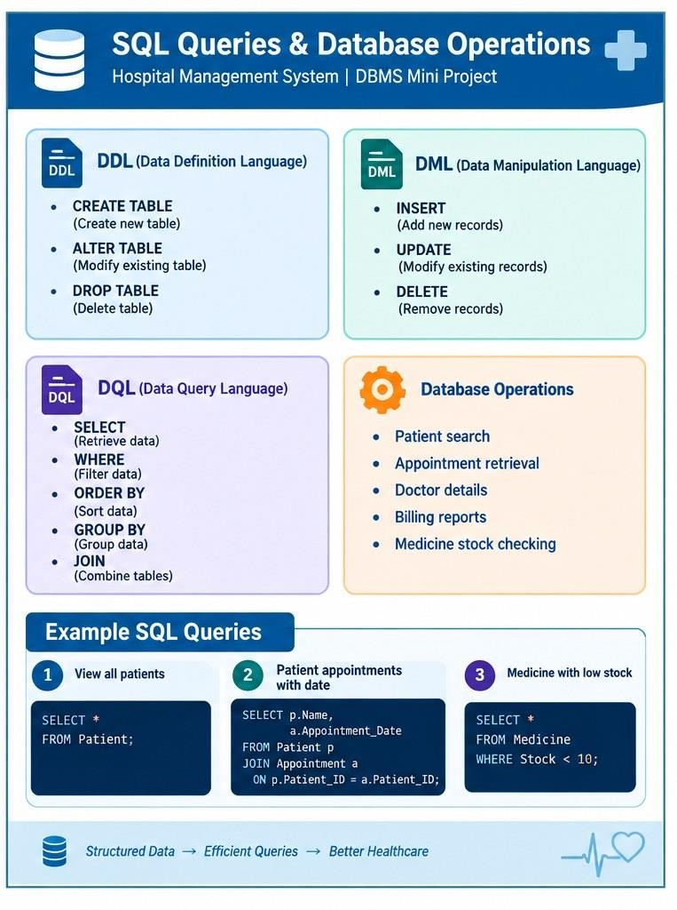

Figure 1: SQL queries and database operations (DDL, DML, DQL)

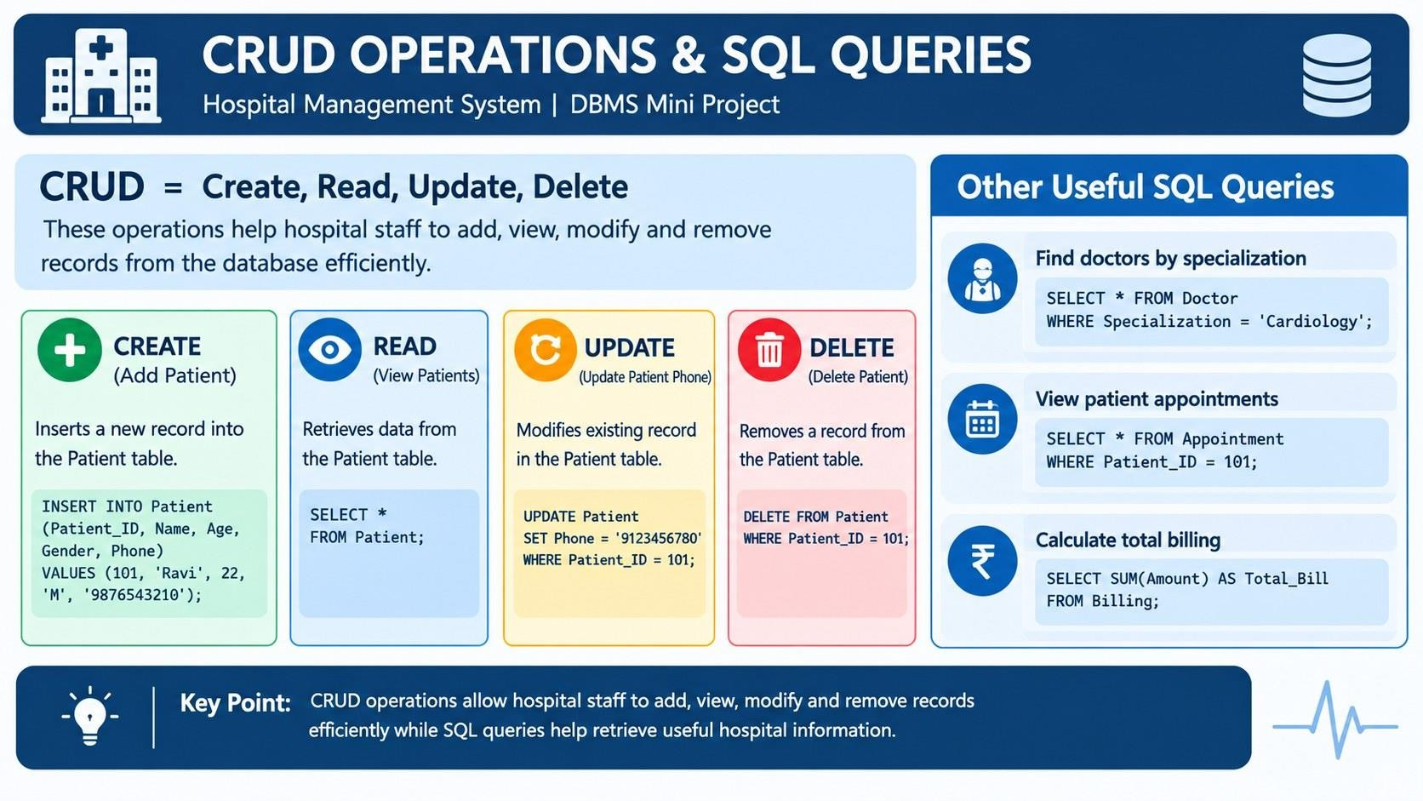
Figure 2: CRUD operations and other useful SQL queries
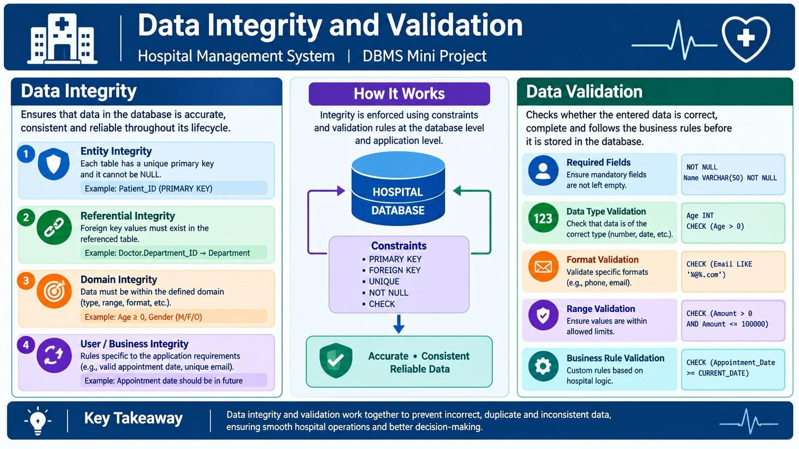
Figure 3: Data integrity and validation

8. MODULES & FUNCTIONALITIES

8.1 System Architecture
The system follows a three-layer architecture. Users access the system based on their roles, the application layer processes their requests, and all data is stored in a centralized relational database.
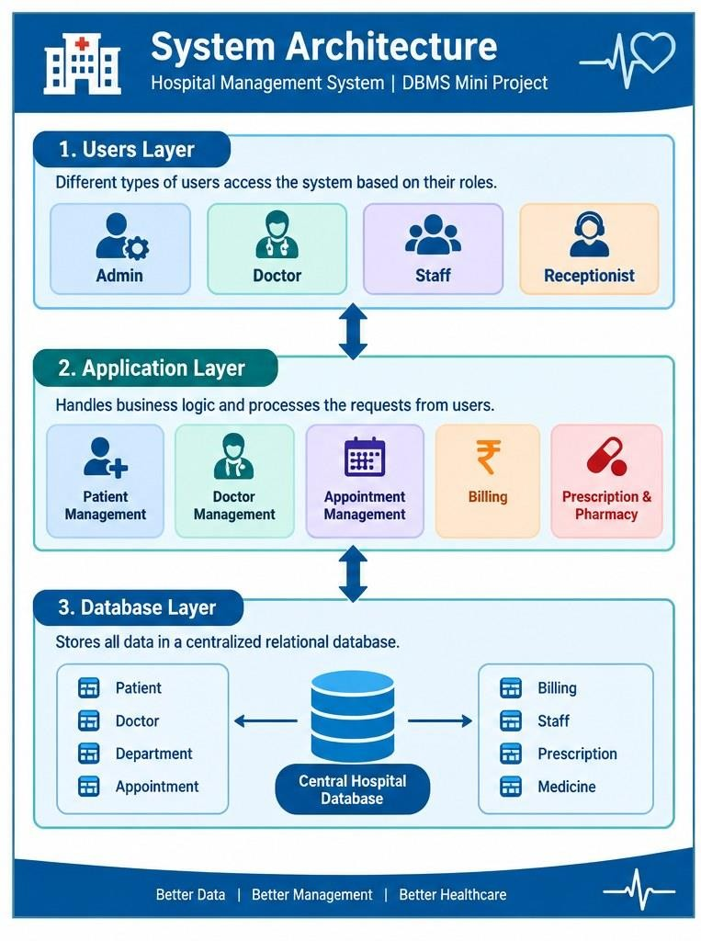
Layer

Description

Components

. Users Layer
1

Different types of users
access the system
based on their roles.

Admin, Doctor, Staff, Receptionist

2
. Application Layer

Handles business logic and processes the
requests from users.

Patient Management, Doctor Management,
Appointment Management, Billing,
Prescription & Pharmacy

3
. Database Layer

Stores all data in a centralized relational
database (Central Hospital Database).

Patient, Doctor, Department, Appointment,
Billing, Staff, Prescription and Medicine
tables

Figure 4: System architecture (three
-
layer model)

8.2 Modules
S.No | Module Name | Functionality
1 | Patient Management | Registers patients and maintains patient ID, name, age, gender, phone, address, and blood group; supports patient search and record updates.
2 | Doctor & Department Management | Maintains doctor details, specialization, experience, and department allocation along with department name and floor.
3 | Appointment Management | Schedules appointments between patients and doctors with date, time, and status, and avoids double booking of doctor slots.
4 | Billing Management | Records bills with amount, payment mode, and date for each patient, and supports total billing reports.
5 | Staff Management | Stores and maintains hospital staff details including name, position, and salary.
6 | Prescription & Pharmacy Management | Maintains medicine name, price, and stock; links prescribed medicines and dosage to appointments; supports low-stock checking.

9. ADVANTAGES OF THE SYSTEM
- Faster patient registration: patient details are stored once and retrieved instantly.
- Better appointment scheduling: doctor slots are managed centrally to avoid conflicts.
- Reduced paperwork: digital records replace paper registers and files.
- Improved security: medical records are protected through role-based, constraint-controlled storage.
- Accurate billing: automated billing removes manual calculation mistakes.
- Better data consistency: normalized tables and integrity constraints avoid duplicate and inconsistent data.
- Faster report generation: SQL queries produce billing, appointment and stock reports quickly.
- Improved communication: all departments work on a single shared database.
- Better patient care: complete patient history is available to doctors when needed.
- Efficient hospital management: overall hospital operations become faster and better organized.

10. GITHUB REPOSITORY & TEAM RESPONSIBILITIES
Repository Link: —
Student Name | Roll Number | Role / Responsibility | Contribution Status
B. BHANU PRAKASH | 25B11AI102 | — | —
M. GANESH REDDY | 25B11AI772 | — | —
T. SANTOSH REDDY | 25B11AIC08 | — | —
G. SIVA RAMA SWAMY | 25B11AI382 | — | —

11. ENHANCEMENTS & FUTURE IMPROVEMENTS
Future improvements can extend the current database with user authentication and role-based access for Admin, Doctor, Staff and Receptionist users, a laboratory module for test records and reports, a front-end interface for hospital staff, online appointment booking, richer reporting and dashboards, automated low-stock alerts for medicines, stored procedures and triggers where supported, indexing for frequently queried columns, audit logging, and automated backup and recovery. These are proposed enhancements rather than implemented features in the current project.

12. CONCLUSION
The Hospital Management System successfully automates hospital operations through a centralized relational database. The design defines eight tables — Patient, Doctor, Department, Appointment, Billing, Staff, Medicine, and Prescription — with primary keys, foreign keys, NOT NULL, UNIQUE, CHECK, and DEFAULT constraints. The sample data and SQL queries demonstrate record creation, retrieval, update and deletion, filtering, joins, and aggregate functions. The system removes redundancy, enforces integrity constraints, secures medical records, reduces paperwork, and ultimately enhances the quality of patient care. The project therefore delivers automation, data integrity, security, efficiency, and better patient c
13
. REFERENCES

1
. Hospital Management System
—

DBMS Mini Project presentation, Department of Artificial Intelligence and
Machine Learning, Aditya University.

2
. Aditya University
—

DBMS project documentation template.

3
. R. E
lmasri and S. B. Navathe, Fundamentals of Database Systems, Pearson.

4
. A. Silberschatz, H. F. Korth and S. Sudarshan, Database System Concepts, McGraw
-
Hill.

5
. GitHub repository: Hospital Management System
—

Add link here.

APPENDIX

A. Complete SQL Script
The final SQL implementation for this project is presented in this report:
- DDL — database table definitions, keys, foreign keys, and constraints (Section 7.1).
- DML — sample data for all eight tables (Section 7.2).
- Queries — representative SQL operations and queries (Section 7.4).
Repository: —

B. Additional Screenshots / Outputs
Additional evidence can include SQL execution screenshots showing table creation, sample data, patient and appointment retrieval, billing totals, medicine stock checks, joins, and constraint validation. The team can add its actual execution screenshots here: Add screenshots here.
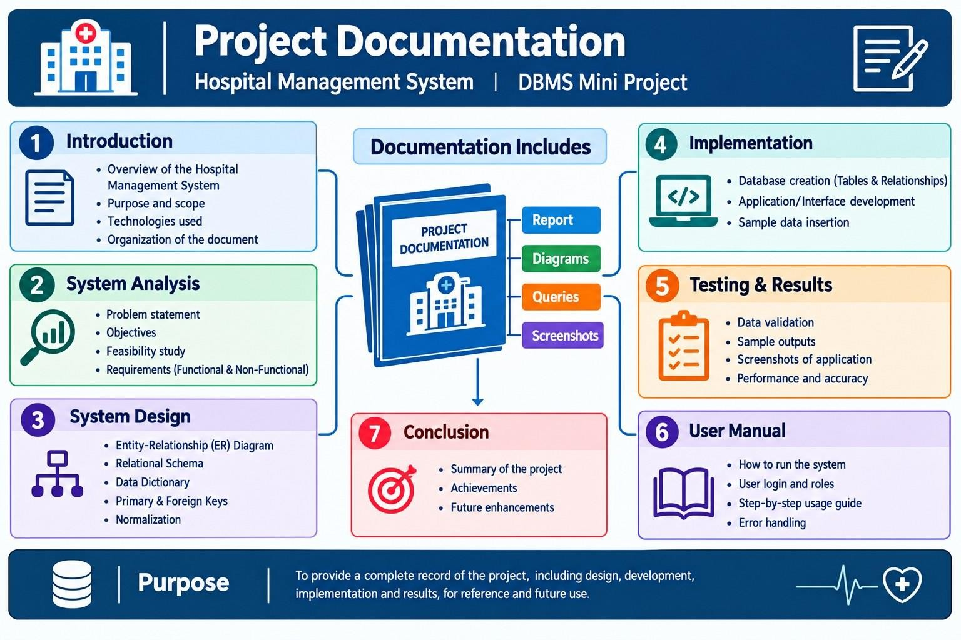
Figure 5: Project documentation overview

