**First Brainstorming Session – Date: 11/6, Location: PHO 8th floor**

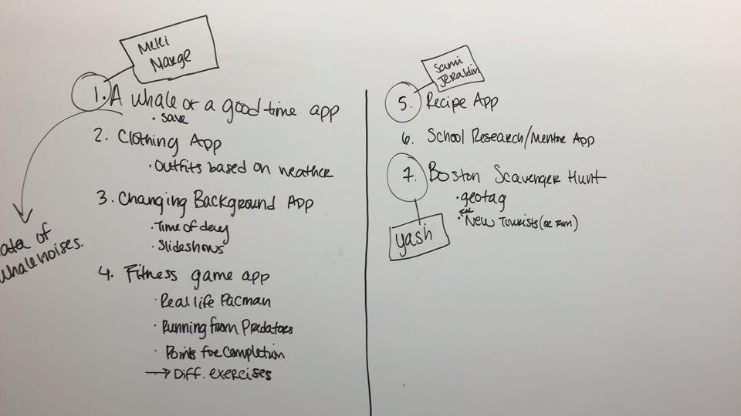

* Team Positions were finalized:
  + GUI Designers – Samantha Chua and Margaret Ann Bolick
  + Interface Designer – Melissa Garcia
  + Processing Designer – Jeraldin Guerrero
  + Team Leader – Yash Agarwal
* We picked the top three ideas and divided them up among members. We would all research the assigned topics and present them during the next meeting (11-08-2015)

**Team Meeting – Date: 11/8, Location: Warren Towers Dining Hall**

Agenda

* Meeting Time
  + Fridays 5-7pm
* Topic finalize
  + Every person will present what they looked into
  + First team vote

Recipe thing – copyright issues; food api access hard; low prioriity

Whale thing – back up; easy

**FINAL – Boston Scavenger Hunt, Google Maps, Tourists, Students**

* Project Ideas – supplemental stuff
  + Random User generator – to play the game against
  + Weather API – advise them about weather where they want to go
  + Email Validation API – validate email
* Rough Timeline
  + My thinking (Yash) – Finish making app by 12-4; 4 weeks. Need to do all the research and start working on it this week
  + Everybody concurs
* Google Drive setup – need to share with everyone
  + Make your own folders and put everything in there so that no one writes over anything
* Everyone knows about their deliverables, document while writing code
* Documentation Manager?
  + Everybody will pitch in
  + Yash will take up the video
* Next Meeting
  + Rough Draft of all Deliverables – just have a file open; keep adding to it
  + Don’t delete anything!
  + Melissa – GitHub, Make Repository and actually use it
  + All – Java, C++; start looking at Android stuff
* Other things people want to bring up
  + Nothing

**Team Meeting – Date: 11/13, Location: Warren Towers Dining Hall**

*UPDATES*

Team Leader and Interface Designer –

* Scavenger Hunt is too vague. Need to focus on either tourist attractions/tours OR game.
* Team decided to go with Boston Guided Tours (Name: TBA)
* We will have three themes – Historical, Art/Museums and Sports
* 9 Places for each theme
* We have a Git Respository – Team Thun Thun
* Interface Designer gave everyone a tutorial on using the Desktop Git

GUI Designers –

* Have a mock up of some screens

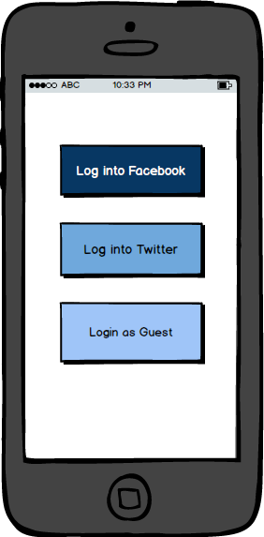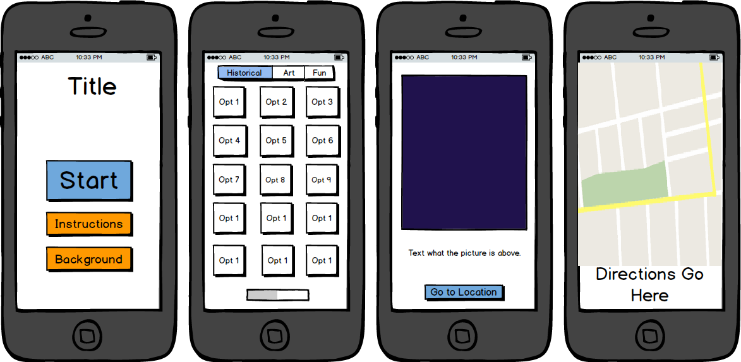

* Everyone agrees that for a first pass, they look really good
* Progress Bar will be a nice idea

Processing Designer –

* Have done some research on Facebook API to log in
* She has been busy reading about JAVA and getting a good grasp on the language and Android Studio

*TASKS ASSIGNED FOR NEXT MEETING*

Team Leader

* Design the tours. Come up with the list of places and find their co-ordinates
* Make a list of features the app should have
  + Everyone agreed that we should first make a functioning app with minimal features before we add stuff to it
* Prepare a script and shot list for the video to be shot partially over Thanksgiving break

Interface Designer

* Work with the Processing Designer to look into the Google Maps API and also, start looking into JAVA
* Research XML and look more into interfacing between JAVA and XML

GUI Designers

* Translate mock-ups to XML files
* Watch Android Studio Tutorials and get a firm grasp of XML features and limitations

Processing Designer

* Look into Google Maps API – First Priority
* Facebook Login, Twitter – look into how much work that would be
* Look into Saving Progress – Progress Bar
* Logging in as guest

Everyone

* Should have some knowledge of JAVA and XML, and should understand how the Simple Tip Calculator works
* Should watch enough Android Studio tutorials to know what the important files/directories are and what they should have
* Should come up with name ideas

**Team Meeting – Date: 11/20, Location: Ingalls Resource Center**

**Meeting Goal – Map out the App, Name and Thanksgiving Tasks**

**Name** – Pahk the Cah (Park the Car)

* Boston Accent is something many tourists no about when they visit Boston
* ‘Pahk the Cah’ i.e. Park the Car implies that users should get out of their cars and walk around Boston
* Adapted from SNL’s ‘Pahk the Cah at Havahd Yahd’

**App Layout**

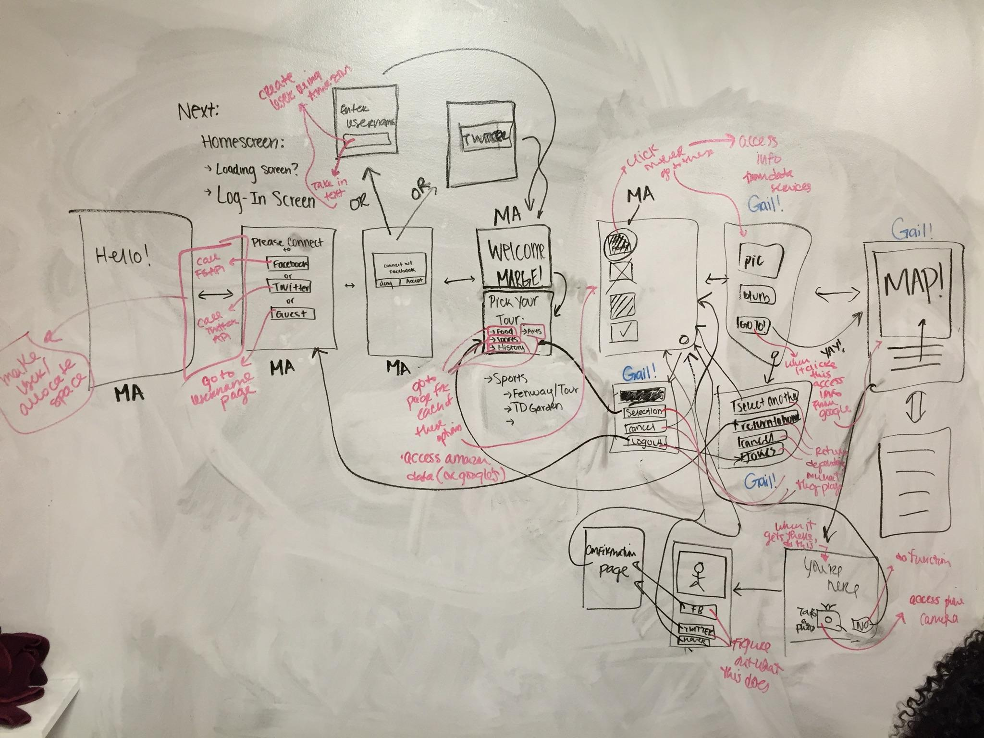

Log- In Screen

* Logo, name
* “Please log in”
* Facebook, Twitter, Guest
* For Facebook and Twitter -> APIs
* Username and Password

Welcome Screen // Welcome separate and then select tour

* “Welcome <name>”
* Profile picture next to the name
* Pick your tour

Back button discussion

* Maybe a button → gives the option of going back to Welcome screen, Selection Screen, Log Out
* Final Decision -

Next screen- Selection page

* NO Progress Bar
* Scrolling functionality – figured out that is automatic when too much text in text-box
* Boxes with pictures of places, grey them out after done

Next screen

* 3 sections
  + Bigger picture
  + Blurb about the picture
  + Button to take them forward

Next Screen - MAP

* GPS Tracking
* Just like Google Maps
* Map with directions; can maybe pull up to see only directions

Then, after they get there.

* Option to take a picture (NEED TO ACCESS CAMERA)

**Task for Thanksgiving and Next Meeting**

Team Leader

* Write blurbs for all places
* No one will be here over Thanksgiving. So, prepare a shot list and script for the video and schedule a day to shoot

Interface Designer

* Look into utilizing phone camera after destination reached
* Interface (Ha!) with Processing Designer to help implement Google Maps API and Login stuff

Processing Designer

* Implement Facebook Login
* Design XML for that page

GUI Designers

* Make XML pages for all screens
* Look up best pictures for all places
* Get back to Team Leader with max words for each Blurb

**Team Meeting – Date: 12/30, Location: Ingalls Resource Center**

**Meeting Goal – Thanksgiving updates, Task Re-Allocation**

**Agenda**

* Role Description
  + GUI Designers continue doing what they have been doing – making XML pages
  + Jeraldin and Melissa working on Google Maps API
  + Yash working on the video
* Updates - what’s done, what’s left?
  + GUI Designers
  + We need to figure out how to connect MA’s xml files to the JAVA. Yash has gotten all the blurbs. We need to connect everything. I also need to do menu pages. We need to figure out how to make the back buttons. <Melissa working on that too> I made two menu pages though (redirection page). My theme was blue (like MA’s).
* Google Maps API - map in app or open google maps?
  + Based on the research, connecting to Google Maps will be better than trying to implement maps in the app
* Video planning - 12/4 video shoot 3 pm
  + Margaret Ann will work on the script. Yash will direct and edit. Jeraldin, Samantha and Margaret Ann will be acting. Yash will need to figure out how to demo the app during the video using split screen.
* GitHub
  + We need to start putting up stuff on GitHub. If you don’t know/ remember how, ask Melissa/Yash
* TENTATIVE DEADLINE FOR APP - 12/7 Monday? We can show it to TAs during Lab
  + Work out bugs over the week
  + Prepare the documentation
  + Edit the video
* Tour composition - final list lock
* More screens

‘About’ screen - Instructions about the app, version number, creators etc.

Margaret Ann will take it on

**Team Meeting – Date: 12/4, Location: ERB 209**

**Meeting Goal – Video Shooting, and Hackathon**

* We shot most of the video except the app demo portion
* Team Leader worked on video editing
* Others all worked on fine tuning the app
* We decide to remove the take a picture feature to focus on fixing the app
* The app is complete but very buggy - Interface and Processing Designers are debugging with help from Julian and Tim

**Final Meeting - Date: 12/11 Location: Ingalls Resource Center**

**Meeting Goal - Documentation Party**

* All documents were partially complete

