Title: **Tabs Course Format with ATS (Activity Tracking System)**

Status: Stable (feedback welcome)

Type: **Course Format + Block**

Moodle version required: **2.3**

Git Repository – Tabs Course Format: <https://github.com/fernandooliveira/moodlefn-tabs>

Git Repository – Tabs Controller Block: <https://github.com/fernandooliveira/moodlefn-tabsadmin>

Support and Feedback: [www.moodlefn.knet.ca](http://www.moodlefn.knet.ca)

Contents of this document:

1

1. Notes
2. Installation Instructions
3. Overview of Tabs Course Format
4. Overview of Activity Tracking System
5. **Notes:**

* The **Tabs Course Format with ATS** is part of the MoodleFN plug-in series for Moodle 2.x, which can be found on [www.moodlefn.knet.ca](http://www.moodlefn.knet.ca).
* The My Progress block was also created to work with the ATS system. Courses that use the ATS should also use the My Progress block, which can be found here: <https://github.com/fernandooliveira/moodlefn-myprogress/blob/master/MoodleFN_My_Progress.pdf?raw=true>

1. **Installation Instructions:**

**Tabs Course Format :**

1. Click on the following link to download the files for this plug-in:

<https://github.com/fernandooliveira/moodlefn-tabs/zipball/master/>

1. Unzip the downloaded file and rename top directory to **fntabs**
2. Copy the **fntabs** directory to **yourmoodlesite/course/format/**

**Tabs Controller Block:**

1. Click on the following link to download the files for this plug-in: <https://github.com/fernandooliveira/moodlefn-tabsadmin/zipball/master>
2. Unzip the downloaded file and rename top directory to **fn_tabs**
3. Copy the **fn_tabs** directory to **yourmoodlesite/blocks/**

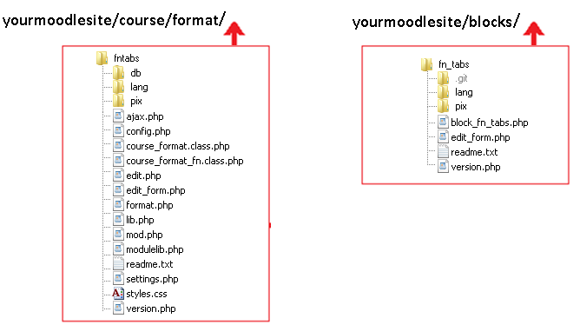

1. **Overview of Tabs Course Format:**

The Tabs Course Format Block controls the following settings:

* Main Heading: Text shown in bar directly above the tabs
* Topic Heading: Text shown on left side of tabs
* Max tabs shown: Number of tabs to show at one time. For example, if a course has 32 weeks/topics and tax tabs is set to 12, then the tabs will be shown in increments of 12 with previous/next links
* Show Section 0: Show/hide the section above the tabs
* Show Only Section 0: Completely hide the tabs section and only show section 0

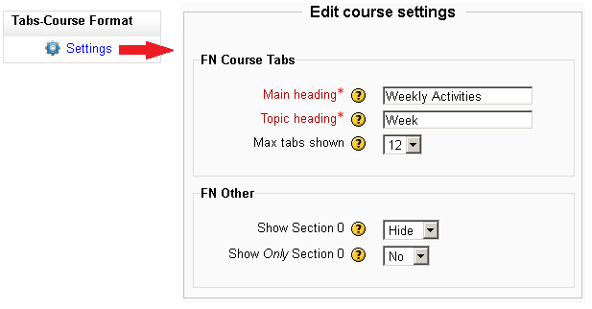

This course has 10 weeks:

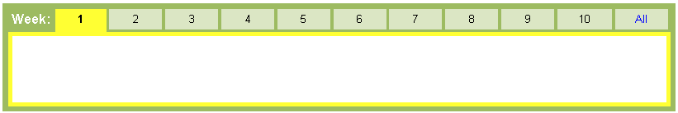

This course has 32 weeks. The “Max tabs shown” value is set to 12 (notice the previous/next links):

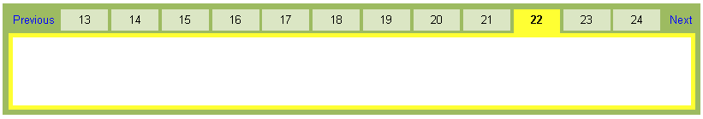

1. **Overview of Activity Tracking System**
2. The ATS uses one of five icons to indicate the status of a given activity, as shown below.
3. When the mouse is rolled over an unselected week, a “tooltip” bubble provides a summary of the activities in that week/section.
4. Each tab has a green or red bar which indicates if a week/topic is complete or incomplete

**Student View:**

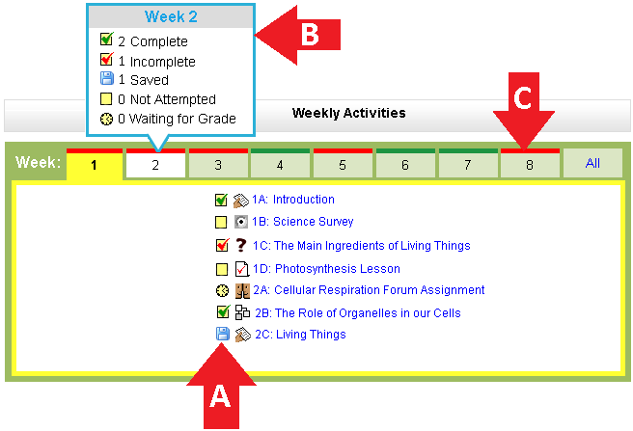

**Teacher View:**

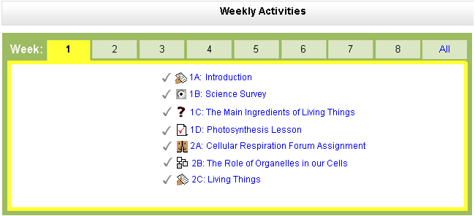

Notice that the status icons, tab tooltips and tab status bars are only seen by students. Instead of the status icons, a checkmark is used to indicate that an activity has completion tracking enabled.

**Note 1:** The ATS relies on the Activity Completion feature that was released as part of Moodle 2.0 (more information about this feature can be found at <http://docs.moodle.org/20/en/Activity_completion>). Activities that do not have the “completion tracking” turned on will not be included in the ATS.

**Note 2:** If an activity has a “Require Grade” condition in the Activity Completion setting, then that activity will show as “complete” when it receives **any** grade.

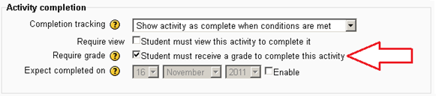

However, if the same activity also has the “[grade to pass](http://docs.moodle.org/20/en/Grade_items)” option enabled in the gradebook, the activity will show as “Incomplete” until it receives a grade that is equal or greater than the “grade to pass” value.

