# **Experiment 3:Basics of FlyingDRONEwith DJI NAZA Flight Controller and FLYSKY FS-i6 Radio Transmitter.**

|  |
| --- |
| **Basics of Flying** **(i) Transmitter Operation, (ii) Arming and Disarming**  **(iii) Hover, (iv) Flying** |

NEXT EXPERIMENT

Flight Controller and RC Caliberation

**7. SOFTWARE SIMULATION**

Simulation is the imitation of the operation of a real-world process or system over time. The act of simulating something first requires that a model be developed; this model represents the key characteristics or behaviors of the selected physical or abstract system or process. The model represents the system itself, whereas the simulation represents the operation of the system over time.

We are using the NAZA MV2 Software for Drone Simulation. here below shows the software icon. Depending on the NAZA we are using we have to choose the either one of the software shown below.

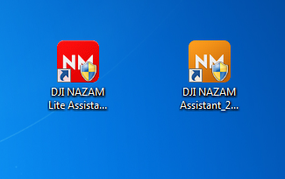

**STEPS TO DO SIMULATION:**

* Open NAZA MV2 software
* Switch on the remote
* After opening the software, it will look like the below shown image

**STEP 1:** In the **VIEW** option we have to check the Channel monitors

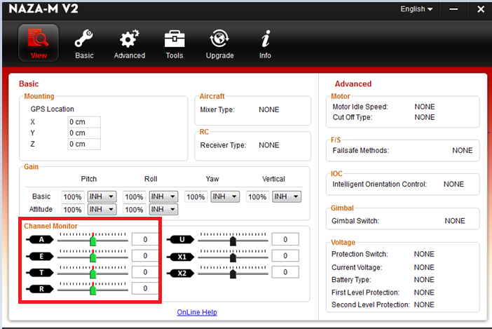

In the remote we have to give the throttle as input and check the channel monitor whether the throttle is moving or not

Same way we have to give the Yaw, Pitch, Roll as inputs from the remote and check the channel monitor whether they are properly working or not

After completion of this go to the next step

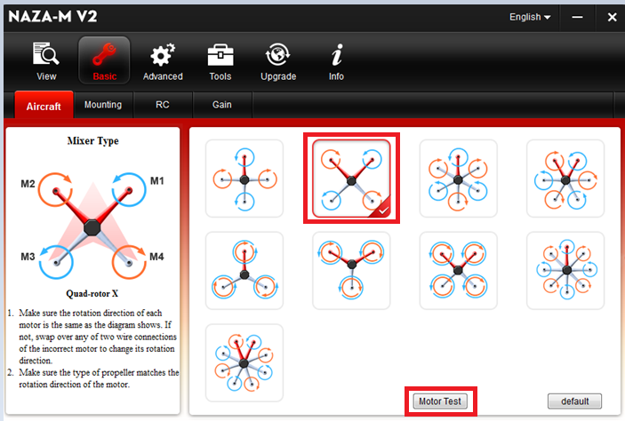**STEP 2:** open the **Basic** option in that we have aircraft, mounting, RC, Gain

**AIRCRAFT:**

* select the type of your drone
* click on motor test
* after clicking on that one box will open click on motor M1 and check the motor orientation
* If the motor M1 was rotating in ANTI-CLOCK wise direction, then no need to change anything
* If the motor M1 was rotating in CLOCK wise direction, then we need to change the any two cables of motor
* same process we have to do for the remaining motor

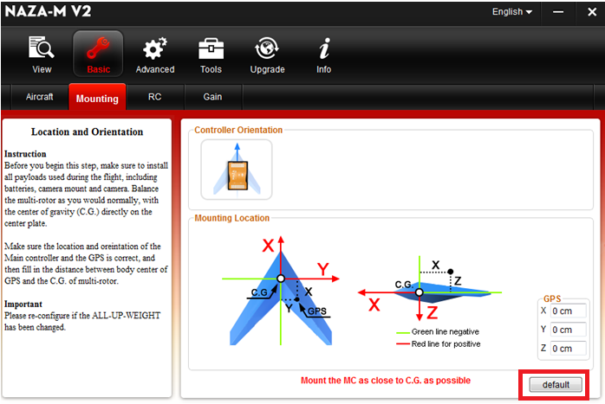**STEP 3:** Now click on mounting option set it as default

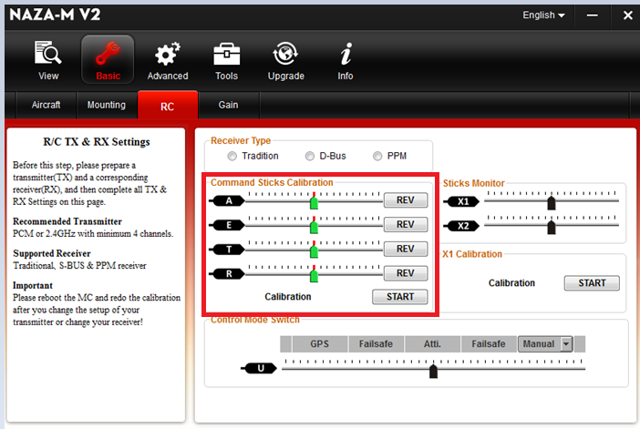**STEP 4:** Now click on RC option and check the sticks calibrations by giving throttle yaw radar and pitch as inputs from the remote and also check the GPS, altitude, manual modes

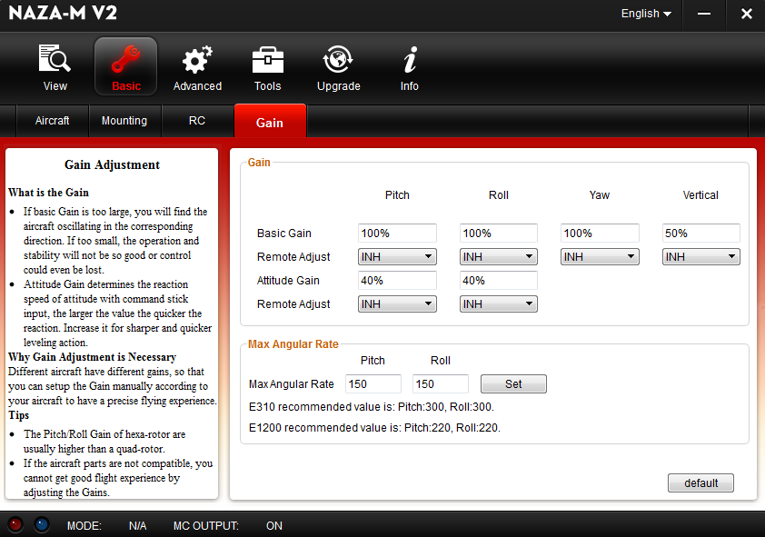**STEP 5:** Now choose the **Gain** option, different aircrafts have different gains so we have to set up it manually

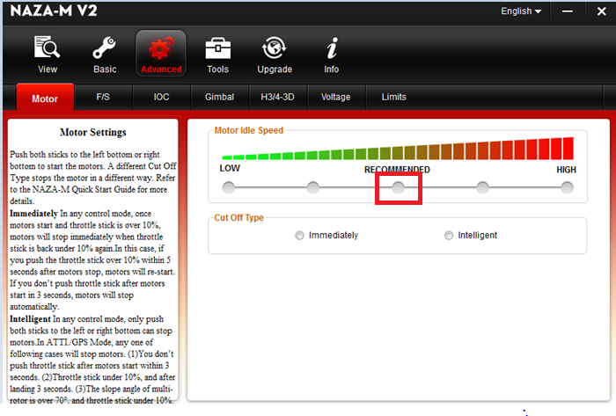**STEP 6:** In **Advanced** settings first choose the **motor** option in that select the recommended option

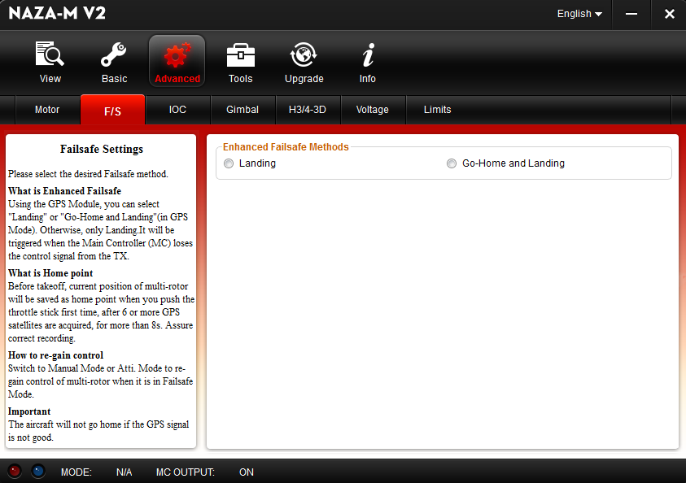**STEP 7:** In **File safe** option we have to choose the either one of option based on our choice

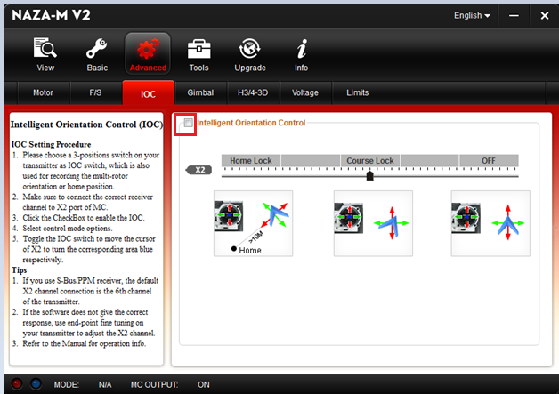**STEP 8:** Based on our application we have to choose the **intelligent orientation control** option

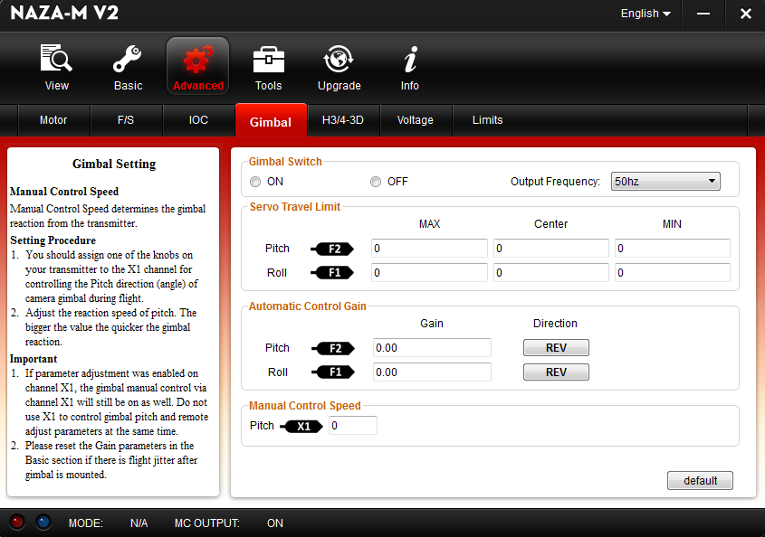**STEP 9:** By using this **gimbal** option we can keep the device level set it as default

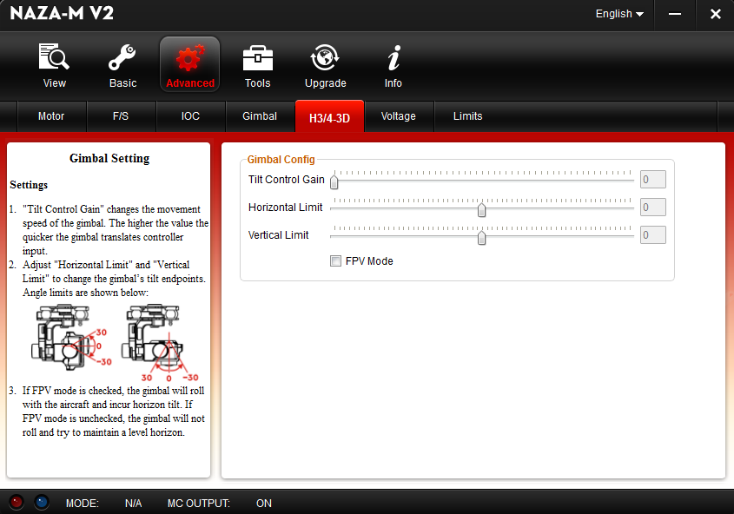**STEP 10:** Check the **H3/4 3D** option no need to change

**STEP 11:** Choose the voltage option and no need to change it

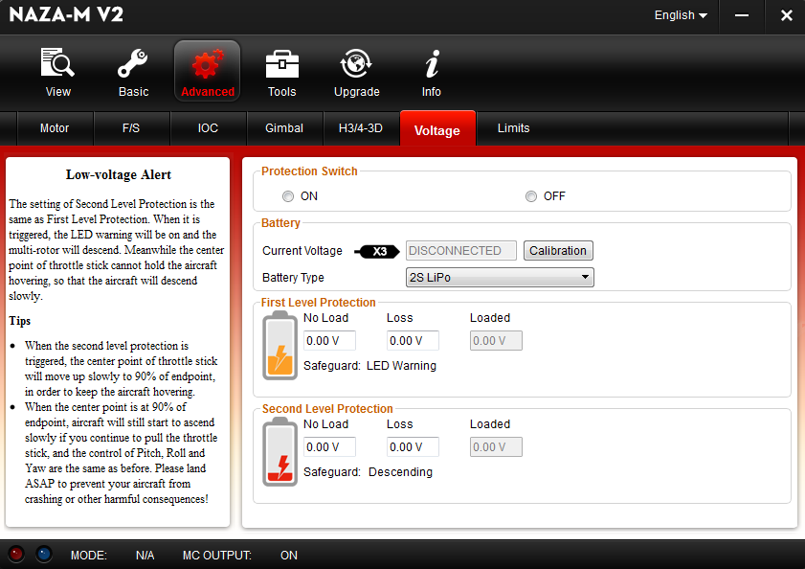

**STEP 12:** In this **Limit** option we have to give the values based on our requirement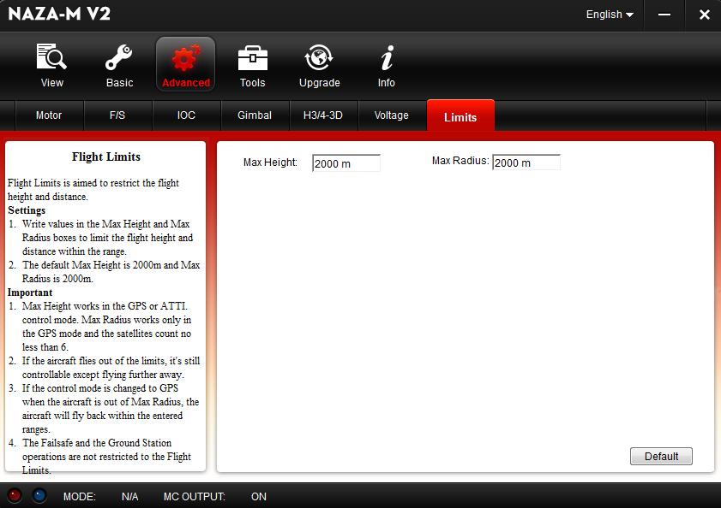

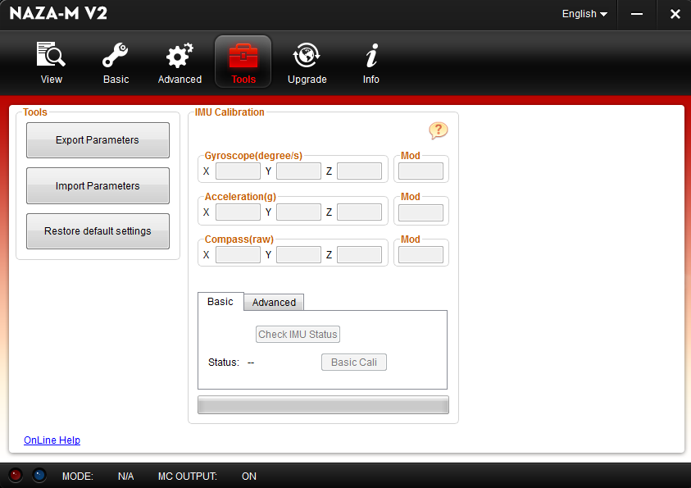**STEP 13:** After completion of all the above steps we have to do the **basic and advanced calibrations**

**STEP 14:** In this **upgrad**e option we have to see the updates only

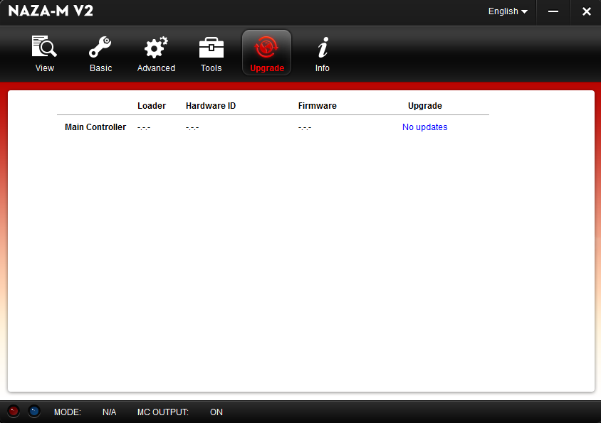

**STEP 15:** Just check the **info** option and close the software

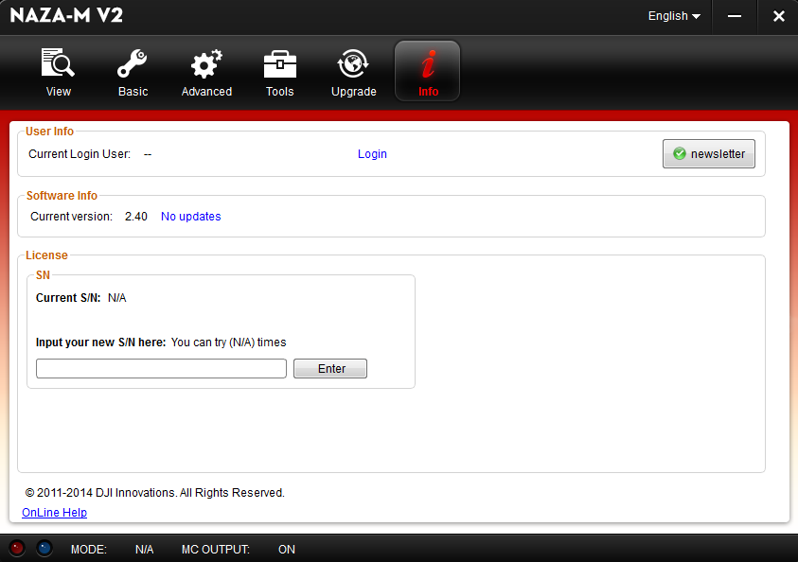

PRACTICALS

**GPS CALIBRATION**

After completion of the drone making before going to the flying we have to do the GPS calibration to maintain drone stable. Before going to do calibration we have to know about GPS indications. GPS have 3 indications those are shown below **Indications:**

No fly /file safe

Good to fly

Ok to fly

**Procedure:**

**Step 1:** Switch on the Remote and Give power supply to the drone

**Step 2:**ON-OFF the GPS button in remote 10 times

**Step 3:** Observe the LED colour. If it is solid green colour it is good to fly it is a yellow colour there is some file safe errors then we have to do GPS calibrations

**Step 4:** First rotate the drone horizontally once and stop it exactly at starting point

**Step 5:**Now solid green LED will blink

**Step 6:**Next place the drone vertically down/up and place it at exactly at starting point

**Step 7:**Now the drone in stable state and ready to fly

**10. How to Fly**

**Procedure:**

**Step 1:** Switch on remote and give power supply to drone

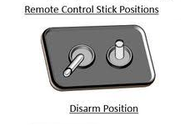**Step 2:** place the two sticks of remote to corners its calling arm initially it starts the motors

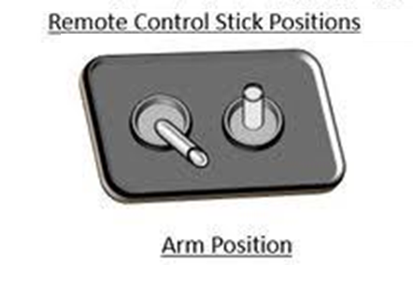

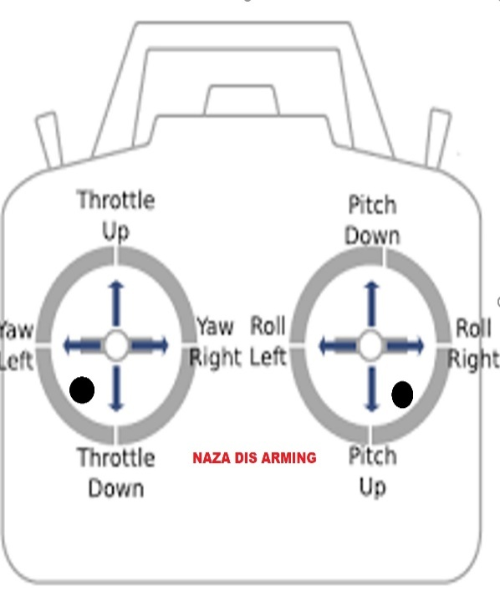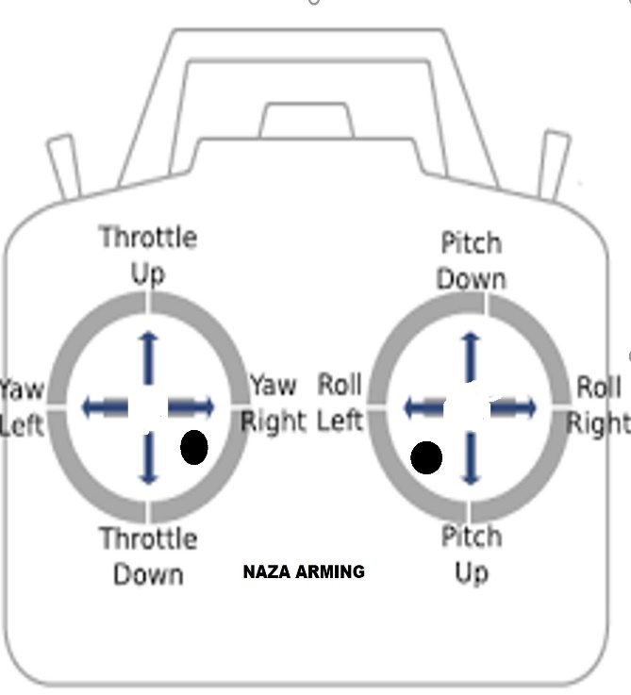

**Step 3:** Raise the throttle by 10% until the drone takeoff

**Step 4:** maintain stability in the drone

**Step 5:** slowly down the throttle to land the drone

