Mohit Garg
3112 Cortland Drive ~ Vestal NY 13850 ~ (607)372-7349 ~ mgarg1@binghamton.edu

PROFILE Currently seeking a full time job opportunity to compliment theory learned at the university level. Solid communication and leadership skills with a background in computer science. Technically proficient in C/C++ programming.

EDUCATION Binghamton University, State University of New York
Master of Science, Computer Science expected May 2015
GPA – 3.84/4.0
Relevant Courses – Computer Architecture, System Programming, Emerging Platforms, Advanced Object Oriented Programming

SRM University, Chennai, India
Bachelor of Technology, Information Technology Aug 2008 - May 2012
CGPA – 8.6/10 (First class with distinction)
Relevant Courses – Operating Systems, Embedded Systems, Programming in Java

TECHNICAL Programming : C, C++,Java, Shell Scripting
SKILLS Web Skills : HTML, CSS, Javascript, Jquery
Embedded Development Boards : Arduino,ARM Mini 2440, 8051 kits.
Other : MySql, PostgreSql, Windows Desktop Application Development

EXPERIENCE Graduate Research Assistant
The Research Foundation for SUNY, Binghamton, New York Feb 2014 - present
- Strategized in design and development of Nano Bio Manufacturing Consortium sponsored ultra-low power portable human performance monitoring system
- Collaborated with teams in UC Berkeley and i3 electronics
Biometric Human Performance Monitor (BHPM) Feb 2014 - present
- Design the circuit conforming to the requirements
- Developed the firmware using the APIs provided by the manufacturer of the SOC
- Created a test setup to validate the firmware and the circuit design
- Technologies used : Bluetooth Low energy SOC , C programming

Post-Graduation Diploma in Embedded System Design
CDAC, under Govt. Of India – Hyderabad, India Aug 2012 – Feb 2013
- Participated in skills development training after getting selected in all India level entrance exam for PG -Diploma course in CDAC (Centre for Development of Advance Computing)
- Technologies learned: Micro-controllers Development using ARM,AVR ; Real Time Operating Systems ; Linux Device Driver Programming ; Andorid Programming
Porting of uCos Operating System on an ARM7 Board Jan – Feb 2013
- Conducted cross-compilation of the OS for a specific arm7 board
- Accomplished this project during the PG diploma course
- Technologies used : ARM7 board , uCos2 Source Code, Keil

Internship at System Platforms Research Laboratories
NEC Corporation, Japan Jun – Aug 2011
- Visited NEC, Japan to understand the Architecture and Concepts of IEEE1888/FIAP (a protocol for energy management for large Infrastructure) and to implement the same in SRM University
- Technologies used:JAVA, Apache-Tomcat Server, Axis2-web services engine, PIC based Sensors
  - “Survey on Architecture and Protocols for Energy Management System” ,
The Institute Of Electronics, Information And Communication Engineers, Technical Report
- “Blackout Monitoring and Analysis at Building in India using FIAP” ,
The Institute Of Electronics, Information And Communication Engineers, Technical Report

O.PROJECTS Implementation of Standard Template Library(STL) Components in C++ Sep – Dec 2014
- Implemented Deque with C++ like features using C Macros
- Implemented Map using Skiplist
- Implemented Array with multi-dimensional support using Variadic Templates

Concurrent web-servers based on various Linux IPCs Oct – Dec 2013
- Developed multi-threaded web server using networking APIs
- Developed other concurrent servers using POSIX IPCs - Shared Memories, FIFOs
- Completed as part of the system programming course
- Technologies used : C , gdb, Linux APIs

RECENT WORK:

Biometric Human Performance Monitor (BHPM):

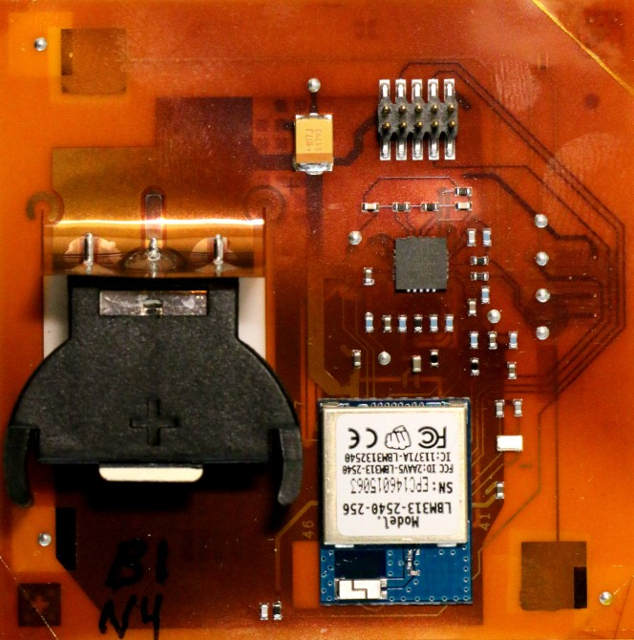
- BHPM is a 2”x2” wearable human monitor based on flexible hybrid electronics (FHE) for recording, communicating and analyzing biometric parameters.
- This device is used to record human ECG signals and was fabricated on a Kapton and can run on a Standard Coin Cell Batteries for days.
- The on-board electronics includes a signal conditioning circuitry that feeds a SoC (system-on-a-chip); the SoC includes an ADC, a 8051 micro-controller and the Bluetooth low energy communication interface.
- Software techniques are used to reduce power requirements and include dynamic adaptation of transmission power, duty cycle of operations and selective activation of the sensing circuitry.
- Data flow includes collection of ecg data via electrodes and then to analog front end and this analog data is being digitized by using the internal 12bit ADC of the SOC. Collected data can then be transmitted to any Bluetooth low energy supporting device.

- This design and the prototype was presented at the Flex Conference 2015 in Monterey, California.

