SWE 6633 Group 6 Semester Project Comprehensive Plan

  - Fall 2020
Marion Garrett Sisk
Kim VanAsselberg
Justin Ross

Table of Contents
Introduction 2
Part 1: Project Description 3
Product Description 3
Description of Deliverables 4
Project Attributes and Measurements 6
Part 2: Process and Methods 7
Project Schedule 7
Project Costs 10
Part 3: Risk Analysis 12
Risk Mitigation 12
Appendix A – Project Deliverables 15
Quick Plan 15
Software Requirements Specification Document (SRS) 18
Design Document 19
Appendix B – Test Scenarios and Data 27

Introduction
This comprehensive plan lays out the project details concerning the creation of a project management application. The layout of the document is such that the entire project is described from all aspects of the POMA process: Planning, Organizing, Management, and Adjustment. Additionally, this document serves as the outline for development by compiling a general product description, requirements, deliverables, goals and measurables, as well as process details and methods. The document also details the costs associated with the project, namely: human costs and software tools. Lastly, the comprehensive plan delves into risk analysis of the project, enumerating risks and detailing mitigation plans for each anticipated risk. The items listed are presented in three distinct parts: Project Description, Process and Methods, and Risk Analysis. Within each part are subsections detailing various aspects of the associated part. The project description section covers an explanation of what the product being produced is, what the purpose of the product is, an overview of each deliverable, as well as project attributes and measurables. The second part, Process and Methods, details the project schedule and tabulates the total cost involved with the project, both in terms of human capital, as well as tools and other equipment that is used to complete the project. Lastly, the Risk Analysis section details the perceived risks associated with the project, as well as plans on mitigating said risks. Taken as a whole, this document contains all of the information needed to successfully create and manage the project from start to finish.

Part 1: Project Description

Product Description
The project centers around the creation of a software application that meets the requirements set forth in the original assignment. This application produced will be a project management application. The application will have a graphical user interface (GUI) that will permit a user to define a requirement for a project, associate a risk with the requirement, and keep track of how many hours of human capital have been spent working on a particular requirement. The application will also facilitate the production of reports, such that the user can get an idea of the status of each requirement within a project. The application will be written in Java with the intention of being run on a desktop PC, such that it can be deployed into multiple computing environments.

What is the purpose of the product?
The purpose of the product is to help facilitate the management of software projects. The product will provide a framework for the accounting of all elements associated with organizing and monitoring a project. By keeping track of requirements for a particular project, associating a developer with said project and/or requirements, and permitting them to enter expended hours, the data can easily be used to support more effective project management techniques; a purpose in which this application excels
.

Description of Deliverables
The deliverables associated with this project are given below and each section details what can be found within each document. For each document that has been completed as of the date of submission of this comprehensive plan, they have been attached to the end of the document in the indicated Appendices. If the document is as yet incomplete, it will be included in the final deliverables for the project.

Quick Plan
The quick plan document is a general overview of the project that includes a brief description of the product, a general project schedule, and an overview of the risks assumed as part of the project. The quick plan is attached in Appendix A – Quick Plan.

Software Project Management Plan Document
The Software Project Management Plan document is this document; also known as a comprehensive plan. This document expands upon the quick plan by going into vastly more detail. The Software Project Management Plan contains a more thorough description of the product, an explanation of the deliverables, a detailed project schedule, full accounting of costs, and a full risk analysis. This document is not attached in an appendix, as it is given here in its entirety.

Software Requirements Specification Document (SRS)
The software requirements specification document contains a collection of use cases written from the points of view of several roles. Each use case is specific and unique. From these use cases the design of the application takes place. Also created from these use cases are the test scenarios. Both the product design and test scenarios are discussed in subsequent sections. For the full list of use cases see Appendix A – SRS.

Design Document
The design document details the architecture and other software models, including the data model. The design document is the next phase after the Software Requirements Specification (SRS) document. The design document is attached in Appendix A – Design Document.

Executable Code
The executable code is a singular executable file that will run an installation routine to permit the application to run on a desktop PC environment. The executable code will be delivered alongside this document, the product reference manual and user’s guide that are described in the next section. The code is provided alongside this document and is contained in the folder ‘project-planning.’

Product Reference Manual and Users Guide
The product reference manual and user’s guide contain all the pertinent information needed for an uninitiated end-user to gain full use of the product. This is a standalone document and will be provided alongside this document, and the executable code. As of the submission of this comprehensive plan, the Product Reference Manual and User’s Guide have not been completed.

Project Attributes and Measurements
For any project, it is important to ensure that the project is both on schedule and on task. To aid in achieving this, the project has several attributes defined such that metrics can be established to verify that requirements have been met. The goals enumerated in this section correspond to the requirements, and the metrics defined are used to ensure the requirements have been met, or that the project is on task. Additionally, the raw test data is presented here.

Goals and Metrics
The software requirements specification (SRS) document details the requirements for the project using a collection of use cases. These uses cases are then used to develop test scenarios. In these test scenarios, the software is measured on how closely each use case defined in the SRS. Each step in each test has a pass or fail response and permits the tester to provide notes detailing any errors. It is the goal of each test to fully pass each test step according to its expected outcome. It is expected that the software application passes each test and associated test step to meet all the goals for this project.

Test Scenarios
Test scenarios are based on the use cases defined in the software requirements specification document. Each test case is provided in Appendix B – Test Cases and Data.

Test Data
The data that is collected during testing must be done during a later phase of the project. The test data is included within Appendix B in this updated document. The data will be collected using the methods detailed on each test case. Please see Appendix B – Test Cases and Data for each test case used

Part 2: Process and Methods

Project Schedule
The project schedule has been designed to work within the constraints of the current semester. The schedule is given below in the following three diagrams. The first table enumerates tasks required to complete the project and documents the estimated length to complete each task in hours. Milestones are indicated using bold font. Additionally, the rightmost column on this table provides the estimated slack time for each task, if present. The second diagram is a critical path diagram that shows the minimum estimated time required to complete the project. The critical path is highlighted in green.

Project Tasks and Time Estimates
Task Number | Description | Pre-Req’s | Hours Req’d | Latest End Date | Slack Time (days)
1 – Group Formation
1.1 | Create post of introduction | None | 1.5 | 9/19 | 0
1.2 | Choose group leader | 1.1 | 3 | 9/20 | 0
1.3 | Choose collaboration platforms | 1.1 | 1.5 | 9/21 | 2
1.4 | Create Scheduled Meeting Invite | 1.3 | 0.5 | 9/23 | 0
1.5 | Determine Group Member Roles | 1.4 | 3 | 9/24 | 0
2 – Requirements Processing
2.1 | Group Reading of Project Assignment | 1 | 1.5 | 9/25 | 0
2.2 | Determine Type of Application | 2.1 | 1.5 | 9/26 | 0
2.3 | Group Discussion to determine Use Cases | 2.2 | 6 | 9/28 | 0
2.4 | Documentation of Use Cases | 2.3 | 1 | 9/30 | 0
2.5 | Create Prototype methods for Database access | 2.1 | 3 | 9/30 | 3
2.6 | Create prototype user interface elements | 2.1 | 3 | 9/30 | 3
2.7 | Collection of use cases and prototypes | 2.5;2.6 | 3 | 10/1 | 0
2.8 | Requirements Review | 2.7 | 4 | 10/2 | 0
2.9 | Assembly of Quick Plan | 2.8 | 4 | 10/3 | 0
2.10 | Review of Quick Plan | 2.9 | 3 | 10/4 | 0
2.11 | Submission of Quick Plan | 2.10 | 0.5 | 10/4 | 0
3 - Design
3.1 | Determine Project Development Environment | 2 | 1.5 | 10/11 | 6
3.2 | Installation of Project Environment | 3.1 | 3 | 10/13 | 0
3.3 | Develop Software Architecture Model | 3.2 | 7 | 10/18 | 0
3.4 | Develop Data Model | 3.2 | 4 | 10/18 | 3
3.5 | Discussion on Required Views for User Interface | 3.2 | 6 | 10/18 | 1
3.6 | Develop User Interface View Prototypes | 3.5 | 7 | 10/20 | 0
3.7 | Create Sequence Diagrams | 3.6 | 5 | 10/22 | 0
3.8 | Creation of Comprehensive Plan Template and Sections | 2 | 5 | 10/23 | 6
3.9 | Risk Analysis | 2,3.8 | 3 | 10/24 | 0
3.10 | Compilation of Comprehensive Plan | 3.8,3.9 | 8 | 10/24 | 0
3.11 | Review of Comprehensive Plan | 3.10 | 3 | 10/25 | 0
3.12 | Submission of Comprehensive Plan | 3.11 | 0.5 | 10/25 | 0
4 - Implementation
4.1 | Create Database | 3.11 | 5 | 11/12 | 18
4.2 | Installation of JavaFX and Scene Builder | 3.11 | 2 | 11/13 | 1
4.3 | Create User Interface Views | 4.2 | 8 | 11/14 | 0
4.4 | Develop Template and Sections for User’s Manual | 4.3 | 8 | 11/16 | 0
4.5 | Create Controller Classes | 4.2,3.1 | 5 | 11/18 | 4
4.6 | Integration of MVC Architecture | 4.5 | 9 | 11/20 | 0
4.7 | Package Creation and Debugging | 4.6 | 5 | 11/21 | 0
5 - Testing
5.1 | Creation of Test Scenarios | 3.7 | 4 | 10/23 | 0
5.2 | Installation Testing in macOS and Windows | 4.7, 5.1 | 8 | 11/23 | 0
5.3 | Completion of Test Scenarios and Data | 4.6,5.2 | 12 | 11/26 | 0
5.4 | Test Results Analysis and Documentation | 5.3 | 5 | 11/27 | 0
5.5 | Additional Time for Debugging | 5.3 | 5 | 11/28 | 0
6 - Release
6.1 | Creation of Project Overview Presentation | 5 | 8 | 11/29 | 0
6.2 | Review of Presentation | 6.1 | 3 | 11/30 | 0
6.3 | Submission of Final Deliverables | 6.2 | 0.5 | 12/1 | 0
 |  |  | Hours |  | Days
 | Totals: |  | 180.5 |  | 44

Critical Path Diagram
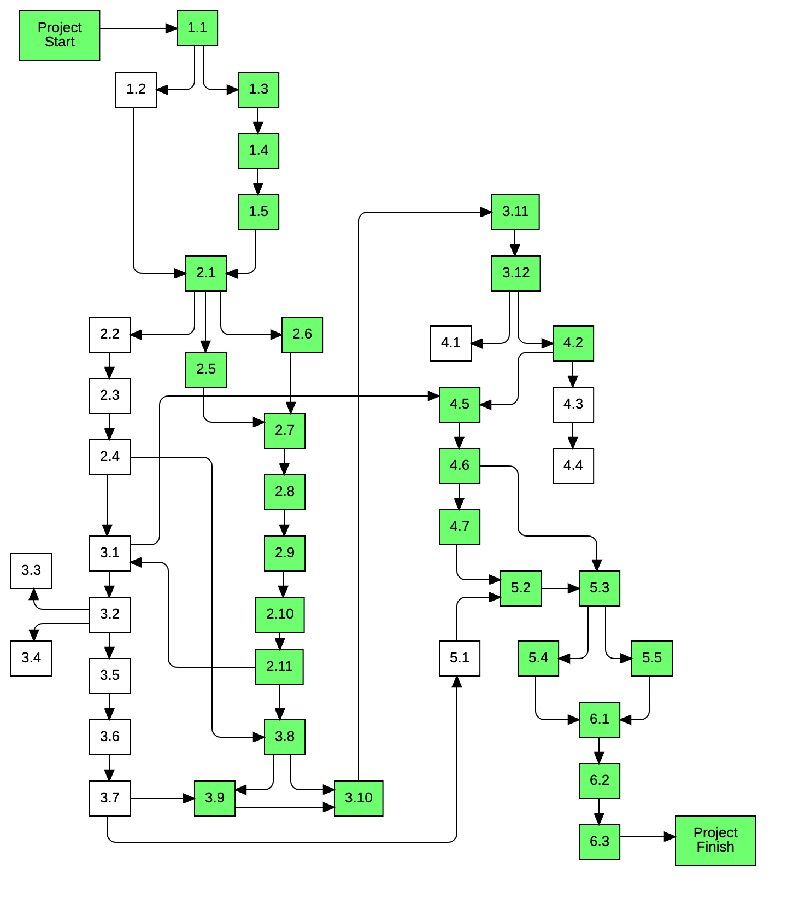
Total Hours in Critical Path: 102.5 Minimum Estimated Hours

Project Costs
Project costs are estimated based on each phase of the project. The most significant cost is that of human resources. The three group members will be working continuously throughout the life of the project. The specific human costs in terms of man-hours is tabulated below. Additionally, a combined resource matrix details specific tools and equipment costs, as well as methodologies used in each phase. Human resources are also present in this diagram.

Human Resource Costs
Project Phase | Working Hours
Group Formation | 9.5
Requirements Processing | 29.5
Design | 53
Implementation | 42
Testing | 34
Release | 11.5
Total: | 180.5

Combined Resource Matrix
Combined Resource Matrix
Project Phases | Requirements Processing | Design | Implementation | Testing | Product Release | Support
Methodologies | Requirements identification;  Requirements prototyping;  Requirements review; | Database design;  UI design;  Architectural design;  System flow design; | Java  JavaFX  SQL  User’s Manual | Test Case Development;  Test result tracking and analysis; | Build and install Java package | Not applicable;
Specific Tools and Equipment | Microsoft Teams;  Sketch App; | MySQL Workbench;  LucidChart | IntelliJ IDE;  MySQL;  MySQL Workbench;  Word;  GitHub; | Junit; | IntelliJ | Not applicable;
Specific Human Resources | 3 | 3 | 3 | 3 | 3 | 0
General Methodology | Project Management  Quality Assurance
General Tools | Project Schedule  Document library maintained in Microsoft Teams  Book: Managing Systems and IT Projects by Frank Tsui
Hardware and Operating Environment | 3 laptops (Mac OS, Windows 10)  1 iPad Pro  1 Relational Database

Part 3: Risk Analysis
The risks associated with the project are tabulated in the following section: Qualitative Risk Register. In this table, each risk is given a likelihood and an impact rating from low to high. Additionally, the risk mitigation strategy is detailed in the rightmost column. Each risk presented has a risk mitigation strategy to best handle these issues, should they arise.

Risk Mitigation

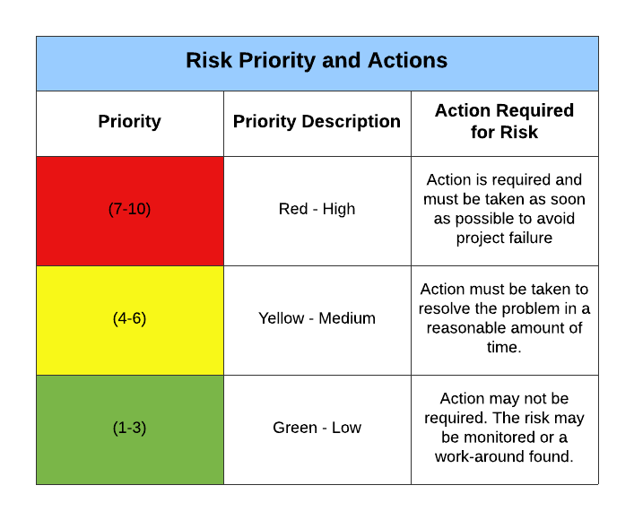
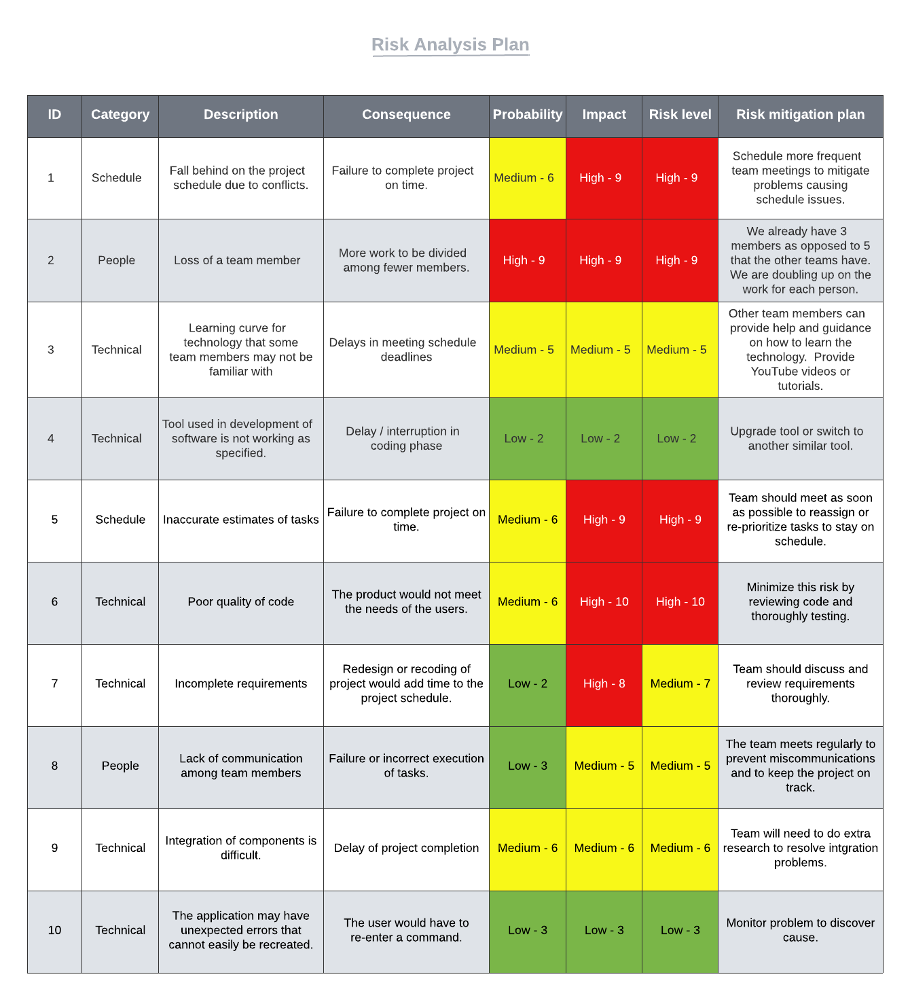

Appendix A – Project Deliverables

Quick Plan

SWE 6633 – Semester Project Quick Plan
Fall 2020 - Group 6

Members
- Garrett Sisk
- Kim Vanasselberg
- Justin Ross

Project/Product Description

The product produced as part of this project will be a project management solution that will permit users to keep track of requirements, goals, and the amount of time spent attaining these goals with respect to the effort expended on each requirement defined.

The product will permit users to enter their time spent on each requirement, and also permit a manager or owner to collect and display the entered time for each requirement. The product will facilitate reporting of time spent on each requirement for the manager to make adjustments to scheduling and other pertinent business activities.

The project will run as an executable on a desktop PC environment and have a graphical user interface such that users and managers can interact with the application in the appropriate manner.

High Level Schedule

- Week 1 (9/7 – 9/13)
  - Initial Group Meeting
  - Division of Tasks
  - Discussion of Project Requirements
    - Brainstorming
- Week 2 (9/14 – 9/20)
  - Exploration of software tools
  - Initial tabulation of requirements
  - Prototype UI exploration
  - Initial documentation
- Week 3 (9/21 – 9/27)
  - Refinement of “Quick Plan”
  - Prototype UI presented
  - Final tabulation of requirements
  - Final tabulation of goals
- Week 4 (9/28 – 10/4)
  - MILESTONE: Submission of “Quick Plan”
  - Begin Development of Comprehensive Plan
  - Develop Data Model
- Week 5 (10/5 – 10/11)
  - Complete final detail project schedule
  - Begin development of production UI
  - Begin development of Database
- Week 6 (10/12 – 10/18)
  - Integration of UI and Database
  - Initial product testing
  - Completion of Comprehensive Plan
- Week 7 (10/19 – 10/25)
  - MILESTONE: Submission of “Comprehensive Plan”
  - Refinement of front and back-end integration
  - Product testing and goal measurement
  - Begin producing product usage documentation
- Week 8 (10/26 – 11/1)
  - Product Testing and Goal Measurement
  - Validation analysis of met requirements
  - Refinement of usage documentation
- Week 9 (11/2 – 11/8)
  - Final Project Build
  - Packaging project into executable
  - Finalizing Documentation
- Week 10 (11/9 – 11/15)
  - MILESTONE: Final Project Submission
    - Submit Documentation alongside

In addition to the rough schedule above, there exists an additional 3-week buffer for schedule overruns and unforeseen issues that may arise. With a roughly 33% margin available for scheduling, the project should be able to accommodate most changes to the schedule while still meeting the completion deadlines.

Cost Estimation

Cost estimation for this project centers around the labor hours required to accomplish the tasks at hand. For clerical items, like meetings, team communication, and individual planning; the hours are taken as a percentage (10%) of the total time estimated to complete the actual task. The task estimations are established with knowledge of previous projects and similar tasks and have been tabulated accordingly. There also exists another 10% margin for changes or discrepancies in the estimated costs to account for potential overruns.

- Requirements Analysis and Tabulation
  - 20 hours
- Documentation
  - 20 hours
- Data Model Implementation
  - 10 hours
- User Interface Development
  - 10 hours
- Data Model and UI Integration
  - 25 hours
- Usage Documentation
  - 10 hours
- Measurement and Validation of Requirements/Goals
  - 10 hours
- Clerical/Management Tasks (~10%)
  - 10 hours
- Schedule Margin (~10%)
  - 10 hours

Total Cost in terms of labor hours: 125 hours

Risk Summary

Major risks for this project include potential group member participation, scheduling conflicts and limitations, as well as technical risks stemming from new experience with software and tools.

Assumptions have included several related to requirements, and deliverables based on past experience and technical feasibility.

Software Requirements Specification Document (SRS)
Use Cases
- As a user, I want to create a new project, so that I can keep track of project details.
- As a user, I want to add a member to a new project so that I can better manage the team.
- As a user, I want to add a requirement to a project so that I can manage product expectations.
- As a user, I want to associate a risk with a project so that I can prioritize requirements.
- As a user, I want to edit project details so that I can keep information up to date.
- As a user, I want to add time expended so that I may track project costs.
- As a user, I want to create a new member so that I can add new hires to projects.
- As a user, I want to create a new requirement so that I can associate them with a project.
- As a user, I want to create a new risk so that I can associate it with a requirement.
- As a manager, I want to know total hours expended per requirement so that I can see how many hours each requirement has consumed.
- As a manager, I want to know total hours expended per project so that I can see how many hours each project has consumed.
- As a manager, I want to know total hours expended per member so that I can see how many hours each member has consumed.
- As an administrator, I want to have a single executable file so that the application can run with minimal setup.
- As a developer, I want to use as much existing code as possible to expedite the development process.

Design Document
Project Architecture:

The project will be loosely coupled as it is made up of different components. The following component diagram shows the interactions between them.

The user interface component will be implemented in JavaFX. The data access component will be implemented in Java. The database component is a MySQL relational database.

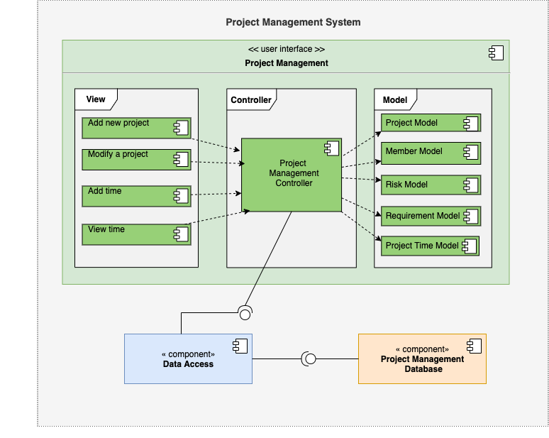

Screen Design:

The following screen layouts will be used in the user interface component.

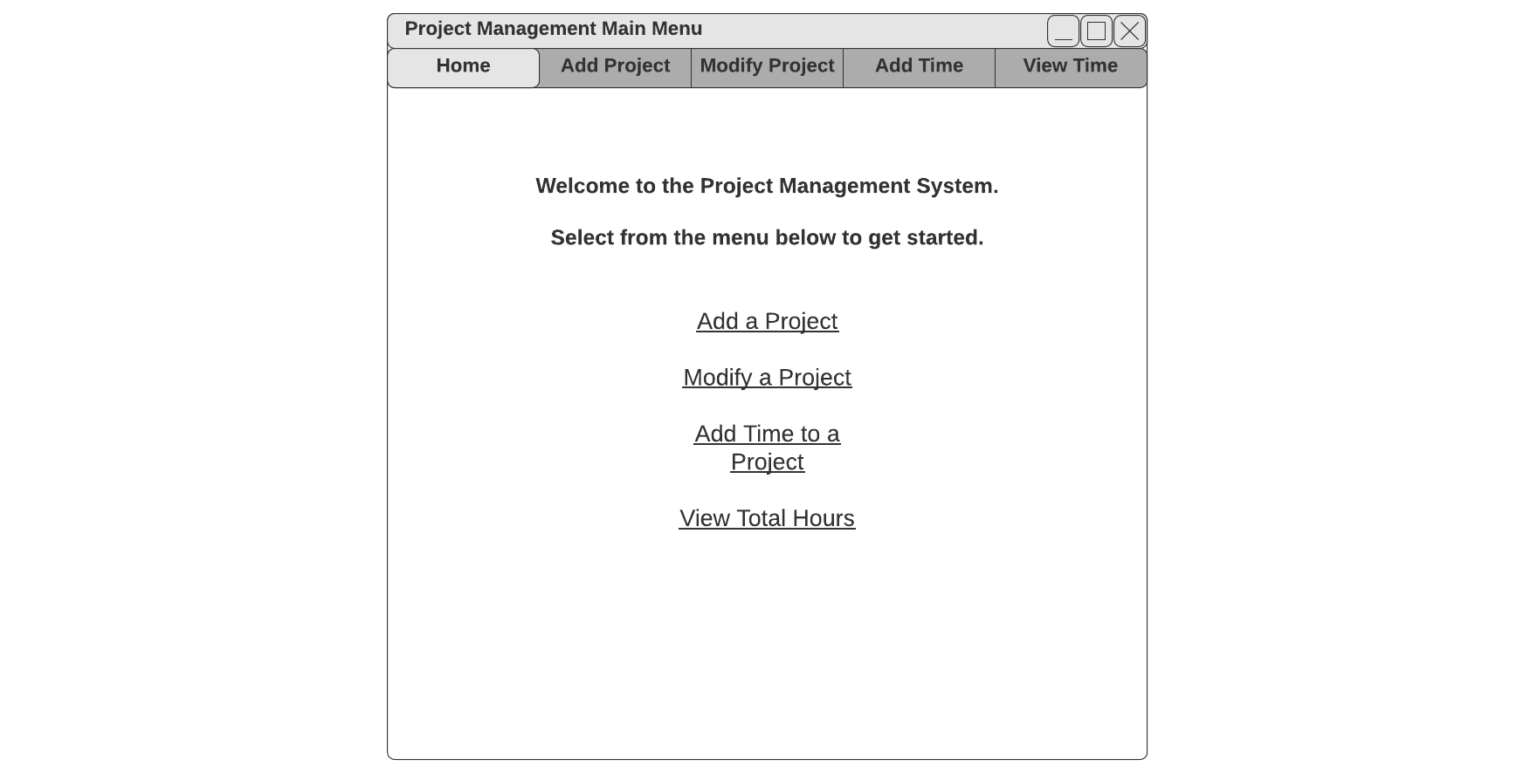

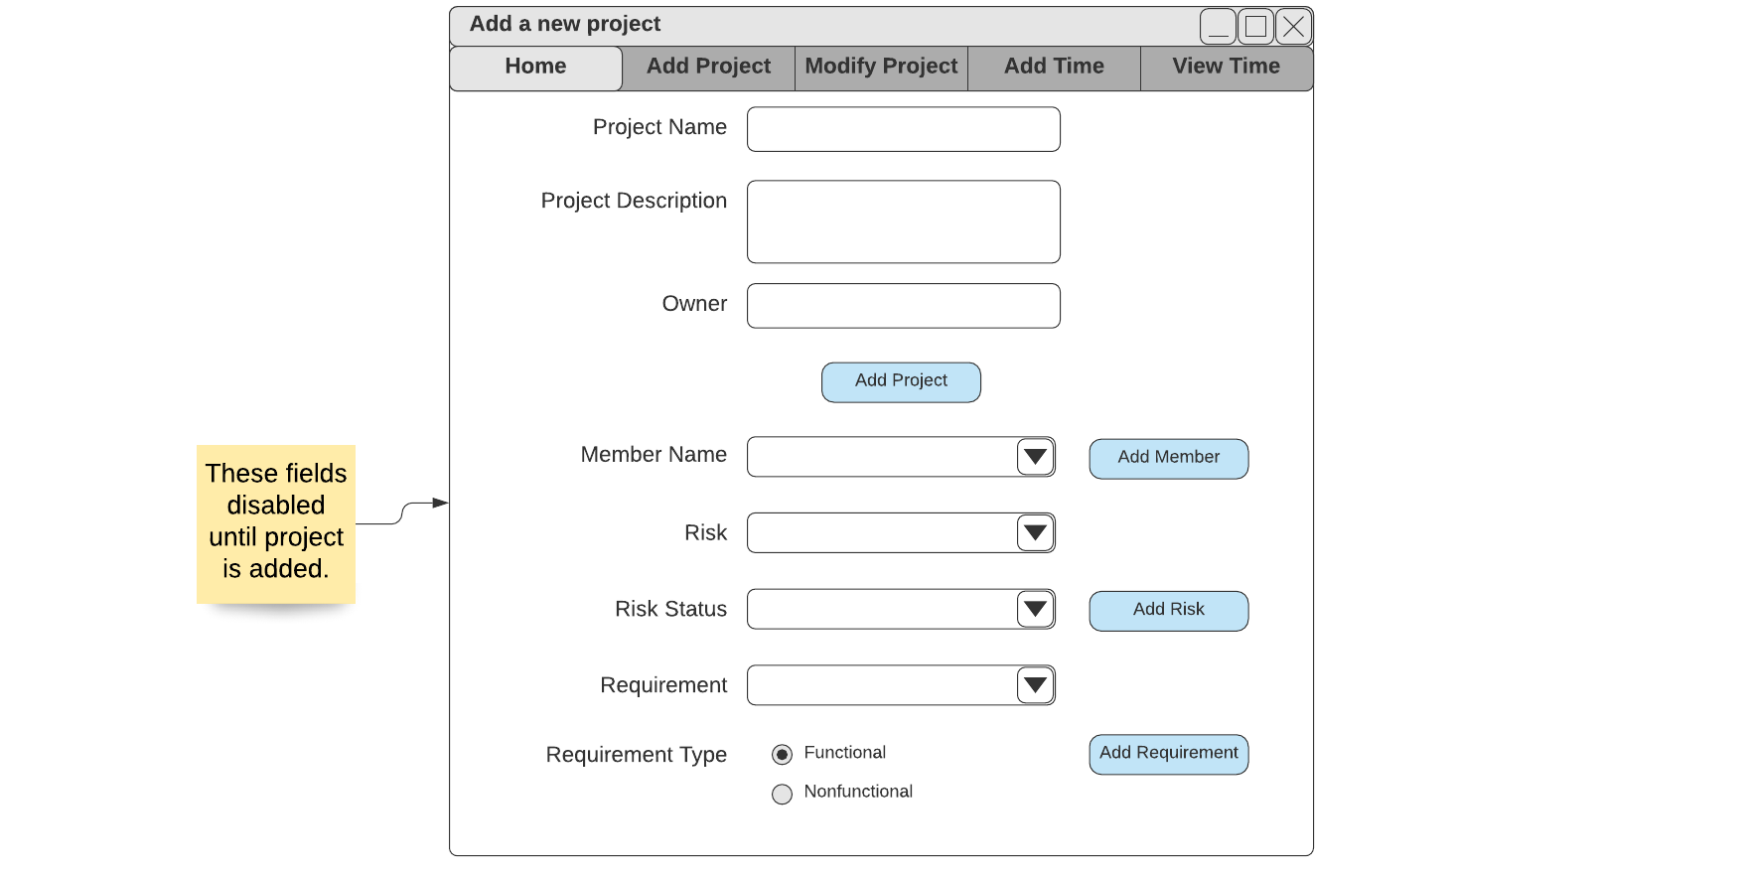

Screen Design (cont.) 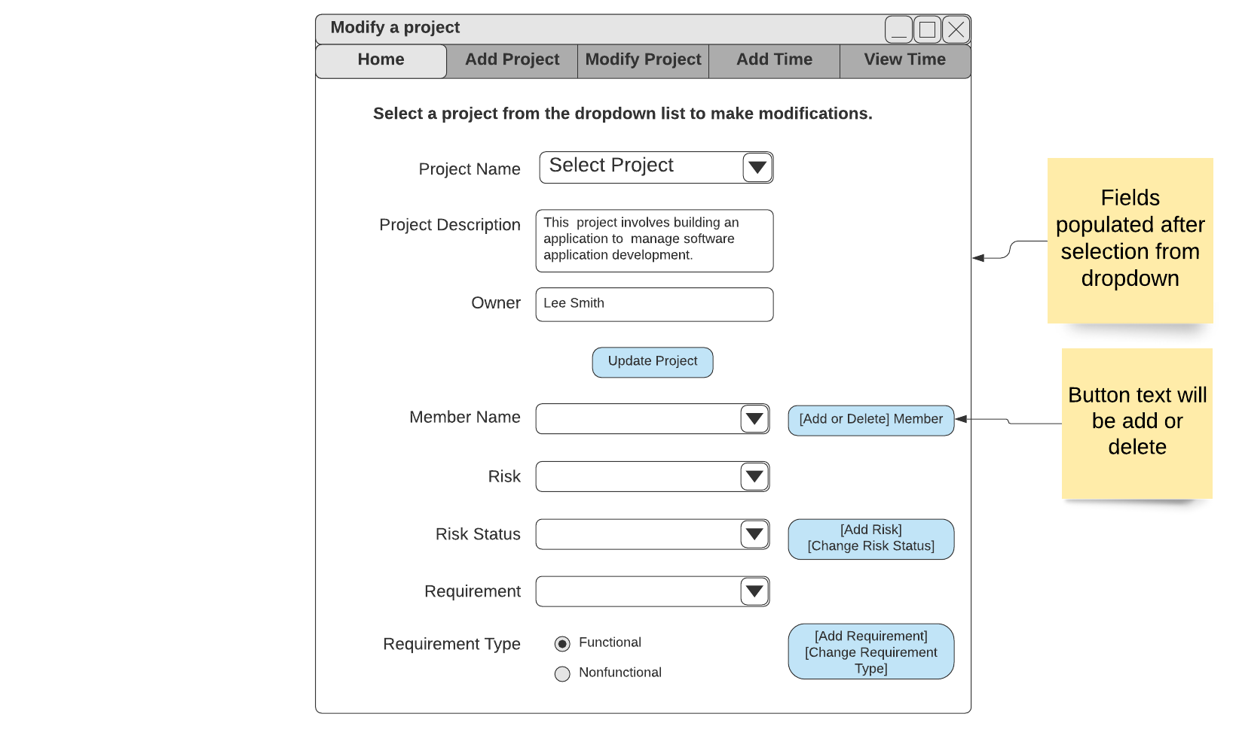

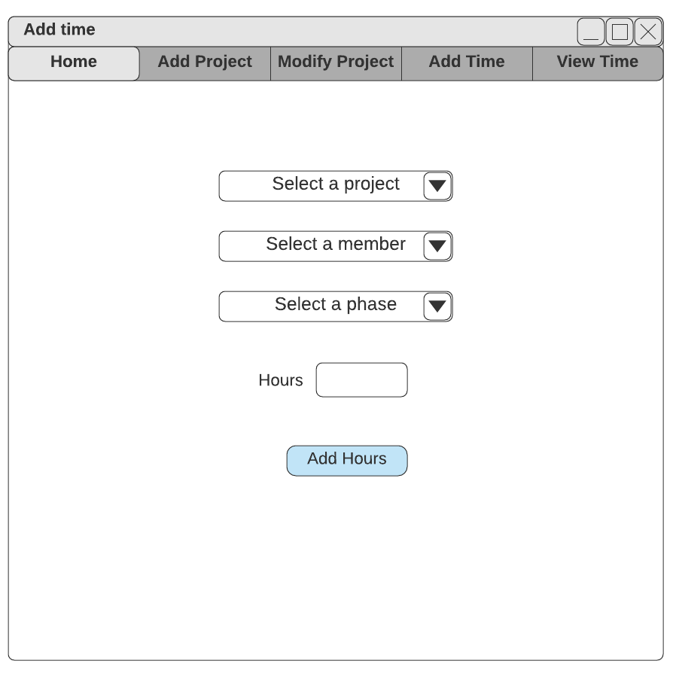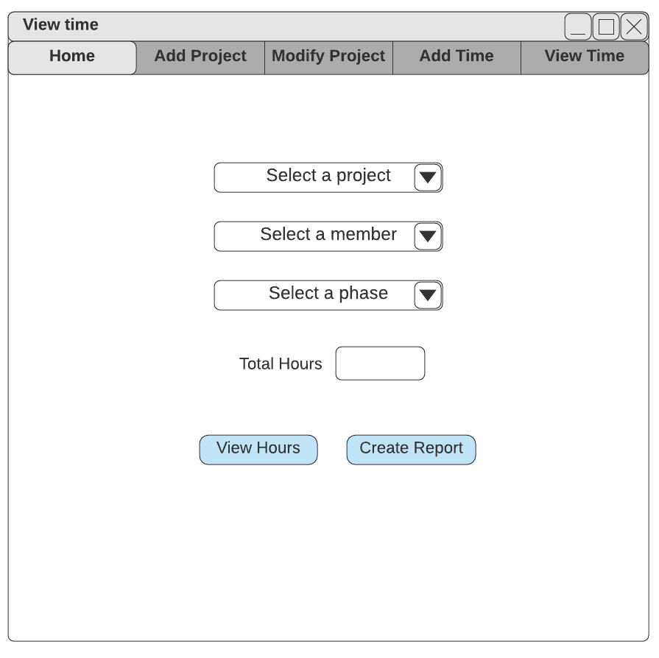

Activity Diagrams:

The activity diagrams show the system flow and separate the actions taken by the different components.
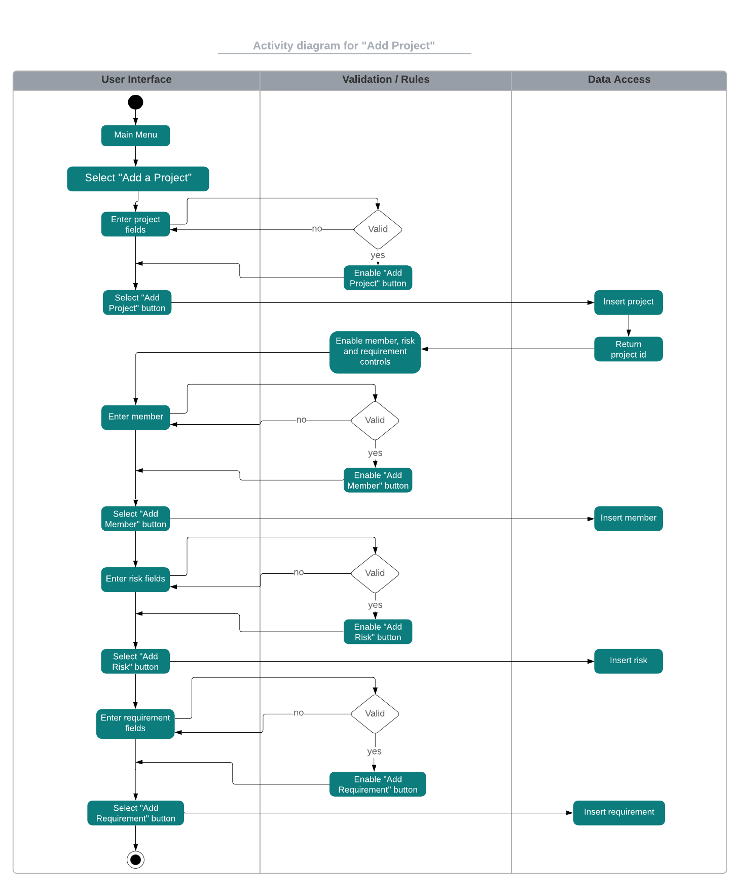

Activity Diagrams (cont.)

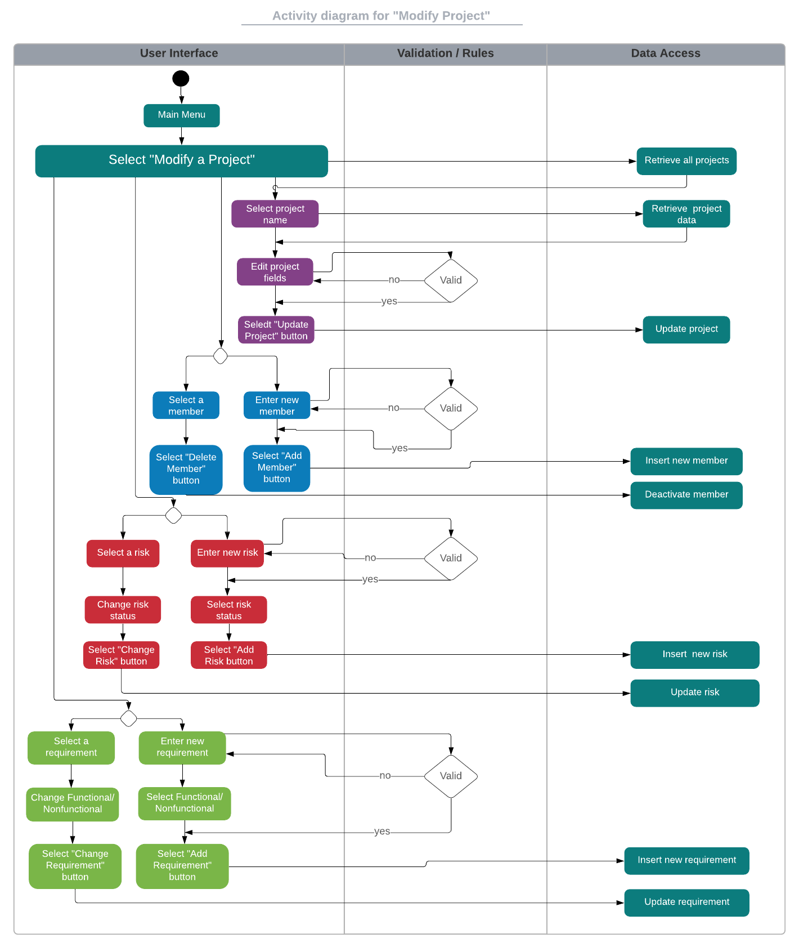

Activity Diagrams (cont.)

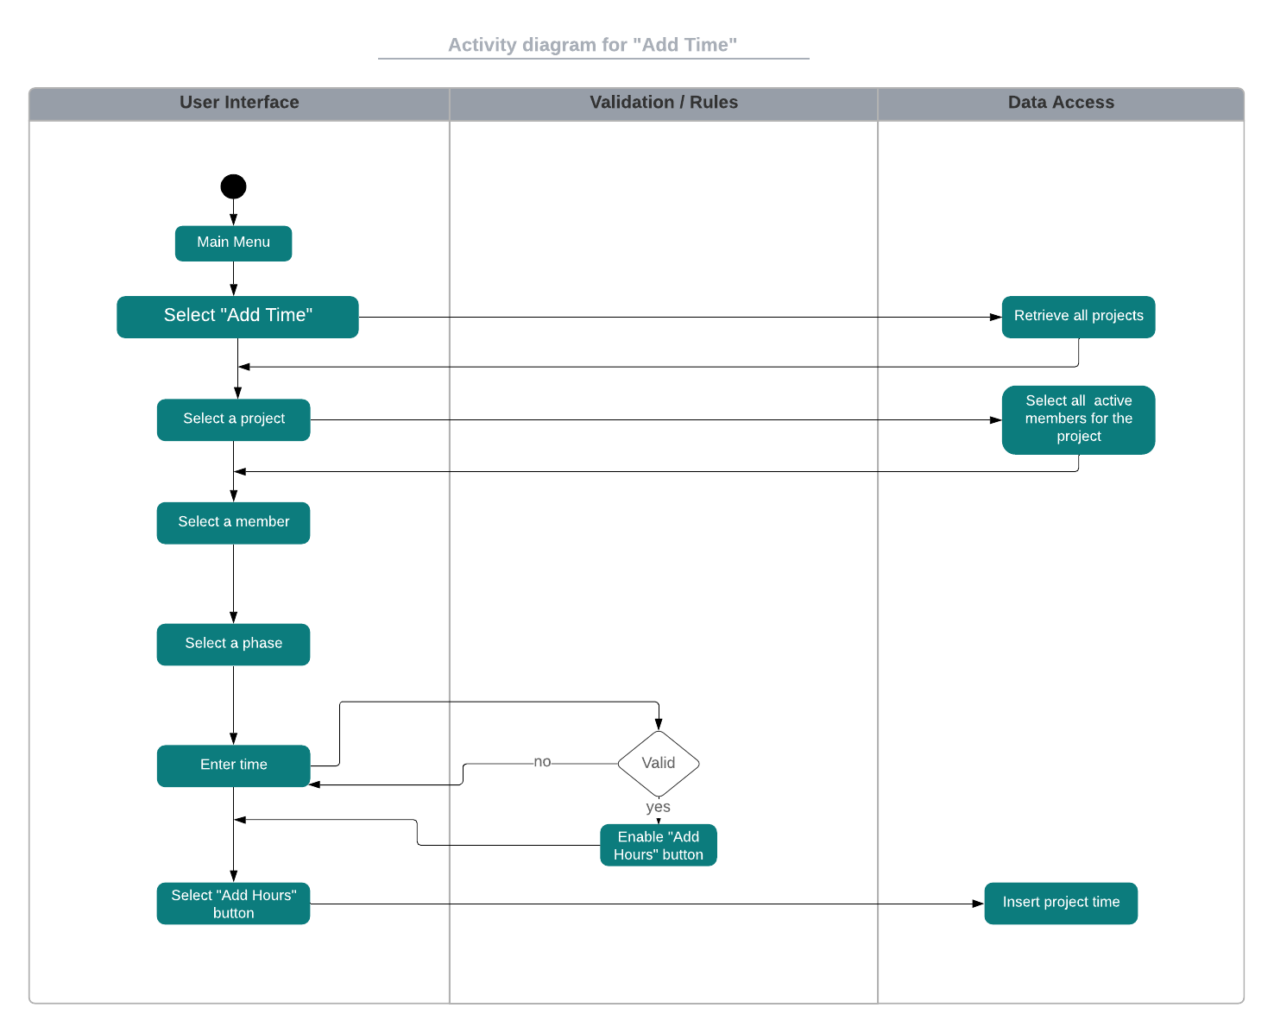

Activity Diagrams (cont.)
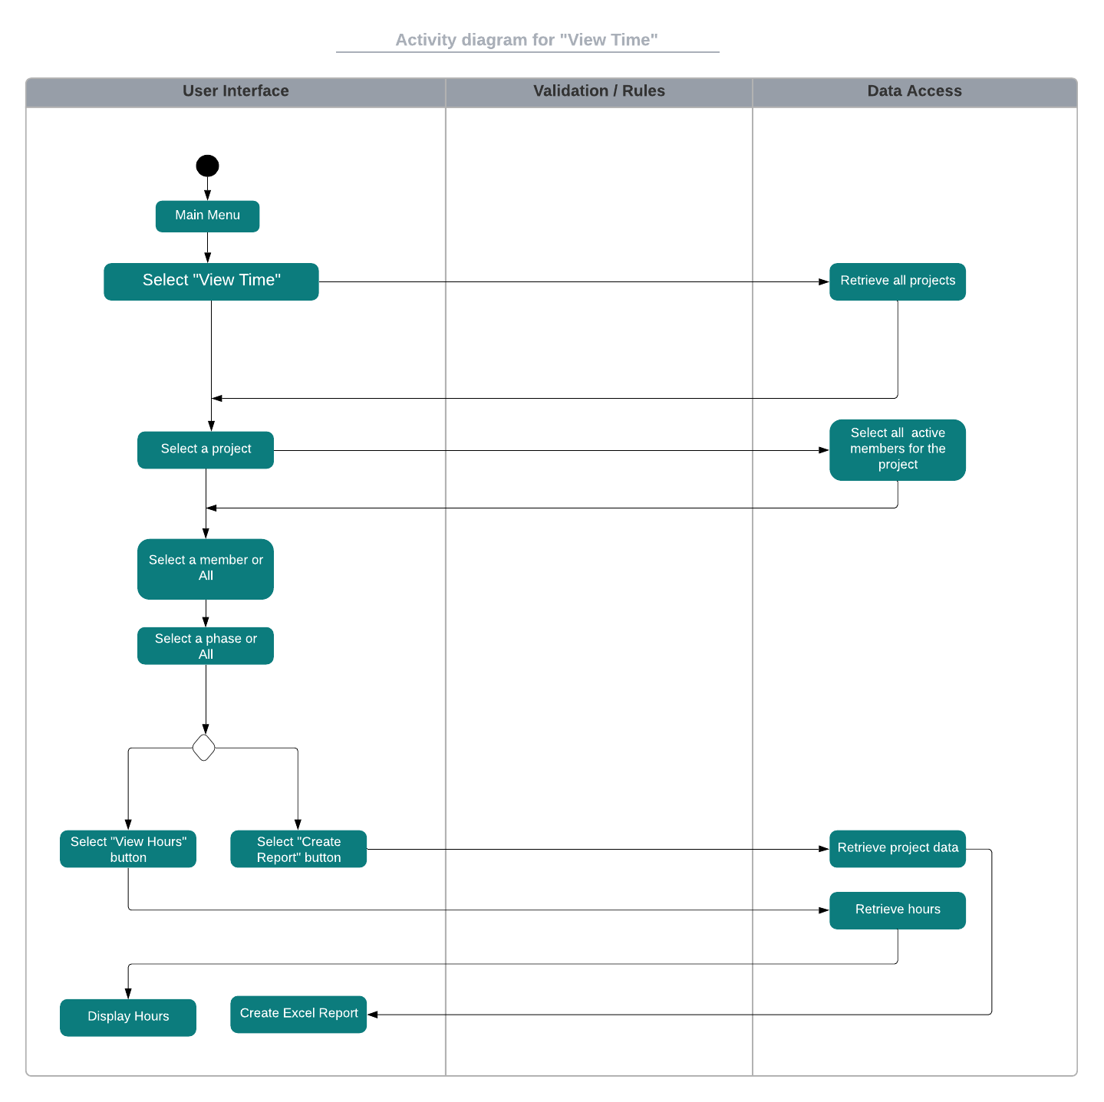

Database Design:

The relational database will be created with MySql. These are the table designs along with their primary keys and relationships with each other.

Appendix B – Test Scenarios and Data
Test Scenario ID | Add A Project-1 | Test Case ID | Add A Project 1A
Test Case Description | Add A Project – Positive | Test Priority | High
Pre-Requisite | None | Post-Requisite | None
Test Execution Steps:

Step Number | Action | Inputs | Expected Output | Actual Output
1 | Open project manager | N/A | Project Manager Homepage | Project Manager Homepage
2 | Select “Add Project” | Click “Add Project” | Add Project View | Add Project View
3 | Enter All Project Fields: Any input in all fields | Project Name: ***  Project Description: ***  Owner: *** | “Add Project” Button Enabled and Project ID | “Add Project” Button Enabled and Project ID

Test Scenario ID | Add A Project-1 | Test Case ID | Add A Project 1B
Test Case Description | Add A Project – Negative | Test Priority | High
Pre-Requisite | None | Post-Requisite | None
Test Execution Steps:

Step Number | Action | Inputs | Expected Output | Actual Output
1 | Open project manager | N/A | Project Manager Homepage | Project Manager Homepage
2 | Select “Add Project” | Click “Add Project” | Add Project View | Add Project View
3 | Leave all fields empty | Project Name: Empty  Project Description: Empty  Owner: Empty | None | None
4 | Enter any input into “Project Description” and “Owner” Fields, leave project name field empty | Project Name: ***  Project Description: Empty  Owner: Empty | None | None

Test Scenario ID | Add A Project-2 | Test Case ID | Add A Project 2A
Test Case Description | Add A Project Disabled Fields - Positive | Test Priority | High
Pre-Requisite | Add A Project-1 Pass | Post-Requisite | None
Test Execution Steps:

Step Number | Action | Inputs | Expected Output | Actual Output
1 | Select “Add Project Button” | Left Click “Add Project” Button | Disabled project input fields displayed | Disabled project input fields displayed
2 | Select any input in all fields and functional requirement type | Member Name: Any  Risk: Any  Risk Status: Any  Requirement: Any:  Requirement Type: Functional | “Add Member” button enabled, “ Add Risk” button enabled, “Add Requirement” button enabled | “Add Member” button enabled, “ Add Risk” button enabled, “Add Requirement” button enabled
3 | Select any input in all fields and non-functional requirement type | Member Name: Any  Risk: Any  Risk Status: Any  Requirement: Any:  Requirement Type: Non-Functional | “Add Member” button enabled, “ Add Risk” button enabled, “Add Requirement” button enabled | “Add Member” button enabled, “ Add Risk” button enabled, “Add Requirement” button enabled
4 | Click the now enabled buttons and functional requirement type | Click “Add Member”, “Add Risk”, and “Add Requirement” button, with functional requirement type selected | “Member Name”, “Risk Status”, “Risk”, and “Requirement” fields clear | “Member Name”, “Risk Status”, “Risk”, and “Requirement” fields clear
5 | Click the now enabled buttons and non-functional requirement type | Click “Add Member”, “Add Risk”, and “Add Requirement” button, with non-functional requirement type selected | “Member Name”, “Risk Status”, “Risk”, and “Requirement” fields clear | “Member Name”, “Risk Status”, “Risk”, and “Requirement” fields clear

Test Scenario ID | Add A Project-2 | Test Case ID | Add A Project 2B
Test Case Description | Add A Project Disabled Fields - Negative | Test Priority | High
Pre-Requisite | Add A Project-1 Pass | Post-Requisite | None
Test Execution Steps:

Step Number | Action | Inputs | Expected Output | Actual Output
1 | Select “Add Project Button” | Left Click “Add Project” Button | Disabled project input fields displayed | Disabled project input fields displayed
2 | Select no entry for all of the enabled fields, and leave requirement type in default | Member Name: None  Risk: None  Risk Status: None  Requirement: None  Requirement Type: Default | “Add Member”, “Add Risk”, and “Add Requirement” buttons remain disabled | “Add Member”, “Add Risk”, and “Add Requirement” buttons remain disabled

Test Scenario ID | Modify Project-1 | Test Case ID | Modify Project-1A
Test Case Description | Modify Project Update Fields - Positive | Test Priority | High
Pre-Requisite | Project must already be created | Post-Requisite | None
Test Execution Steps:

Step Number | Action | Inputs | Expected Output | Actual Output
1 | Select “Modify Project” | Left Click “Modify Project” Button | Modify Project view appears | Modify Project view appears
2 | Select “Project Name” from dropdown | Project Name: Any | Project Description and Owner fields auto-populate | Project Description and Owner fields auto-populate
3 | Change “Owner” field contents to anything but current contents, and add any number of characters in “Project Description” field | Project Description: Current contents + ***  Owner: Any other than current | “Update” button enabled | “Update” button enabled
4 | Update project fields | Left click “Update” button | Project Description: new description  Owner: new owner | Project Description: new description  Owner: new owner

Test Scenario ID | Modify Project-1 | Test Case ID | Modify Project-1B
Test Case Description | Modify Project Update Fields - Negative | Test Priority | High
Pre-Requisite | Project must already be created | Post-Requisite | None
Test Execution Steps:

Step Number | Action | Inputs | Expected Output | Actual Output
1 | Select “Modify Project” | Left Click “Modify Project” Button | Modify Project view appears | Modify Project view appears
2 | Select “Project Name” from dropdown | Project Name: Any | Project Description and Owner fields auto-populate | Project Description and Owner fields auto-populate
3 | Leave project fields contents the same as auto populated, and select update | Project Description: Auto Populated Contents  Owner: Auto Populate Contents | none | none

Test Scenario ID | Modify Project-2 | Test Case ID | Modify Project-2A
Test Case Description | Modify Project Member Add Positive | Test Priority | High
Pre-Requisite | Project must already be created | Post-Requisite | None
Test Execution Steps:

Step Number | Action | Inputs | Expected Output | Actual Output
1 | Select “Modify Project” | Left Click “Modify Project” Button | Modify Project view appears | Modify Project view appears
2 | Select any project name from “Project Name” dropdown | Project Name: Any | Project Description and Owner fields auto-populate | Project Description and Owner fields auto-populate
3 | Input any new name into “Member Name” field | Member: Any non-existing name | “Add” button enabled | “Add” button enabled
4 | Add member | Left click “Add” button | New name in “Member Name” dropdown list | New name in “Member Name” dropdown list

Test Scenario ID | Modify Project-2 | Test Case ID | Modify Project-2B
Test Case Description | Modify Project Member Remove Positive | Test Priority | High
Pre-Requisite | Project must already be created | Post-Requisite | None
Test Execution Steps:

Step Number | Action | Inputs | Expected Output | Actual Output
1 | Select “Modify Project” | Left Click “Modify Project” Button | Modify Project view appears | Modify Project view appears
2 | Select “Project Name” from dropdown | Project Name: Any | Project Description and Owner fields auto-populate | Project Description and Owner fields auto-populate
3 | Select any member from “Member Name” dropdown | Member: Any | “Remove” button enabled | “Remove” button enabled
4 | Remove member | Left click “Remove” button | Removed member name no longer dropdown option | Removed member name no longer dropdown option

Test Scenario ID | Modify Project-2 | Test Case ID | Modify Project-2C
Test Case Description | Modify Project Member Add/Remove Negative | Test Priority | High
Pre-Requisite | Project must already be created | Post-Requisite | None
Test Execution Steps:

Step Number | Action | Inputs | Expected Output | Actual Output
1 | Select “Modify Project” | Left Click “Modify Project” Button | Modify Project view appears | Modify Project view appears
2 | Leave “Member Name” field empty | Member Name: Empty | none | none

Test Scenario ID | Modify Project-3 | Test Case ID | Modify Project-3A
Test Case Description | Modify Project Member Change Risk Status Positive | Test Priority | High
Pre-Requisite | Project must already be created | Post-Requisite | None
Test Execution Steps:

Step Number | Action | Inputs | Expected Output | Actual Output
1 | Select “Modify Project” | Left Click “Modify Project” Button | Modify Project view appears | Modify Project view appears
2 | Select any project name from “Project Name” dropdown list | Project Name: Any | Project Description and Owner auto populate | Project Description and Owner auto populate
3 | Enter any new risk | Risk: Any | “Add” Risk Button enabled | “Add” Risk Button enabled
4 | Select risk status for new risk | Risk Status: Any new status | None | None
5 | Change risk status | Left click “Change Risk Status” button | Risk status in “Risk Status” field updated to new risk status | Risk status in “Risk Status” field updated to new risk status

Test Scenario ID | Modify Project-3 | Test Case ID | Modify Project-3B
Test Case Description | Modify Project Member Add Risk - Positive | Test Priority | High
Pre-Requisite | Project must already be created | Post-Requisite | None
Test Execution Steps:

Step Number | Action | Inputs | Expected Output | Actual Output
1 | Select “Modify Project” | Left Click “Modify Project” Button | Modify Project view appears | Modify Project view appears
2 | Select any project name from “Project Name” dropdown list | Project Name: Any | Project Description and Owner auto populate | Project Description and Owner auto populate
3 | Enter any new risk in “Risk Status” field | Risk: Any new Risk | none | none
4 | Select any risk status from “Risk Status” dropdown list | Risk Status: Any | “Add Risk” button enabled | “Add Risk” button enabled
5 | Change risk status | Left click “Change Risk Status” button | New risk added to “Risk” drop down list, and risk status updated | New risk added to “Risk” drop down list, and risk status updated

Test Scenario ID | Modify Project-3 | Test Case ID | Modify Project-3C
Test Case Description | Modify Project Member Risk - Negative | Test Priority | High
Pre-Requisite | Project must already be created | Post-Requisite | None
Test Execution Steps:

Step Number | Action | Inputs | Expected Output | Actual Output
1 | Select “Modify Project” | Left Click “Modify Project” Button | Modify Project view appears | Modify Project view appears
2 | Select any project name from “Project Name” dropdown list | Project Name: Any | Project Description and Owner auto populate | Project Description and Owner auto populate
3 | Select any risk from “Risk” drop down, and leave “Risk Status” drop down unchanged and click “Add” | Risk: Any  Risk Stats: Current Risk Status | none | none
4 | Leave “Risk” field drop down empty, and select any risk status from “Risk Status” dropdown | Risk: Empty  Risk Status: Any | none | none
5 | Leave “Risk” field empty and leave “Risk Status” field empty | Risk: Empty  Risk Status: Empty | none | none

Test Scenario ID | Modify Project-4 | Test Case ID | Modify Project-4A
Test Case Description | Modify Project Change Requirement Type- Positive | Test Priority | High
Pre-Requisite | Project must already be created | Post-Requisite | None
Test Execution Steps:

Step Number | Action | Inputs | Expected Output | Actual Output
1 | Select “Modify Project” | Left Click “Modify Project” Button | Modify Project view appears | Modify Project view appears
2 | Select any project name from “Project Name” dropdown list | Project Name: Any | Project Description and Owner auto populate | Project Description and Owner auto populate
3 | Enter and add any new requirement with requirement type any | Requirement: Any  Requirement Type: Any | New requirement added to requirement drop down list | New requirement added to requirement drop down list
4 | Select newly added requirement from dropdown list | Requirement: Previously added requirement | “Change” button enabled | “Change” button enabled
5 | Change Requirement Type | Requirement Type: Opposite of current type | “Change” button enabled | “Change” button enabled
6 | Click change requirement button | Requirement Type: Opposite of Current | Requirement type updated | Requirement type updated
7 | Select same requirement as before from “Requirement” drop down list | Requirement: Same as previous | “Change” button enabled | “Change” button enabled
8 | Select the original requirement type | Requirement Type: Original requirement type | “Change Requirement Type” button enabled | “Change Requirement Type” button enabled
9 | Change Requirement Type | Left click “Change Requirement Type” button | Requirement Type: original requirement type | Requirement Type: original requirement type

Test Scenario ID | Modify Project-4 | Test Case ID | Modify Project-4B
Test Case Description | Modify Project Requirement Negative | Test Priority | High
Pre-Requisite | Project must already be created | Post-Requisite | None
Test Execution Steps:

Step Number | Action | Inputs | Expected Output | Actual Output
1 | Select “Modify Project” | Left Click “Modify Project” Button | Modify Project view appears | Modify Project view appears
2 | Select any project name from “Project Name” dropdown list | Project Name: Any | Project Description and Owner auto populate | Project Description and Owner auto populate
3 | Enter any new requirement into “Requirement” field, but leave “Requirement Type” unselected | Requirement: Any  Requirement Type: Unselected | “Change” button enabled | “Change” button enabled
4 | Leave requirement drop down field empty and select and requirement type | Requirement: Empty  Requirement Type: Any | None | None

Test Scenario ID | Add Time-1 | Test Case ID | Add Time-1A
Test Case Description | Add Time-Positive | Test Priority | High
Pre-Requisite | Project must already be created, member must already be added to project | Post-Requisite | None
Test Execution Steps:

Step Number | Action | Inputs | Expected Output | Actual Output
1 | Open project manager | Left Click Project Manager Executable | Project Manager Homepage | Project Manager Homepage
2 | Navigate to the add time screen | Left click “Add Time” | Add Time view appears | Add Time view appears
3 | Select a input from the three dropdown lists | Select a Project: Any  Select a Member:  Any  Select a Phase:  Any | The three fields populate with the selected input from the dropdown list | The three fields populate with the selected input from the dropdown list
4 | Select a date using date picker | Date: Any | Date field updated | Date field updated
5 | Enter any positive number in the “Hours” input field | Hours: ℤ⁺ | None | None
6 | Select “Add Hours” button | Left click “Add Hours” button | Hours field cleared and hours updated | Hours field cleared and hours updated

Test Scenario ID | Add Time-1 | Test Case ID | Add Time-1B
Test Case Description | Add Time-Negative | Test Priority | High
Pre-Requisite | Project must already be created, member must already be added to project | Post-Requisite | None
Test Execution Steps:

Step Number | Action | Inputs | Expected Output | Actual Output
1 | Open project manager | Left Click Project Manager Executable | Project Manager Homepage | Project Manager Homepage
2 | Navigate to the add time screen | Left click “Add Time” | Add Time view appears | Add Time view appears
3 | Select any for all fields, but enter no input in “Hours” field | Select a Project: Any  Select a Phase: Any  Select a Member:  Any  Date: Any  Hours: Empty | None | None
4 | Leave all drop down fields empty, and enter any positive number in “Hours” field | Select a Project: Empty  Select a Phase: Empty  Select a Member: Empty  Date: Empty  Hours: ℤ⁺ | None | None
5 | Select any input from all three drop down fields, select any date, and enter any number less than or equal to zero in “Hours” field | Select a Project: Any  Select a Phase: Any  Select a Member:  Any  Date: Any  Hours: Any # <= 0 | Negative sign automatically deleted | Negative sign automatically deleted

Test Scenario ID | View Time-1 | Test Case ID | View Time-1A
Test Case Description | View Time Categorized-Positive | Test Priority | High
Pre-Requisite | Project must already be created, member must already be added to project, time must already be added to project, member, and phase | Post-Requisite | None
Test Execution Steps:

Step Number | Action | Inputs | Expected Output | Actual Output
1 | Open project manager | Left Click Project Manager Executable | Project Manager Homepage | Project Manager Homepage
2 | Navigate to the View Time screen | Left click “View Time” | View Time view appears | View Time view appears
3 | Select member, phase, and date | Member, phase, and date radio buttons selected | None | None
4 | Select any project from dropdown list | Dropdown list: Any | Dropdown list populated with select project name, and all hours for project displayed for all categories | Dropdown list populated with select project name, and all hours for project displayed for all categories

Test Scenario ID | View Time-1 | Test Case ID | View Time-1B
Test Case Description | View Time Total-Positive | Test Priority | High
Pre-Requisite | Project must already be created, member must already be added to project, time must already be added to project, member, and phase | Post-Requisite | None
Test Execution Steps:

Step Number | Action | Inputs | Expected Output | Actual Output
1 | Open project manager | Left Click Project Manager Executable | Project Manager Homepage | Project Manager Homepage
2 | Navigate to the View Time screen | Left click “View Time” | View Time view appears | View Time view appears
3 | Leave all fields un-checked | Member, phase, and date un-selected | none | none
4 | Select project from dropdown list | Dropdown: any | Total hours for project displayed | Total hours for project displayed

Test Scenario ID | View Time-1 | Test Case ID | View Time-1C
Test Case Description | View Time - Negative | Test Priority | High
Pre-Requisite | Project must already be created, member must already be added to project, time must already be added to project, member, and phase | Post-Requisite | None
Test Execution Steps:

Step Number | Action | Inputs | Expected Output | Actual Output
1 | Open project manager | Left Click Project Manager Executable | Project Manager Homepage | Project Manager Homepage
2 | Navigate to the View Time screen | Left click “View Time” | View Time view appears | View Time view appears
3 | Check all field | Member, phase, and date checked | none | none
4 | Leave project drop down empty | Dropdown: Empty | none | none

