Unit 3 Sample Test

(Scroll to the last page of this document for the answers.)

|  |
| --- |
| **Part I.** For each of the following statements, identify the numbered words as one of the following |
| a.) quantifier  b.) part of the subject term  c.) part of the copula  d.) part of the predicate term  Then answer the questions that follow each sentence. |

|  |  |  |  |  |  |
| --- | --- | --- | --- | --- | --- |
| (1) | (2) | (3) | (4) | (5) | (6) |
| No | pop | stars | are | tortured | souls. |

7. Is the statement above (a) universal or (b) particular?

8. Is the statement above (a) affirmative or (b) negative?

|  |  |  |  |  |  |
| --- | --- | --- | --- | --- | --- |
| (9.) | (10.) | (11.) | (12.) | (13.) | (14.) |
| All | chickens | are | fine | feathered | friends. |

15. Is the statement above (a) universal or (b) particular?

16. Is the statement above (a) affirmative or (b) negative?

(17) (18) (19) (20)

Some mutants are X-men.

21. Is the statement above (a) universal or (b) particular?

22. Is the statement above (a) affirmative or (b) negative?

|  |  |
| --- | --- |
| **Part II.** Identify each of the following statements as (a) A, (b) E, (c) I, or (d) O.   1. All men are mortals. 2. Some adventurers are not magicians. 3. All archanists are people who practice sympathy. 4. Some practitioners of sygaldry are archanists. | 1. Some songs are not good songs. 2. All policemen are upstanding citizens. 3. No machinists are rich people. 4. Some lawyers are not rich people. |

**Part III.** The instructions for part IV refer to Figure IV and Answer-Code IV.

|  |
| --- |
| a.) shade out region 1  b.) shade out region 2  c.) shade out region 3  d.) shade out region 4  e.) x in region 1  ab.) x in region 2  ac.) x in region 3  ad.) x in region 4 |

Answer-Code IV:

Figure IV

1

2

3

4

P

S

For each of the following statements, draw a Venn diagram, with the subject on the left and the predicate on the right. Then, for each number, choose the letter from Answer-Code IV that describes your Venn diagram in relation to Figure IV. I do not need to see your diagram.

1. No Youtube videos are educational gold mines.
2. Some Youtube videos are time wasters.
3. All guitars are instruments.
4. Some balalaikas are three stringed instruments.
5. No ouds are middle eastern instruments.
6. Some people are not consumers.
7. Some animals that can communicate are not humans.
8. No reptiles are emotional creatures.
9. Some dogs are not game show contestants.
10. Some 80’s rappers are geniuses.

**Part IV:** For each of the following statements, choose the best translation into standard form.

1. No one goes through this.
   1. All people are people who go through this.
   2. Some people are people who don’t go through this.
   3. No people are people who go through this.
   4. This sucks.
2. There are worse things awaiting man than death.
   1. No things awaiting man are things worse than death.
   2. Some things awaiting man are things worse than death.
   3. All things worse than death are things awaiting man.
   4. Some things awaiting man are not things worse than death.
3. People over 40 are all technologically challenged.
   1. All people over 40 are technologically challenged people.
   2. No people over 40 are technologically challenged people.
   3. Some people over 40 are not technologically challenged people.
   4. Old people suck.
4. All Japanese people eat natto.
   1. Some Japanese people are natto eaters.
   2. All Japanese people are natto eaters.
   3. All natto eaters are Japanese people.
   4. Ew, gross!
5. Only Japanese people eat natto.
   1. Some Japanese people are natto eaters.
   2. All Japanese people are natto eaters.
   3. All natto eaters are Japanese people.
   4. Ew, gross!
6. Some cartoons are funny.
   1. Some cartoons are funny things.
   2. No cartoons are funny things.
   3. All cartoons are funny things.
   4. I like Homer Simpson.
7. There are no time machines.
   1. No machines are time machines.
   2. Some machines are not time machines.
   3. All time machines are machines.
   4. The morlocks outnumber the eloi.
8. Every time you go away, you take a piece of me with you.
   1. All times you take a piece of me with you are times you go away.
   2. All times you go away are times you take a piece of me with you.
   3. No times you go away are times you take a piece of me with you.
   4. Baby can’tcha see, we got everything goin’ on and on and on.
9. John wears a suit whenever he goes to work.
   1. All times John wears a suit are times John goes to work.
   2. All times John goes to work are times John wears a suit.
   3. No times John goes to work are times John wears a suit.
   4. Work sucks.
10. Not all TV shows are insipid.
    1. Some TV shows are insipid shows.
    2. Some TV shows are not insipid shows.
    3. All TV shows are insipid shows.
    4. Disney should go out of business.

**Part V: Categorical Syllogisms**

**Syllogism 1**

P1. All zebras are striped animals.

P2. Some mammals are not striped animals.

1. Therefore some mammals are not zebras.

Fill in the diagram for *the premises and only the premises* of the syllogism, with the minor term on the left and the major term on the right. Remember to do premises that involve shading first. Describe your diagram by choosing the letter from the answer-code that describes the corresponding region for each number.

55

54

56

57

51

52

53

M

Z

S

Answer-Code

1. shaded
2. blank
3. x on the border
4. x completely inside

58

59. Is the syllogism (a) valid or (b) not valid?

60. Is the syllogism (a) valid or (b) not valid?

**Syllogism 2**

P1. All zebras are mammals.

P2. Some mammals are not striped animals.

1. Therefore some striped animals are not zebras.

65

64

66

67

61

62

63

S

Z

M

Answer-Code

1. shaded
2. blank
3. x on the border
4. x completely inside

68

1. Is the syllogism (a) valid or (b) not valid?
2. Is the syllogism (a) valid or (b) not valid?

**Syllogism 3**

P1. All canines are mammals.

P2. Some mammals are not dogs.

1. Therefore some dogs are not canines.

75

74

76

77

71

72

73

M

Answer-Code

1. shaded
2. blank
3. x on the border
4. x completely inside

78

D

C

1. Is the syllogism (a) valid or (b) not valid?
2. Is the syllogism (a) valid or (b) not valid?

**Syllogism 4**

* 1. Some dracs are creatures with ugly heads.
  2. Some humans are not creatures with ugly heads.

1. Therefore, some humans are not dracs.

85

84

86

87

81

82

83

U

Answer-Code

1. shaded
2. blank
3. x on the border
4. x completely inside

88

H

D

89. Is the syllogism (a) valid or (b) not valid?

90. Is the syllogism (a) valid or (b) not valid?

**Syllogism 5**

* 1. No athletes are couch potatoes.
  2. All boxers are athletes.

1. Therefore no boxers are couch potatoes.

Proceed as with syllogism 1.

95

94

96

97

91

92

93

B

C

A

Code Reminder:

1. shaded
2. blank
3. x on the border
4. x completely inside

98

99. Is the syllogism (a) valid or (b) not valid?

1. Is the syllogism (a) valid or (b) not valid?

**Extra Credit:** Consider the following argument. It is not a categorical syllogism in standard form, but it can be manipulated into one, by replacing some statements with equivalent statements. Translate it into a categorical syllogism in standard form. Then do a Venn diagram for the argument and state whether it is valid. **(possible 10 extra credit points)**

All priests are bearded men.

Some clean-shaven men are not scholars.

Therefore some scholars are not priests.

ANSWERS

|  |  |  |  |
| --- | --- | --- | --- |
| 1. A 2. B 3. B 4. C 5. D 6. D 7. A 8. B 9. A 10. B 11. C 12. D 13. D 14. D 15. A 16. A 17. A 18. B 19. C 20. D 21. B 22. A 23. A 24. D 25. A | 1. C 2. D 3. A 4. B 5. D 6. B 7. AB 8. A 9. AB 10. B 11. E 12. E 13. B 14. E 15. AB 16. C 17. B 18. A 19. B 20. C 21. A 22. A 23. B 24. B 25. B | 1. B 2. B 3. B 4. B 5. D 6. A 7. A 8. B 9. A 10. A 11. C 12. B 13. B 14. C 15. B 16. A 17. A 18. B 19. B 20. B 21. C 22. B 23. B 24. C 25. B | 1. A 2. A 3. B 4. B 5. B 6. B 7. C 8. C 9. C 10. B 11. B 12. B 13. B 14. B 15. B 16. B 17. B 18. A 19. A 20. A 21. A 22. B 23. B 24. A 25. A |

Extra Credit Answers on Next Page

Extra Credit

Rewritten as a syllogism:

No priests are clean-shaven men.

Some clean-shaven men are not scholars.

Therefore some scholars are not priests.

Venn Diagram

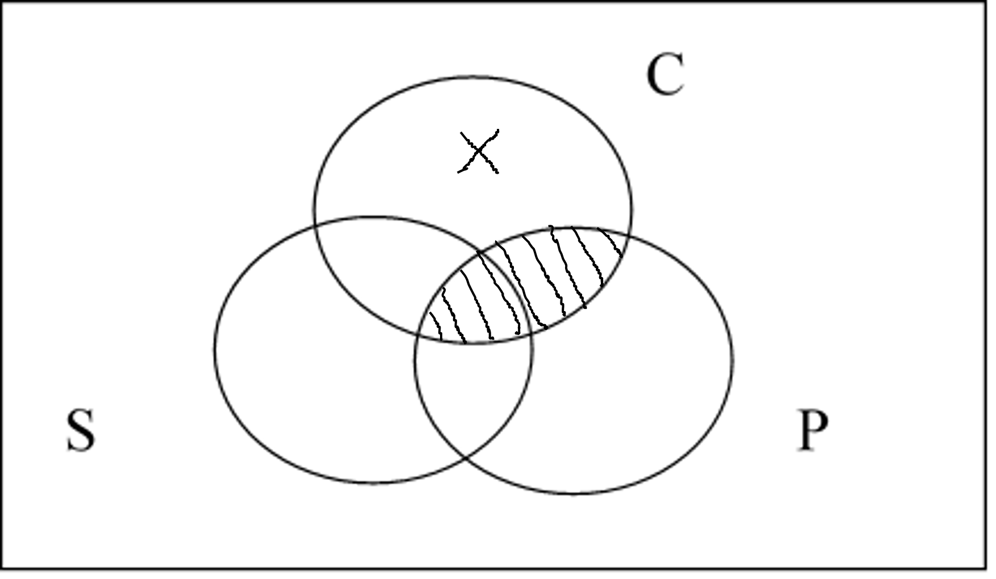

Invalid