SMART STREET LIGHTING WITH PREDICTIVE CONTROL
A QNX REAL-TIME OPERATING SYSTEM BASED IMPLEMENTATION
On The Domain Of
SMART CITY – EMBEDDED SYSTEMS AND IoT
Prepared by
INFINITY SPARKS
TEAM MEMBERS:
Ashwithaa B
Gayathri M
Kamaladevi SP
Department Of
ELECTRONICS AND COMMUNICATION ENGINEERING


PRINCE SHRI VENKATESHWARA PADMAVATHY ENGINEERING
COLLEGE [AN AUTONOMOUS INSTITUTION], CHENNAI-127
ANNA UNIVERSITY: CHENNAI 600 025
Batch 2023-2027

ABSTRACT
Street lighting is one of the largest recurring energy expenses for urban municipalities, and conventional installations illuminate roads at fixed, full brightness irrespective of whether the road is occupied. This project presents a predictive, multi-zone smart street-lighting system built around the QNX real-time operating system running on a Raspberry Pi. The system divides a stretch of road into independent lighting zones, each monitored using Light Dependent Resistor (LDR) sensors for ambient daylight and Passive Infrared (PIR) and Infrared (IR) sensors for vehicle or pedestrian occupancy. Rather than reacting only after a vehicle enters a zone, the system continuously studies current occupancy, the activity of neighbouring zones and historical traffic patterns to anticipate which zone will need illumination next, and pre-illuminates that zone before traffic arrives. Sensing, prediction, lighting control and emergency handling are implemented as independent QNX tasks that communicate through message queues, with strict priority scheduling ensuring that an emergency push-button event always overrides normal energy-saving behaviour and drives every zone to full brightness. The prototype is built entirely from low-cost, readily available components, and the control logic relies on core real-time operating system concepts including multitasking, priority-based preemptive scheduling, inter-process communication, event-driven processing, timers and state machines. The system is validated through zone-wise illumination behaviour, prediction accuracy and emergency-response testing. The result is a low-cost, modular prototype that demonstrates how real-time embedded design principles can be combined with simple, inexpensive sensors to deliver meaningful energy savings without compromising road safety.

CHAPTER 1 - INTRODUCTION
Street lighting exists to keep roads safe and visible after dark, but the way most installations are operated has changed very little in decades: lamps are switched on at dusk and held at maximum brightness until dawn, regardless of how much traffic actually uses the road at any given moment. In a typical urban stretch, traffic volume falls sharply during late-night hours, yet the lighting infrastructure continues to draw full power. This mismatch between actual usage and energy expenditure represents a significant and largely avoidable cost for municipalities, and it is the starting point for this project.
Advances in low-cost embedded computing, inexpensive sensing hardware and real-time operating systems make it possible to design street lighting that behaves intelligently rather than statically. This report describes a prototype system, developed by team Infinity Sparks under the Smart City / Embedded Systems and IoT track, that brings together ambient-light sensing, occupancy detection and traffic-pattern prediction on a QNX-based embedded platform.

1.1 Predictive Lighting Requirement
Most sensor-based lighting systems proposed so far are purely reactive: a sensor detects the presence of a vehicle or pedestrian and switches the light on only after that presence is registered. The proposed system instead studies current occupancy, the activity of neighbouring zones and historical traffic patterns in order to anticipate which zone will require illumination next, and pre-illuminates that zone before traffic arrives. This closes the brief window in which a zone would otherwise remain under-illuminated relative to what is actually needed.

1.2 Real-Time Operating System Approach
Sensing, prediction, lighting control and emergency handling must be executed repeatedly and at appropriate time intervals so that changes in road conditions can be detected and the lighting response can be generated without unacceptable delay. The proposed system therefore uses the QNX real-time operating system to organise these functions as independent tasks. Priority-based preemptive scheduling, message queues, timers and event-driven processing are used to coordinate the tasks, and the emergency-handling task is given the highest scheduling priority so that safety is never compromised for the sake of energy savings.

1.3 Report Organisation
The following chapters walk through the problem being addressed, the research that motivated the chosen approach, the design of the proposed solution, the methodology and system architecture, the key features that distinguish the system from existing approaches, an assessment of feasibility and impact, a cost estimate, an implementation roadmap, and concluding remarks.

CHAPTER 2 - PROBLEM STATEMENT AND OBJECTIVES

2.1 Problem Statement
Conventional streetlights are typically operated at a fixed brightness level throughout the night, even during periods when a road segment sees little or no traffic. This design choice leads directly to unnecessary and avoidable energy consumption, since lamps continue to draw full power whether or not anyone is present to benefit from full illumination.
A number of sensor-based lighting systems have been proposed to address this, but the majority of them are purely reactive. These systems do not anticipate future lighting demand based on the flow of traffic, so there is always a brief window in which a zone is under-illuminated relative to what is actually needed, and there is no coordination between the many independent lighting zones that make up a real road network.

2.2 Key Challenges
- Unnecessary energy consumption during low-traffic periods, since fixed-brightness systems cannot scale illumination down when the road is empty.
- Limited adaptation to daylight and occupancy conditions in systems that rely on a single sensing modality.
- Lack of predictive lighting based on traffic patterns, so illumination always lags slightly behind the vehicle or pedestrian it is meant to serve.
- Lack of coordination between multiple lighting zones, meaning neighbouring zones cannot share information about oncoming traffic.
- Emergency events require immediate priority over energy-saving operations, a requirement that purely reactive or purely energy-driven systems are not designed to guarantee.

2.3 Project Objectives
The project sets out to design and prototype a street-lighting system that closes the gap identified above. The specific objectives are listed below.

ID | Objective
O1 | Design a multi-zone street-lighting architecture in which each zone can be independently monitored and controlled.
O2 | Combine ambient light sensing (LDR) and occupancy/motion sensing (PIR and IR) so that lighting responds to both daylight conditions and the physical presence of road users.
O3 | Implement a prediction mechanism that uses current occupancy, neighbouring-zone activity and historical traffic patterns to anticipate which zone will require illumination next.
O4 | Pre-illuminate the predicted zone ahead of time so that light is available exactly when traffic arrives, rather than immediately after.
O5 | Build the control logic on the QNX real-time operating system, using separate tasks and message-queue based communication for sensing, prediction, lighting control and emergency handling.
O6 | Guarantee that emergency events are given the highest scheduling priority, so that safety is never compromised for the sake of energy savings.
O7 | Validate the design on a low-cost Raspberry Pi based hardware prototype suitable for demonstration and further field trials.

CHAPTER 3 - RESEARCH AND BACKGROUND
Before finalising the system design, the team surveyed the lighting-control strategies already in common use, in order to understand their strengths and their limitations. Four broad approaches were considered, summarised in Table 3.1.

3.1 Existing Lighting-Control Approaches
Approach | Mechanism | Limitation
Conventional Lighting | Fixed brightness at dusk-to-dawn operation | Higher, unnecessary energy usage regardless of traffic
LDR-Based Lighting | Day/night switching based on ambient light | No awareness of traffic or occupancy
PIR / IR-Based Lighting | Motion- or beam-break-triggered activation | Purely reactive; light turns on only after arrival
Predictive Lighting | Uses traffic patterns to anticipate demand | Requires coordination and processing not present in simple sensor circuits
Table 3.1: Comparison of existing lighting-control approaches.

3.2 Research Gap
Across all four approaches, no single existing system combines daylight sensing, occupancy detection and traffic-pattern-based prediction into one coordinated, real-time, multi-zone platform that can also guarantee emergency priority. Conventional and LDR-based systems ignore occupancy entirely; PIR- and IR-based systems react only after the fact; and none of the reactive approaches share information between neighbouring zones or incorporate historical traffic data into their decisions. This gap, namely the need for a real-time, multi-zone system that combines daylight, occupancy and traffic patterns with emergency priority control, is the specific problem this project addresses.

CHAPTER 4 - PROPOSED SOLUTION AND SYSTEM ARCHITECTURE

4.1 Proposed Solution
To close the research gap identified above, the project proposes a QNX-based, multi-zone smart street-lighting system running on a Raspberry Pi. The road is divided into a series of independently addressable lighting zones (Z1, Z2, Z3 and Z4 in the prototype), each fitted with its own PIR and IR occupancy sensors, while a shared LDR sensor monitors overall ambient daylight. The main elements of the proposed solution are:
- Develop a QNX-based multi-zone smart street-lighting system on Raspberry Pi.
- Use LDR, PIR and IR sensors to monitor ambient light and road occupancy in each zone.
- Dynamically adjust zone brightness based on real-time conditions rather than a single fixed level.
- Predict upcoming lighting demand using traffic movement and historical patterns, so the next zone is lit before the vehicle reaches it.
- Use QNX real-time tasks and message queues for all inter-module communication, with emergency events receiving the highest scheduling priority.
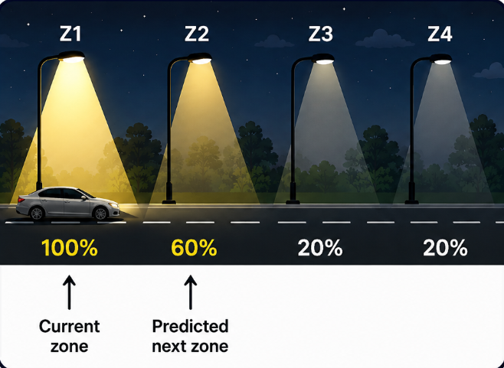
Figure 4.1: Predictive zone-wise illumination - the current zone is fully lit, the predicted next zone is pre-illuminated, and downstream zones remain dimmed.

4.2 System Architecture
The overall data and control flow of the system is summarised in the block diagram below. Ambient light readings from the LDR and occupancy readings from the four zone-wise PIR and IR sensors are collected by the Sensor Task running under QNX. These readings are passed, via a message queue, to the Prediction Task, which combines current occupancy, traffic history and the activity of neighbouring zones to predict which zone will need illumination next. The Lighting Controller task then converts these decisions into PWM/GPIO signals that drive the LED lighting zones. A separate, high-priority Emergency Task listens for a push-button input and, when triggered, overrides the Lighting Controller directly to drive every zone to 100% brightness. A CLI/Dashboard module observes the system for monitoring and logging purposes without participating in the control loop itself.
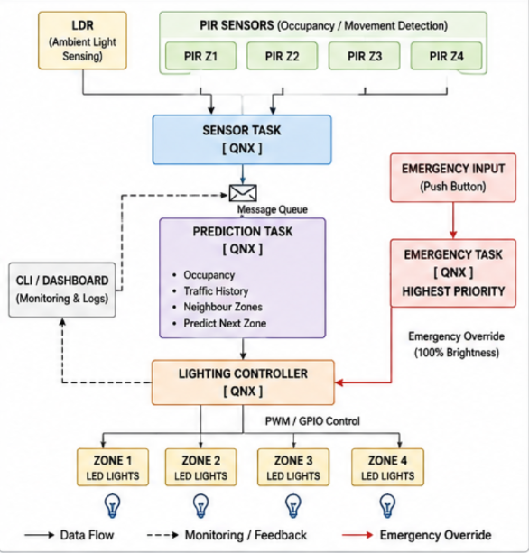
Figure 4.2: System block diagram showing sensing, prediction, lighting control and emergency-override paths.

CHAPTER 5 - METHODOLOGY AND QNX TASK ARCHITECTURE

5.1 Methodology
The system was designed and implemented following the sequence below, moving from zone definition through sensing, prediction and, finally, real-time task coordination.
- Divide the road into multiple intelligent lighting zones that can be independently monitored and controlled.
- Use the LDR to detect ambient light and PIR and IR sensors to detect occupancy or movement within each zone.
- Maintain low-intensity lighting during low-traffic nighttime conditions so that energy is not wasted on empty road segments.
- Increase the occupied zone to full illumination as soon as movement is detected within it.
- Predict upcoming lighting demand using current occupancy, neighbouring-zone activity and historical traffic patterns.
- Pre-illuminate the predicted zone before traffic actually reaches it, closing the reaction-time gap left by purely reactive systems.
- Implement sensing, prediction, lighting control and emergency handling as separate QNX tasks that communicate through message queues rather than shared global state.
- Assign the highest scheduling priority to emergency handling, allowing it to override normal energy-saving operation whenever it is triggered.

5.2 Embedded Hardware Architecture
The prototype is built entirely from low-cost, readily available components. A Raspberry Pi 4/5 acts as the main processing unit, reading the LDR through an MCP3008 analogue-to-digital converter and the four zone-wise PIR and IR sensors directly over GPIO. Zone brightness is driven through PWM/GPIO outputs, and a dedicated emergency push-button provides a hardware interrupt path for the highest-priority override.

5.3 QNX Software and Task Architecture
On the software side, the system is organised into five QNX tasks, each with a clearly defined responsibility and scheduling priority, as summarised in Table 5.1.

Task | Primary Responsibility | Priority Intent
Emergency Task | Detect push-button input and override all zones to full brightness | Highest
Lighting Controller | Convert lighting decisions into PWM/GPIO brightness commands | High
Sensor Task | Read LDR and zone-wise PIR and IR sensors and forward the data | Medium-High
Prediction Task | Predict next-zone demand from occupancy, history and neighbouring zones | Medium
CLI / Dashboard | Monitor and log system behaviour without joining the control loop | Lowest
Table 5.1: QNX task responsibilities and priority ordering.
These tasks rely on core real-time operating system concepts, namely multitasking, priority scheduling, preemption, inter-process communication through message queues, event-driven processing, timers and timeouts, and state machines, all of which QNX provides natively. Scheduling priority runs from the Emergency Task (highest) through the Lighting Controller, Sensor Task and Prediction Task, down to the Monitoring/Dashboard module (lowest), which ensures that safety-critical behaviour is never starved by routine sensing or logging activity.
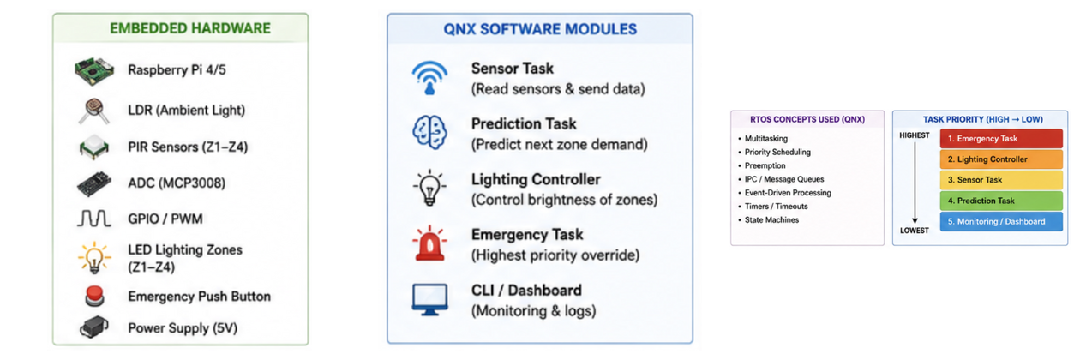
Figure 5.1: Embedded hardware components, QNX software modules, RTOS concepts used, and task priority ordering (highest to lowest).

5.4 Key Features and Novelty
What distinguishes this system from existing street-lighting approaches is not any single sensor or component, but the way sensing, prediction and real-time scheduling are combined into one coordinated platform. The key features are:
- Adaptive, zone-wise illumination that scales brightness to the actual occupancy of each individual zone rather than the road as a whole.
- Predictive lighting based on expected traffic demand, so illumination is ready before a vehicle or pedestrian arrives rather than immediately after.
- Historical traffic-pattern analysis that improves the accuracy of predictions over time.
- Coordinated control of neighbouring lighting zones, allowing activity in one zone to inform the behaviour of the next.
- A real-time QNX task architecture that keeps sensing, prediction, control and emergency handling cleanly separated and independently schedulable.
- Priority-based emergency override that guarantees full illumination during critical events, regardless of the current energy-saving state.
- Continuous energy-saving monitoring through the CLI/Dashboard module, giving operators visibility into system behaviour over time.

CHAPTER 6 - TESTING AND RESULTS
The system was tested end-to-end on the QNX Momentics IDE, running the compiled application on a Raspberry Pi target (192.168.137.28) over the network debug connection. The console output logs the raw LDR and IR readings, the ambient condition, the zone-occupancy decision and the resulting LED state for every control cycle, allowing the sensing, prediction and lighting-control stages to be verified together against live sensor data.

6.1 No-Vehicle / Idle Condition
With the ambient sensor reporting night-time conditions and all three IR channels idle, the controller correctly reports “NO VEHICLE” for every cycle and holds all three LEDs off, confirming that the idle/low-power state is not triggered falsely in the absence of occupancy.
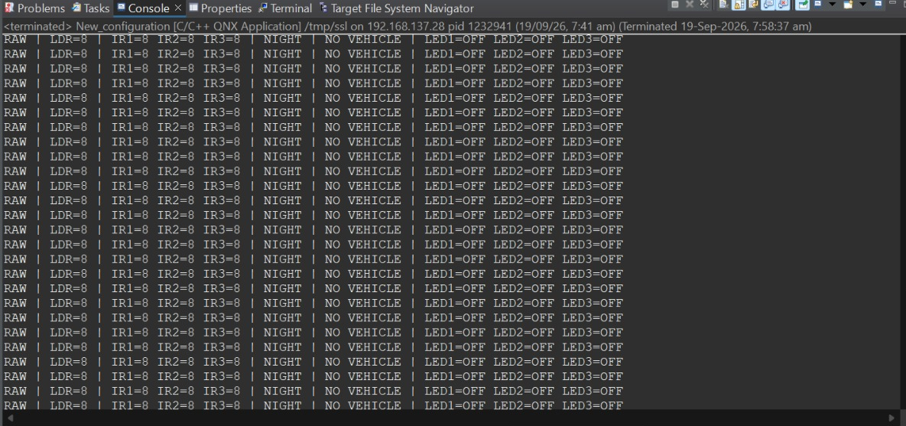
Figure 6.1: Console log under night, no-vehicle conditions — LED1, LED2 and LED3 all remain OFF.

6.2 Zone 1 Detection and Predictive Pre-Illumination
When IR1 registers a vehicle, the controller reports “ZONE 1 DETECTED”, immediately switches LED1 ON for the occupied zone, and simultaneously switches LED2 ON with a (PREDICTED) tag for the neighbouring zone — confirming that the predictive pre-illumination logic anticipates the next zone rather than waiting for it to be occupied.
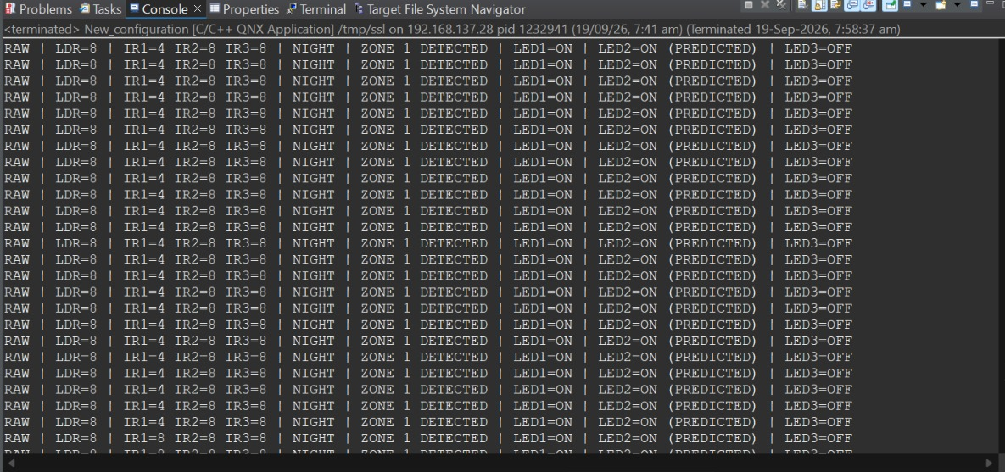
Figure 6.2: Zone 1 occupancy detected — LED1 ON (current zone) and LED2 ON – PREDICTED (next zone).

6.3 Zone 2 Detection and Predictive Hand-Off
As the vehicle moves forward and IR2 registers occupancy, the controller reports “ZONE 2 DETECTED”. LED2 now switches to its confirmed ON state for the occupied zone while LED3 is pre-illuminated as the predicted next zone, and LED1 turns off behind the vehicle — demonstrating that the prediction hand-off tracks the vehicle correctly from one zone to the next.
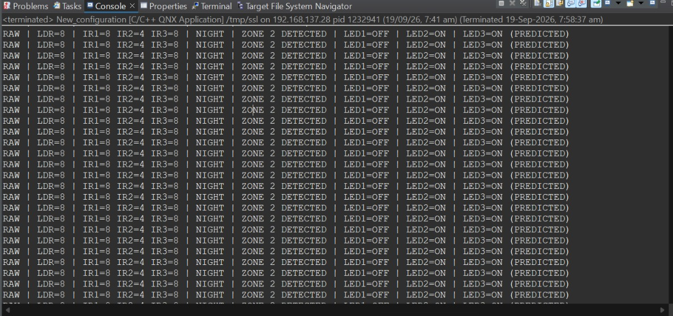
Figure 6.3: Zone 2 occupancy detected — LED2 ON (current zone) and LED3 ON – PREDICTED (next zone).

6.4 Zone 3 Detection and Return to Idle
When IR3 registers occupancy, the controller reports “ZONE 3 DETECTED” and switches LED3 to its confirmed ON state. Once the vehicle clears all three zones, the system correctly reverts to the “NO VEHICLE” state with every LED off, shown in the final rows of the same log, confirming that the zone state machine releases illumination cleanly once a zone is no longer occupied.
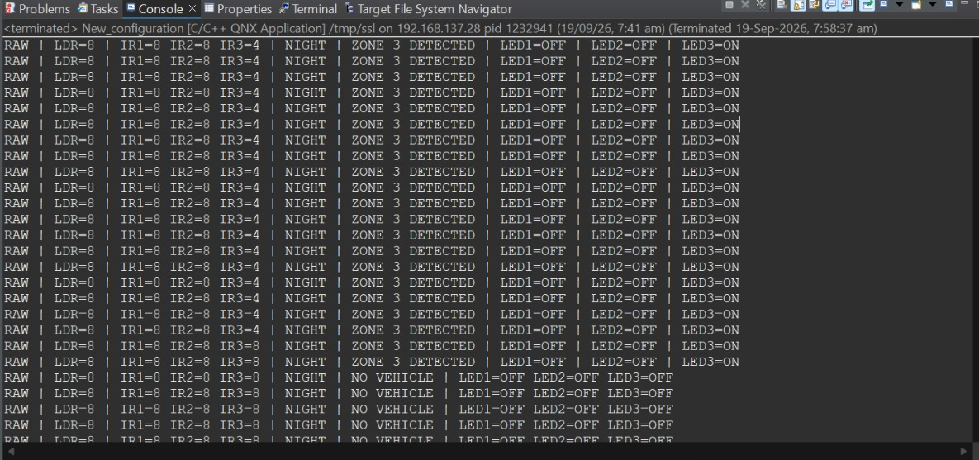
Figure 6.4: Zone 3 occupancy detected (LED3 ON) followed by the system returning to the idle “NO VEHICLE” state as the vehicle clears the zones.

6.5 Observations
- Zone occupancy is detected correctly and independently for each of the three monitored zones (Zone 1, Zone 2, Zone 3).
- The predictive logic consistently pre-illuminates the zone ahead of the occupied one, tagging it (PREDICTED) in the console output rather than waiting for actual occupancy.
- LED state transitions track the vehicle's movement across zones in real time, with the trailing zone's LED turning off as the vehicle moves ahead.
- The system correctly returns to the idle, all-LEDs-off state once no zone reports occupancy, matching the expected night/no-vehicle behaviour.

CHAPTER 7 - FEASIBILITY, IMPACT AND IMPLEMENTATION PLAN
The design was deliberately kept within the reach of a low-cost, buildable prototype so that feasibility could be demonstrated directly rather than only argued for on paper. At the same time, the choice of a real-time operating system and a predictive, zone-based control strategy was made specifically to maximise the safety and energy impact of the system once deployed.

7.1 Feasibility
- The prototype can be implemented using QNX on a Raspberry Pi together with PIR and IR sensors, an LDR, an ADC/GPIO/PWM signal chain and LED lighting zones.
- The design uses low-cost and readily available hardware, keeping the barrier to building and testing the prototype low.
- A modular, zone-based architecture allows the same design to be expanded to additional road segments without redesigning the core system.
- QNX enables priority-based, real-time execution of sensing, control and emergency tasks, which is difficult to guarantee on a general-purpose, non-real-time operating system.

7.2 Impact
- Potential to reduce energy consumption and unnecessary illumination by scaling brightness to actual road usage.
- Maintains road safety through occupancy-aware lighting and a dedicated emergency override path.
- Emergency override ensures immediate full-brightness lighting during critical situations, regardless of the energy-saving state at the time.
- Provides a scalable foundation for broader smart-city street-lighting applications beyond the prototype scale.

7.3 Estimated Budget
The prototype was costed using standard, off-the-shelf components, keeping the total build cost low enough for a student project while remaining representative of a realistic small-scale deployment. The itemised estimate is shown in Table 7.1.

Sr. No. | Component | Quantity | Approx. Cost (Rs.)
1 | Raspberry Pi 4 (4GB) | 1 | 5,000
2 | PIR Sensors | 4 | 400
3 | IR Sensors | 4 | 200
4 | LDR + Resistors | 1 set | 100
5 | ADC Module (MCP3008) | 1 | 250
6 | LEDs + Driver / MOSFET Circuitry | 4 Zones | 500
7 | Emergency Push Button | 1 | 100
8 | Breadboard + Jumper Wires | - | 400
9 | Power Supply (5V) | 1 | 500
10 | Prototype Road / Model Materials | - | 500
11 | Miscellaneous | - | 250
 | Total Estimated Cost |  | 8,200 (Approx.)
Table 7.1: Itemised prototype cost estimate.

7.4 Implementation Roadmap
Implementation was planned over a fourteen-day schedule, moving from architecture and environment setup through sensor integration, task development and, finally, full-system testing and demonstration. The plan is summarised in Table 7.2.

Day | Work
1 | Finalize system architecture and module requirements
2 | Set up QNX development environment
3 | Configure QNX on Raspberry Pi
4 | Interface LDR, PIR and IR sensors
5 | Implement GPIO / PWM LED control
6 | Develop Sensor Task (QNX)
7 | Implement multi-zone state machine
8 | Implement traffic data collection and history
9 | Develop prediction algorithm
10 | Implement IPC / Message Queues in QNX
11 | Implement Emergency Task and priority override
12 | Integrate all modules + CLI / Dashboard
13 | Testing - energy saving, prediction accuracy, emergency response
14 | Debugging, validation, documentation and final demo
Table 7.2: Fourteen-day implementation roadmap.

CHAPTER 8 - CONCLUSION AND FUTURE SCOPE
The project demonstrates that a low-cost, Raspberry Pi based prototype running QNX can bring together daylight sensing, occupancy detection and traffic-pattern prediction into a single, coordinated street-lighting system. By treating sensing, prediction, lighting control and emergency handling as independent real-time tasks communicating through message queues, the design keeps each concern cleanly separated while still guaranteeing that emergency events always take precedence over energy-saving behaviour.
The main conclusions of the project are summarised below.
- The proposed system intelligently combines daylight, occupancy and traffic-based lighting patterns.
- Predictive control and coordinated multi-zone management ensure energy efficiency and improved road safety together, rather than trading one off against the other.
- The QNX real-time architecture, with priority-based scheduling, ensures reliable, responsive and safe operation even under emergency conditions.
- The system is scalable, cost-effective and suitable for real-world smart-city deployments beyond the prototype scale demonstrated here.
- It can be implemented and tested using QNX on a Raspberry Pi with the low-cost components listed in the budget estimate.
Future work could extend the prototype with a larger number of zones, integration with real vehicular traffic sensors or cameras for richer prediction data, wireless communication between zone controllers to support genuinely city-scale deployments, and longer-term field trials to validate the projected energy savings against real-world traffic patterns.
Taken together, this project contributes towards building smarter, safer and more sustainable cities through intelligent and predictive street lighting.

