SmartHire – HTB Medium

Enumeration
- As always I begin with an nmap scan of the target machine
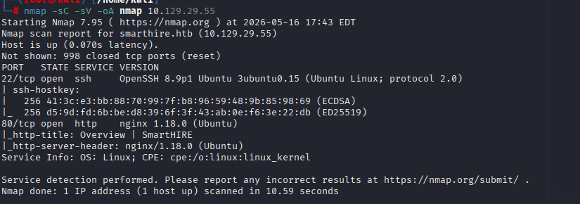
Figure 1
- I can see there is a webpage, so I add the target IP and ‘smarthire.htb’ to /etc/hosts
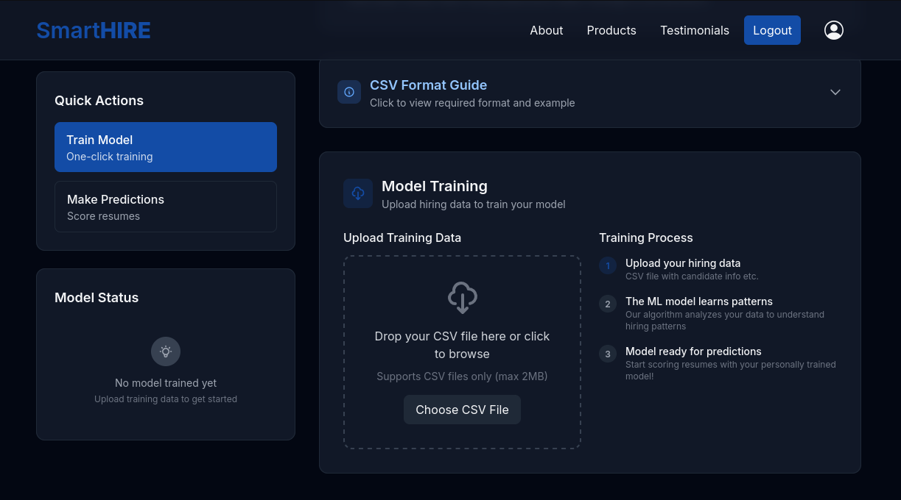
Figure 2
- Going to the website revealed a login page which I set up an account on. We can see that this website is allowing csv file uploads in order to train ML models. Let’s do our due diligence and go ahead and enumerate directories using gobuster.
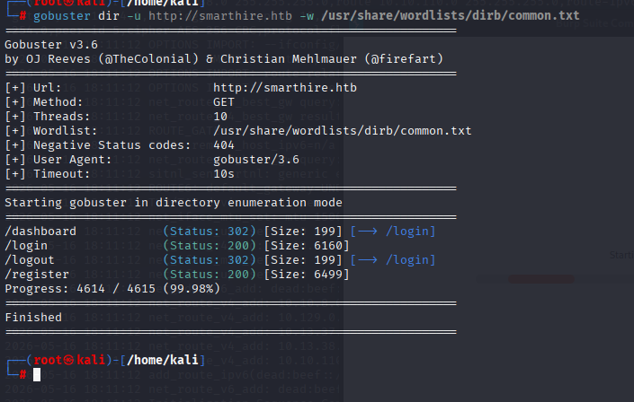
Figure 3
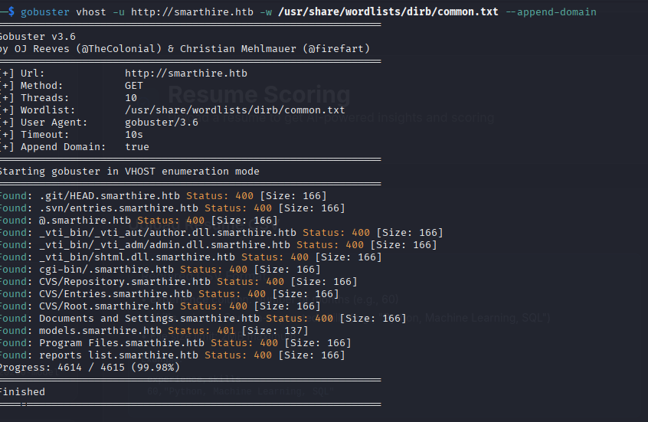
Figure 4
- Regular dir mode didn’t return much that I didn’t already see, so I checked for Vhosts and found models.smarthire.htb. Let’s add models.smarthire.htb to /etc/hosts and then navigate to it in browser.
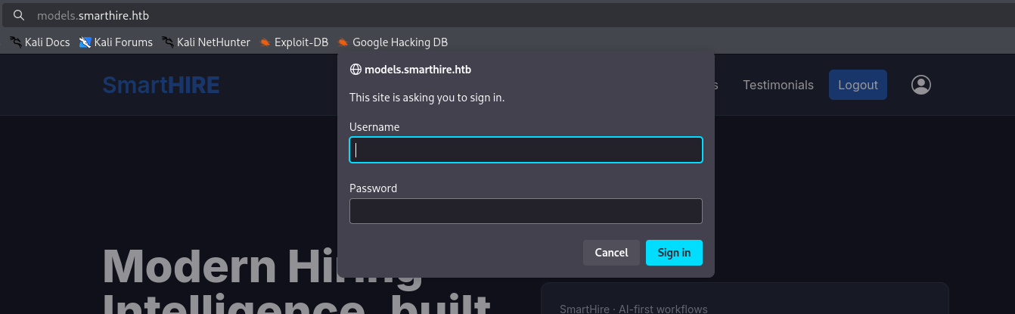
Figure 5
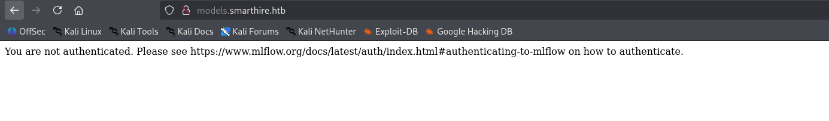
Figure 6
- Canceling the sign in process reveals version information about what service they are using to train and deploy models. Let’s see if there are any default credentials for mlflow.
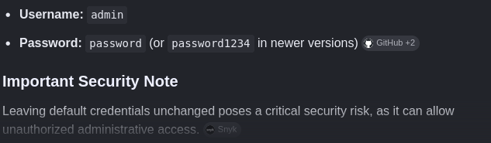
Figure 7
- Simple google search reveals default creds.
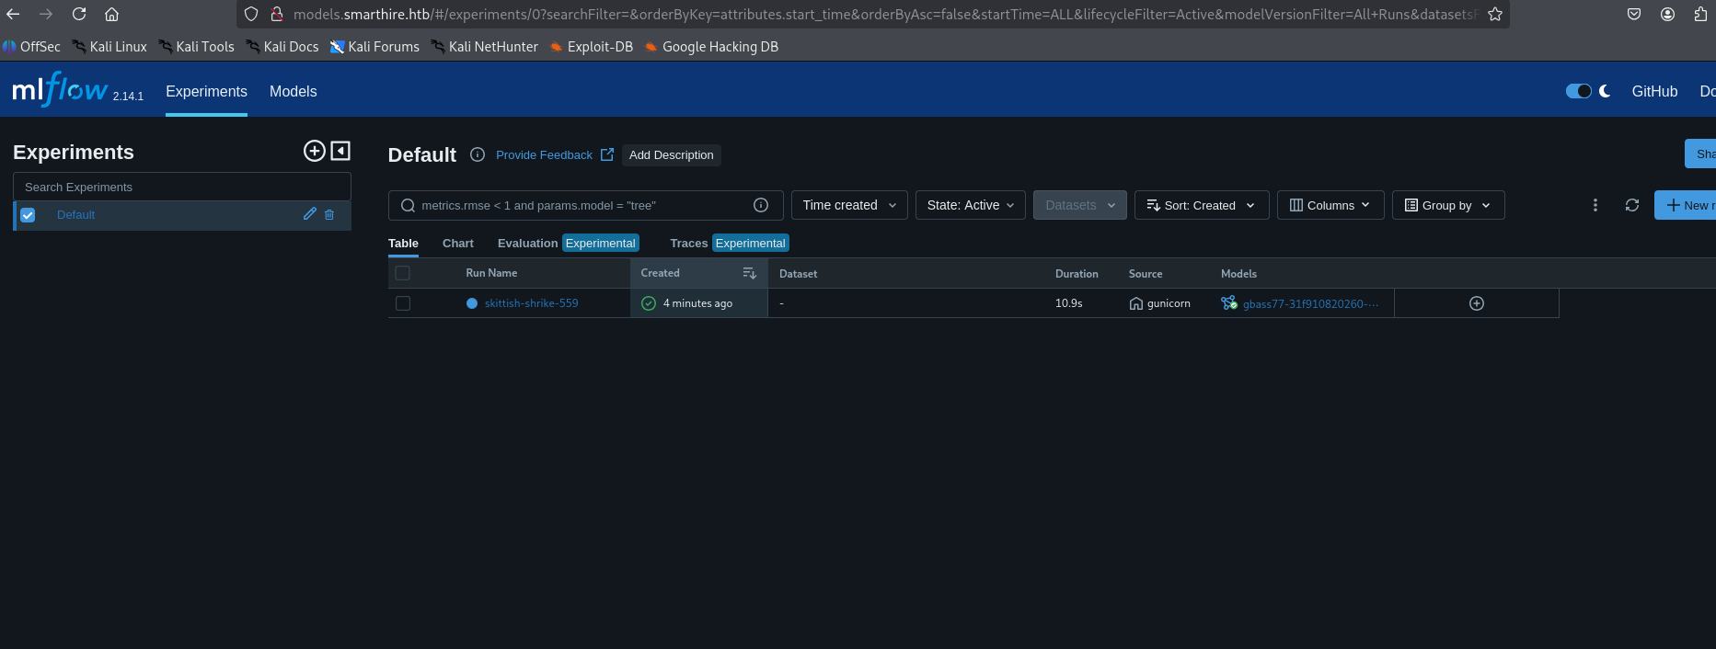
Figure 8

Attack
- Thankfully they actually work, and we can view our model that we had previously trained, as well as seeing that this is mlflow 2.14.1 which has known CVE-2024-37054
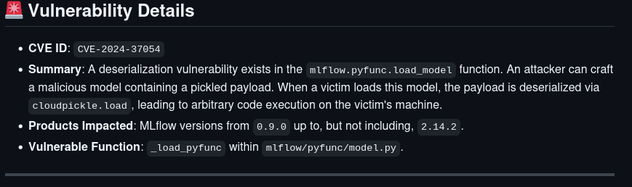
Figure 9
- So, we can upload a malicious model that depickles an included payload, and run any command we want on the host machine. So, let’s try to get our reverse shell.
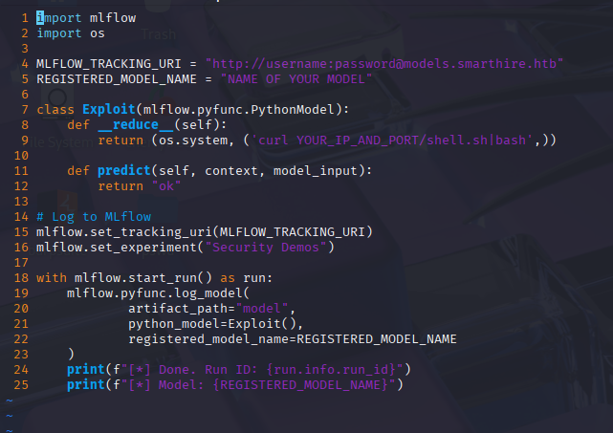
Figure 10
- Numerous failed attempts at running the original POC lead me to need to rewrite the script to just download a file from my host machine and instantly run it.
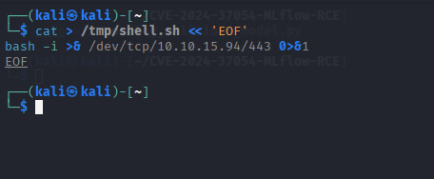
Figure 11 - Contents of shell.sh
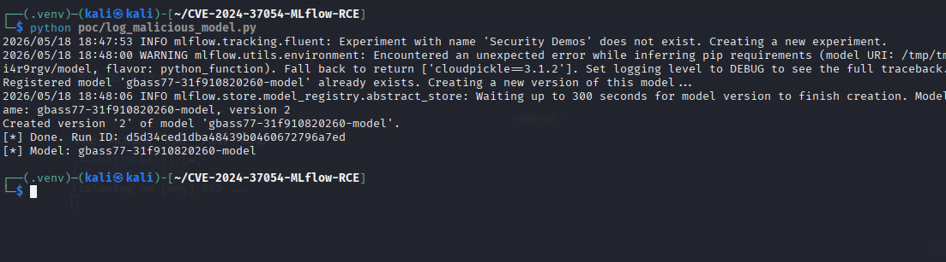
Figure 12
- We run the poc and get an udated malicious model that can be used to run our reverse shell
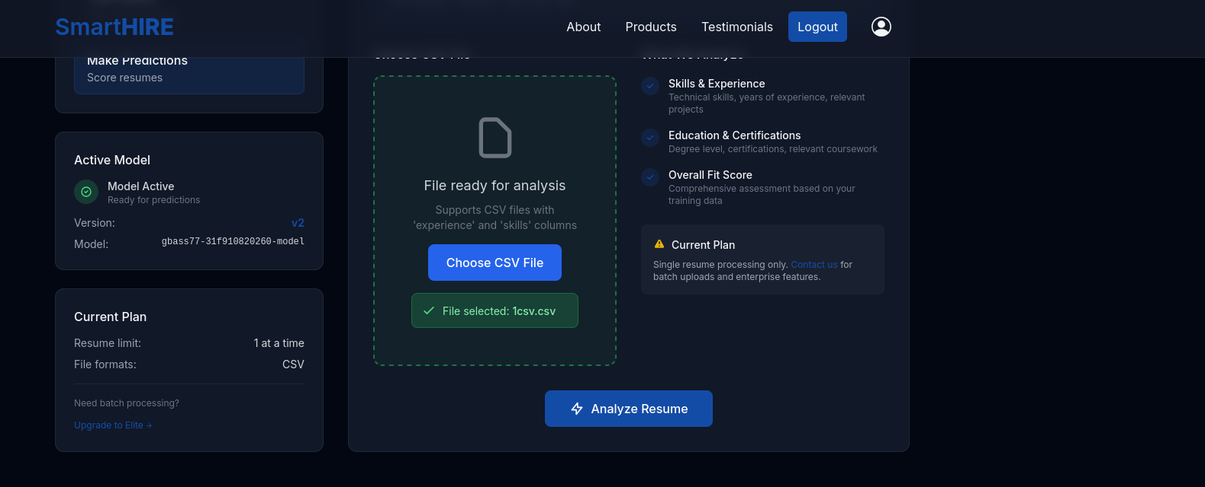
Figure 13
- Return to the dashboard and upload an arbitrary csv file, then click Analyze Resume. The contents of the csv do not matter as calling the model will run the pickled payload anyway
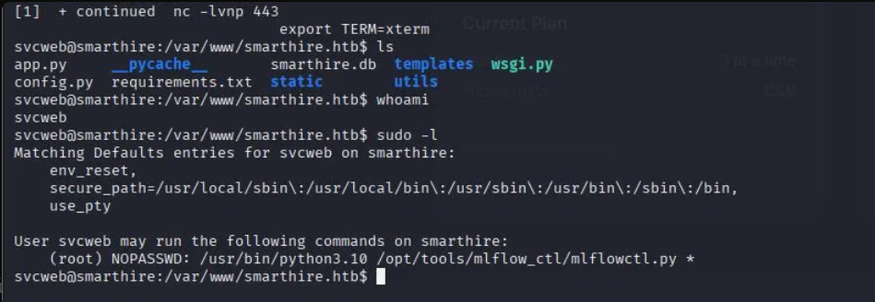
Figure 14
- The reverse shell hit and we are in. Stabilize your shell and lets immediately check sudo -l. This shows we can run arbitrary files as root with no password :D. At this point we can run ‘cat ~/user.txt’ to get the user flag.

Privesc
- Curl LinPeas from your attacking machine and run it. On this machine it reveals that mlflowctl.py does site.addsitedir which adds .pth files. So, create a .pth in dev that imports a malicious module to get root flag.
  - echo "import os; os.system('cat /root/root.txt > /tmp/flag.txt')" > /opt/tools/mlflow_ctl/plugins/dev/exploit.pth
  - Then:
sudo /usr/bin/python3.10 /opt/tools/mlflow_ctl/mlflowctl.py status
cat /tmp/flag.txt
- By this point you should have the root flag

Extra Thoughts
Getting user was the most time consuming part of this box. It was not necessarily difficult as it relies on a publicly available CVE with POC, however getting all your dependencies in check so that the script can actually run was a bit of a pain. Once you have user and can run linpeas, getting root was trivial.

