FITBUDDY
AI FITNESS PLAN GENERATOR
PROJECT DOCUMENTATION
FastAPI • Gemini Generative AI • SQLAlchemy • SQLite • Jinja2

Table of Contents
1. Project Overview
2. Problem Statement
3. Objectives
4. Scope
5. Functional Requirements
6. Non-Functional Requirements
7. Technology Stack
8. System Architecture
9. Project Structure
10. Module Description
11. Generative AI Integration
12. Database Design
13. Application Workflow
14. User Interface
15. API Documentation
16. Feedback-Based Updating
17. Error Handling
18. Security and GitHub
19. Installation and Setup
20. Testing
21. Deployment
22. Limitations
23. Future Enhancements
24. Conclusion
Appendix A. Commands
Appendix B. Environment Configuration

1. Project Overview
FitBuddy is a web-based Generative AI application that creates personalized seven-day workout plans and nutrition or recovery tips from user inputs such as age, weight, fitness goal and workout intensity. The supplied project documentation defines a FastAPI backend, Jinja2 frontend, Gemini AI services and SQLite persistence through SQLAlchemy. It also defines a feedback loop that updates an existing workout plan.
The implemented project follows this architecture while using Google's modern GenAI Python SDK. Gemini model names are configurable through environment variables, and the AI client includes demo mode and retry handling for temporary service failures.

2. Problem Statement
Generic workout routines may not match an individual's fitness goal, body information or preferred intensity. A user may also find that a generated plan needs more cardio, more recovery or a different level of difficulty. FitBuddy addresses this by generating a personalized plan and allowing the user to submit feedback for an AI-assisted revision.

3. Objectives
- Collect user fitness information through a simple web form.
- Generate a structured seven-day workout plan using Gemini.
- Generate a concise nutrition or recovery tip.
- Store users and plans using SQLAlchemy and SQLite.
- Update an existing plan using user feedback.
- Expose core functionality through FastAPI APIs.
- Provide an administrative view of users and plans.
- Keep API credentials outside source code.
- Support demo mode without a live Gemini request.
- Retry temporary AI service failures.

4. Scope
The project covers the complete local application: frontend pages, FastAPI routes, request validation, database persistence, Gemini integration, feedback-based updates, admin viewing, REST APIs, Swagger/OpenAPI documentation and local deployment through Uvicorn.
FitBuddy is an educational and software demonstration application. Its generated fitness content should not be treated as medical diagnosis or professional medical advice.

5. Functional Requirements
ID | Requirement | Description
FR-01 | User Input | Collect username, user ID, age, weight, goal and intensity.
FR-02 | Workout Generation | Generate a personalized seven-day workout plan.
FR-03 | Nutrition Tip | Generate a goal-related nutrition/recovery tip.
FR-04 | Persistence | Store user and plan data in SQLite.
FR-05 | Feedback | Revise the plan using user feedback.
FR-06 | Admin View | Display registered users and plans.
FR-07 | REST API | Expose core functions through FastAPI.
FR-08 | Demo Mode | Allow local testing without Gemini.

6. Non-Functional Requirements
- Usability: simple browser-based interaction.
- Maintainability: separate configuration, AI, database and route modules.
- Reliability: retry temporary AI failures.
- Security: keep credentials in environment variables.
- Portability: recreate the environment from requirements.txt.
- Extensibility: change supported Gemini models through configuration.

7. Technology Stack
Technology | Purpose | FitBuddy Use
Python | Programming | Application backend
FastAPI | Web/API framework | Routes and API documentation
Uvicorn | ASGI server | Runs the application
Jinja2 | Template engine | Dynamic HTML
HTML/CSS/JavaScript | Frontend | User interface
SQLAlchemy | ORM | Database persistence
SQLite | Database | Local storage
Google GenAI SDK | AI integration | Gemini requests
Pydantic | Validation | Structured inputs
python-dotenv | Configuration | Loads .env

8. System Architecture
Browser
|
v
Jinja2 HTML / JavaScript
|
v
FastAPI Routes
|----------------------|
v v
Business / Validation SQLAlchemy
| |
v v
Gemini AI SQLite
|
v
Workout / Tip / Updated Plan
The frontend collects input and displays results. FastAPI coordinates validation, AI calls, database operations and template rendering. The Gemini layer generates or revises text. SQLAlchemy manages persistence in SQLite.

9. Project Structure
FitBuddy_AI_Fitness_Plan_Generator/
├── app/
│ ├── main.py
│ ├── config.py
│ ├── database.py
│ ├── models.py
│ ├── schemas.py
│ ├── gemini_client.py
│ ├── gemini_generator.py
│ ├── gemini_flash_generator.py
│ ├── updated_plan.py
│ ├── routes.py
│ └── api.py
├── templates/
│ ├── base.html
│ ├── index.html
│ ├── result.html
│ └── all_users.html
├── static/
│ ├── css/style.css
│ └── js/app.js
├── .env.example
├── .gitignore
├── requirements.txt
├── README.md
└── test_app.py
Local only: .env, .venv/, fitbuddy.db

10. Module Description
Module | Responsibility
main.py | Creates the FastAPI application and initializes services.
config.py | Loads environment configuration.
database.py | Creates database engine/session and initialization.
models.py | Defines SQLAlchemy database entities.
schemas.py | Defines validated request structures.
gemini_client.py | Creates Gemini client, sends prompts, demo mode and retries.
gemini_generator.py | Builds workout-generation prompts.
gemini_flash_generator.py | Handles nutrition/recovery tip generation.
updated_plan.py | Builds feedback-based plan updates.
routes.py | Browser-facing application routes.
api.py | REST API endpoints.
templates/ | Jinja2 pages.
static/ | CSS and JavaScript.

11. Generative AI Integration
The AI integration is isolated in app/gemini_client.py. Other modules use a shared generate_text(prompt, model) function. The API key is loaded from the environment rather than hard-coded.
GOOGLE_API_KEY=YOUR_REAL_KEY
GEMINI_WORKOUT_MODEL=your-supported-model
GEMINI_TIP_MODEL=your-supported-model
DEMO_MODE=false
The three major AI functions are workout generation, nutrition/recovery tip generation and feedback-based workout-plan updating. The original documentation describes Gemini Pro for structured workout generation and feedback updates and Gemini Flash for quick nutrition tips. The current implementation keeps model selection configurable because model availability can change.

12. Database Design
USERS
- id
- user_id
- username
- age
- weight
- goal
- intensity
WORKOUT_PLANS
- id
- user_id
- original_plan
- updated_plan
- nutrition_tip
- timestamps
The database preserves user information and the generated plan so that feedback can be applied to an existing plan and the original and revised versions can be displayed.

13. Application Workflow
- User opens the FitBuddy home page.
- User enters name, ID, age, weight, goal and intensity.
- FastAPI validates the submitted data.
- User information is stored.
- A structured workout prompt is sent to Gemini.
- A seven-day plan is returned.
- A nutrition/recovery tip is generated.
- The plan and tip are stored.
- result.html displays the result.
- User may submit feedback.
- The original plan and feedback are sent to Gemini.
- The revised plan is stored and displayed.

14. User Interface

14.1 Home Page
index.html collects the user's fitness information and submits it to the workout-generation route.

14.2 Result Page
result.html displays user information, workout plan and nutrition/recovery tip, and provides the feedback form.

14.3 Admin Page
all_users.html displays registered users and their original and updated plans for administrative inspection.

15. API Documentation
Method | Endpoint | Purpose | Input
GET | /api/health | Health check | None
POST | /api/generate-workout | Generate plan | User data
POST | /api/nutrition-tip | Generate tip | Goal/context
POST | /api/update-plan/{user_id} | Update plan | Feedback
GET | /api/users | List users | None
GET | /api/users/{user_id} | Get user | Path user_id
DELETE | /api/users/{user_id} | Delete user | Path user_id
FastAPI provides interactive API documentation at http://127.0.0.1:8000/docs.

16. Feedback-Based Updating
Original Plan + User Feedback
|
v
Update Prompt
|
v
Gemini
|
v
Updated Plan
|
v
SQLite + UI
Feedback can request changes such as more cardio, more recovery days or a different difficulty. The application retrieves the stored plan, applies the feedback through a new AI request and saves the revised result.

17. Error Handling and Reliability
The current AI client supports demo mode, missing-key checks, empty-response checks and retry handling for temporary service failures. During development, Gemini returned HTTP 503 because the model was experiencing high demand. The client was updated to retry with progressive delays of 2, 4 and 8 seconds.
Attempt 1 -> request
503 -> wait 2s
Attempt 2 -> request
503 -> wait 4s
Attempt 3 -> request
503 -> wait 8s
Attempt 4 -> request
still unavailable -> clear error
Retries improve resilience but cannot guarantee an upstream model will be available. Therefore the model identifier remains configurable.

18. Security and GitHub
API keys are credentials and must not be committed to GitHub. The real .env file should be excluded by .gitignore. The repository should contain .env.example with placeholders.
.env
.venv/
__pycache__/
*.pyc
*.db
*.sqlite
*.sqlite3
If a real API key is ever committed, treat it as exposed and rotate/revoke it. Deleting the file later does not remove the secret from Git history.

19. Installation and Setup
- Install Python 3.13.x.
- Open the project in VS Code.
- Create the environment: python -m venv .venv
- Activate: .venv\Scripts\Activate.ps1
- Install: python -m pip install -r requirements.txt
- Copy .env.example to .env.
- Add the Gemini API key.
- Set DEMO_MODE=true for testing without Gemini, or false for live AI.
- Run: python -m uvicorn app.main:app --reload
- Open http://127.0.0.1:8000.
- Open http://127.0.0.1:8000/docs for API testing.

20. Testing

20.1 Basic Test
python --version
python -m uvicorn --version
python -m uvicorn app.main:app --reload

20.2 Functional Test
- Home page loads.
- CSS and JavaScript load.
- Valid user data is accepted.
- Demo mode generates a sample plan.
- Live mode calls Gemini.
- Feedback changes the stored plan.
- Admin view displays stored records.
- API endpoints respond through /docs.

20.3 AI Failure Test
A 503 response was reproduced during development. The retry messages confirmed that temporary Gemini failures are detected and retried before the application returns an error.

21. Deployment
The project is currently suitable for local development and demonstration. A production deployment should add secure secret management, HTTPS, stronger authentication, a production database, logging, rate limiting and monitoring.
- Use HTTPS.
- Use a production database for multi-user workloads.
- Protect administrative endpoints with authentication and authorization.
- Store secrets in a secure secret manager.
- Add monitoring and structured logs.
- Add rate limits around AI endpoints.

22. Limitations
- Generated content depends on the selected Gemini model and prompts.
- AI services can experience 503 or rate-limit errors.
- Fitness output is not medical advice.
- SQLite is primarily appropriate for local/small deployments.
- Administrative access should be strengthened for production.
- Model names and availability can change.

23. Future Enhancements
- User authentication and role-based access.
- Progress tracking and workout history.
- Weight and adherence charts.
- Exercise images and videos.
- PDF workout-plan export.
- PostgreSQL or another production database.
- Automated unit and integration tests.
- AI model fallback and availability checks.
- Prompt versioning and evaluation.
- Cloud deployment.
- Privacy, consent and data-retention controls.

24. Conclusion
FitBuddy demonstrates a complete Generative AI workflow connecting a browser interface, FastAPI backend, SQLAlchemy/SQLite persistence and Gemini AI. It generates personalized seven-day workout plans, provides nutrition/recovery guidance and supports feedback-driven plan revision.
The modular structure makes the project suitable for academic demonstration, portfolio presentation and future development. The AI client is separated from business logic, making model configuration and reliability improvements easier to maintain.

Appendix A. Commands
python -m venv .venv
.venv\Scripts\Activate.ps1
python -m pip install -r requirements.txt
python -m uvicorn app.main:app --reload
Application:
http://127.0.0.1:8000
API documentation:
http://127.0.0.1:8000/docs

Appendix B. Example .env
GOOGLE_API_KEY=YOUR_REAL_GEMINI_API_KEY
GEMINI_WORKOUT_MODEL=your-supported-gemini-model
GEMINI_TIP_MODEL=your-supported-gemini-model
DATABASE_URL=sqlite:///./fitbuddy.db
ADMIN_TOKEN=change-this-token
DEMO_MODE=false

Appendix C. GitHub Checklist
- Upload source code, templates, static files, requirements.txt and README.md.
- Upload .env.example with placeholders.
- Do not upload .env.
- Do not upload .venv/.
- Do not upload fitbuddy.db.
- Do not upload Python cache files.
- Search the repository for API keys before pushing.
- Rotate any key that was previously exposed.

Project Execution Screenshots
Project Execution Screenshots
The following screenshots were captured from the running FitBuddy application and document the main execution stages.
Figure 1 – FitBuddy Home Page
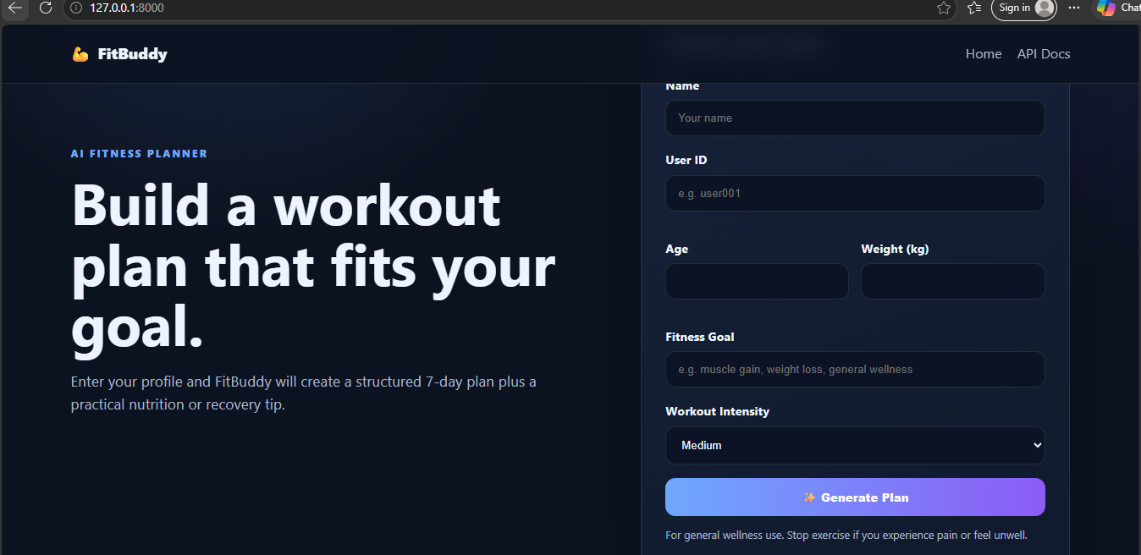
The FitBuddy home page where the user enters name, User ID, age, weight, fitness goal and workout intensity before generating a plan.
Figure 2 – Generated Personalized Fitness Plan
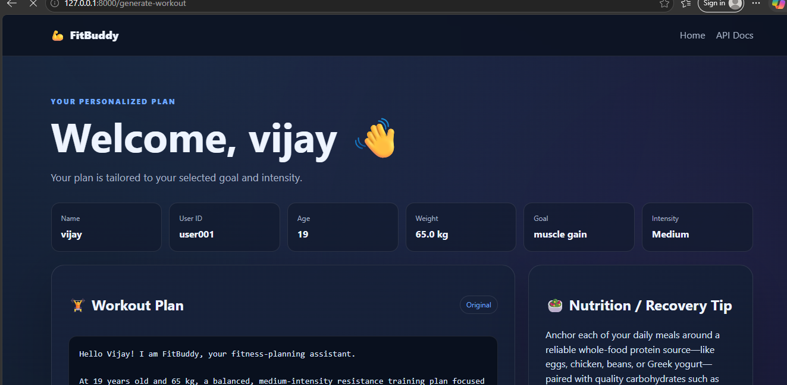
The generated-plan page showing the personalized user information, workout plan and Nutrition / Recovery Tip.

