BLOGNEST
Generate High-Quality Blog Content Using AI
PROJECT REPORT
A RESTful Backend Platform using Node.js, Express.js, MongoDB and Google Gemini AI
Backend Development Project
TEAM MEMBERS
CAPTAIN: Joyce Mary P
Samyuktha R
Ragul Prashad D
Sakthivel V
Kishore R

BlogNest – Description
BlogNest is a secure and intelligent RESTful backend application developed to simplify blog creation, content management, and AI-assisted writing. It is built using Node.js and Express.js and uses MongoDB with Mongoose ODM for data storage, validation, and database operations.
The platform integrates Google Gemini AI to support features such as AI-powered blog generation, AI FAQ assistance, AI WeatherWise insights, and AI FitTrack recommendations. These features help users create useful and context-aware content with less manual effort.
Security is an important part of the system. JWT (JSON Web Tokens) is used for authentication, while role-based access control supports Admin, Editor, Author, and Reader roles. bcrypt.js is used for secure password hashing. The backend also supports blog management, categories and tags, comment management, media metadata, advanced search, and centralized error handling.
Additional security measures such as request validation, input sanitization, rate limiting, and structured logging improve the reliability and security of the application. The modular design also makes BlogNest easy to maintain and extend.

Scenario-Based Case Study

Background
Priya is a content creator who manages multiple blogs. She needs a simple and organized system to create posts, manage drafts, schedule publications, organize categories and tags, and monitor reader engagement.

Problem
- Managing multiple drafts, categories, and tags is difficult.
- There is limited visibility into post performance and reader engagement.
- Content approval and comment moderation can be time-consuming.
- Media uploads and related metadata need better organization.
- Different users require different levels of access and permissions.

Solution
BlogNest provides a centralized backend API that separates application business logic from frontend delivery. It provides role-based permissions and services for content scheduling, category management, media registration, blog management, and user access control.

Usage
- Author: Creates blog posts, organizes drafts, registers media paths, and reviews performance information for their posts.
- Editor/Admin: Reviews content queues, changes publishing status, moderates comments, and manages user privileges.
- Reader: Views published posts and can submit comments through the available API endpoints.

Outcome
The backend centralizes content workflows and reduces delays in blog management. Mongoose validation helps maintain structured data, while authentication and role-based security ensure that protected operations are available only to authorized users.

1. Software Requirements
Requirement | Purpose
Operating System | Windows 10/11, macOS or Linux; the project supports cross-platform development.
Node.js (v16 or above) | Provides the runtime environment for the backend server and routing.
npm (v8 or above) | Manages and installs the required Node.js packages.
Express.js | Provides the framework for creating RESTful API routes and backend services.
MongoDB | Stores user accounts, blog posts, categories, comments and related data.
Mongoose | Provides schemas, validation and database operations for MongoDB.
Google Gemini AI | Supports AI-based blog generation, summaries and intelligent content features.
Postman | Used to test API requests, responses and protected endpoints.
Visual Studio Code | Used as the main code editor and development environment.

2. Hardware Requirements
- Processor: Intel Core i5 (8th Generation or above), AMD Ryzen 5, or equivalent.
- RAM: Minimum 8 GB; 16 GB is recommended when running MongoDB and multiple development processes.
- Storage: At least 1 GB of available storage for the project and supporting tools.

EPIC 1: PROJECT ARCHITECTURE
BlogNest follows a modular, layered backend architecture. Incoming API requests pass through the Express server, authentication and authorization middleware, business logic services, and database layers before a response is returned.
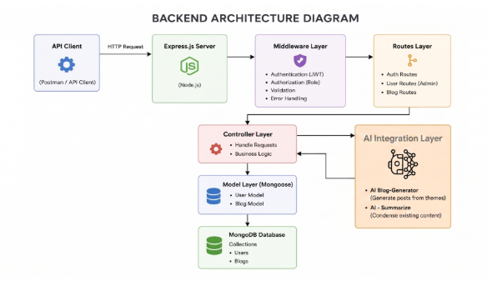

Components Definition
API Interface: Tools such as Postman send requests to different API routes and receive JSON responses.
Express Server Gateway: Handles HTTP methods such as GET, POST, PUT and DELETE, processes JSON requests, and manages CORS.
Authentication & Role Middleware: Reads JWT tokens, validates the user identity, and checks whether the user's role is authorized to access a protected route.
Services / Business Logic: Controls blog lifecycle operations such as Draft, Pending Approval, Scheduled and Published, as well as comment and reporting workflows.
Database Interface Layer: Mongoose connects the application to MongoDB and performs database operations.
AI Flow: Connects the backend with external AI services for blog generation and content summarization.
BlogGenerator with AI: Automates the creation of blog drafts by using the AI service with the required content information.

Entity-Relationship (ER) Diagram Description
The database structure contains collections that are connected through logical references. The main entities described in the project are User and Post.
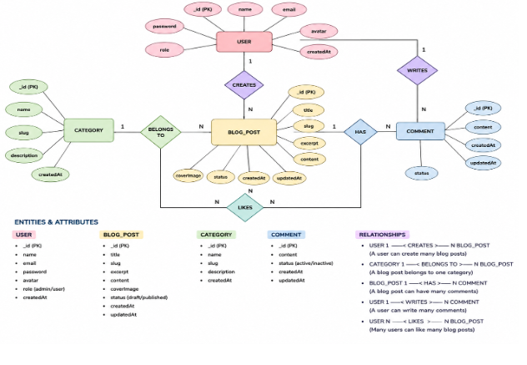

1. User Entity
- _id – Primary Key (ObjectId)
- name – String, Required
- email – String, Required and Unique
- password – String, Hashed and Required
- role – String, Default: reader

2. Post Entity
- _id – Primary Key (ObjectId)
- userID – Foreign Key referencing the User Collection
- name – String, Required; represents the blog title
- photo – Object/String path or link
- message – String; main blog content
- likes – Number, Default: 0
- timestamps – Enabled

Key Structural Mappings
- User to Post (One-to-Many): One author can create multiple blog posts.
- User to Comment (One-to-Many): A user can submit multiple comments on different posts.
- Post to Comment (One-to-Many): One blog post can contain multiple comments.

Key Features
- Role-Based Route Guarding: Prevents unauthorized users from accessing protected operations.
- CRUD Blog Management: Supports creating, reading, updating and deleting blog content.
- Categorization System: Categories and tags help organize and find blog content.
- Comment Moderation: Comments can be managed using approved, pending and spam states.
- Sanitization Safeguards: Request data is sanitized to reduce XSS and NoSQL injection risks.
- AI-Driven Blog Generation: Uses Large Language Model (LLM) services and prompts to create structured blog posts.
- Intelligent Content Summarization: Processes longer articles and produces shorter summaries and metadata.

Roles and Responsibilities
Admin: Manages users, role assignments, comments and system-level information.
Editor: Reviews pending content, manages publishing activities and maintains categories.
Author: Creates blog posts and manages content associated with the author's account.
Reader: Reads published posts and submits comments using an authenticated account.

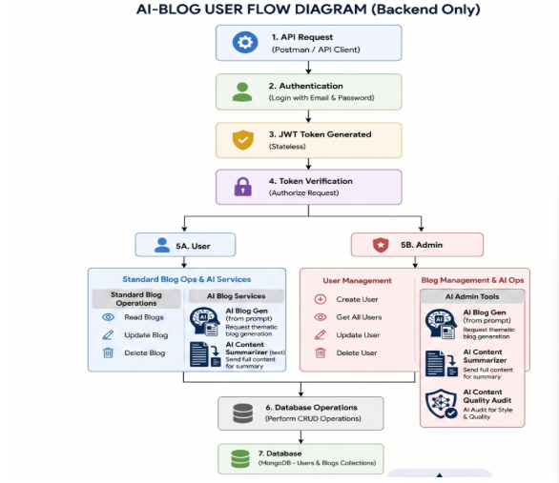

MVC Architecture Pattern
BlogNest uses the Model-View-Controller (MVC) approach to separate data management, application processing, and API routing. This separation makes the backend easier to develop and maintain.

Model Layer (Data Blueprint)
The Model Layer defines the structure of database documents using Mongoose schemas. It specifies fields, validation rules, default values and other database requirements before data is stored in MongoDB.

Controller Layer (Execution)
The Controller Layer receives requests from routes, validates the required information, communicates with models and services, performs the required operation, and returns a JSON response.

View Layer (API Routing Interface)
Since BlogNest is a headless backend service, it does not use traditional HTML view templates. The API routing layer connects incoming requests to the appropriate controller functions.

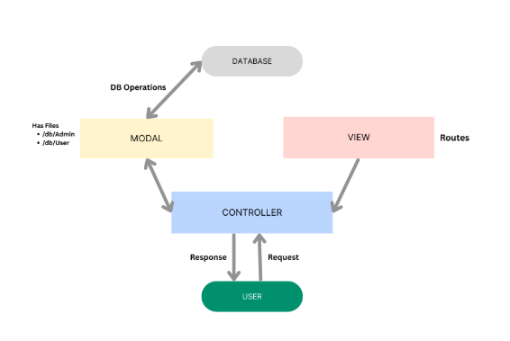

EPIC 2: PROJECT SETUP AND CONFIGURATION

Creating Project Folder
- Create a new folder using the project name.
- Inside the project folder, create the required folders.
- Create a folder named Server.
- Open the Server folder in Visual Studio Code.

Server Setup (npm init)
Open the Server folder in the VS Code terminal and initialize the Node.js project:
npm init -y
Create the following file:
- server.js
Create the following folders:
- models
- controllers
- routes

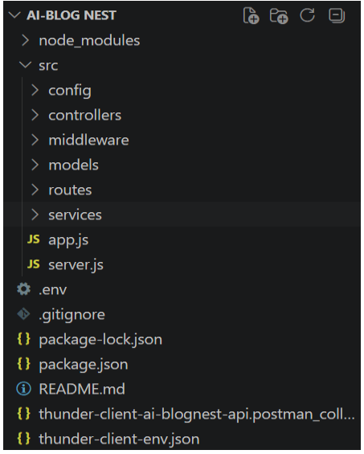

EPIC 3: BACKEND DEVELOPMENT

Server.js
The server.js file is used to start the backend server and connect the application with the required configuration and routes.
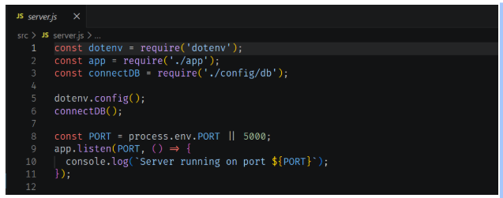

App.js
The app.js file contains the main Express application configuration, middleware setup and API route integration.

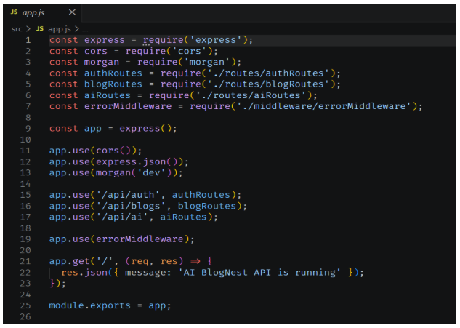

EPIC 4: DATABASE CONFIGURATION

DB Connection
- Configure MongoDB for the backend application.
- Install Mongoose in the Node.js project.
npm install mongoose
- Create the MongoDB database connection.
- Create the required schemas and models.

Create Database Connection
The database must be connected before performing backend operations. The MongoDB connection code is placed in the appropriate database configuration file.

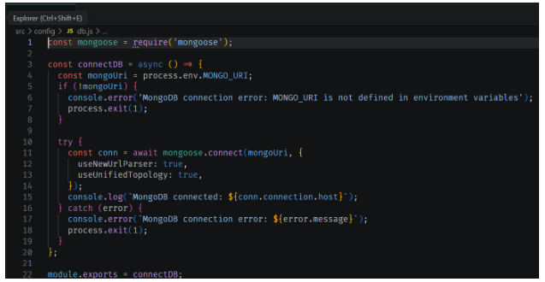

Mongoose Schema Definitions
Mongoose schemas define the structure and validation rules of the documents stored in MongoDB.

1. Identity Resource Document Schema (schemas/userModel.js)
The user schema defines the fields and validation rules required when a new user record is created.

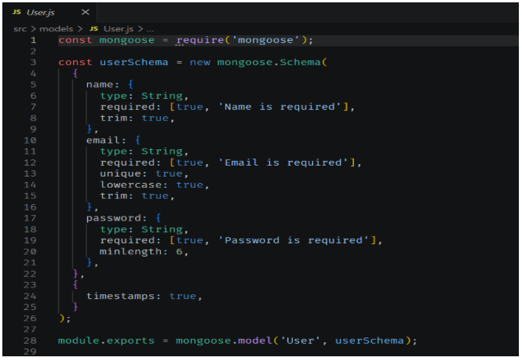

EPIC 5: PROJECT EXECUTIONS
- Install Postman or Thunder Client as a VS Code extension.
- Start the backend server using the following command:
npm start

API Testing
The following API operations are tested using Postman or Thunder Client. The testing process verifies requests, responses, authentication and the main backend functions.

User Registration
Tests the API for creating a new user account.

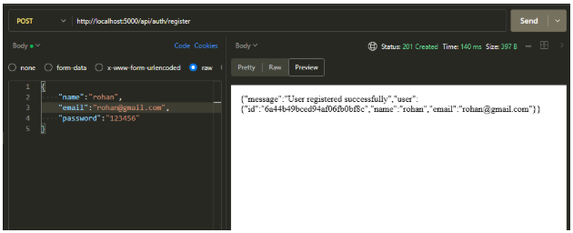

User Login
Tests authentication and verifies that the user can obtain the required access token.

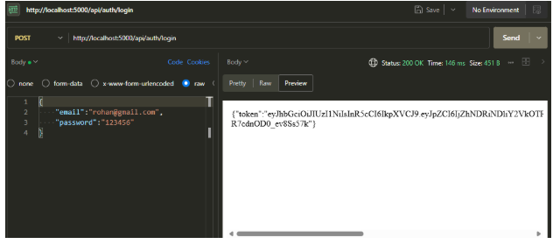

Create Blogs
Tests the API used by an authorized user to create a new blog post.

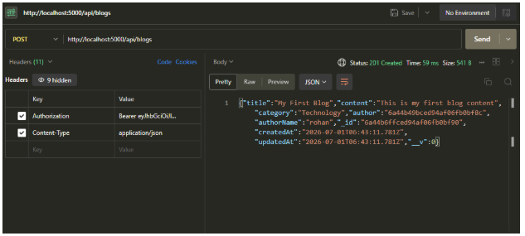

Fetch Blogs
Tests the API used to retrieve available blog posts.

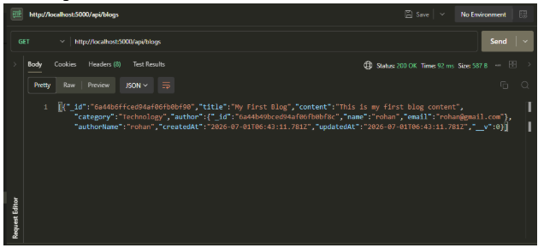

Generate AI Blogs
Tests the AI-powered endpoint used to generate blog content based on the information provided by the user.
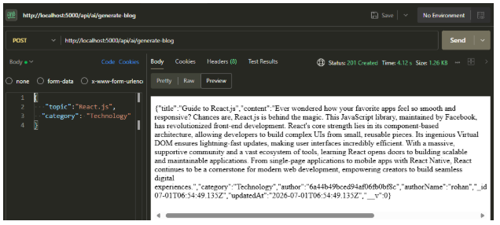

Summarize Blogs
Tests the AI summarization endpoint used to create a shorter summary from blog content.

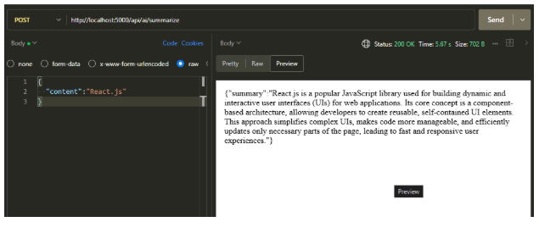

Demo Video
The project demonstration video shows the main BlogNest backend features and their execution.
[Demo Video:https://drive.google.com/file/d/1oMFl5jiLd6l6zC_cMIQRStaFLbVVmxTH/view?usp=drivesdk]

CodeDrive
The project source code is maintained in the provided CodeDrive resource.
Code Drive : Code

Project Summary
BlogNest provides a complete backend platform for blog management and AI-assisted content creation. By combining Node.js, Express.js, MongoDB, Mongoose, JWT authentication, role-based authorization and Google Gemini AI, the project supports secure content workflows, blog generation, summarization, comment management and organized content storage.

