ṣ

ANSWERBOT- AI-POWERED FAQ AND CUSTOMER SUPPORT AUTOMATION.

Team Members:
- Veera bathran (captain)

- Divakar S

- Saravanan V

- Sumesh S

Description
The AI FAQ Assistant is a secure and intelligent REST API application developed to manage Frequently Asked Questions (FAQs) and provide AI-powered assistance. The project is built using Node.js and Express.js for backend development and MongoDB with Mongoose for storing and managing user and FAQ data.
The application provides user registration and login using JWT authentication. Passwords are securely protected using bcrypt hashing. Authenticated users can create and manage FAQ records, search FAQs using keywords, and use Google Gemini AI to generate FAQ content and answers.
The project follows a modular backend structure with separate controllers, routes, models, middleware, services, configuration, and utility files. It also includes validation and centralized error handling to make the API more secure, organized, and easier to maintain.
Scenario-Based Case Study
Background
Priya is a customer support manager who handles many repeated questions from users. Managing these questions manually takes a lot of time. She needs a system where frequently asked questions can be stored, organized into categories, searched quickly, and updated easily.
She also wants to use AI to generate FAQ questions and answers instead of preparing every response manually.
The AI FAQ Assistant provides a centralized backend system to solve these problems. Users can register and log in securely, create FAQs, search existing FAQs, and use Gemini AI for generating FAQ content.
Problem
- Managing a large number of FAQs manually is time-consuming.
- Creating clear questions and answers for every FAQ requires extra effort.
- Finding a particular FAQ from many records can be difficult.
- FAQs need to be organized into categories such as Technology, Education, Health, Banking, and General.
- User authentication is required to protect FAQ creation and management operations.
- Passwords and user information need to be stored securely.
- Users need an easy way to generate FAQ content using AI.
- Without proper access control, unauthorized users may modify or delete FAQ records.
- A centralized database is required to store and manage users and FAQ information efficiently.
Solution
The AI FAQ Assistant provides a centralized backend to manage FAQs securely. It supports FAQ creation, searching, database storage, user authentication, and AI-powered FAQ generation.
Usage
- Authenticated Users: Register, log in, create FAQs, use AI assistance, and manage their own FAQs.
- Public Users: View and search available FAQs.
Outcome
The system reduces manual work and makes FAQ management easier. JWT authentication, bcrypt password hashing, and Mongoose validation help protect user and FAQ data.
1. Software Requirements
- Operating System: Windows 10/11, macOS, or Linux
- Node.js: v18 or above
- npm: v9 or above
- Express.js: Backend REST API framework
- MongoDB + Mongoose: Database and data management
- Thunder Client / Postman: API testing
- Visual Studio Code: Code editor
2. Hardware Requirements
- Processor: Intel Core i5 / AMD Ryzen 5 or equivalent
- RAM: 8 GB minimum
- Storage: 1 GB available space
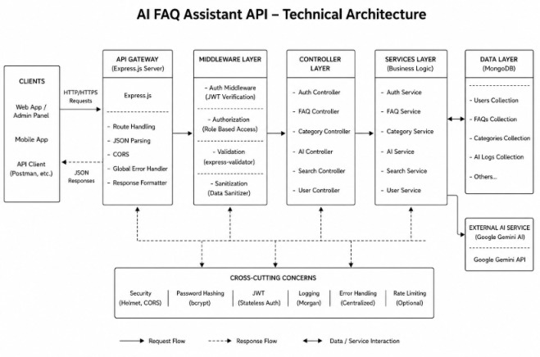

Epic 1: Project Architecture
The AI FAQ Assistant uses a layered backend architecture. Requests pass through the Express server, authentication middleware, controllers and services before reaching MongoDB or the Gemini AI service.
Main Components
- API Interface: Thunder Client/Postman is used to test API endpoints.
- Express Server: Handles GET, POST, PUT and DELETE requests.
- Authentication Middleware: Validates JWT tokens for protected routes.
- Services: Handles FAQ, authentication and AI-related logic.
- Database Layer: Mongoose connects the application with MongoDB.
- AI Service: Google Gemini is used to generate FAQ content and answers.
Entity-Relationship Description
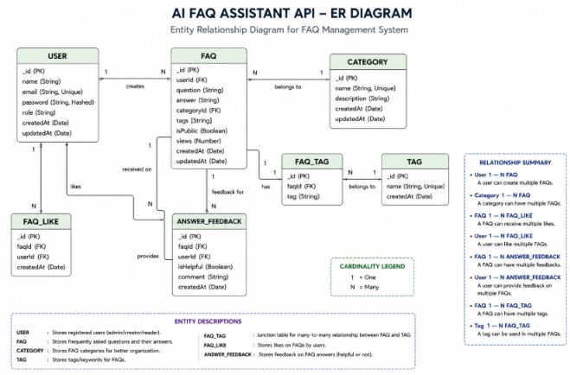
1. User
- _id
- name
- email
- password
- role
- createdAt
- updatedAt
2. FAQ
- _id
- question
- answer
- category
- createdBy
- createdAt
- updatedAt
3. AI Generation
- topic
- generatedQuestion
- generatedAnswer
- generatedCategory
- generatedAt
4. Category
- categoryName
- description
- totalFAQs
Relationships
- User → FAQ: One-to-Many
- Category → FAQ: One-to-Many
- User → AI FAQ: One-to-Many
- FAQ → Search: Search retrieves matching FAQs.
Key Features
- JWT Authentication
- AI FAQ Generation
- FAQ Search
- FAQ CRUD Operations
- Category Management
- bcrypt Password Encryption
- Error Handling
- Mongoose Validation
- RESTful API
- MongoDB Integration
Roles and Responsibilities
Admin
- Manage users
- Manage FAQs
- Manage categories
- Monitor AI-generated content
Content Creator
- Create FAQs
- Edit and delete own FAQs
- Generate FAQs using AI
- Organize FAQs into categories

Authenticated User
- View FAQs
- Search FAQs
- Generate AI answers
- Access profile
Public User
- View FAQs
- Search FAQs
- Cannot modify FAQs
- Cannot access protected routes

User Flow
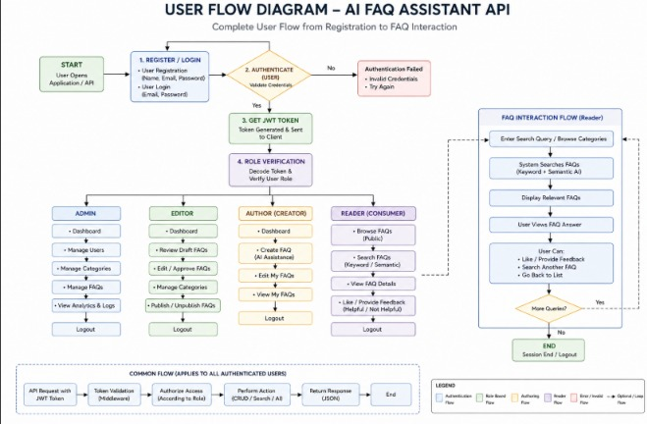

MVC Architecture Pattern
The system architecture structures its source configuration layers around the Model-View-Controller design pattern to completely decouple components:
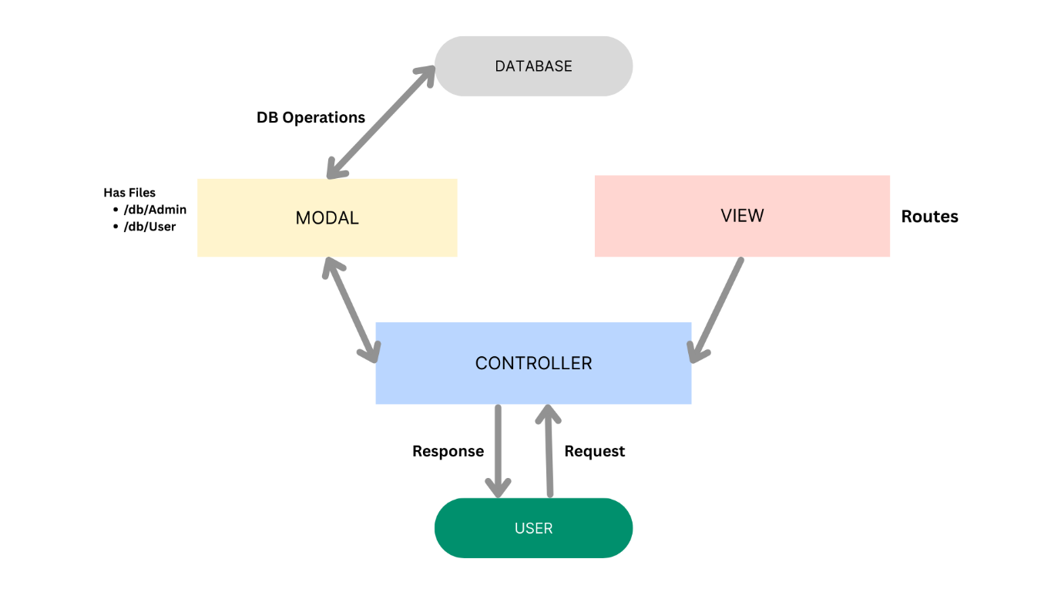

The system architecture structures its source configuration layers around the Model-View-Controller design pattern to completely decouple components:
Model Layer (Data Blueprint)
Defines structural blueprints via strongly enforced Mongoose schemas mapping explicit fields into raw collection items inside MongoDB. It sets field rules and defaults before validation persistence occurs.
Controller Layer (Execution Matrix)
The intermediary brain of the ecosystem. It captures request vectors from execution routes, checks structural request constraints, delegates processing workflows directly to models or services, and packages resultant output into standard JSON return arrays.
View Layer (Routing Network Interface)
In this pure headless backend service context, standard user-interface template views do not exist. Instead, the interface layer lives as an API Routing Layer. It links network requests on specified paths directly to their associated controller handler logic maps.
Epic 2: Project Setup and Configuration
- Creating Project Folder
- Create the project folder.
- Create the src folder.
- Open the project in VS Code.
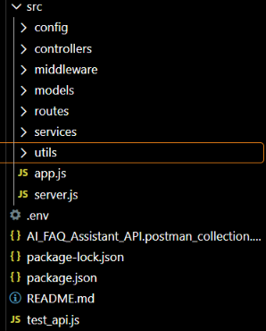
Server Setup
npm init -y
npm install express mongoose dotenv cors jsonwebtoken bcrypt @google/genai

Project Structure
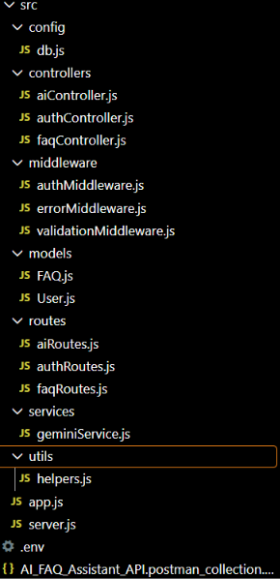
Epic 3: Backend Development

1.src/server.js
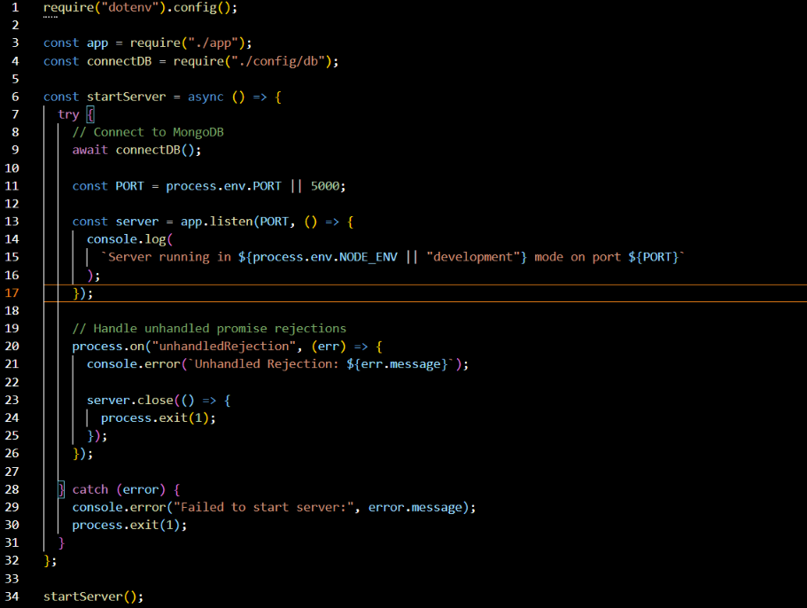
2. src/app.js
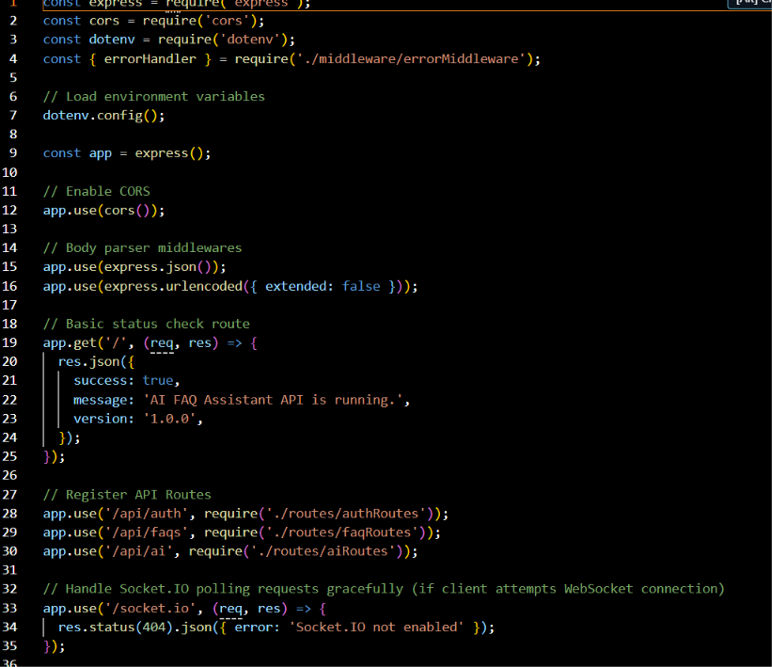

3. authMiddleware.js
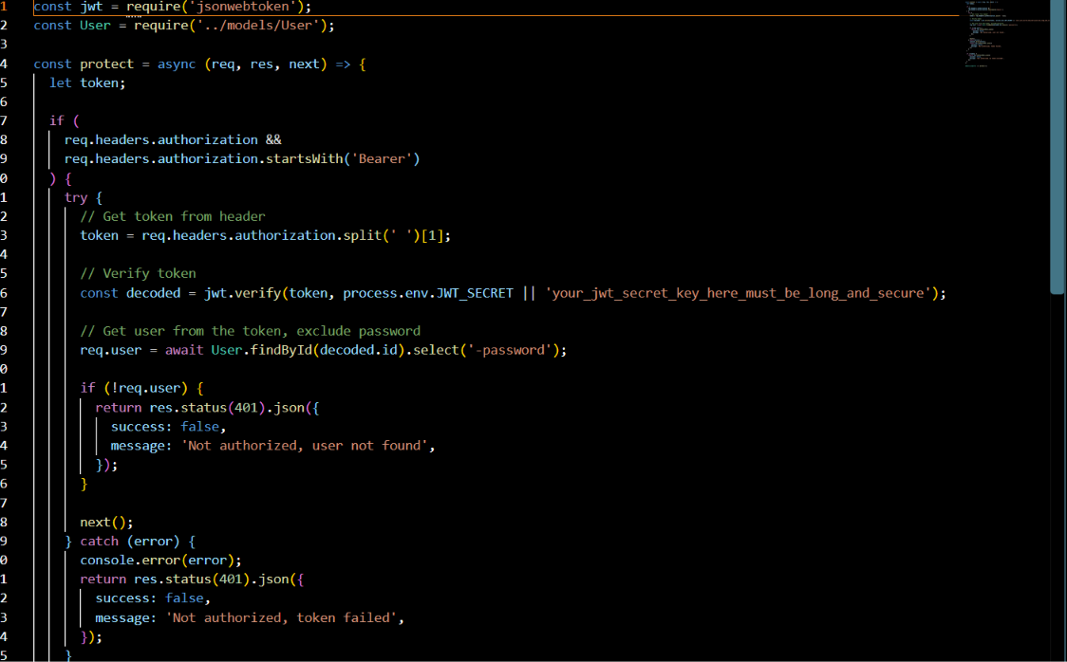
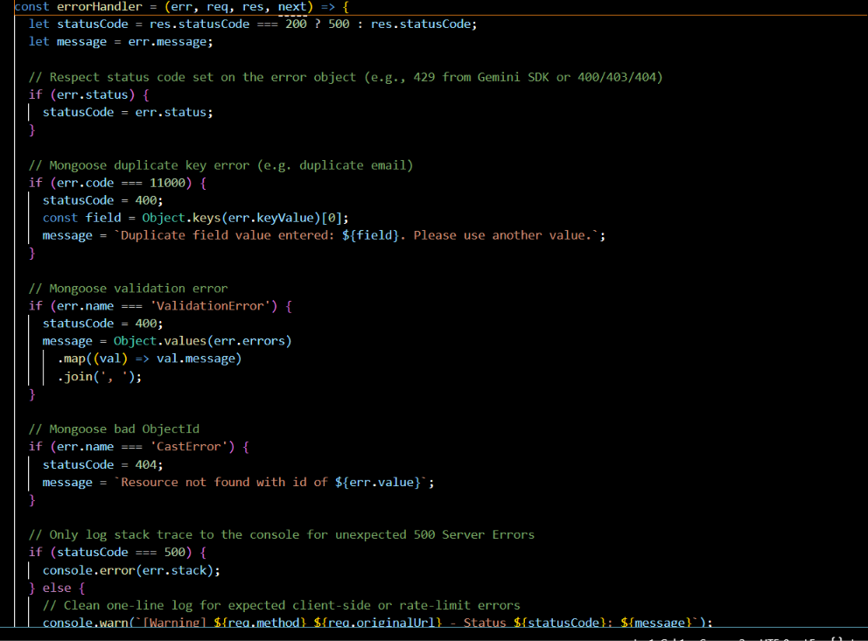
4. errorMiddleware.js
Epic 4: Database Configuration
User Model
Mongoose Schema Definitions
1. Identity Resource Document Schema (src/models/User.js)
Enforces profile field criteria validations and hooks password hashing steps prior to user document persistence:
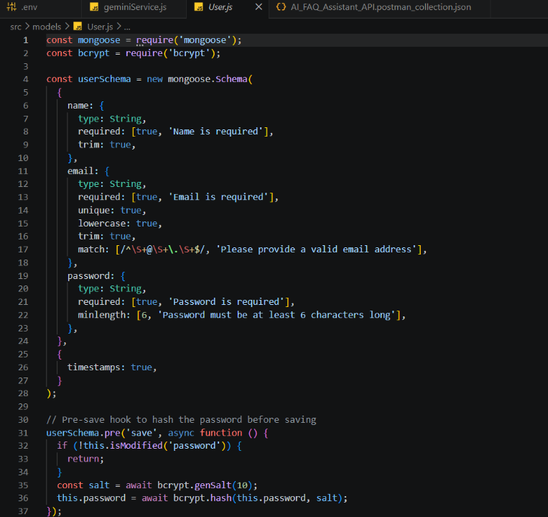
2. FAQ Resource Document Schema (src/models/FAQ.js)
Models core properties and maps a distinct relational reference link back to the source creator document:

API Router Interface Endpoints
1. Public Authentication Operations (src/routes/authRoutes.js)

2. Protected FAQ Operations (src/routes/faqRoutes.js)
JavaScript

3. AI Automation Operations (src/routes/aiRoutes.js)

Epic 5: Project Executions
Running the API Application
- Install Postman or ThunderClient (VS Code extension).
- Start the backend development server environment parameters:
Bash

npm run dev
API Testing Specification Demo
To verify operational structural integrity via execution endpoints, map endpoints using the configurations below:
1. Identity Onboarding Path Registration
- Route: POST /api/auth/register
- Access: Public
- Payload Request Body JSON:
JSON

{
"name": "Priya Sharma",
"email": "priya@writeflow.com",
"password": "securepassword123"
}

2. Profile Login Verification Quey
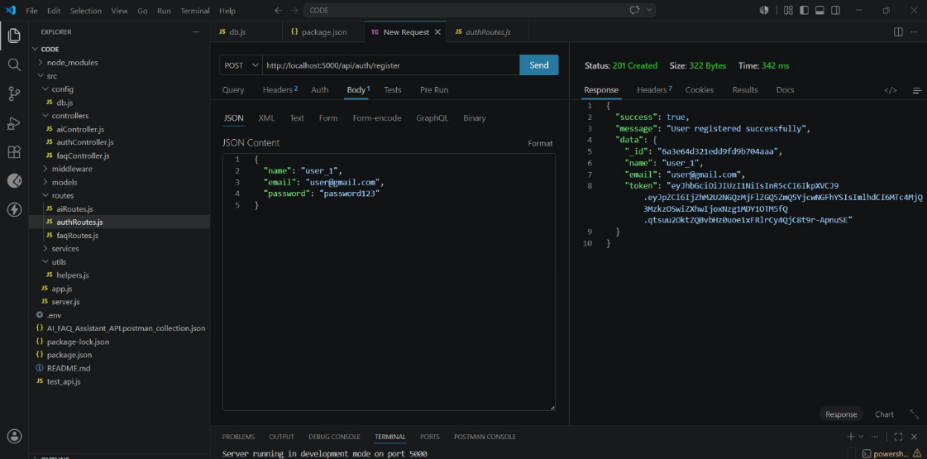
- Route: POST /api/auth/login
- Access: Public
- Payload Request Body JSON:
JSON

{
"email": "priya@writeflow.com",
"password": "securepassword123"
}
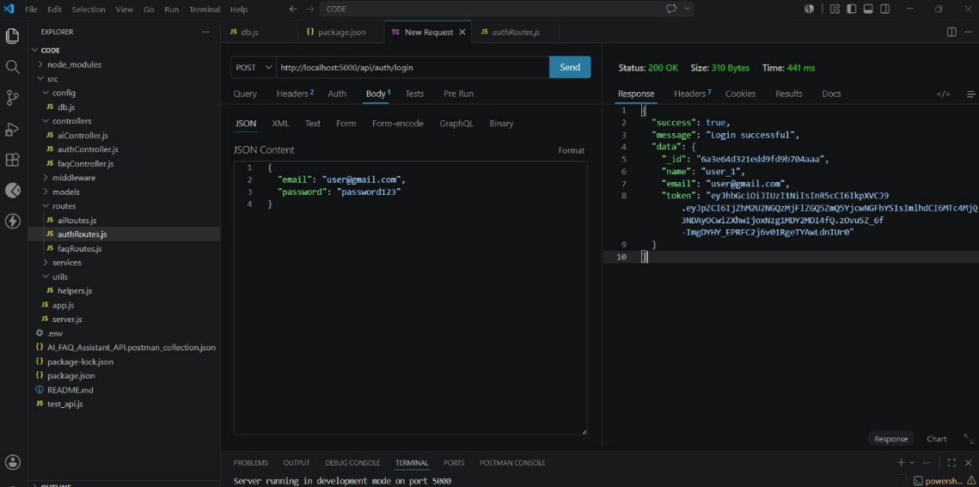
3. Resource Entity Creation (FAQ)
- Route: POST /api/faqs
- Access: Private (Bearer <JWT Token>)
- Payload Request Body JSON:
JSON

{
"question": "How do I configure custom category tags?",
"answer": "Navigate to settings panel, append keyword tags arrays, and save schema.",
"category": "Configuration"
}
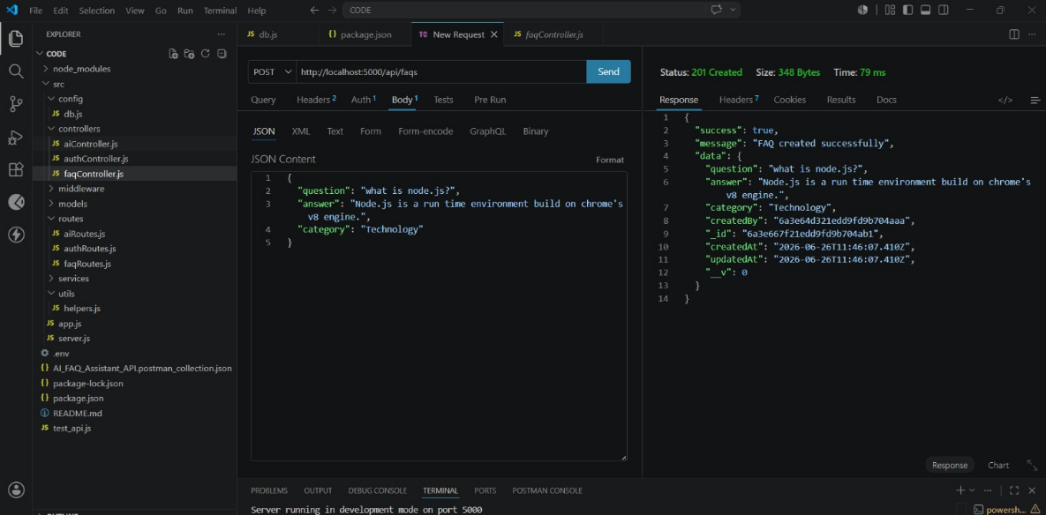
4. Keyword Resource Entity Fetching (Search)
- Route: GET /api/faqs/search?q=configure
- Access: Public

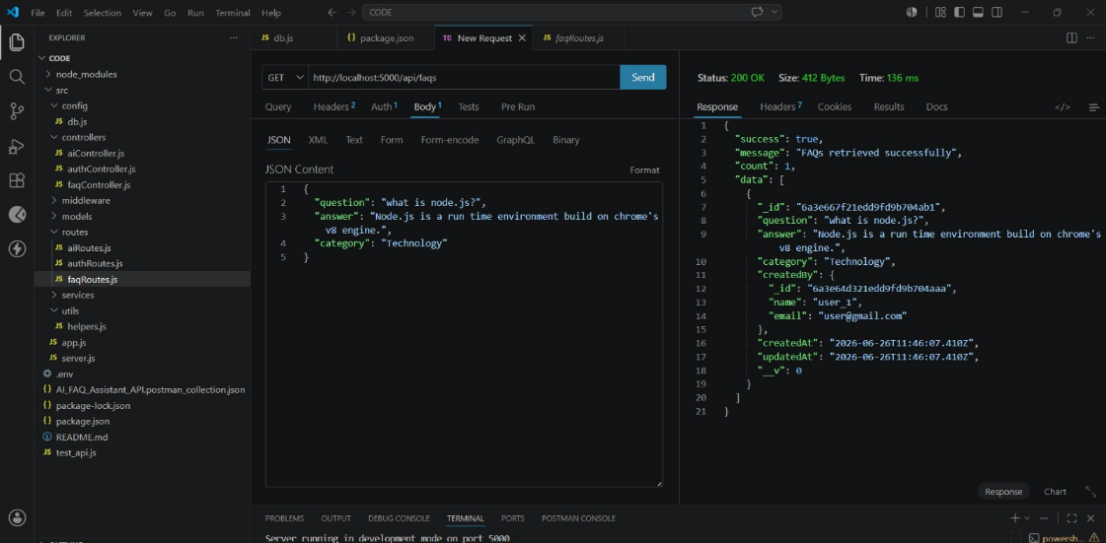

5. AI Intelligent Content Automation (Generate FAQ Pair)
- Route: POST /api/ai/generate-faq
- Access: Private (Bearer <JWT Token>)
- Payload Request Body JSON:
JSON

{
"topic": "Mongoose schema indexing validation runtime workflow optimization"
}
Github link: https://github.com/mgc7veera24-spec/AI-FAQ-Assistant-API
DEMO VIDEO: https://drive.google.com/file/d/19Z4sR8WKOIOYhr28_cjccC6x3MTLZMII/view?usp=sharing

