Name: **Manuel G. Cespedes**

Panther-ID: x x x - 0088 (last 4 digits)

Course: COP 4710

Assignment#: 4

Due: Wed, June 11, 2014

#1)

Relational diagram

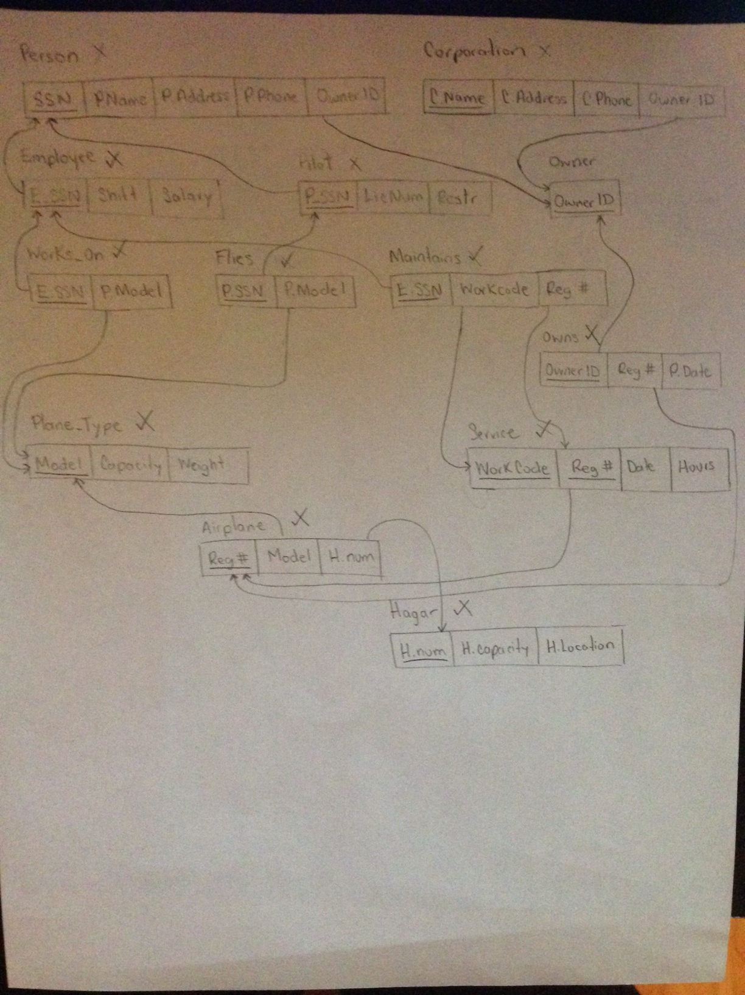

SQL script for database in file: airport.sql

#2)

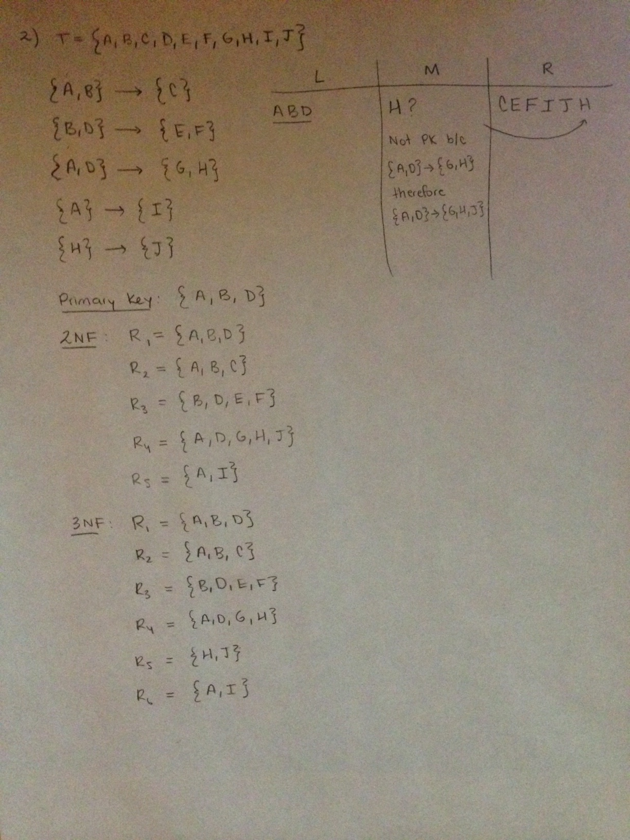

#3) & #4)

