TripSync AI Trip Planner - End-to-End Flow

System Architecture Overview
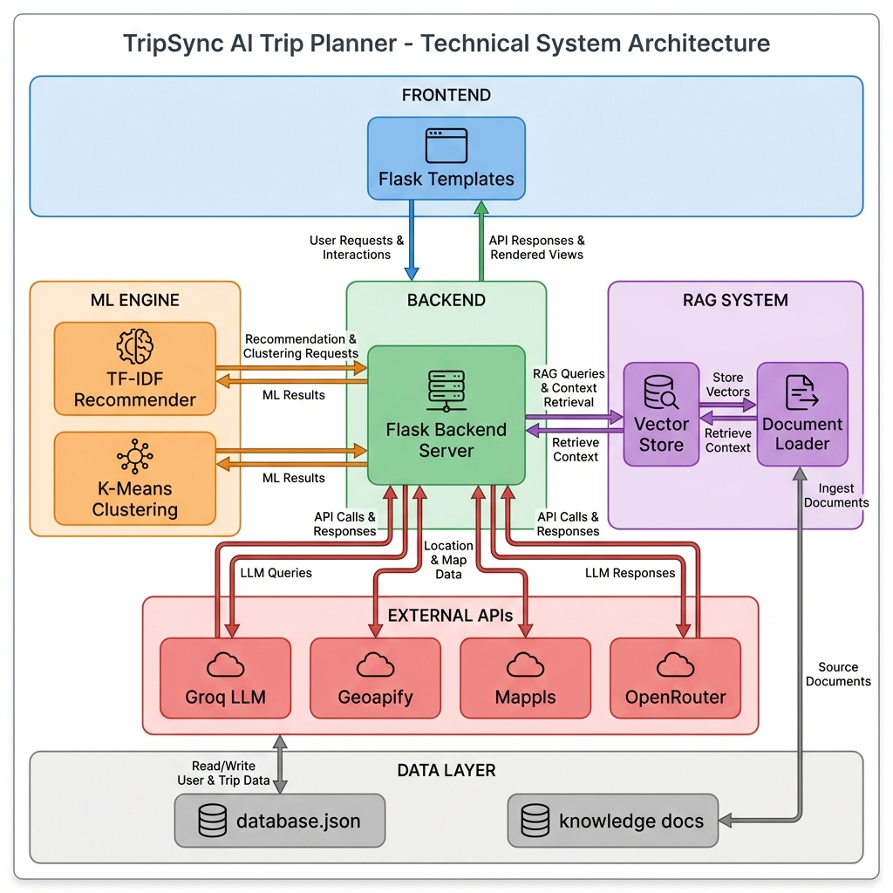
TripSync Architecture Diagram
flowchart TD
subgraph Frontend
UI[index.html - User Form]
end
subgraph Flask Backend
APP[app.py - Main Server]
PS[places_service.py]
MS[mappls_service.py]
LDB[local_db_service.py]
IMG[image_service.py]
PB[prompt_builder.py]
LLM[llm_service.py]
end
subgraph ML Engine
REC[recommender.py - TF-IDF]
CLU[clustering.py - KMeans]
end
subgraph RAG System
LD[loader.py]
VS[vector_store.py]
QR[query_rag.py]
KD[(Knowledge Docs)]
end
subgraph External APIs
GROQ[Groq LLM API]
GEO[Geoapify API]
MAPPLS[Mappls API]
OPENAI[OpenRouter Embeddings]
end
UI --> |POST /api/plan-trip| APP
APP --> LDB
APP --> PS
APP --> MS
APP --> REC
REC --> CLU
APP --> PB
PB --> LLM
LLM --> GROQ
PS --> GEO
MS --> MAPPLS
QR --> VS
VS --> LD
LD --> KD
VS --> OPENAI

1. User Input (Frontend)
File: index.html
The user provides: - Source (starting city) - Destination (target city) - Budget (total ₹ amount) - People (number of travelers) - Days (trip duration) - Transport Mode (flight/train/bus/car/bike) - Preferences (spiritual, adventure, nature, history, beach, romantic, shopping, nightlife)

2. Backend Processing Flow
File: app.py

Step-by-Step Execution:
Step | Component | Description
1 | local_db_service | Load local database (database.json)
2 | places_service | Get coordinates for destination via Geoapify API
3 | Local DB Check | Find destination in local DB or fetch from API
4 | mappls_service | Get distance/route info between source & destination
5 | ML Recommender | Rank attractions using TF-IDF + preferences
6 | prompt_builder | Construct detailed LLM prompt with context
7 | llm_service | Call Groq API (Llama 3.3-70B) for itinerary generation

3. ML Engine Components

3.1 Content Recommender (TF-IDF)
File: recommender.py
class ContentRecommender:
# Uses TF-IDF Vectorizer for text-based similarity
tfidf = TfidfVectorizer(stop_words='english')
Algorithm: 1. Feature Extraction: Combines category, spot_name, description into text content 2. TF-IDF Vectorization: Creates sparse matrix of term frequencies 3. Cosine Similarity: Computes relevance between user preferences and places 4. Multi-Objective Scoring: - Preference Score (60%) - TF-IDF similarity - Distance Score (20%) - Gaussian decay based on haversine distance - Budget Score (20%) - Heuristic matching

3.2 Geographic Clustering (K-Means)
File: clustering.py
class PlaceClustering:
# Groups places by lat/lon for day-wise allocation
kmeans = KMeans(n_clusters=5)
scaler = StandardScaler()
Purpose: Groups nearby attractions to minimize travel time within each day.

4. RAG (Retrieval-Augmented Generation) System
[!NOTE] The RAG system reduces LLM hallucinations by grounding responses in domain-specific knowledge.

4.1 Document Loading
File: loader.py
Loads .txt files from knowledge_docs/: - safety.txt - Safety tips - seasons.txt - Best travel seasons - temple_rules.txt - Temple etiquette

4.2 Vector Store & Embeddings
File: vector_store.py
Component | Technology
Embedding Model | openai/text-embedding-3-small (via OpenRouter)
Similarity Metric | Cosine Similarity
Vector Dimension | 1536
flowchart LR
A[Text Chunks] --> B[get_embedding]
B --> C[OpenRouter API]
C --> D[1536-dim Vectors]
D --> E[_vector_index]
F[Query] --> G[Cosine Similarity]
E --> G
G --> H[Top-K Results]

4.3 Query Interface
File: query_rag.py
async def query_rag_async(query: str) -> str:
store = get_vector_store()
results = await store.similarity_search(query, k=3)
# Returns formatted snippets with source metadata

4.4 Alternative FAISS Implementation
File: build_index.py
Uses sentence-transformers (all-MiniLM-L6-v2) with FAISS for local vector search: - Generates 384-dim embeddings - Creates IndexFlatL2 for exact L2 search - Saves index to faiss_index/places.index

5. Prompt Engineering
File: prompt_builder.py

Prompt Components:
- System Instructions: Role as expert Travel Planner
- Trip Details: User inputs (destination, budget, days, etc.)
- Key Requirements: Strict JSON output, real place names
- Context Injection:
  - Distance info from Mappls API
  - RAG context (safety tips, seasonal info)
  - ML-ranked places list
- Budget Distribution: Auto-calculated allocation percentages
- JSON Schema: Strict output format for frontend parsing

6. LLM Service
File: llm_service.py
Configuration | Value
API | Groq Cloud
Model | llama-3.3-70b-versatile
Temperature | 0.7
Max Tokens | 6000
Fallback: Generates template-based JSON itinerary if API fails.

7. Data Layer

Raw Data Sources
File | Content
places.txt | Destination descriptions
spots.txt | Tourist attractions
food_options.txt | Restaurant data
stay_options.txt | Hotel information
travel_options.txt | Transport routes

Processed Database
File: database.json (5 MB)
Structure:
[
{
"place_name": "Mahabaleshwar",
"coords": { "lat": 17.92, "lon": 73.65 },
"attractions": [
{ "spot_name": "Venna Lake", "description": "..." }
]
}
]

8. External API Integrations
Service | API | Purpose | File
Geoapify | Places API | Geocoding, POI search | places_service.py
Mappls | Routing API | Distance calculation, route polylines | mappls_service.py
Groq | LLM API | Itinerary generation | llm_service.py
OpenRouter | Embeddings | RAG vector embeddings | vector_store.py

9. Complete Request Flow Diagram
sequenceDiagram
autonumber
participant U as User
participant F as Frontend
participant A as app.py
participant DB as local_db_service
participant P as places_service
participant M as mappls_service
participant ML as recommender.py
participant RAG as query_rag
participant PB as prompt_builder
participant LLM as llm_service
participant G as Groq API
U->>F: Fill trip form
F->>A: POST /api/plan-trip
A->>DB: load_local_db()
A->>P: get_coordinates(destination)
P-->>A: {lat, lon}
A->>DB: find_destination()
alt Not in DB
A->>P: get_places_by_name()
A->>DB: upsert_destination()
end
A->>M: get_distance_info(source, dest)
M-->>A: {distance, duration}
A->>ML: get_recommendations(dest, prefs, days, budget)
ML->>ML: TF-IDF vectorize attractions
ML->>ML: Compute cosine similarity
ML->>ML: Rank by multi-objective score
ML-->>A: ranked_places[]
A->>PB: build_prompt(user, context)
Note over PB: Injects ranked places,<br/>distance info, budget allocation
PB-->>A: structured_prompt
A->>LLM: call_llm(prompt)
LLM->>G: POST /chat/completions
G-->>LLM: JSON itinerary
LLM-->>A: itinerary_text
A-->>F: Stream response
F-->>U: Display itinerary

Summary Table: ML & RAG Files
Category | File | Key Technology
ML | recommender.py | TF-IDF, Cosine Similarity
ML | clustering.py | K-Means, StandardScaler
ML | train_models.py | Model training script
RAG | loader.py | Document chunking
RAG | vector_store.py | OpenRouter Embeddings
RAG | query_rag.py | Similarity search
RAG | build_index.py | FAISS Index Builder
RAG | embeddings.py | SentenceTransformers

