PROJECT REPORT
Portfolio + ATS Resume Builder
A local, browser-based tool that generates 10 designed portfolio websites and a scored, ATS-friendly resume from a single set of entered details
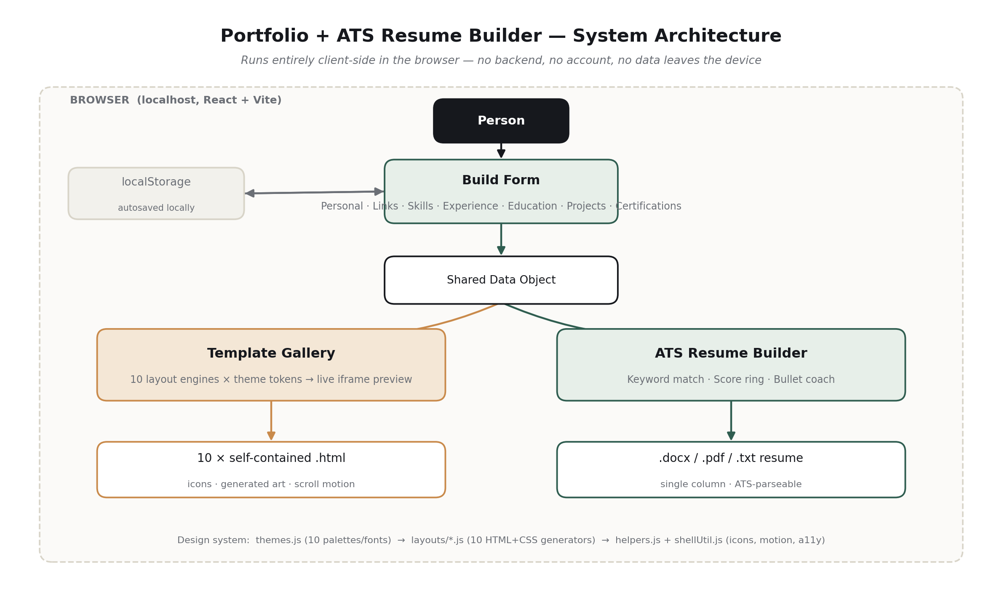
Prepared: August 2026
Type: React (Vite) single-page application · Runs locally via VS Code

Table of Contents
1. Introduction
2. System Analysis
3. System Requirements
4. System Architecture and Design
5. Module Description
6. Implementation Highlights
7. Testing
8. Results and Discussion
9. Advantages and Limitations
10. Future Scope
11. Conclusion
References

1. Introduction

1.1 Background
Job seekers today are expected to arrive with two very different artifacts: a personal portfolio website that shows their work, and a resume formatted precisely enough to survive an Applicant Tracking System (ATS) before a human ever reads it. Producing both well typically means learning web design or hiring a designer for the portfolio, and separately learning what ATS software actually parses for the resume — two skill sets most candidates do not have time to build.
This project addresses both needs with a single local tool: the person fills in their details once, and the tool generates ten distinct, professionally designed portfolio websites and a single-column, ATS-safe resume — complete with a content quality score and specific, actionable suggestions — from that one entry.

1.2 Problem Statement
Design a locally-run application that, from one set of user-entered details (personal information, links, skills, work experience, education, projects, and certifications), produces:
- Multiple visually distinct, ready-to-publish portfolio website designs, without requiring the user to write any code or install design software.
- A resume formatted for reliable ATS parsing, with the ability to tailor it to a specific job posting and to measure and improve its content quality.

1.3 Objectives
- Collect a person's professional details through a single, well-structured form.
- Generate at least ten portfolio website designs from that data, each visually distinct rather than a recolored duplicate of another.
- Allow the person to preview and download any design as a self-contained file requiring no build step to use.
- Generate a resume in a single-column, ATS-parseable format, exportable as .docx, .pdf, and .txt.
- Score resume content quality and coach the person toward stronger, quantified, action-verb-led bullet points.
- Optionally tailor the resume's skills ordering and add a matched-keyword section based on a pasted job description.
- Run entirely on the person's own machine, with no account, backend server, or data transmission required.

1.4 Scope
The tool covers manual data entry (resume upload/parsing is out of scope for this version), ten portfolio designs, and resume generation with scoring, coaching, and tailoring. It is delivered as a standalone project the person runs locally with Node.js and a code editor such as VS Code.

2. System Analysis

2.1 Existing Approaches and Their Limitations
- General-purpose website builders (Wix, Squarespace, Carrd) require hosting, accounts, and ongoing subscriptions, and are not tailored to resume/portfolio content structure.
- Resume builder websites typically upload the person's data to a third-party server and often place ATS-safe formatting behind a paywall.
- Manually formatting a resume in Word risks accidentally introducing tables, text boxes, or multi-column layouts that many ATS parsers cannot read correctly.
- None of the common tools combine portfolio generation and ATS resume generation from a single shared data entry step.

2.2 Proposed System
The proposed system is a single-page React application that keeps all data in the browser (via localStorage), exposes one data-entry form that feeds two independent generators — a portfolio template engine and an ATS resume engine — and produces downloadable output files directly from the browser using client-side libraries (docx, jsPDF), with no server round-trip.

2.3 Feasibility
- Technical: All required operations (HTML generation, DOCX/PDF creation, keyword extraction) are achievable client-side with mature, well-documented JavaScript libraries.
- Operational: The person only needs Node.js and a code editor already common in a developer's toolkit; non-developers can still run it by following the two documented terminal commands.
- Economic: No hosting, subscription, or API cost — the project has zero recurring cost to run or maintain.

3. System Requirements

3.1 Hardware Requirements
Component | Minimum
Processor | Any modern dual-core CPU
RAM | 4 GB (8 GB recommended)
Disk space | ~200 MB for dependencies
Display | 1280×800 or larger recommended for the builder UI

3.2 Software Requirements
Layer | Technology
Runtime | Node.js 18+ / npm
Framework | React 18
Build tool | Vite 5
Editor (recommended) | Visual Studio Code
Document generation | docx (DOCX), jsPDF (PDF)
Browser | Any modern evergreen browser (Chrome, Edge, Firefox, Safari)

4. System Architecture and Design
The application has no backend. A person's browser runs the entire React application; data entered in the Build Form is held in a single in-memory data object (and mirrored to localStorage for persistence across reloads) and passed by reference to two independent rendering engines.

Figure 1 — High-level system architecture

4.1 Data Model
A single JavaScript object is shared across the entire application:
- personal — full name, title, email, phone, location, summary
- links — LinkedIn, GitHub, personal website, X/Twitter
- skills — an array of free-text skill strings
- experience — an array of roles, each with company, title, dates, location, and an array of achievement bullets
- education — an array of school entries with degree, field, and dates
- projects — an array of side/professional projects with description, tech stack, and link
- certifications — an array of certification entries

4.2 Portfolio Generation Design
Each of the ten portfolio designs is produced by a pure function that takes the shared data object and a theme definition (color palette, font pairing, layout identifier) and returns a complete, self-contained HTML document as a string — including inlined CSS, inline SVG icons, and a small vanilla-JavaScript scroll-reveal script. Ten theme configurations (in themes.js) are mapped to ten layout-generator functions (in layouts/*.js) through a small registry (templates/index.js), so adding an eleventh design requires only a new theme entry and a new layout function.

4.3 Resume Generation Design
The resume module reuses the same shared data object. A keyword-extraction utility tokenizes a pasted job description, filters common stop-words, and ranks remaining terms by frequency; a matching utility compares those terms against the person's listed skills to compute matched and missing keyword sets. A separate scoring utility computes three sub-scores — impact, completeness, and (when a job description is present) keyword match — which are combined into a single weighted 0–100 score. The same shared data, plus the tailored skill ordering and matched keywords, is passed to three independent exporters: a DOCX generator, a PDF generator, and a plain-text generator.

5. Module Description

5.1 Data Entry Module
A single form, organized into seven switchable sections (Basic details, Links, Skills, Experience, Education, Projects, Certifications), collects everything the other two modules need. A skill-tag input, repeatable entry blocks for experience/education/projects/certifications, and a one-click sample-data loader make the form fast to fill in or demo.
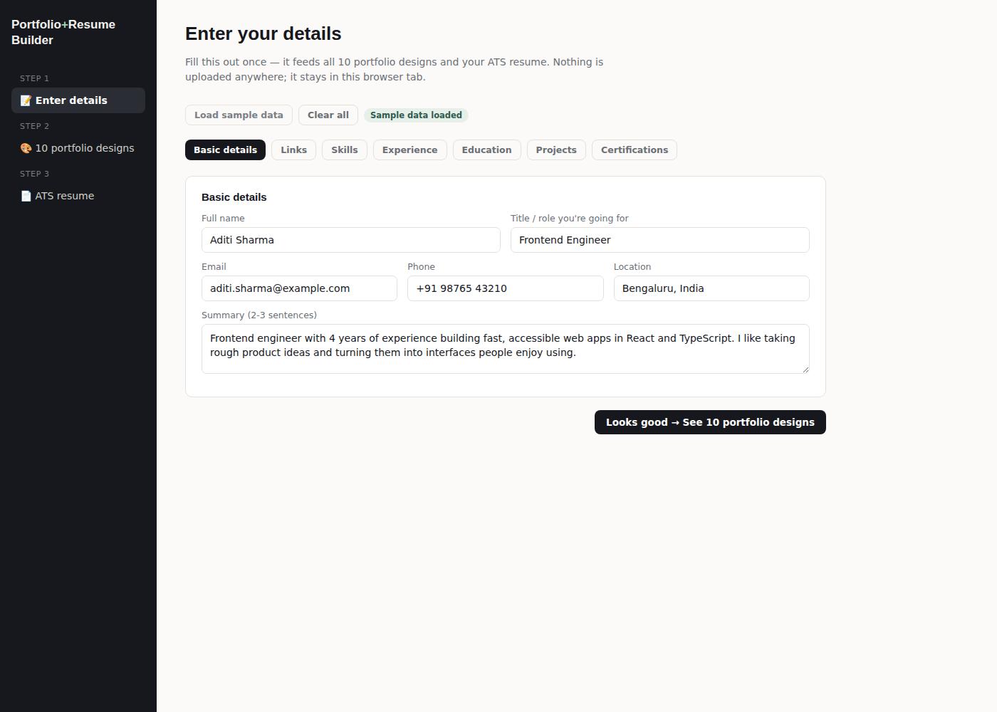
Figure 2 — Data entry form (Basic details section, sample data loaded)

5.2 Portfolio Template Gallery
All ten designs render live, in parallel, inside sandboxed iframes as soon as data is entered, so the person can compare them side by side before choosing one. Each card offers a full-size preview and a one-click HTML download.
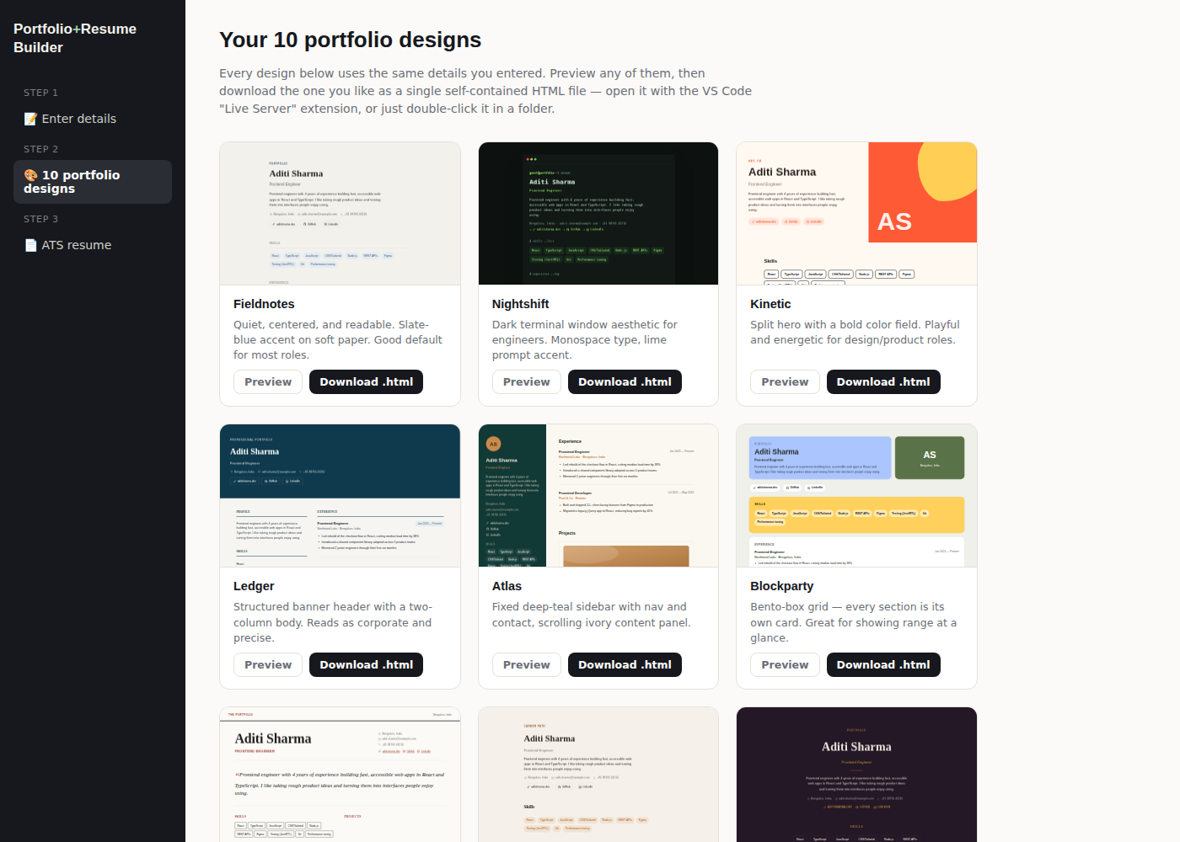
Figure 3 — Template gallery with live previews of all 10 designs
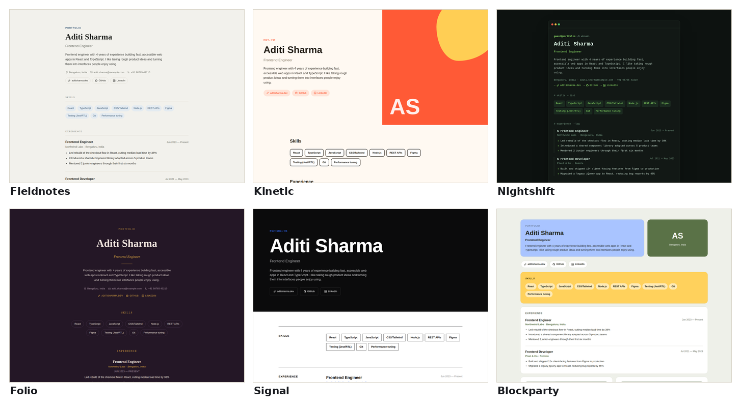
Figure 4 — Six of the ten designs, illustrating the range of visual identities (Fieldnotes, Kinetic, Nightshift, Folio, Signal, Blockparty)

Design highlights
Design | Layout concept
Fieldnotes | Quiet, centered editorial layout — slate-blue accent on soft paper
Nightshift | Dark terminal-window aesthetic with monospace type for engineers
Kinetic | Split hero with a bold color field; playful, energetic tone
Ledger | Corporate banner header with a structured two-column body
Atlas | Fixed deep-teal sidebar with contact info, scrolling ivory content panel
Blockparty | Bento-box grid — every section is its own card
Chronicle | Editorial magazine masthead with a pull-quote summary
Ascent | Vertical timeline for career progression, earthy palette
Folio | Plum background, gold serif type — a quietly luxe elegant portfolio
Signal | Agency-scale type on black and white with one shock accent color

5.3 ATS Resume Builder
This module surfaces three things at once: a live 0–100 resume score with a category breakdown, a keyword-match panel (only shown once a job description is pasted), and a bullet coach that flags specific weak bullet points and offers one-click rewrites.
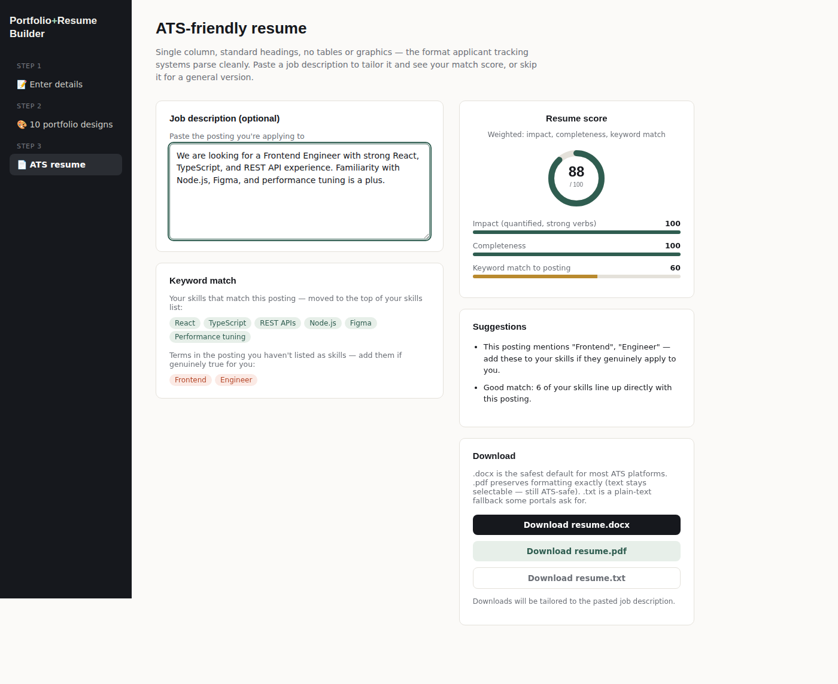
Figure 5 — Resume tab with a job description pasted: score ring, keyword match, and download options
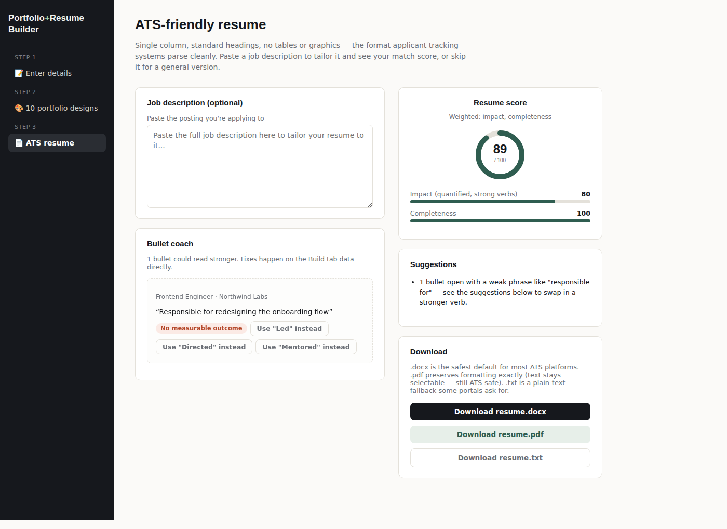
Figure 6 — Bullet coach flagging a weak opener ("Responsible for...") with suggested strong verbs
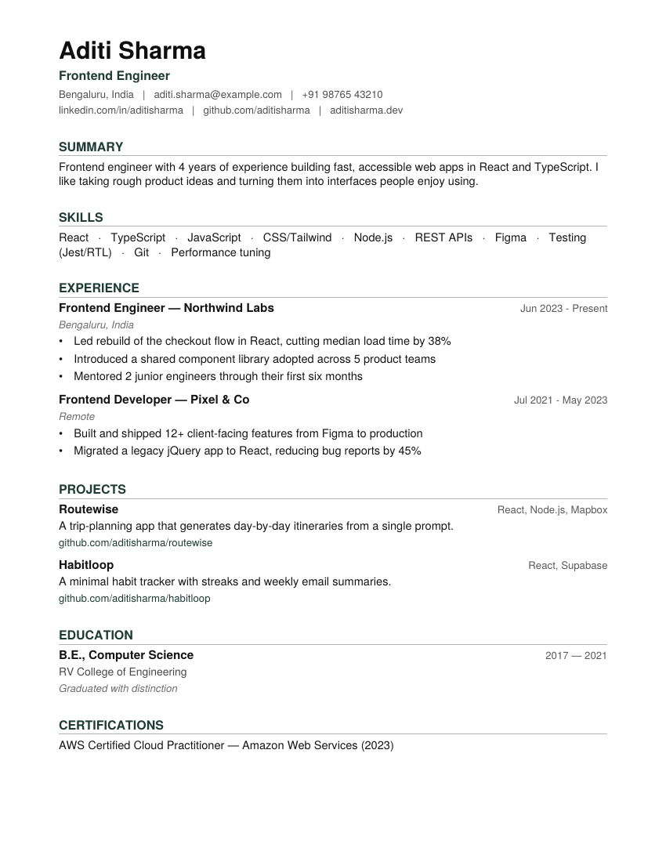
Figure 7 — Generated PDF resume output: single column, standard headings, no tables or graphics

6. Implementation Highlights

6.1 Generated Project Art
Rather than requiring project screenshots to be uploaded, each project card renders a deterministic abstract SVG banner: the project name is hashed to pick a repeatable pattern and gradient tint derived from the active theme's accent color, so the artwork always matches the chosen design's palette and never repeats identically across unrelated projects.

6.2 Motion With Safe Fallbacks
Scroll-reveal animation uses IntersectionObserver with staggered per-item delays and a hero entrance animation. During implementation and testing, a real defect was found and fixed: content that a person had not yet scrolled to remained permanently invisible in two situations — browsers with JavaScript disabled, and "Print to PDF," which renders the current DOM state without simulating a scroll. This was corrected with a <noscript> CSS override and a beforeprint event handler that forces all content visible before printing, and was re-verified by rendering and inspecting each design.

6.3 Resume Scoring Heuristics
The score, keyword match, and bullet coach are computed with rule-based heuristics (regular expressions, a curated stop-word list, and a categorized "strong verb" bank) rather than a call to an external AI service. This keeps the tool fully offline and keeps the person's data inside the browser tab, at the cost of the suggestions being pattern-based rather than a true natural-language rewrite.

6.4 ATS-Safe Document Generation
Both the DOCX and PDF exporters deliberately avoid tables, columns, text boxes, and embedded graphics — the layout elements most likely to be misread or dropped by ATS parsing engines — using only paragraphs, headings, and a single right-aligned tab stop for date ranges.

7. Testing
Testing combined automated generation checks, visual regression via rendered screenshots, and a scripted end-to-end click-through of the running application.
Test | Method | Result
All 10 templates generate valid HTML | Node script rendering each theme with sample data | Pass — all 10 produced well-formed documents
Production build compiles | vite build | Pass — no errors, clean bundle output
Portfolio visual QA | Playwright screenshots of each design, full scroll-through | Pass — motion, icons, and generated art render correctly
No-JS / print fallback | Manual DOM inspection with reveal not yet triggered | Defect found and fixed (see 6.2)
Keyword extraction & matching | Sample job description against sample skill set | Pass — correct matched/missing keyword sets
.docx resume generation | Generated and converted to inspect layout | Pass — single column, correct sections
.pdf resume generation | pdfinfo + pdftoppm render, pdftotext extraction | Pass — correct pagination after a heading-orphan fix; text fully extractable
Bullet coach apply flow | End-to-end Playwright click-through in the running app | Pass — bullet rewritten live, score updated 89 → 93

8. Results and Discussion
The completed application meets each objective set out in Section 1.3: it collects data through one form, generates ten distinct portfolio designs downloadable as single-file HTML, and produces a resume scored across impact and completeness, tailorable to a job description, and exportable in three formats.
In one recorded test pass, applying a single bullet-coach suggestion — replacing the opening phrase "Responsible for" with "Led" — raised the impact sub-score from 80 to 88 and the overall resume score from 89 to 93, demonstrating that the scoring model responds sensibly to genuine content-quality improvements rather than being cosmetic.
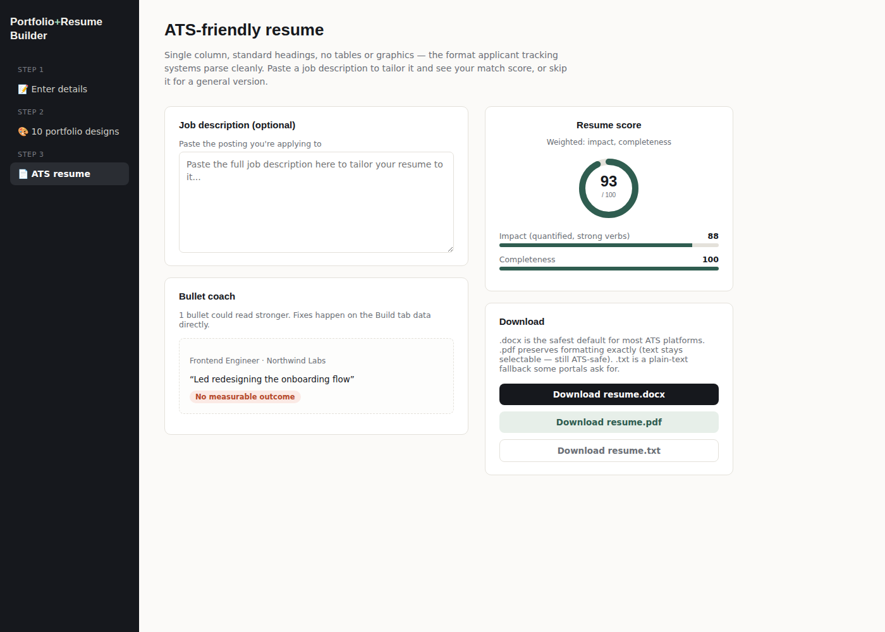
Figure 8 — Score after applying one bullet-coach suggestion

9. Advantages and Limitations

9.1 Advantages
- Single data entry drives both deliverables — no duplicate data entry between portfolio and resume.
- Runs fully offline after installation; no account, server, or recurring cost.
- Ten genuinely distinct designs rather than one template with color swaps.
- Resume output is deliberately structured to avoid common ATS-parsing failure modes.
- Actionable, specific coaching (not just a numeric score) for improving resume content.

9.2 Limitations
- No resume file upload/parsing — all data entry is manual in this version.
- Bullet coaching and scoring are heuristic, not a true AI-generated rewrite.
- Project thumbnails are generated abstract art, not real project screenshots.
- Designed for a single person's local use; there is no multi-user or account layer.

10. Future Scope
- Resume upload with automatic field extraction (PDF/DOCX parsing) to pre-fill the form.
- Optional integration with an LLM API for genuine natural-language bullet rewriting, kept opt-in to preserve the fully offline default.
- Support for uploading real project screenshots in place of generated artwork.
- Additional export target: a static site generator output (e.g., a ready-to-deploy folder for GitHub Pages) alongside the single-file HTML.
- A cover-letter generator sharing the same underlying data model.

11. Conclusion
The Portfolio + ATS Resume Builder demonstrates that a single, carefully modeled set of personal/professional data can drive two very different but equally important job-search deliverables — a designed portfolio website and an ATS-safe resume — from one local, dependency-light application. Its ten-design portfolio gallery and rule-based resume scoring and coaching system were built, tested, and verified end-to-end, including catching and correcting a real accessibility/print defect during development, and the project is structured so that both the design system and the resume-scoring rules can be extended without restructuring the application.

References
- React documentation — https://react.dev
- Vite documentation — https://vite.dev
- docx (npm package) — DOCX generation library
- jsPDF (npm package) — client-side PDF generation library
- Web Content Accessibility Guidelines (WCAG) 2.1 — prefers-reduced-motion and focus-visible guidance

