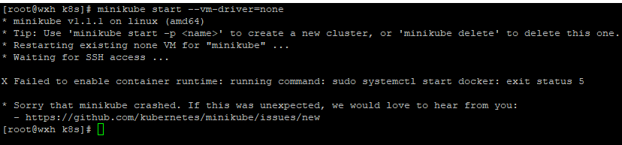

解决办法 安装docker

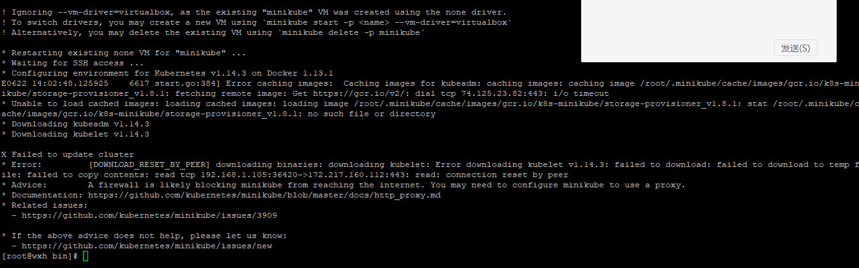

docker 环境：

Cannot connect to the Docker daemon at unix:///var/run/docker.sock. Is the docker daemon running?

systemctl daemon-reload

systemctl restart docker.service

问题：error pulling image configuration: unknown blob

yum remove docker \

docker-client \

docker-client-latest \

docker-common \

docker-latest \

docker-latest-logrotate \

docker-logrotate \

docker-engine

先删除rm -rf ~/.minikube

需要VirtualBox-5.2.x86_64 的版本