THE NEW DATA QUALITY SYSTEM IN THE HYDROMETEOROLOGICAL NETWORK OF THE BASQUE COUNTRY

M. Maruri¹, L. Lantarón^{1, 2}, A. Vallejo³, J.A Romo², M. Serrano³, B. Manso^{1, 2}

¹ Mathematical Applied Department
² Electronics and Telecommunications Dep.
Engineering School of Bilbao,
University of the Basque Country
Alameda Urquijo s/n
48013 Bilbao (Spain)
Tel: 94 601 20 00
Fax: 94 601 42 96
mariadelasmercedes.maruri@ehu.es
laulansi@hotmail.com
juanantonio.romo@ehu.es
conborja@gmail.com

³ Dominion Technologies, S.L.
Elcano, 9
48008 Bilbao (Spain)
Tel: 94 423 84 00

a.vallejo@dominion.es
m.serrano@dominion.es

ABSTRACT

The Basque Country has a complex topographic characterized by plenty of short basins which present a high risk of flooding close lands due to the frequent precipitations typical of this region. For this reason, since 1991 a dense hydrometeorological network, with more than 100 AWSs spread over the territory, is available. Nowadays, this network is under renovation by the installation of new generation AWSs with processing resources that allow a quality control in-situ.
In 2001 a meteorological data quality system was designed. It was a system based on different levels with procedures which evaluated data and obtained its associated quality parameter. But, in that moment, the available technology limited the scope of QC performance to time series in the data processing centre. With the renewal of the network, the Bureau of Meteorology and Climatology (DMC) and the Basque Meteorology Agency (Euskalmet) have promoted a R&D project to review the quality system.
As in any work of these features, it has been necessary to undertake a comprehensive collection and bibliographic review on meteorological data QC/QA systems. Regarding previous item, both guides and manuals published by WMO have been revised as well as several articles and papers related to the experiences developed by other meteorological bureaus.
This research shows a quality system that is applied throughout whole information flow and integrates all its components. This QC/QA system consists of several modules. Initially, there is a control previous to data acquisition, that specifies the own characteristics of each station, its environmental conditions and its maintenance and calibration, so to determine its compliance with the requirements of each application. As well it is made use of the processing capacity of datalogger to apply a succession of filters to measurements before sending them. And in data processing center the system based on levels is maintained, readjusting its parameters to the new reality of the network. Moreover, it has been necessary to redefine the structures which summarize the control carried out on data (since it is not required to pass through all QC modules) and report about the result. Finally, a system that manages the whole information generated and satisfies the requirements of DMC-Euskalmet has been achieved.

1. Introduction and Objectives

The Basque Country is situated in north of the Iberian Peninsula in the eastern part of the Cantabrian coast and covers an extension of 7233 km². Its climate is influenced by its geographical location, demarcated between the Bay of Biscay and the Ebro valley and flanked by the Cantabrian Mountains to the west, the Pyrenees to the east and south closed for the Iberian.

The topography of the region is complex and have multitude of short basins. In those situations in which persistent rain is prolonged for days, there is a high risk of overflowing rivers. In order to obtain information in these situations as detailed as possible, the DMC and Euskalmet together with the Provincial Councils have been deployed since 1991, throughout whole territory, a dense network with over 100 automatic stations (AWS) of hydrometeorological nature that collect data every 10 minutes. The surface observing system is completed with various meteorological and ocean buoys and platforms, two high-frequency coastal radars, a wind profiler in Punta Galea, a C-band dual Doppler weather radar in Kapildui and a lightning detection system. In addition, the acquired data are complemented by other meteorological information available on the Web.

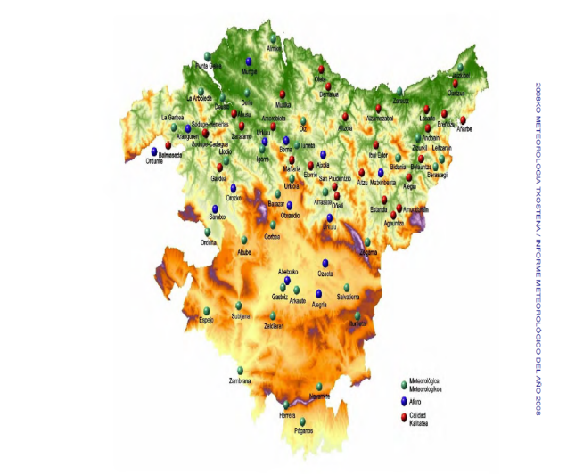
Figure 1. Hydrometeorological AWS network in the Basque Country

The DMC has always taken into consideration the importance of carrying out quality control data. Due to lack of an appropriate inspection reduce the data usefulness, decrease the capacity of reaction and become worse the management of information. In 2001 it was designed a first quality system based on a set of evaluation checks by levels, even thought the available technology only allowed run the lowest level of quality control. Since 2007, the network of AWS manufactured by Geonica is being replaced by Campbell stations. These new equipments provide increased processing capacities and facilities on site. Along with this deployment, a R&D project has been promoted by the public institutions with aim of improving and optimizing the observing system. The research presented here is developed under this project, called "ETORTEK – ISD: Instrumentation, Sensors and Data".

This paper addresses the need to associate to each observation a parameter which it is indicative of the data uncertainty. This parameter, known as quality of meteorological data, allows established whether the data is suitable for different applications. To determinate it, it has been identified diverse aspects that may affect data quality all over the information flow according to WMO guidelines. All of this is integrated within the metadata and the new database model.

2. Methodology

The designing of a meteorological data quality system is an issue of great complexity. But even more if one of the main pursued objectives is to obtain system that is robust and stable over time. The difficulty lies in the numerous factors of different nature involved in data acquisition, transmission and processing. To deal with this problematic, the first stage of this research has been focused on make a study which makes possible to determinate those relevant agents that may affect data reliability.

The analysis of information flow aids the design of a quality system that takes into account all those components that may affect measurements of diverse meteorological variables from their acquisition to their employment by users in different applications. It is necessary to consider, those factors directly related to the instrumentation, as well as those concerning the labor done by the manager of station location and configuration, by maintenance and calibrations teams and by the information manager. This last one has at his disposal controls and tools to act on information flow and its storage.

After identifying those sources that may have an influence on data, the work has been focused in study relevant information on them. The search, collection, synthesis and unification of whole found bibliographic have been a complex process but it really has a great intrinsic interest. This phase has been essential to familiarize with meteorology, observing instrumentation and with all of these definitions and procedures associated with data quality system.

The dimensions of the published literature have become necessary to set different working lines to attack the study. On the one hand the analyzed information flow has provide the base on which the information review has been arranged, on the other hand revision of the term "quality" has gave the framework of designed system.

The initial jobs of search and study were concentrated in aspects about quality management systems (QMS), for which the ISO normative has been reviewed. In particular, a general description of the two principal concepts associated with the term "quality" has been considered, those are quality control (QC) and quality assurance (QA). After this, it has been examined in detail the definition provided by WMO for these two components applied to a system that determines the reliability of data.

Both, the analysis of data flow and the study of the framework for quality systems have made possible the conceptual model on which the design has been consolidated.

Following this model, it has been observed that it is very difficult to assess the data quality if there is not knowledge about the performance and installing conditions of that instrumentation which is involved in the acquisition of the meteorological observations.

To understand instrumental behavior, it has been mainly studied "Handbook of applied meteorology," Houghton D. D., 1985, "The Guide to Meteorological Instruments and Methods of Observation, WMO No.8, Seventh edition, 2008, and some websites to study the process of measure each meteorological variable. Moreover, it has been revised the manuals of the data acquisition system of Campbell which is being installed in the Basque Country, in order to see the processing capabilities of this module. In parallel it has been reviewed the software package that this manufacturer offers to its customers with the purpose of meeting the requirements on technical monitoring (RTADQ version 1.0, Real Time Software Acquisition). Likewise, that information about equipment which maintenance and calibration teams work has been available.

In regard to instrumentation conditions, it has been studied the sitting classification developed by M. Leroy (MeteoFrance), the work of WMO to prepare an international standard WMO-ISO with respect to this arrangement and the employment of it which takes place in various networks of NOAA. In order to determine an initial quality level that will affect all data recorded in the AWS.

The next step has been concentrate in an exhaustive and comprehensive study of the state of art on meteorological data quality system. These types of systems are mainly based on the approach of several automatic procedures in order to check data quality. They provide a structure of the quality parameter associated with data. And they present a monitoring system that allows the vigilance of network performance, as well as quality control.

In conformity with this, not only spanish normative (UNE - AENOR) related to AWS networks and regulations and guidelines proposed by WMO (Guides and handbooks, I. Zahumenský) in respect of data quality systems have been revised, but also it has been found a great number of articles and publications with regard to this kind of quality systems. This information is concerned with experiences implemented by meteorological services or with joint projects of various instrumental networks. The main references studied are:
- QualiMET in German Meteorological Service (DWD, The Deutscher Wetterdienst)
- QC/QA in Oklahoma Mesonetwork
- Automated Operational Validation of Meteorological Observations in the Netherlands
- QC in Switzerland (MeteoSwiss)
- Data QC in AWOS Network in Turkey (TSMS)
- Data QC in Galicia (Department of Environment of Xunta de Galicia)
- Nordklim, HQC in Nordic co-operation within climate activities (Denmark, Iceland, Finland, Norway and Sweden)
- QC & Monitoring System in NOAA's Meteorological Assimilation Data Ingest System
- FORALPS project: Data QC in Alpine Meteorological Services (Austria, Slovenia, Switzerland, Italy: Valle d'Aosta, Trento, Bolzano, Lombardia, Piemonte, Liguria, Veneto, Friuli Venezia Giulia)
- Meteorological Data QC in CIOMTA project (Climate change and carbon sinks in Argentina
- Oceanography:
- "Manual of Quality Control Procedures for Validation of Oceanographic Data " IOC/CEC (Intergovernmental Oceanographic Commission/ Commission of the European Communities)
- ARGO program, collaboration between 26 countries
- ESEOO, Establishment of a Spanish system of operational oceanography
- The Global Ocean Observing System (GOOS) Data and Information Management System (DIMS)
- MEDAR/MEDATLAS II, Mediterranean Data Archaeology and Rescue
- Mersea IP, Marine EnviRonment and Security for the European Area – Integrated Project

Because of the necessity of integrating all factors that are presented along the data flow and influence the quality of measurements, it has been fundamental to keep a continuous two-way communication with the different managers and teams. Moreover, pay attention to comments on data quality from those users who directly work with observation has had a great importance. Furthermore, it has been working with the metadata and model data designers, so the quality system may be considered within the metadata and supported by the new information system. This multidisciplinary communication has helped to keep a continuous feedback and to improve the system design including all their contributions.

3. Results

3.1. Conceptual Model

The analysis of information flow reflects the life of the data since its acquisition until it becomes part of the database. Through it, the data is subject to numerous factors which influence their quality. Comprehend it as a whole is a very complex task, but fundamental to design a fully integrated system. For this reason, it is necessary to define a strategy to face up the problem, in this case, a simplified diagram of the data flow, on which work to identify all sources that provide information about data, has been created. The following figure shows the developed sketch used for the study of all these influence factors.

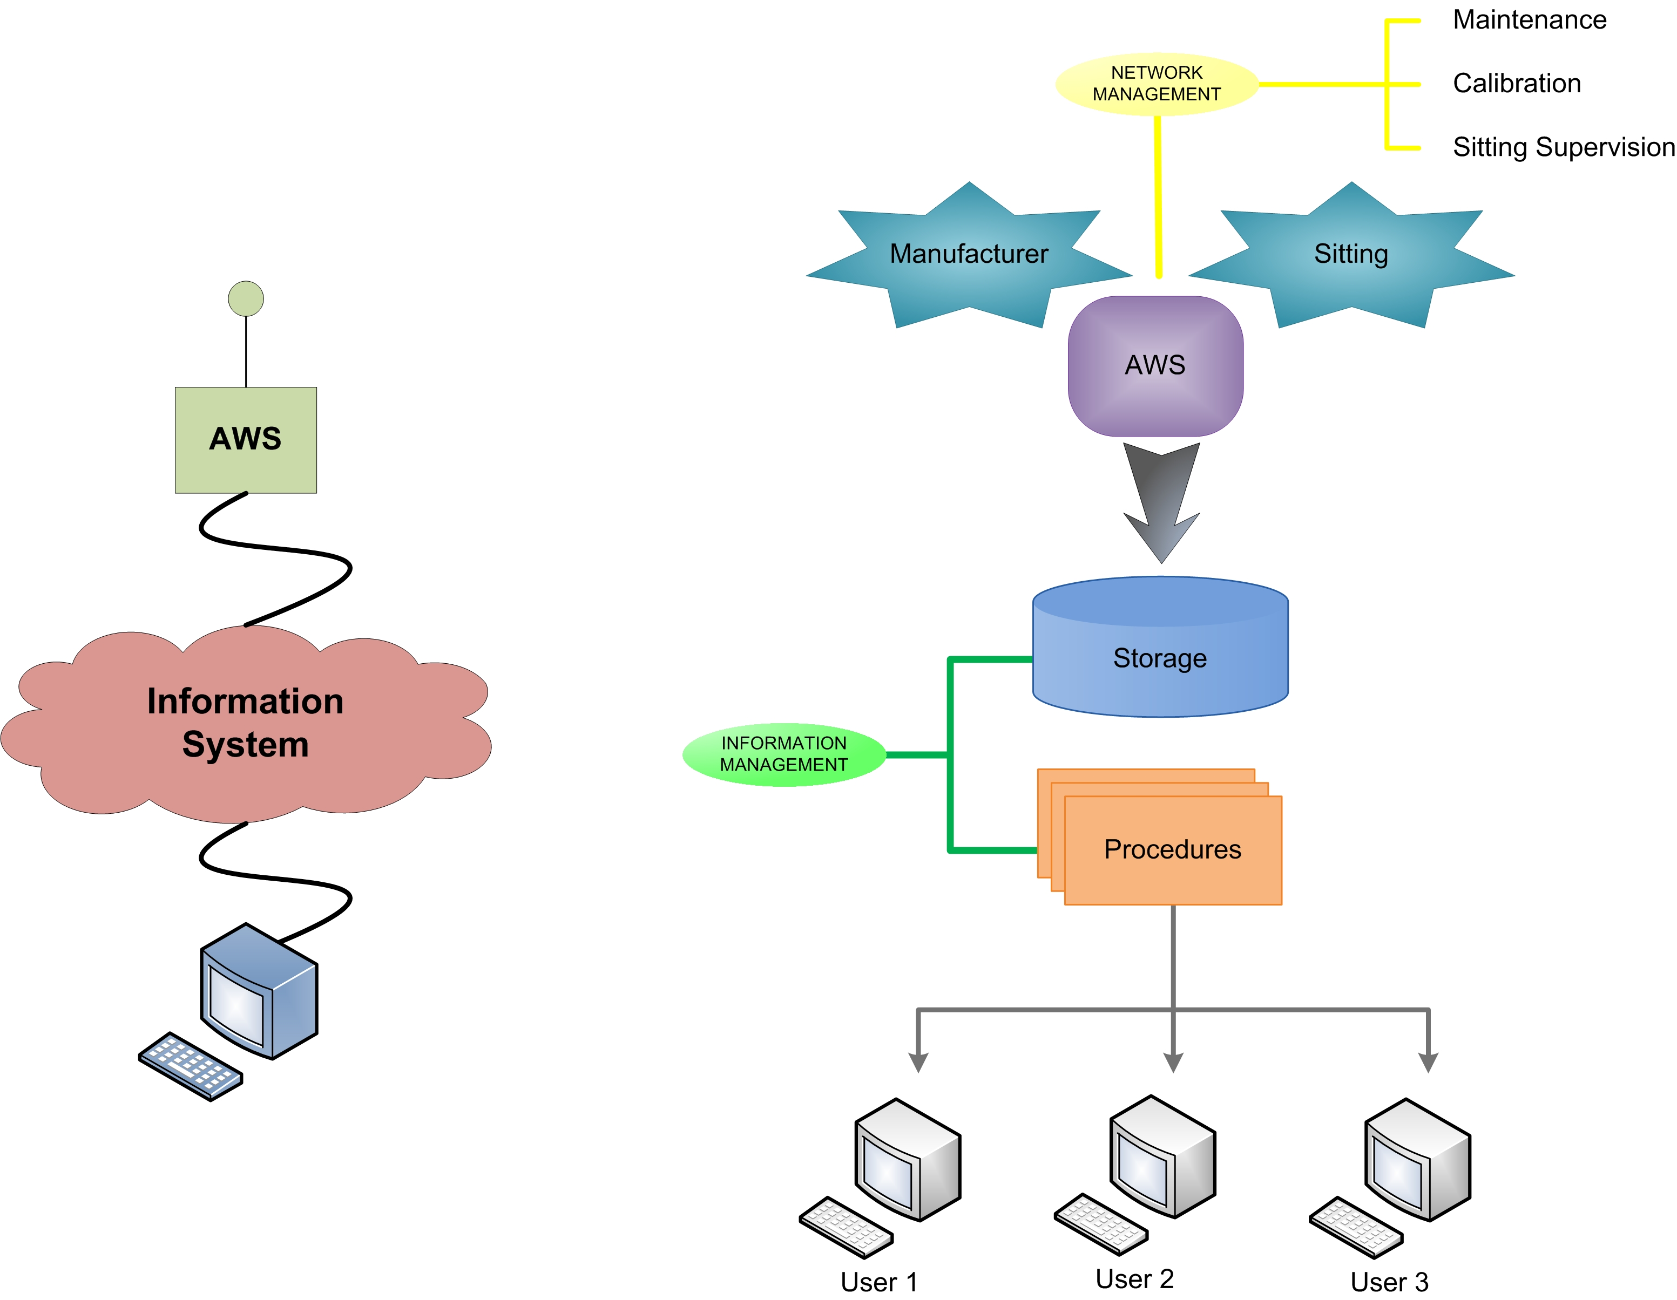
Figure 2. Diagram for Data Flow

The study of ISO QMS has served as a base for establishing the framework of data quality system. This combined with the previous diagram of information flow has determinated the conceptual model on which meteorological data quality system has been designed.

After the analysis of influences found, it has been noted the importance of keeping a continuous communication among the responsible of each component of the observing system. In order to maximize this multidisciplinary dialogue and cooperation, it has been designed questionnaires addressed to participants of the project. These forms have made possible to collect relevant information concerning the data operation and quality issues. This has helped to introduce the concept of "global integration" in the proposed quality system.

3.2. Meteorological Data QC/QA System

The study of quality management systems (ISO normative) in enterprise environments and of the vision about data quality systems by WMO and other experiences developed by diverse meteorological services, gives the two quality approaches which frame the components of data quality system, quality control (QC) and quality assurance (QA). From the bibliographic literature, it has been decided to organize the components of the quality system in the following way.

The checks performed on data to set its quality level fall within QC. These procedures are divided into three parts. The first one consists in an analysis of the effect of representativeness of the station on the data. The second and third elements are based on the implementation of various tests on the data, both at the station such in the data processing centre.

The monitoring which is necessary to ensure the proper performance of whole system is located in QA framework. The responsibilities of this component are watch network and keep track of data and its associated quality before it is ingested by applications, in order to ratify or not obtained results in QC.

3.2.1 QC: Procedures

Initial QC

The representativeness of observations depends largely on conditions of environment where AWS is placed and on instrumentations installation status that conform the station. In order to include these aspects in quality of observations, a control in delayed mode which should be revised periodically is applied. This control is a study about location and site conditions according to the sitting classification analyzed in the bibliography (M. Leroy).

In order to determinate this quality level, some forms have been developed. These ones allow collect all relevant information in that regard: on surrounding area topography, equipment distribution on the station and on these points that are evaluated by sitting classification.

AWS QC

This component is referred to set of instrumental filters (I. Zahumenský) applied in real-time. These tests help determine if obtained measurements are possible with available instrumentation and whether they are feasible according to other sensors measures at station.

Parameters for the procedures have been determined after considering technical features of the equipments presented in the AWS. These settings remain constant over time, nevertheless they should be revised whenever an instrumentation change succeeded.

Table 1. AWS QC tests
 | Checked Feature | Name | Test | Result
Raw Data | Plausibility | Instrumental Range |  | ✓ | Good
 |  |  |  | ✗ | Erroneous
Raw Data | Temporal Consistency | Difference | 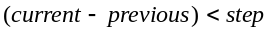 | ✓ | Good
 |  |  |  | ✗ | Suspect
10' Data | Internal Consistency | 2 parameters relation | 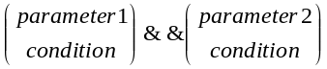 | ✗ | Inconsistent

DPC QC
In centre where data is processed, the quality control is intended to check the format of data which it is received in centre every 10 minutes arriving from all AWSs of the network and, by other hand, to validate observations according to regional climate variability (2001 quality system in the Basque Country; WMO; I. Zahumenský; various projects and experiences of meteorological bureau).

 Data Format
Structure of received data is analyzed in order to ensure that there are no transmission errors. If any verification fails, the data is sent to the monitoring system for visual inspection. Tests applied check:
- "Data quantity"
It is checked if the amount of received data is the quantity that were expected.
- "Station identifier and location"
It is verified if information about station (name, code, UTM coordinates and altitude) corresponds to which is associated with station in the database.
- "Time mark"
It is validated measurement instant, it verifies if both date and time associated with each observation are correct.

 Observations properties
This is a series of meteorological filters applied in real or quasi-real time. In that control point the data feature of plausibility, temporal and internal consistency, in addition to spatial consistency, are analyzed by intricate levels in a more elaborate mode, taking advantage of mayor processing capacity and availability of data from other AWSs. Tests parameters are specified by the analysis not only of the typical microclimate of the region where station is located, but also of particular conditions impact of the installation place. A tool in Matlab has been developed for obtain the concrete weather variability at site, this program studies the data provided by DMC of previous years, both Geonica data associated with historical database as Campbell ones related to current database. Due to this observations variability at each concrete site, these parameters are not static in time and require to be reviewed seasonally or with a frequency determinate for the analysis that has been carried out.

Table 2. DPC QC tests
Checked Feature | Name | Test | Result
Plausibility | Instrumental Range |  | ✓ | Good
Plausibility | Instrumental Range |  | ✗ | Suspect
Temporal Consistency | Maximum allowed variability | 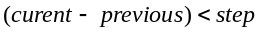 | ✓ | Good
Temporal Consistency | Maximum allowed variability |  | ✗ | Failed test
Temporal Consistency | Minimum required variability | 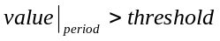 | ✓ | Good
Temporal Consistency | Minimum required variability |  | ✗ | Failed test
Temporal Consistency | Standard deviation | 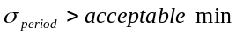 | ✗ | Suspect
Internal Consistency | Several parameters relation | 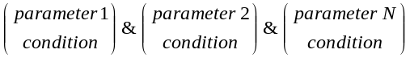 | ✗ | Inconsistent
Spatial Consistency | Optimal interpolation | 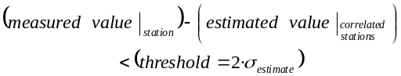 | ✓ | Good
Spatial Consistency | Optimal interpolation |  | ✗ | Suspect
Spatial Consistency | Simple regression curve | 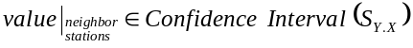 | ✓ | Good
Spatial Consistency | Simple regression curve |  | ✗ | Suspect

3.2.2 QA: Monitoring

This component consists of two elements (NOAA MADIS). The first one allows monitor the performance of each device on the network and deal with problems that may occur. While the second one makes a monitoring of data and its quality, this enables a subjectively interaction with the information.

Network QA

It examines the behavior of surface network. It includes a set of statistics about the performance of each AWS and communication link. It is generated, both regularly and on user demand, reports which collect information about:
- number of observations available and planned for each variable (completeness of data Total), 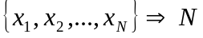;
- Total number of observations that fail QC for each variable (data quality), 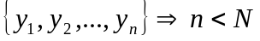;
- Percentage of failed observations (quality data), 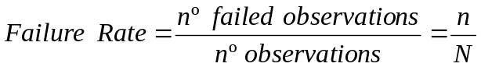;
- Error and threshold values for each observation failed (reason for failure);
- RMS (Root Mean Square) error, percentage of failed observations for each station (quality statistics), 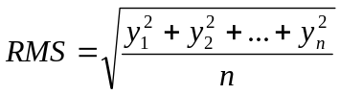.

Moreover, it allows know the technical status of equipment, detect instrumental problems and generates alerts addressed to the teams responsible of instrumental maintenance and calibration for rapid solution.

Data + QFlag QA

Before feeding applications it must be ensured that data meet the requirements needed for each service. In order to this, a visual inspection of measures and their QC results is performed.

 Visual inspection

- Represent time evolution of variables at several levels of aggregation
- Chart variables and derived parameters ⇒ analysis of:
  - averages values at a specific time of day;
  - average, maximum and minimum;
  - accumulated values;
  - other statistical analysis:

In addition to, the monitoring tool allows make subjective corrective actions on data and/or its quality flags and on QC methods. Thus, modifications to allow continuous update and improvement of system performance are proposed.

3.2.3 System Outputs: Quality Flags

The existing meteorological data quality systems are based on indicate a parameter about data uncertainty, but this parameter, called quality flag, is presented as a number that establishes a categorization of data quality or indicates the quality level applied. However, in this research it has been concluded that this type of structure is very useful when time is a predominant factor (analysis in real or quasi-real time), but it is not sufficient to provide information on all factors the influence the data quality and it also requires a flag to ponder the data validity. The three structures designed for quality parameter are described following.

 Categorical QFlag
It is assigned a "simple" descriptor to indicate data quality. Ten levels, of which two are reserved for expand the categorization if necessary, are used.

 Detailed QFlag
This is a structure that provides information on the different QC/QA levels applied to data. Two codes are used, the first one indicates QC tests passed and the second one specifies if it has been monitored or not.

 Numerical QFlag
There are some applications for which it is more useful to have a numeric label (weight in %) that ponder data validity. The threshold to establish data validity is defined according to accuracy required for each application.

Table 3. Categorical QFlag

Code | Definition | Interpretation
0 | No QC | No quality checked
1 | Good | Good data
2 | Inconsistent | Data probably good
3 | Doubtful | Data probably bad but correctible
4 | Erroneous | Bad data
5 | Corrected | Corrected Data
6, 7 | No used | Reserved for future use
8 | Interpolated | Reconstructed data
9 | Missing value | Missing data

Table 4. Detailed QFlag
 | Code | Description
1st Code | 0 | No validation process
1st Code | 1 | Pass range test  Valid data at level 1
1st Code | 2 | Pass temporal consistency test  Valid data at level 2
1st Code | 3 | Pass internal consistency test  Valid data at level 3
1st Code | 4 | Pass spatial test  Valid data at level 4
1st Code | 5 | Pass format data verification  Valid data at level5
1st Code | 6 | No valid data
1st Code | 7 | Future use
1st Code | 8 | Future use
1st Code | 9 | No registered data
2nd Code | 0 | No visual inspection
2nd Code | 1 | Visual inspection

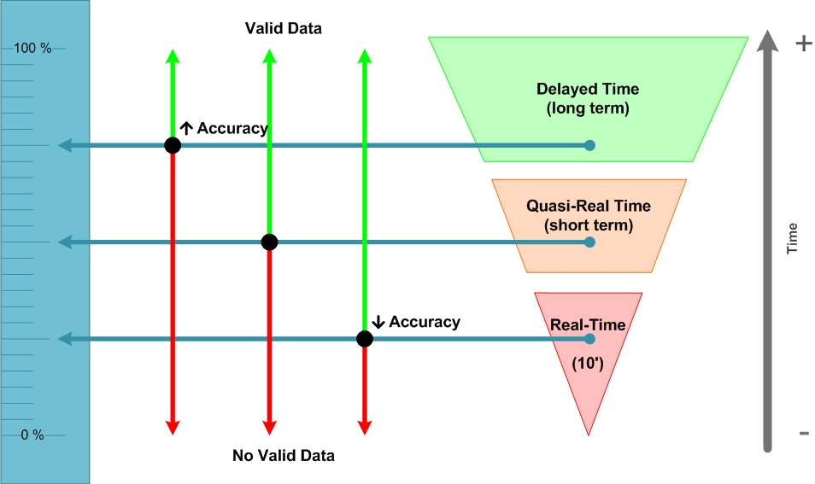
Figure 3. Numeric QF (%)

4. Conclusions

It is essential to design a meteorological data QC/QA system that is totally integrated. Nevertheless is a matter with no a simple resolution. For this reason, it is such important to consider the conceptual model that must be established to carry out a research about all elements that may affect data along its useful life, according to the appropriate framework in regard to check quality. This model is derived from, on the one hand, the analysis of information flow from meteorological variable measurement to data utilization by users in different applications and on the other hand from the revision of the approaches in conformity with quality management.

Taking this conceptual model as foundation, it has been made a comprehensive literature review. A numerous bibliographic sources which are very valuables have been found on quality systems developed in other observing networks. Nevertheless there are few completely integrated systems. The difficulty resides in the fact that it is fundamental to involve working groups from different fields and it is also necessary to have a technology base that supports an advanced information management.

This is the reason for which the intercommunication is other relevant issue that must be considered. With respect to this, the research group has been in permanent contact with DMC principal responsible of infrastructure, with Euskalmet engaged of information management and with maintenance and calibration groups. In this way, everyone has been able to contribute with their viewpoints about discussed issues. As consequence, a first approach was revised in order to improve the plenary integrated QC/QA system that it has been finally developed. This design may be assumed with no problems by a meteorological service with same dimensions that DMC. This feedback must continue active with the purpose of preserving dynamic nature of the QC/QA system, since the system may be revised and adjusted depending on current reality of the observing system in every moment and on requirements of the diverse applications.

Due to arduous character of the QC/QA system implementation, a modular design has been considered. This kind of system is composed of autonomous components and provides a great flexibility. The independence among the diverse modules allows the system's integrity not to be threatened by the absence of any element. Furthermore, its development, modification or replacement can be performed without affecting the rest of the system.

Acknowledgment
We would like to thank to the Bureau of Meteorology and Climatology (DMC), Dept. of Public Work and Transports, Government of the Basque Country; the Basque Meteorology Agency (Euskalmet); the enterprise Dominion Technologies and the University of the Basque Country for its technical and economical support under the ETORTEK - ISD Project.

References
- ISO 9000: “Quality management systems - Fundamentals and vocabulary”, December 2000.
- ISO 9001: “Quality management systems - Requirements”, December 2000
- ISO 9004: “Managing for the sustained success of an organization -- A quality management approach”, December 2000
- "Handbook of applied meteorology," D.D. Houghton, 1985.
- UNE 500510 IN: “Automatic weather stations networks. General matters and nomenclature”, January 2005.
- UNE 500520: “Automatic weather stations networks. Criteria for the localization of sites and installation of sensors. Acquisition characteristics and sampling”, June 2002.
- UNE 500530: “Automatic weather stations networks. Characterization of the instrumentation. Automatic weather stations maintenance criteria and sensor calibration”, November 2003.
- UNE 500540: “Automatic weather stations networks: Guidance for the validation of the weather data from the station networks. Real time validation”, September 2004.
- UNE 500550: “Automatic weather stations networks. Format of weather recordings exchange. Metadate”, May 2003.
- UNE-EN ISO 19119: “Automatic weather stations networks. Format of weather recordings exchange. Metadate”,March 2007.
- "Validación en tiempo real de datos de redes meteorológicas". M. Maruri, 2001. UPV-EHU.
- “Guide to Meteorological Instruments and Methods of Observation”, WMO - No.8.
- “Guide to the Global Observing System”, WMO - No.488.
- “Guide to Hydrological Practices”, WMO – No. 168
- “Manual on the Global Observing System”, WMO - No.544.
- “Manual on the Global Data-Processing and Forecsting System”, WMO - No.485.
- “Manual on the Global Telecommunication System”, WMO - No.386.
- “Guidelines on Climate Data Management”, WCDMP – No.60, WMO/TD – No.1376.
- “Guidelines on Climate Observation Networks and Systems”, WCDMP - No.52, WMO/TD - No.1185.
- “TECO Presentations & Papers”, 1998 – 2008.
- “ET-AWS Final Reports”, First – Fifth sessions.
- “ET-ST&MT Final Reports”, First & Second sessions.
- “CIMO WIGOS-PP”, Third session.
- “Complex Quality Control of Meteorlogical Observations”, L.S. Gandin, November 1987.
- “A Transparent Method for the Analysis and Quality Evaluation of Irregularly Distributed and Noisy Observational Data”, R. Steinacker, C. HäBerli and W. Pöttschacher, July 2000.
- “Quality Control Tools Formeteorological Data In The Meteoswiss Datawarehouse System”, M. Musa, E. Grüter, M. Abbt ,C. Häberli, E. Häller, U. Küng, T. Konzelmann, R. Dössegger. Switzerland.
- “The Data Warehouse System of MeteoSwiss: Concept and First Experiences”, E. Grüter, C. Häberli, D. Tombros, N. Tschichold, W. Krottendorfer, R. Höfler. Switzerland.
- “A Data Warehouse Architecture for MeteoSwiss: An Experience Report”, C. Häberli, D. Tombros. Switzerland.
- “Instrumental Quality Control On Raw Data Collected By Automatic Weather Stations Of A New Ground-Based Measurement Network In Switzerland”, Y.-A. Roulet, J. Rast, A. Heimo, B. Calpini. Switzerland
- “Swissmetnet – The New Automatic Meteorological Network Of Switzerland: Transition From Old To New Network, Data Management And First Results”, S. Suter, T. Konzelmann, C. Mühlhäuser, M. Begert, A. Heimo. Switzerland.
- “QM Manual of the Central Institute for Meteorology and Geodynamics”, ZAMG,AUSTRIA.
- “Automatic Weather Stations Network of The Department of Environment of Galicia: Data Acquisition, Validation and Quality Control”, S. Salsón, J.A. Souto. Spain.
- “Procedimientos de Validación de Datos de Estaciones Meteorológicas Automáticas. Aplicación a la Red de Información Agroclimática de Andalucía”, J. Estévez, P. Gavilán. Spain.
- “Data Quality Control Procedures in Alpine Meteorological Services”, M. Salvati, E. Brambilla. 2008. Italy
- “Quality Control Of High Resolution Data From Aws In The Network 2000 Of The Deutscher Wetterdienst”, R. Spengler. Germany.
- “Manual Quality Control of Meteorological Observations. Recommendations for a common Nordic HQC System”, L. Andresen, H. Björnsson, U. Fredriksson, K. Iden, C. Jacobsson, Þ. Pálsdóttir, O. Pettersson, P. Rissanen, A. Samuli, F. Vejen. June 2003. Nordklim.
- “Quality Control of Meteorological Observations. Automatic Methods Used in the Nordic Countries”
- F. Vejen, C. Jacobsson, U. Fredriksson, M. Moe, Lars Andresen, E. Hellsten, P. Rissanen, Þ. Pálsdóttir, Þ. Arason. April 2002. Nordklim.
- “Quality Control of Meteorological Observations. Description of potential HQC systems”, P. Svensson, H. Björnsson, A. Samuli, L. Andresen, L. Bergholt, O.E. Tveito, S. Agersten, O. Pettersson, F. Vejen. March 2004. Nordklim
- “Nordic Methods for Quality Control of Climate Data”, P. Rissanen, C. Jacobsson, H. Madsen, M. Moe, Þ. Pálsdóttir, F. Vejen. April 2000. Nordklim
- “Visualisation tools for climate data”, Y. Westman, S. Agersten, A. Drebs and P. Svensson. June 2001. Nordklim.
- “Handbook for the Meteorological Observation”. September 2000. KNMI. Netherlands.
- “Integrated Hydrometeorological Monitoring Solutions and Network Management”, Hannu Kokko, Helsinki, Finland.
- “Quality Assurance Procedures In The Oklahoma Mesonetwork”, M.A. Shafer, C.A. Fiebrich, D.S. Arndt. S.E. Fredrickson, T.W. Hughes. June 1999. AMS.
- “Assessing The Quality Assurance System For The Oklahoma Mesonet With Accuracy Measures”, P.K. Hall Jr., A.G. Mccombs, C.A. Fiebrich, R.A. Mcpherson. NOAA.
- “An Update On Madis Observation Ingest Integration, Quality Control, And Distribution Capabilities”, P.A. Miller, M.F. Barth, L.A. Benjamin. January 2005. IIPS.
- “Ingest, Integration, Quality Control, and Distribution of Surface Mesonet Observations Using NOAA’s Meteorological Assimilation Data Ingest System”, P. Miller. June 2004. NOAA.
- “Meteorological Assimilation Data Ingest System – MADIS”, Patricia A. Millar (NOAA – Forecast Systems Laboratory)
- “Observation Data Requirements for Surface Transportation”, Dr. Jim O’Sullivan. 3rd National Surface Transportation Weather Symposium. July 2006.
- “Quality Assurance and Quality Control Procedures”, Robert A. Baxter, Short Course on Introduction to Meteorological Instrumentation and Observation Techniques, Pasadena.
- “Hydrometeorological Measurements”, Melanie A. Wetzel, Desert Research Institute and University of Nevada. AMS Short Course on Instrumentation, January 2001
- “CIOMTA, Informative Bulletins”, 01-06.
- “Datos Meteorológicos, Su Control Y Tratamiento”, S. Vanlesberg, Dr. L. Fibbi, L.S. Ibarrola, Dra.C. Crotti. CIOMTA.
- “The CIOMTA’s Integrated System”, S. Milera, N. Pautasso, Dra. C. Crotti.
- “Manual of Quality Control Procedures for Validation of Oceanographic Data”, CEC: DG-XII, MAST and IOC: IODE.
- “Argo quality control manual”, January 2008.
- “Controles de Calidad para Series Temporales en el Ámbito del Eseoo”.
- “Gosud Real-Time QC”, November 2003.
- “Protocol. Part I: Exchange Format And Quality Checks For Observed Profiles. Medar-Medatlas” C. Maillard, M. Fichaut. December 2001.
- “In-situ real-time data quality control. MERSEA IP”, L Petit de la Villéon, C Coatanoan, M Edwards, J Karstensen, V Cardin. November 2005.

- http://www.euskalmet.euskadi.net/
- http://www.wmo.int
- http://www.campbellsci.com/
- http://www.meted.ucar.edu/
- http://madis.noaa.gov/
- http://www.ciomta.com.ar/

News for June 2010: http://www.diariovasco.com/v/20100615/al-dia-sociedad/alerta-lluvias-euskadi-20100615.html http://www.que.es/ultimas-noticias/sucesos/201006171055-mantiene-alerta-naranja-lluvias-pais.html http://www.rtve.es/noticias/20100616/riesgo-lluvias-intensas-mantiene-alerta-naranja-a-pais-vasco-navarra/335784.shtml

