A quick Guide to R Markdown

# What is R Markdown

Markdown is a simple formatting syntax for authoring HTML, PDF, and MS Word documents. You can embed and evaluate code chunks within these documents. Markdown documents have the extension *.Rmd* and consist of three types of content:

1. Metainformation like title and author
2. Code chunks and
3. Text

# Installation

For installing RMarkdown use one of the following commands in RStudio:

install.packages("rmarkdown")

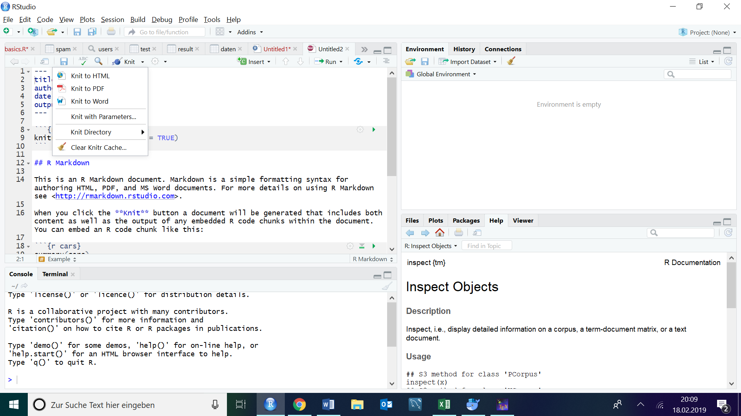If you want to generate PDF output, you will need to install LaTeX. In order to generate a report, use the "Knit" button in RStudio or use the render() command.

Figure 1. Using the „Knit“-Button to render documents

# Creating a R Markdown Document

Using RStudio click on File -> New File -> R Markdown. Select your preferred default output format. The default document will contain a header with the document title, author, creation date and output format.

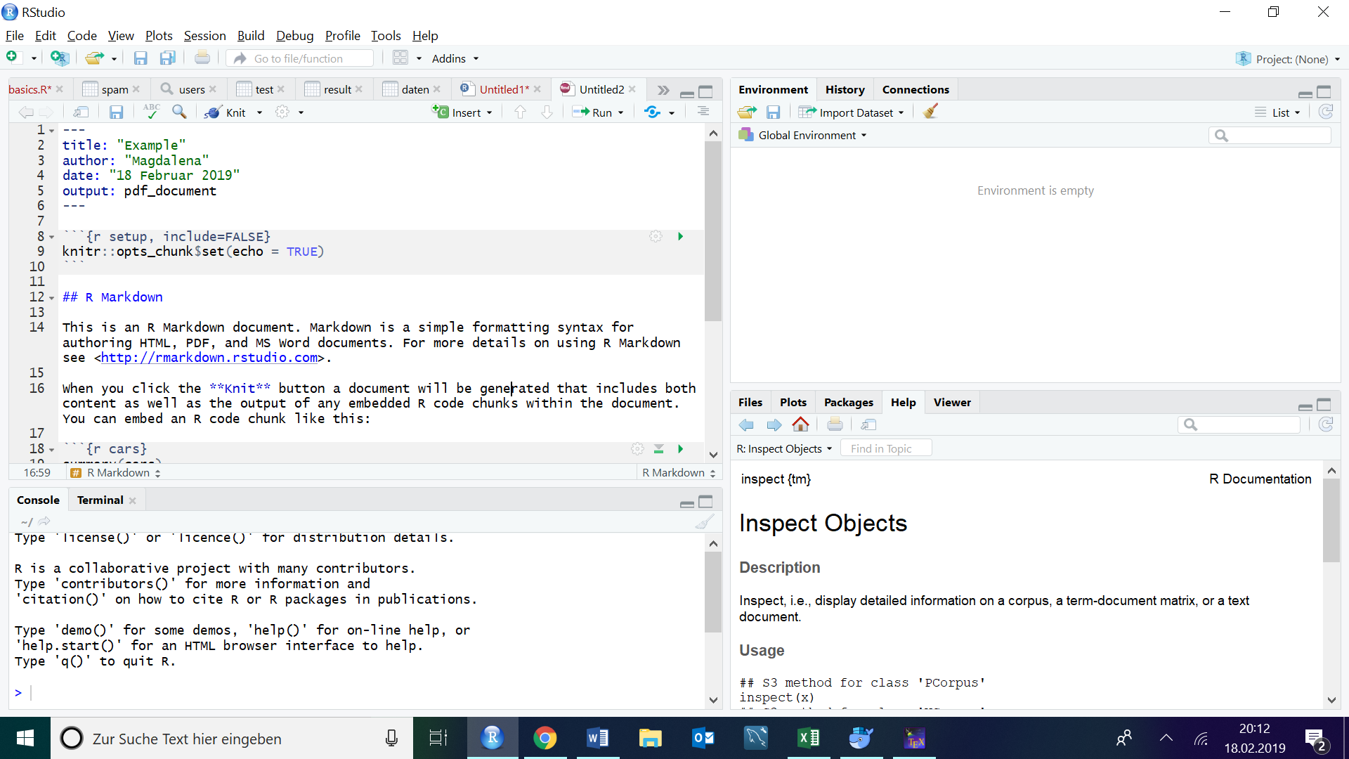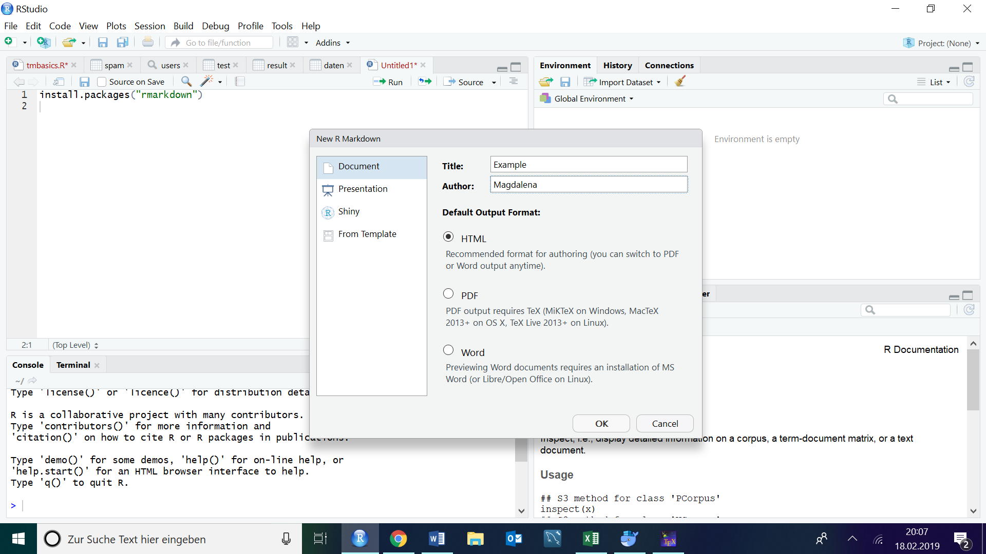

Figure . Default R Markdown File

Figure 3. Creating a R Markdown file

# Embedding R Code

# Embedding R Plots

# Transforming R Markdown Files

There are two ways to transform R Markdown Files: to knit or to convert. The *knitr* functions are already included in the R Markdown-package. Knitr will run each chunk of R code in the document and append the results of the code to the document next to the code chunk. Converting will transform the R Markdown file into a new format such as HTML, PDF or a MS Word file without changing text, code, graphs and formatting from the original file. It is common to do both these transformations in one step. For creating a report use the command rmarkdown::render().

## References

<https://rmarkdown.rstudio.com/lesson-6.html>  
<https://rmarkdown.rstudio.com/authoring_basics.html>  
<https://www.rstudio.com/wp-content/uploads/2015/02/rmarkdown-cheatsheet.pdf>