Bubba Lyrics

New England institute of technology | SE264.05 USER INTERFACE DESIGN

A website for Looking Up Hit Songs

Thomas Cass | Michael Dobachesky

Contents

Version History 2

Song Information Website 2

Technical Limitations 2

UI Design Patterns 3

User Stories 4

Diagrams of site structure 5

Rough Wireframes 8

Link To Clickable Prototype 12

User Reviews 12

Wireframes 13

Notes on Final Comps 23

Final Comps 24

Who Did What (For JavaScript Final) 34

# Version History

|  |  |  |
| --- | --- | --- |
| Version | Date | Change |
| 1.0 | 4/9/2016 | Documentation Created |
| 1.1 | 4/16/2016 | Flowcharts Revised |
| 2.0 | 4/28/2016 | Milestone two implemented |
| 2.1 | 4/30/2016 | Synced wireframe and charts |
| 2.2 | 5/8/2016 | Revamped Everything |
| 3.0 | 5/17/2016 | Added updated comps |
| 3.1 | 5/19/2016 | Added updated structure |
| 3.2 | 5/21/2016 | Update appearance for site |
| 3.3 | 5/24/2016 | Documented fine details |
| 3.4 | 5/28/2016 | Added distribution of work |

# Song Information Website

This is a website that users can go on to get all of the information about their favorite songs. Users will be able to look up lyrics and music videos, and even possibly download an mp3.

There will be three different types of users:   
**Casual User** - Can only search for and view information on songs.  
**Community User** - Can do everything a casual user can, but also has the option to add new songs to the site. A site admin will still have to approve the songs before it is uploaded.  
**Admin** - Can do everything a casual user can do but is also allowed to delete, edit, and approve songs.

# Technical Limitations

We are mainly using Bootstrap with JavaScript and PHP. We want our design to be responsive so we will have to make sure that everything is positioned appropriately. We would like to get a large number of songs from a public API, but we are not sure if we will be able to do that because of our own knowledge at the time of making this website. Bootstrap will allow us to make a responsive website that changes with the user’s device, but it alone will not be sufficient for displaying the multitude of songs that our website will hold. For this, we will need to connect to a database using PHP. Also, we would like to bring life into our website by using JavaScript. The main thing we are looking at with JavaScript is creating a carousel for displaying hits and top artists. In total, JavaScript will allow us to make the page more interactive, used with PHP for connecting to a database, and bootstrap for animating the raw HTML, we will be able to make a website where users can interactively browse and locate information on a number of different songs.

# UI Design Patterns

#### Getting Input

* Maybe a password strength meter
* Add input feedback when signing in, making an account, and adding a song
* Use good defaults on any input text boxes
* Use structured format where applicable

#### Navigation

* Add a carousel to the songs within each album, maybe even across albums
* Maybe pagination with song names instead of numbers
* Maybe an accordion menu for artists, albums, and songs
* Maybe a vertical or horizontal dropdown menu for artists, albums, and songs
* Breadcrumbs for navigation
* Home link in the top left corner
* Search bar (maybe with a drop down menu to make the artist and / or album more specific)

#### Dealing with Data

* Maybe add album art or something in a slideshow
* Allow the images to zoom
* Add autocomplete to search
* Use live filter for search

# User Stories

#### Add song

* Keyboard Access
* Form access for adding new song data
* Submit Button

#### Edit song

* Keyboard Access
* Form Access for editing current song data
* Submit Button

#### Delete song

* Keyboard Access
* Checkboxes to indicate which songs to delete
* Submit Button

#### View song info

* Keyboard Access
* Access to add, edit, delete available song data

#### Song filter

* Keyboard Access
* Drop-down menu to select filter for songs

#### Navigation

* Keyboard Access
* Ability to navigate easily through artists/songs

# Diagrams of site structure

#### Causual Landing

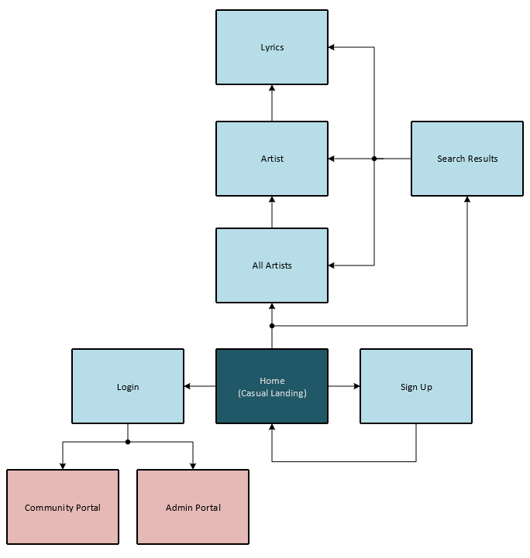

#### Community Landing

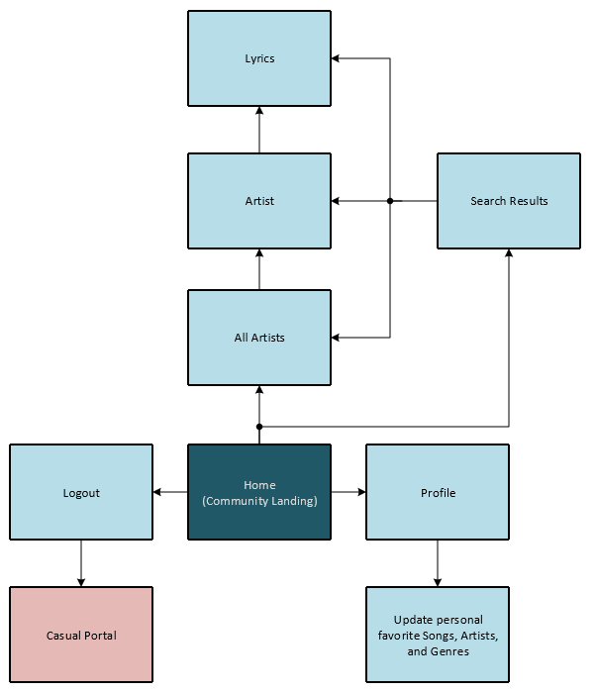

#### Admin Landing

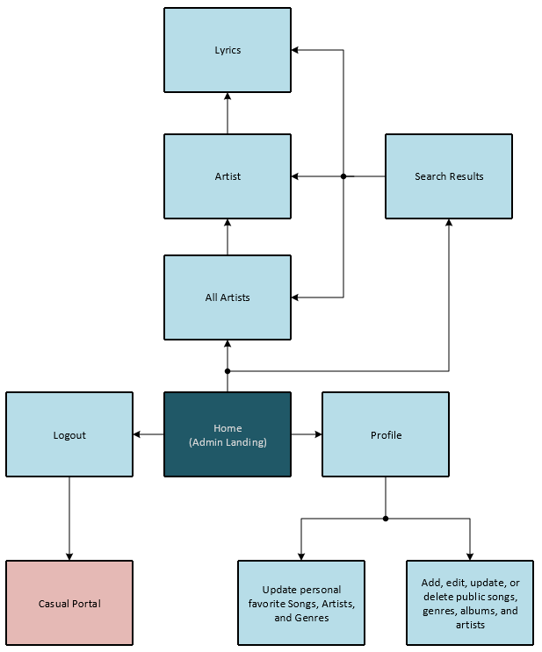

# Rough Wireframes

#### Home Page

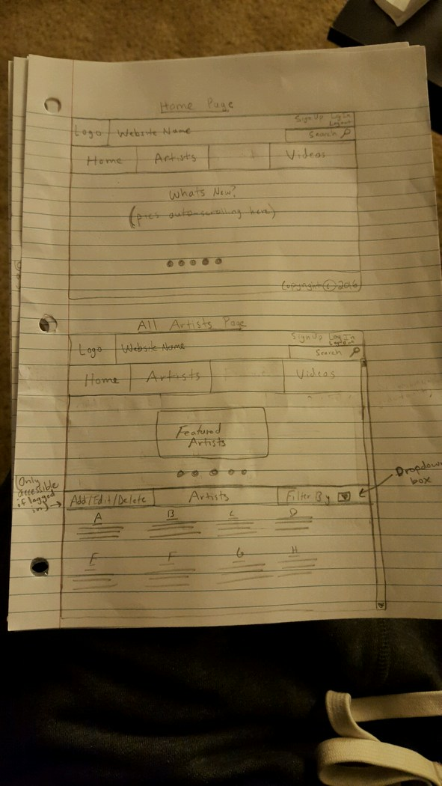

#### Sign-up / Login

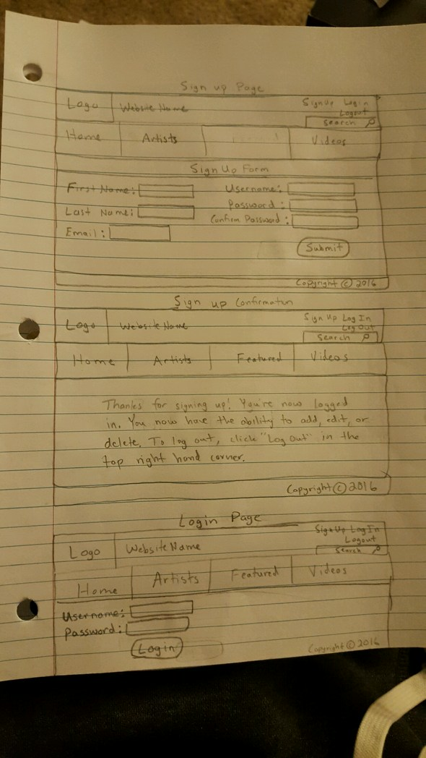

#### Artist page

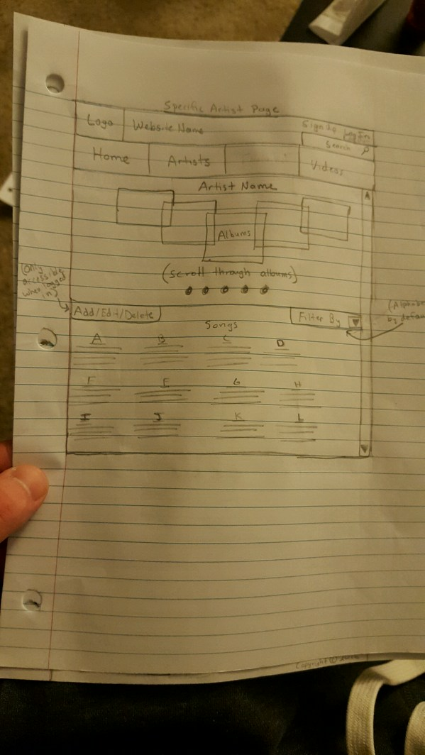

#### Videos Page

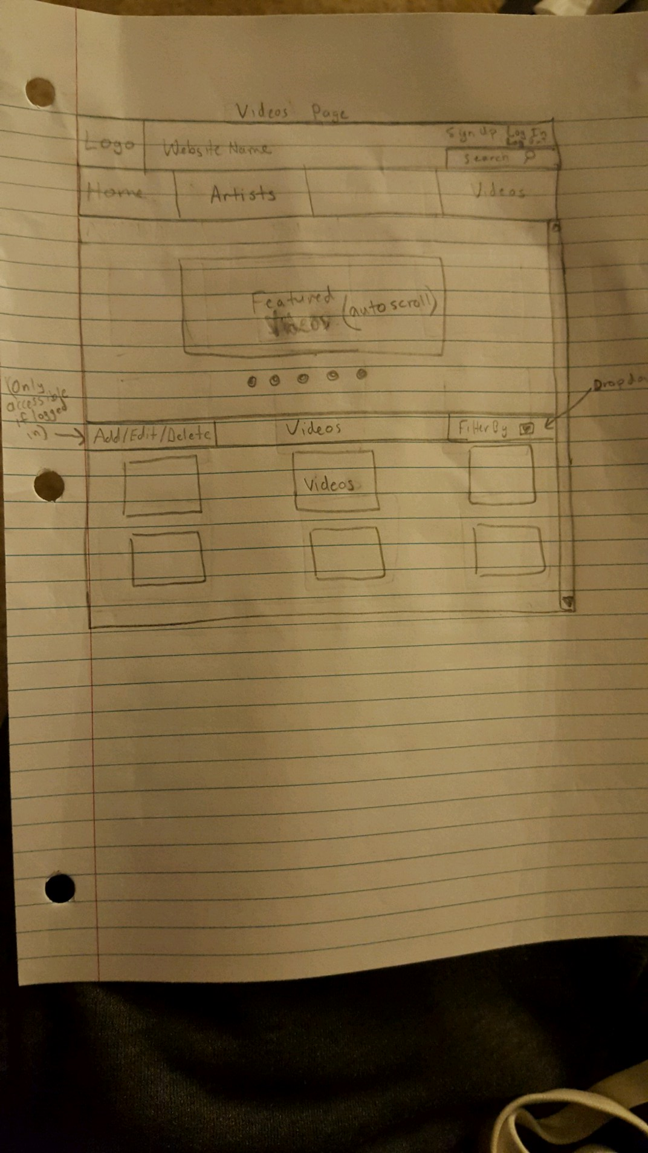

# Link To Clickable Prototype

[Bubba Lyrics Clickable Prototype](https://invis.io/Q678ILGRJ)

<https://invis.io/Q678ILGRJ>

# User Reviews

#### Inexperienced User: Jim

* Put up a top 50 or 100 instead of just 10 because people get bored with just the top 10
* Allow songs to be played and highlight the lyrics in sync with the song
* Create a bio page for artists

#### Average User: Nova

* On the news tab, the boxes look incomplete because they are falling into the footer
* The list of artists and also the list of songs should both have scroll bars
* Confused as to of the difference between all artists and specific artist
* If she wants to see the artist, she would just click the letter. She would not search so the extra search options seem redundant
* Breadcrumbs say lyrics page, they could just say lyrics
* Make less clicks to get to songs

#### Experienced User: Fred

* Not sure if the top ten is referencing artists or songs
* He likes the carousel idea
* The letter searching is redundant if a search bar exists

# Wireframes

#### Home

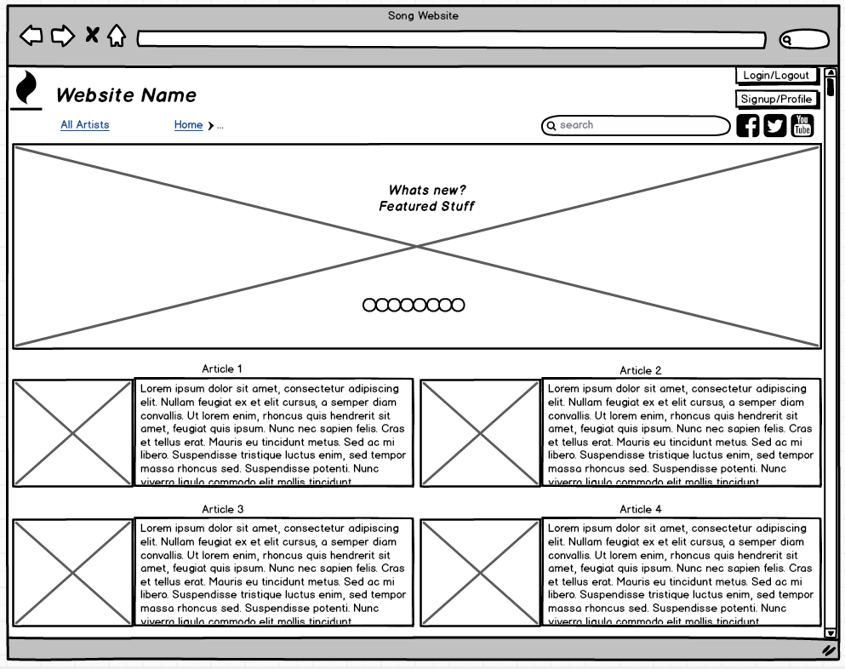

#### Sign-Up

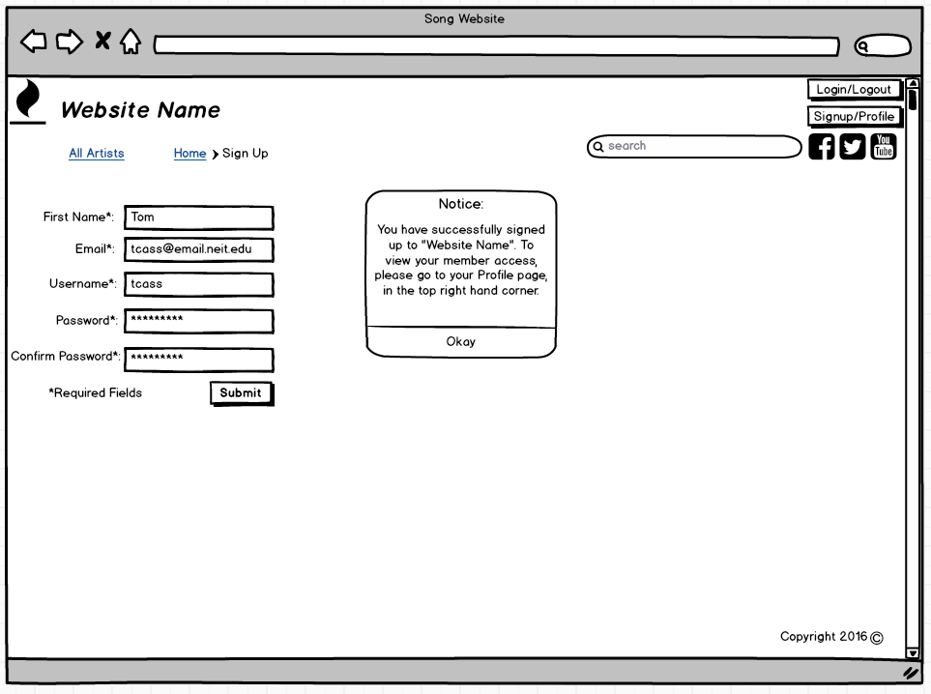

#### Log-In

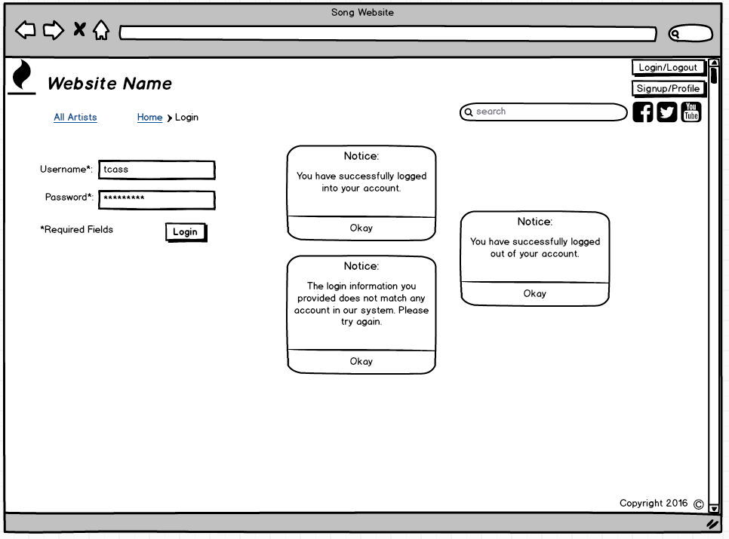

#### All Artists

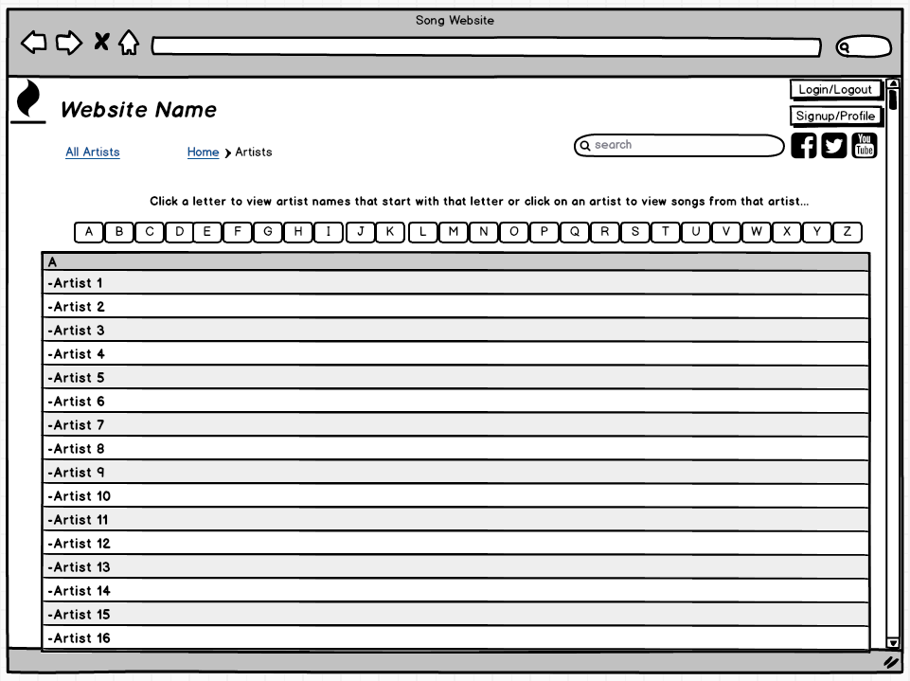

#### Specific Artist

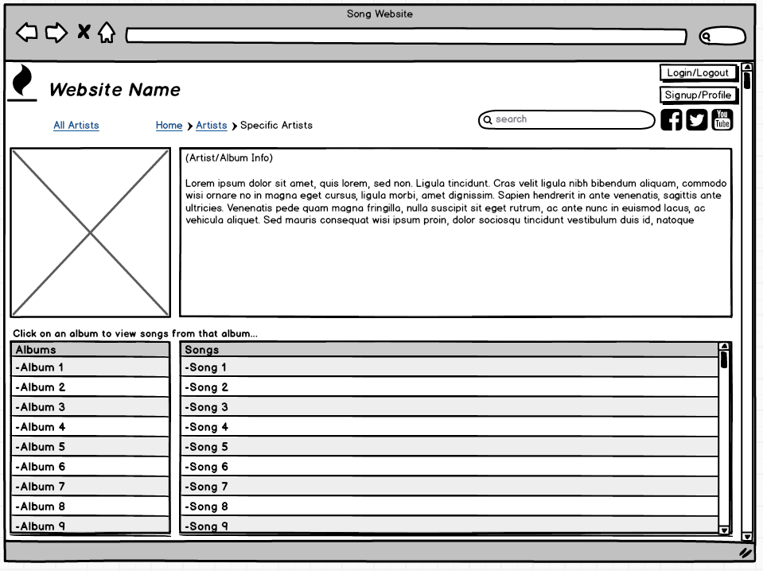

#### Song Details

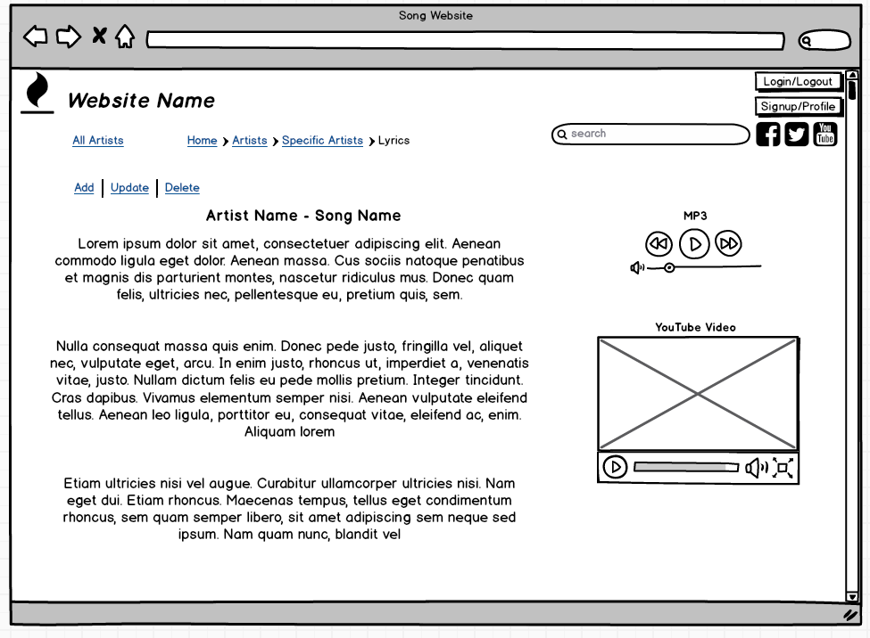

#### Profile

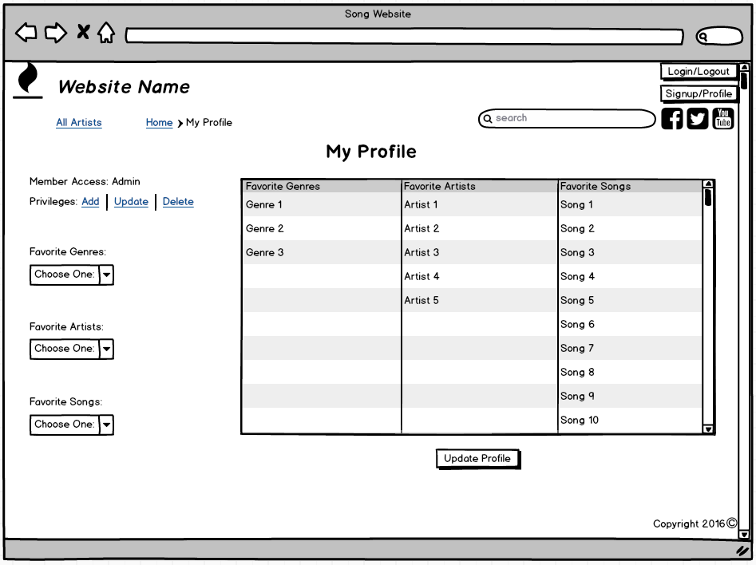

#### Add Song

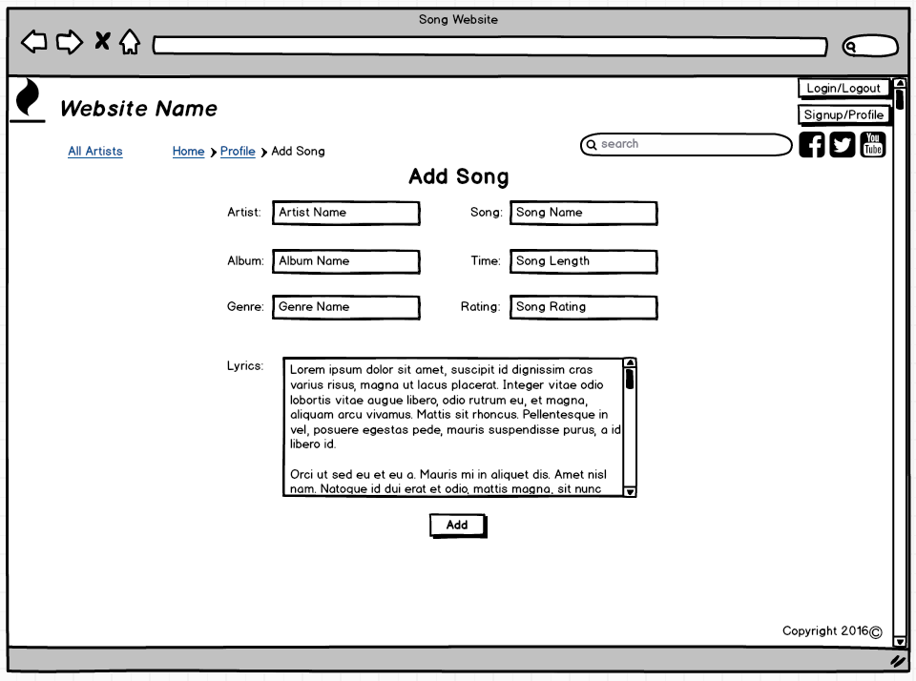

#### Update/Delete Song

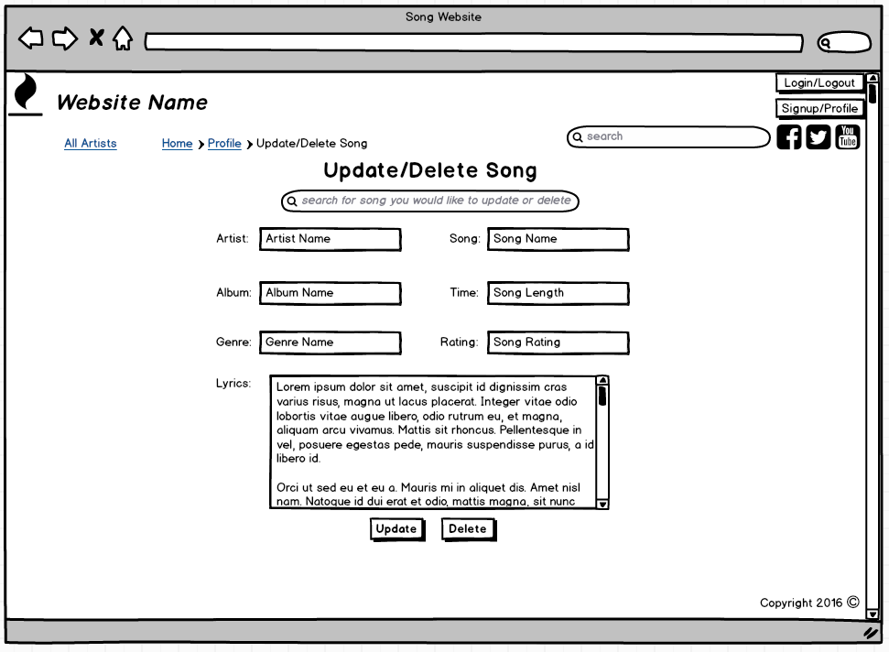

#### Search Results

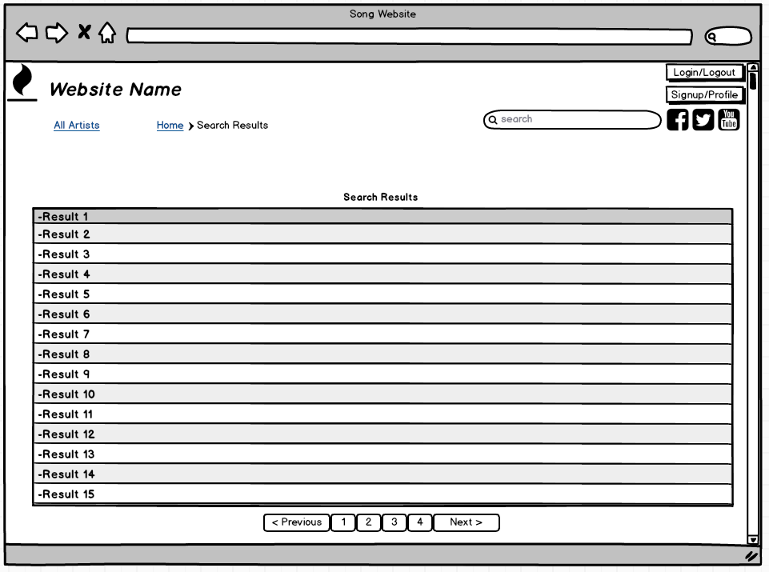

# Notes on Final Comps

#### These notes are to be used as a guide, but not strictly followed

Profile/Signup, and Login/Logout buttons are toggled when the user is logged in and logged, as noted by the slash.

Font of the header should be something that stands out like Copperplate Gothic or Papyrus.

Font size of the header should be around 30-50px on a normal size computer screen, and should scale to a similar ratio on different devices.

Content in the site should be in Bodoni, and around 10-18px on a normal computer screen. Again, scaling to different size devices.

Background should be a darker shade.

There should be a carousel on the front page with a high quality photo pertaining to music.

Search button should allow you to search thorough top artists relating to the keywords used.

On the artist page, first you will click an album, then you will choose the song in that album.

Singles should have an album of the song name with the word “single” after it.

The lyrics page should have a working mp3 and video, and the lyrics should highlight with the current position of the song.

The header should be the darkest element on the page, and the navigation the lightest.

The entire site should be responsive to the size of the window or screen it is being viewed on.

# Final Comps

#### Home

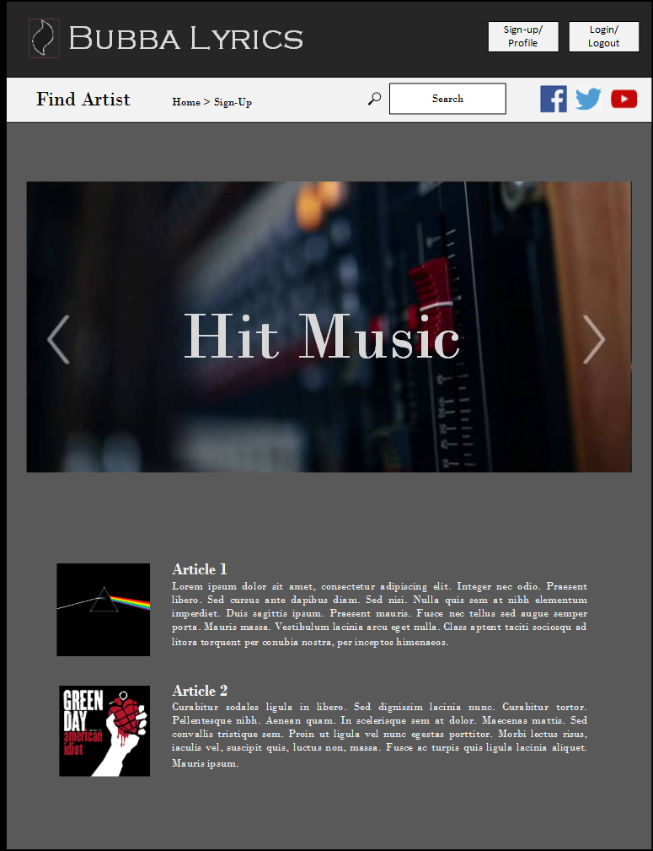

#### Sign-Up

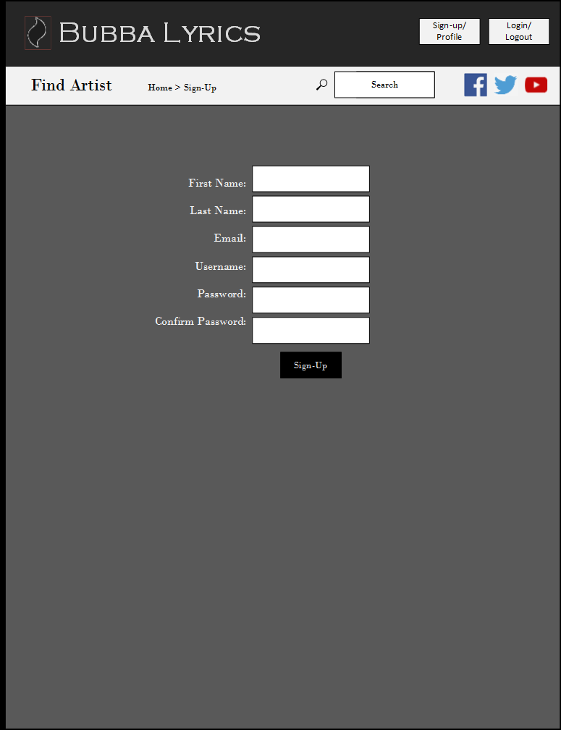

#### Log-in

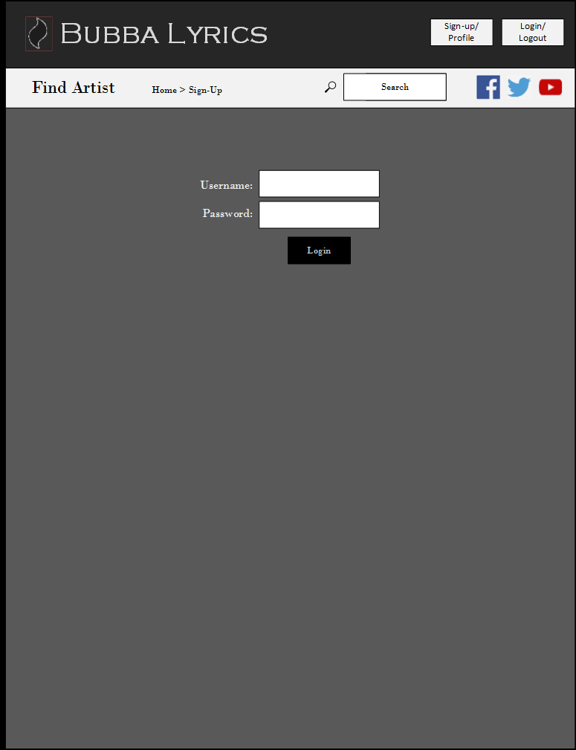

#### All Artists

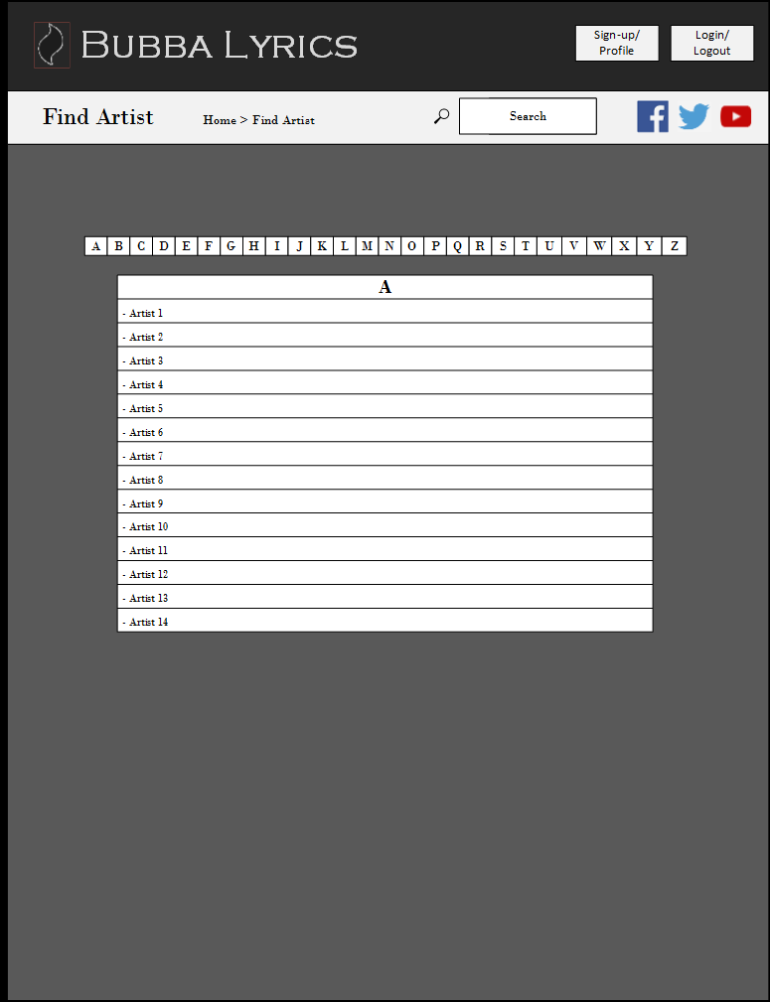

#### Specific Artist

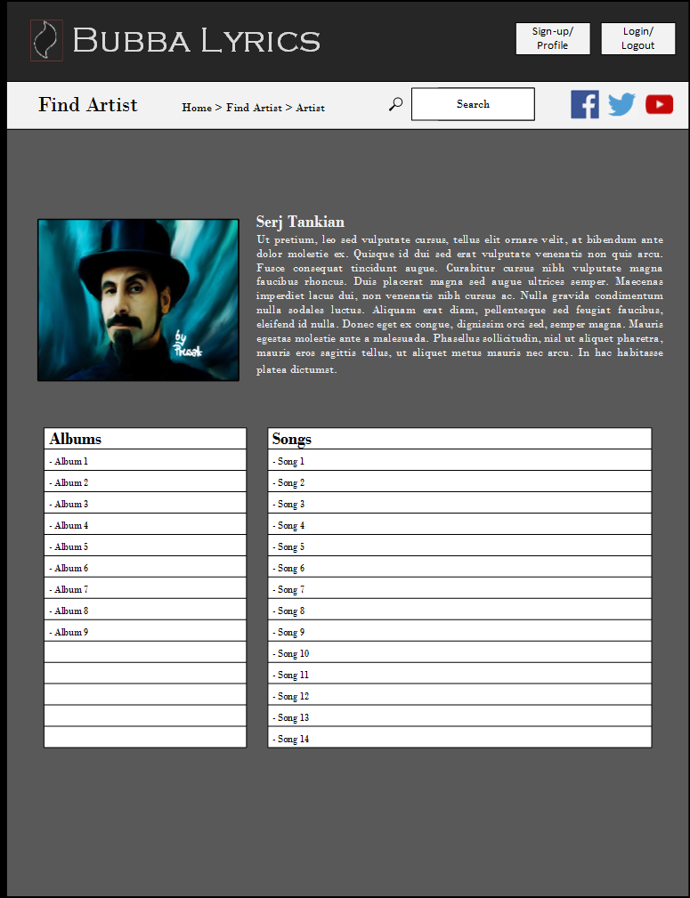

#### Song Details

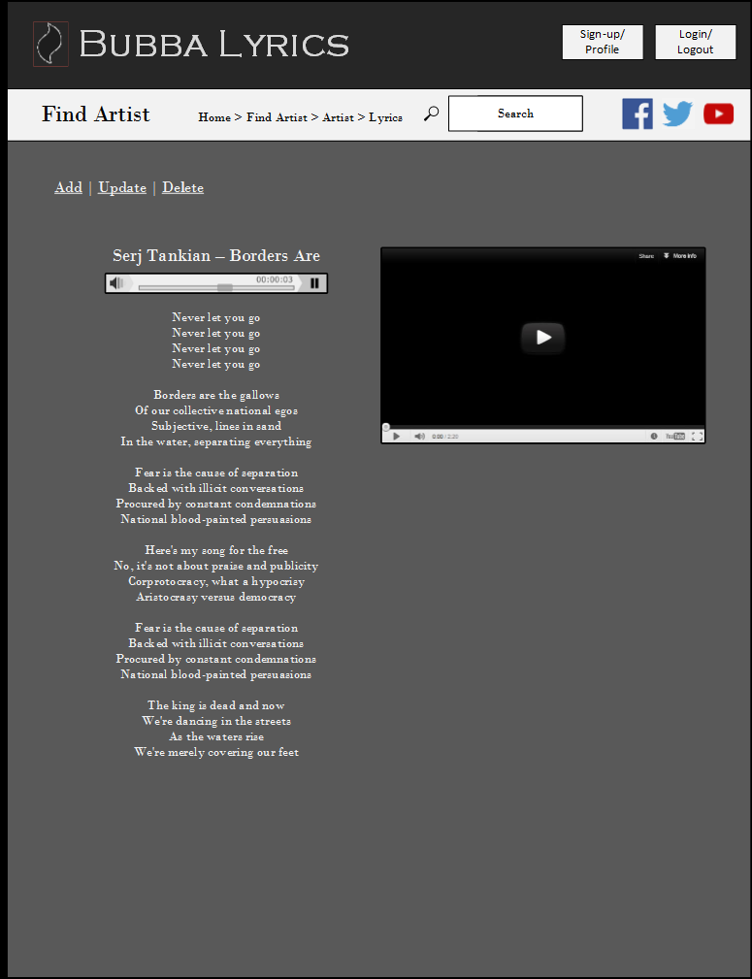

#### Profile

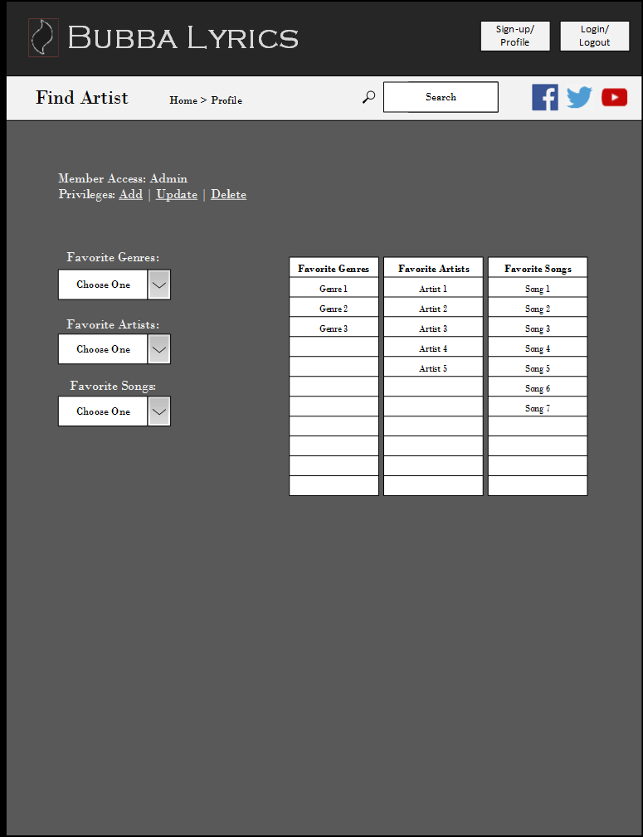

#### Add Song

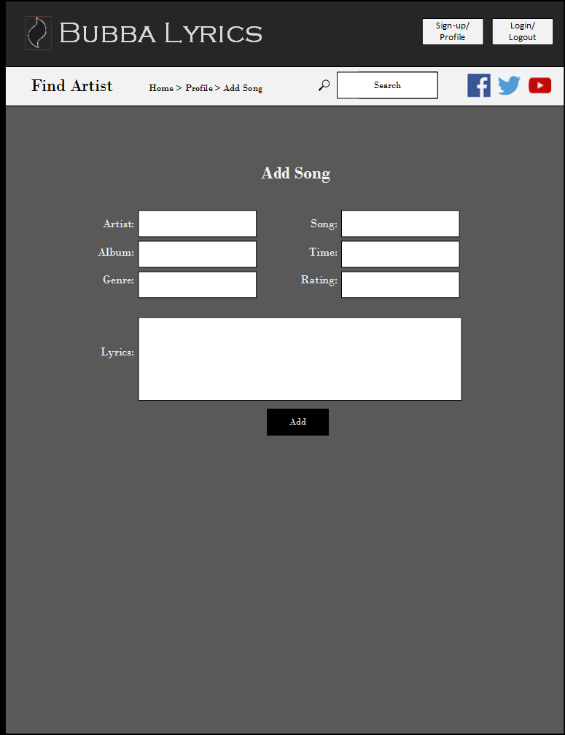

#### Update / Delete Song

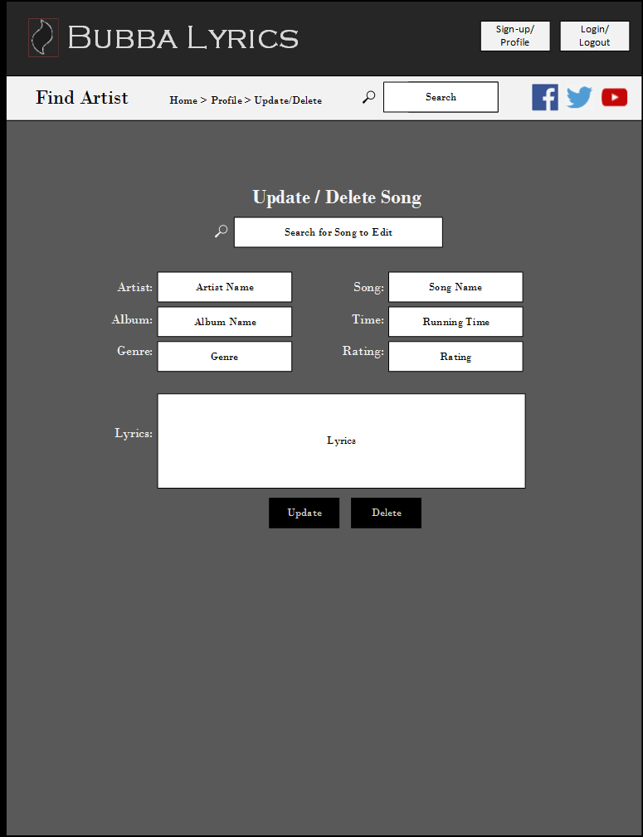

#### Search Results

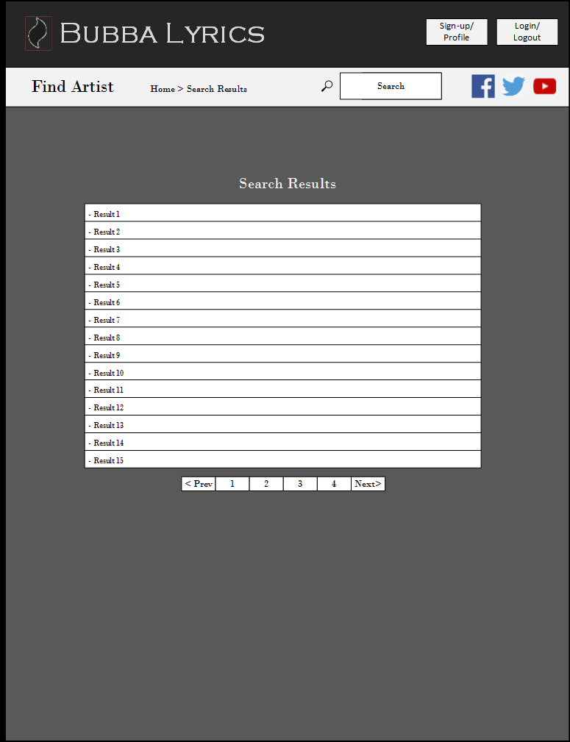

# Who Did What (For JavaScript Final)

We both did a lot of the work on this project together, so it is hard to say exactly who did what. However, there were areas where each of us might have concentrated on more exclusively. This may be true, but in the totality of it all, it’s safe to say that we mainly worked together for the majority of the project. The list that follows will give you a rough idea of where each of us concentrated our efforts the most, but don’t take it as concrete.

#### Tom Cass – Concentrated On the Front End stuff

* Rough Wire Frames
* Wire Frames
* HTML/CSS/Bootstrap
* JQuery UI
* Canvas Element
* Designing the overall look

#### Mike Dobachesky – Concentrated On the Back End Stuff

* Diagrams of Site Structure
* Final Comps
* JavaScript/Ajax Functionality
* PHP Functionality
* Database Management
* Establishing the inner workings

As previously stated, this is only a rough idea of what each of us did. In the larger picture, we both worked a together on both the front and back end of the site. However, if we must define exactly what each of us did, this list will give you somewhat of an idea.