

Bahir Dar University
Bahir Dar Institute of Technology
Faculty of Civil and Water Resources Engineering
Model Exit Exam Questions

Department: Hydraulic and Water Resources Engineering
Exam Year: 2024

Course Name: Fluid Mechanics | Course Code:
- Which of the following is the basic principle of fluid mechanics?
- Momentum principle
- Energy equation
- Continuity equatio
- All of the above mentioned
- Which of the following fluid properties is independent of the sample size?
- Extensive property
- Intensive Property
- Chemical Property
- Physical Property
....

Course Name: Hydraulics
- Which of the following is not true about an open channel flow?
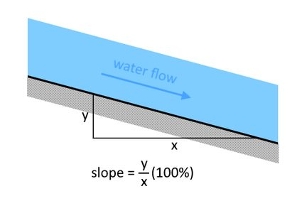
Figure 1 question 3 image example image(Note : this image is just for example)
- It is a fluid flow through some confined section with a free surface in contact with the atmosphere.
- It is a flow where the surface will have constant atmospheric pressure everywhere.
- It is a flow of water in a channel with freely flowing open ends.
- It is a flow mainly driven by the force balance between gravity and friction forces.
- None of the above

Answers
1 | D
2 | B
3 | C
5
6

