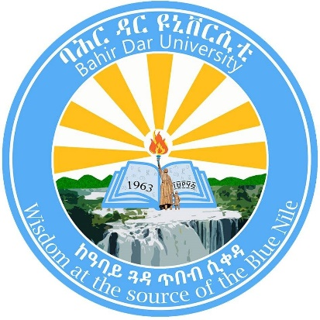

**Bahir Dar University**

**Bahir Dar Institute of Technology**

**Faculty of Civil and Water Resources Engineering**

**Model Exit Exam Questions**

**Department: Hydraulic and Water Resources Engineering**

**Exam Year: 2024**

|  |  |
| --- | --- |
| **Course Name: Fluid Mechanics** | **Course Code:** |

1. Which of the following is the basic principle of fluid mechanics?
2. Momentum principle
3. Energy equation
4. Continuity equatio
5. All of the above mentioned
6. Which of the following fluid properties is independent of the sample size?
7. Extensive property
8. Intensive Property
9. Chemical Property
10. Physical Property

....

### **Course Name: Hydraulics**

1. Which of the following is not true about an open channel flow?

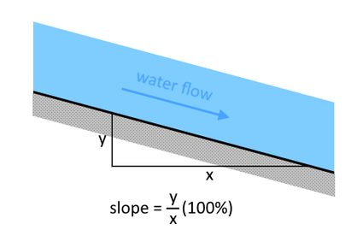

Figure 1 question 3 image example image(**Note** : this image is just for example)

1. It is a fluid flow through some confined section with a free surface in contact with the atmosphere.
2. It is a flow where the surface will have constant atmospheric pressure everywhere.
3. It is a flow of water in a channel with freely flowing open ends.
4. It is a flow mainly driven by the force balance between gravity and friction forces.
5. None of the above

**Answers**

|  |  |
| --- | --- |
| 1 | D |
| 2 | B |
| 3 | C |
| 5 |  |
| 6 |  |