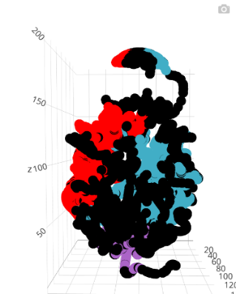One page summary

# Compartmentalization

Two schemes**:** **Rough**(Internal, External, Hat), and **Continents**(Laurasia, Godwana, Antarctica, Tethys).

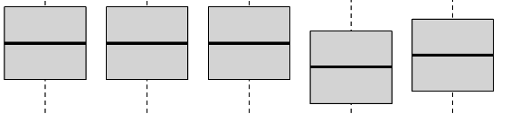Land continents of **higher than average** coexpression, separated by Ocean of **lower than average**.

Laurasia and Godwana are the larger. They occupy opposite sides. Antarctica is smaller, made of centromeres. Tethys is rich in genes having to do with “Metabolic pathways”.

# Promoter-site histone profile sphere test

7 completely distinct clusters, 3 of which in Laurasia, another 3 in Godwana (opposite sides).

Slight shift of histone distribution in all histones/all 7 clusters.

Term enrichments in the 4 larger: Terpenoid biosynthesis, Ribosomal binding and TF motifs.

Without exception, these clusters under-represent duplicated genes.

# Transcription factor motifs Jaccard distance sphere test

4 small clusters, 3 of which near the centromeric pole, the smaller 4th occupying a quadrant of the Hat, in the **insulator** (“Tethys”) region.

This cluster yields a rich collection of enrichments due to its 4 “special” genes.

The other 3 yield enrichments as well.

# Pairwise gene coexpression score sphere test

Almost half of the spheres have a significant (PAdj < 1%) average coexpression score. We use these to construct the Continents compartmentalization. Most important is distinction between land and sea.

# Signals not yielding clusters are SSD/WGD, Species count/Taxa

# Histone profile 1D search

Extracted 12 segments of low entropy. Spread around all continents.

Almost all relevant genes hidden in “Internal” region.

One of them (**II**) enriched in **acetyl-CoA transmembrane transporter activity.**

3 of them (**IV-A, VII-B, X**) enriched in TF motifs.