Subscription Database

Mitchell Gerber and Jason Carpenter

We will be creating a subscription service that is based off of an MMO style game. Systems like this retain and manipulate large amounts of user data and developer data. To approximate this we will create a multi-table, multi-ui, and multi-data manipulating system.We plan to create a back end system that will utilize a MySQL database to store user and game information. We will also create a front end user interface to simulate actions within an actual game. The user interface will also offer admin support to add additional content to the game system. It will store and hold user data, purchase data, and subscription statuses. The source of our data will be generated examples done by hand as most of the data is user specific. Five data tables will be utilized. A User Data table, which will contain Name, Username, and last-name and person specific account information. There will be a purchase database with credit card info, subscription length remaining, and purchase success. There will be a user service data, which will hold in avatar information, location, and game data. We will also utilize a guilds table which will contain player association lists, similar to a friends list from other social media applications. There will be a game data table which will have quest information, location in world, and various other details. The user ui will have a quests log that will allow completion of quests from the page. This will manifest as a Boolean indicator in the quests table.

The application will consist of several ui pages. A primary login page for user’s that are already subscribed. Upon login the user will be presented with a ui that displays the combined data from the user table, purchase table, and guild table. A basic logout and register page will also be included. This will be handled as JSPs running from a servlet. A user will login and be able to access their purchases, user game data, and generic user data. If they are not registered they will be prompted with a register page. Admin’s will have authority to add game content, remove users, and manage payment data.

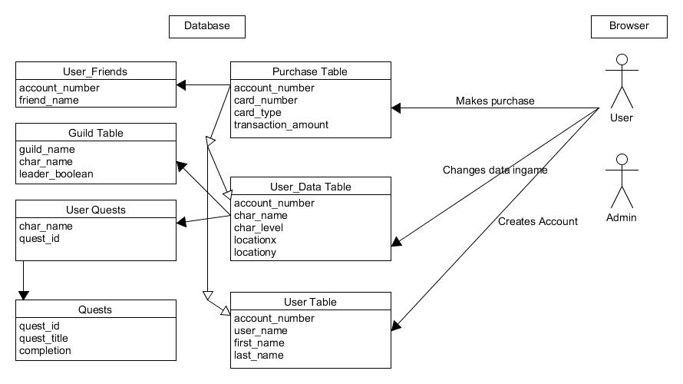

Tiered design:

1. A browser ui for users and a ui for admins to add/manipulate data

2. A data filter for input and output formatting

3. The database itself divided into the tables shown in the graph