Function toPolar2d

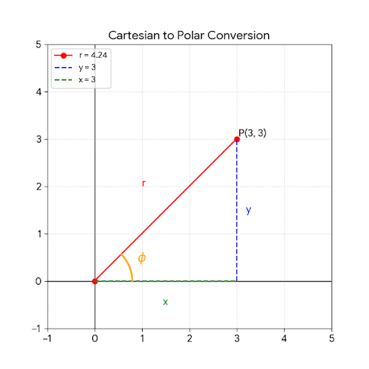
The graphic below illustrates the relationship between Cartesian coordinates $(x, y)$ and Polar coordinates $(r, \phi)$ as implemented in your toPolar2d method.
Mathematical Components
In the transformation from Cartesian to Polar coordinates, we represent a point $P(x, y)$ in terms of its distance from the origin and its angle relative to the positive $x$-axis:
- Radius ($r$): The Euclidean distance from the origin $(0,0)$ to the point $P(x,y)$.
$$r = \sqrt{x^2 + y^2}$$
In Java, this is computed using Math.sqrt(x*x + y*y) or Math.hypot(x, y).
- Phase ($\phi$ or $\text{phi}$): The angle (in radians) between the positive $x$-axis and the line connecting the origin to $P$.
$$\phi = \operatorname{atan2}(y, x)$$
The Math.atan2(y, x) function is superior to $\arctan(y/x)$ because it:
  - Handles the case where $x = 0$ (vertical lines).
  - Correctly identifies the quadrant (I, II, III, or IV) based on the signs of both $x$ and $y$.
  - Returns a value in the range $(-\pi, \pi]$.
Visual Representation
The generated plot shows a point $P(3, 3)$:
- The green dashed line represents the $x$ component.
- The blue dashed line represents the $y$ component.
- The red solid line is the radius $r$, which is the hypotenuse of the right triangle formed by $x$ and $y$.
- The orange arc represents the angle $\phi$ (in this case, $45^\circ$ or $0.785$ radians).
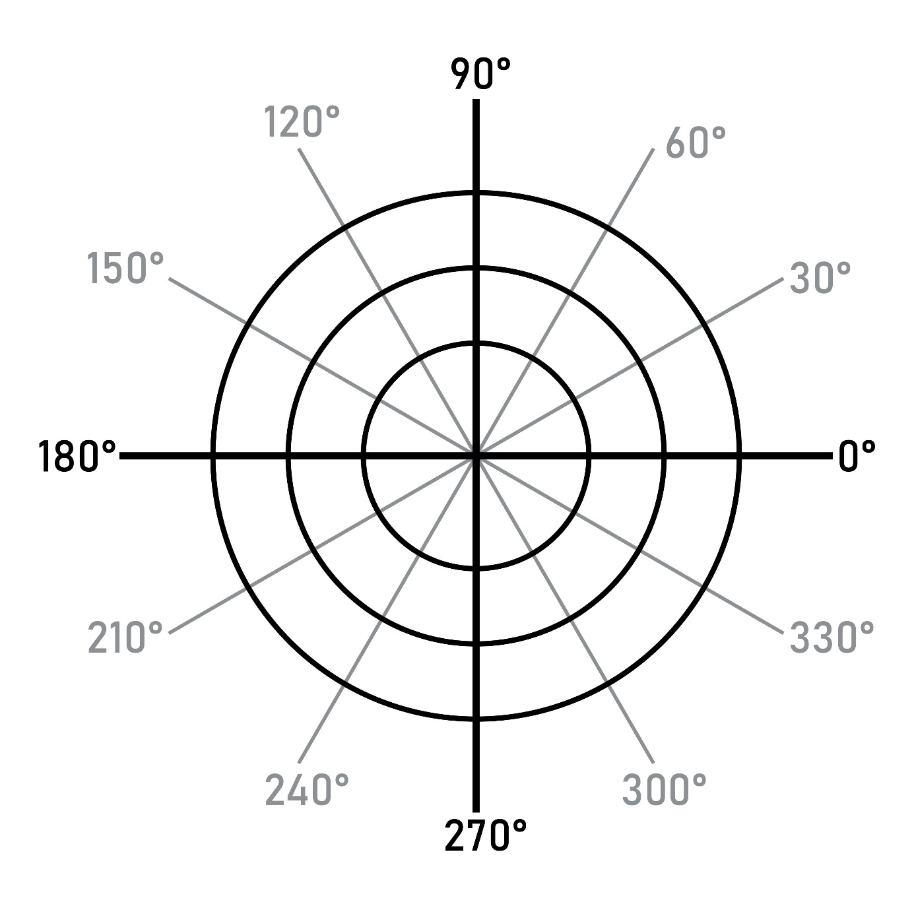
Shutterstock
Range and Units
- $r$ is always non-negative ($r \ge 0$).
- $\phi$ is measured in radians. As you noted in your previous questions:
  - $\pi/2 \approx 1.57$ rad $\rightarrow 90^\circ$
  - $\pi \approx 3.14$ rad $\rightarrow 180^\circ$
  - $-\pi/2 \approx -1.57$ rad $\rightarrow -90^\circ$ (or $270^\circ$)

