**Dementia Friendly Music Player**

<http://DementiaMusicPlayer.org>

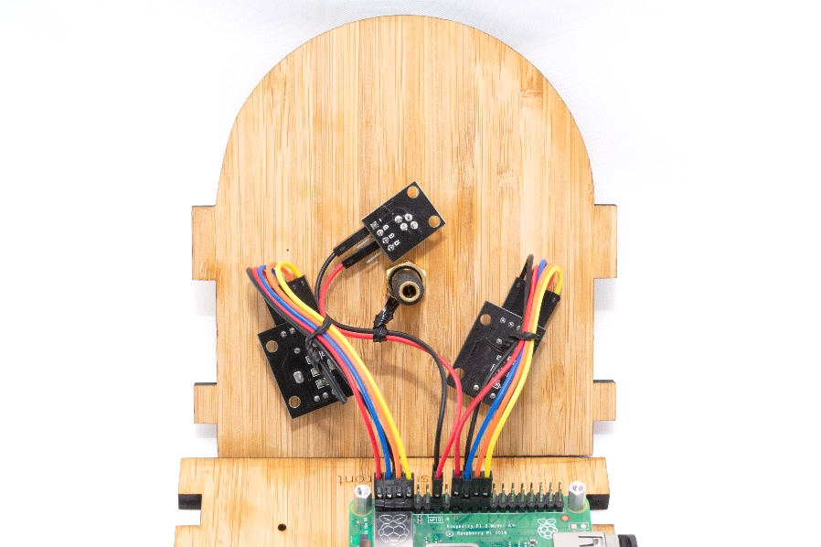

**What is it?**

* A music player designed for people with dementia
* I was inspired by the documentary [Alive Inside](https://www.youtube.com/watch?v=8HLEr-zP3fc) that shows that people with dementia can experience profound joy when listening to their favorite music
* People with dementia have likely forgotten how to use modern devices like phones and CD players
* The vintage style invokes memories from youth - as those memories tend to be the strongest
* It worked for my Dad - he knew what do without any help!
* So I open sourced the plans and it is working for others too

**Is it easy to make one?**

* Yes! No soldering, no woodworking
* You order all of the parts online, and then put them together
* Just follow the step-by-step instructions, takes 3-5 hours

**What does it cost?**

* The plans & software are free of course
* You buy the parts from Amazon etc. (I don’t sell anything)
* The parts cost $75-$215, depending on the model, or $45-$120 if you make 10+ units at once

**What about the wood case?**

* Most people order the case from an online laser shop (included in the costs above)
* But you are welcome to laser cut or 3D print it yourself and save some money

**Where is the music?**

* On a regular USB thumb drive

**How do I get started?**

* Choose a model – see below

**Choose a Model**

|  |  |  |  |  |  |
| --- | --- | --- | --- | --- | --- |
|  | **Use headphones?** | **Use external powered speakers?** | **Built-in speakers?** | **Speakers auto mute with headphones?** | **Parts cost & notes** |
| **Standard Model – Bamboo** | ✓ | ✓ | X | X | * **This is probably the model you want – easy to make, versatile** * Good choice if only used with headphones or only used with external powered speakers * If the need is to switch often between headphones and speakers, consider the Deluxe model instead * The case is laser cut bamboo * [Step by step building instructions with photos](https://drive.google.com/file/d/1LcmB_fAMv4CN2TgR8uXmKdnNxFXOQQqo/view) * Parts: ~$140, or ~@$65 for 10+ units |
| **Standard Model – 3D Printed** | ✓ | ✓ | X | X | * Same as the standard model above, but 3D printable * 3D print it yourself or with your 3D printer friend * If the need is to switch often between headphones and speakers, consider the Deluxe model instead * [Step by step building instructions with photos](https://drive.google.com/file/d/1-zkX9R0WrLMp0yBKbd908232atTdkMPl/view) * Parts: ~$55, or ~@$45 for 10+ units |
| **Plus Model - Bamboo** | X | X | ✓ | X | * Built-in speakers - not intended for use with headphones or external speakers * The case is laser cut bamboo * Not difficult to make, but somewhat harder than those above * [Step by step build instructions with photos](https://drive.google.com/file/d/1uoR0IgDkjAgpxgIjOMJj7dMlVibkeWGc/view) * Parts: ~$200, or ~@$95 for 10+ units |
| **Deluxe Model – Cherry** | ✓ | ✓ | ✓ | ✓ | * When headphones are plugged in, the built-in speakers automatically mute * The case is laser cut cherry MDF * Not difficult to make, but somewhat harder than those above * [Step by step build instructions with photos](https://drive.google.com/file/d/1StA9wp04A96cAVZujWYcxH7HCvyK77GH/view) * Parts: ~$250, or ~@$120 for 10+ units |