**Instructions for running the celebrity-pet paradigm**

**Before starting -**

* Connect the DAQ-cable to the laptop.
* Restart the laptop
* Restart Blackrock computer
* Connect microphone
* Make sure wireless connection is off
* Make sure you know which version to run [1-4] – **the same version should be chosen before sleep and after sleep** (learning and testing)
* START RECORDING
* START Blackrock-Clinical system TTL (make sure you see it on the screen)

**Load Paradigm –**

All files are located under –

/Users/CNLmac3/Documents/Paradigms/visualPAL_v2/

1. Write in Matlab

/Users/CNLmac3/Documents/Paradigms/visualPAL_2/visualPAL_RUN_ME

1. **Send TTLs?** press YES
2. **Patient’s number** – enter 3 digits (i.e. 112)
3. What part –

**0** – is just for demonstrating the task – before starting, walk the patient through the slides and explain the idea -

**Make sure they say the name of the animals out**-**loud** – and emphasize they need to think of a link between person and pet.

**1** – Learning and testing #1 –

1. **Learning -** make sure the patient can name ALL the animals (we don’t care if the name is correct).
2. Testing – please fill in the table on pg 3

**2** – Testing #2 (usually after nap) – Remind them what is the task – After each image they should select YES (left key) if they remember it or NO if they don’t. If they do remember they will be asked what pet was associated with the person.

please fill in the table on pg 4

5) Choose test version [1-3] – same version should be chosen for learning and testing !

**Instructions for training –**

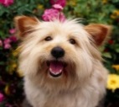

**Learning** - You'll see 25 pairs like this one -

Focus on memorizing the animal on the left.

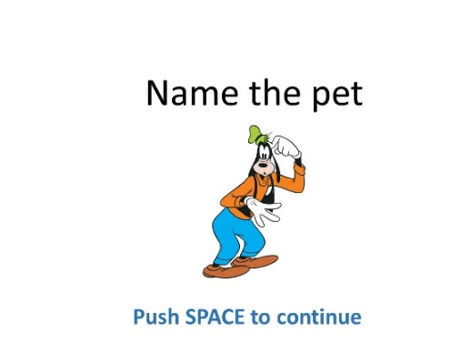

**Say the name of the animals out**-**loud** – **take your time - try to make up a sentence that will help you memorize the pet for each owner**

**Instructions for Testing –**

**Make sure the microphone is next to subject and you have a pen+paper to write the answers**

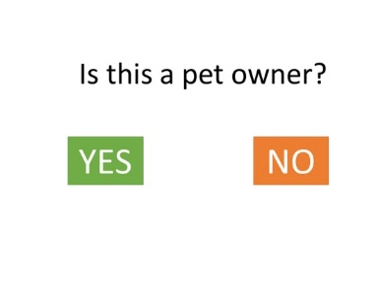

**LEFT ARROW = YES**

**RIGHT ARROW = NO**

1. 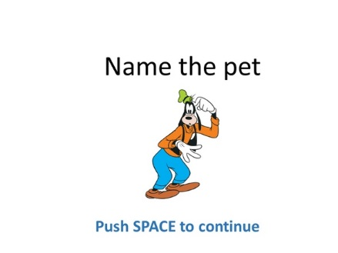

**LEFT ARROW = YES**

**RIGHT ARROW = NO**

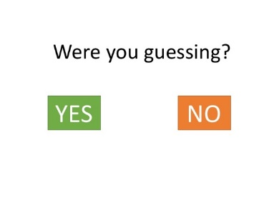

**APPENDIX A – General questions**

**Pt # ______ Age ___________ Gender ___________**

**Handness (right\left) ___________**

**Last seizure __________________**

**Test version [1-3] ______________**

|  |  |  |  |  |
| --- | --- | --- | --- | --- |
|  | **Date** | **Start time** | **Time from last sleep** | **End time** |
| Started pre-nap learning |  |  |  |  |
| Nap time |  |  |  |  |
| Started post-nap testing |  |  |  |  |

**When did you wake up from your last sleep period and how long was it?**

**Are you taking any medication that may affect your sleep?**

**Did you manage to sleep through the nap (well\partially\not at all)?**

**General comments\suggestions -**

**TESTING RESULTS – PRE NAP**

|  |  |  |  |
| --- | --- | --- | --- |
| **IMAGE NUMBER**  **(Left side of screen)** | **Is this a pet owner?**  **(Y/N)** | **Name of the pet: Enter -**  **Name**  **X** if doesn’t remember  __ Leave empty if this is not a  pet owner | **Comments?** |
| **1** |  |  |  |
| **2** |  |  |  |
| **3** |  |  |  |
| **4** |  |  |  |
| **5** |  |  |  |
| **6** |  |  |  |
| **7** |  |  |  |
| **8** |  |  |  |
| **9** |  |  |  |
| **10** |  |  |  |
| **11** |  |  |  |
| **12** |  |  |  |
| **13** |  |  |  |
| **14** |  |  |  |
| **15** |  |  |  |
| **16** |  |  |  |
| **17** |  |  |  |
| **18** |  |  |  |
| **19** |  |  |  |
| **20** |  |  |  |
| **21** |  |  |  |
| **22** |  |  |  |
| **23** |  |  |  |
| **24** |  |  |  |
| **25** |  |  |  |
| **26** |  |  |  |
| **27** |  |  |  |
| **28** |  |  |  |
| **29** |  |  |  |
| **30** |  |  |  |
| **31** |  |  |  |
| **32** |  |  |  |
| **33** |  |  |  |
| **34** |  |  |  |
| **35** |  |  |  |
| **36** |  |  |  |
| **37** |  |  |  |
| **38** |  |  |  |
| **39** |  |  |  |
| **40** |  |  |  |

**TESTING RESULTS – POST NAP**

|  |  |  |  |
| --- | --- | --- | --- |
| **IMAGE NUMBER**  **(Left side of screen)** | **Is this a pet owner?**  **(Y/N)** | **Name of the pet: Enter -**  **Name**  **X** if doesn’t remember  __ Leave empty if this is not a  pet owner | **Comments?** |
| **1** |  |  |  |
| **2** |  |  |  |
| **3** |  |  |  |
| **4** |  |  |  |
| **5** |  |  |  |
| **6** |  |  |  |
| **7** |  |  |  |
| **8** |  |  |  |
| **9** |  |  |  |
| **10** |  |  |  |
| **11** |  |  |  |
| **12** |  |  |  |
| **13** |  |  |  |
| **14** |  |  |  |
| **15** |  |  |  |
| **16** |  |  |  |
| **17** |  |  |  |
| **18** |  |  |  |
| **19** |  |  |  |
| **20** |  |  |  |
| **21** |  |  |  |
| **22** |  |  |  |
| **23** |  |  |  |
| **24** |  |  |  |
| **25** |  |  |  |
| **26** |  |  |  |
| **27** |  |  |  |
| **28** |  |  |  |
| **29** |  |  |  |
| **30** |  |  |  |
| **31** |  |  |  |
| **32** |  |  |  |
| **33** |  |  |  |
| **34** |  |  |  |
| **35** |  |  |  |
| **36** |  |  |  |
| **37** |  |  |  |
| **38** |  |  |  |
| **39** |  |  |  |
| **40** |  |  |  |