- In the header, include a heading element with a title for the home page, then add another heading element with the purpose or tagline for the website. In the nav area, include links (using an unordered list) you will provide to the other webpages in the website.
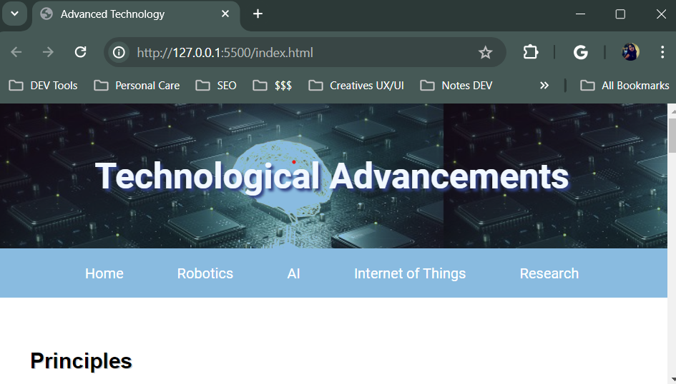
- You now need to add image to your home page, create two new pages for your website, add a list, add more images, and include absolute links that open in a new tab.
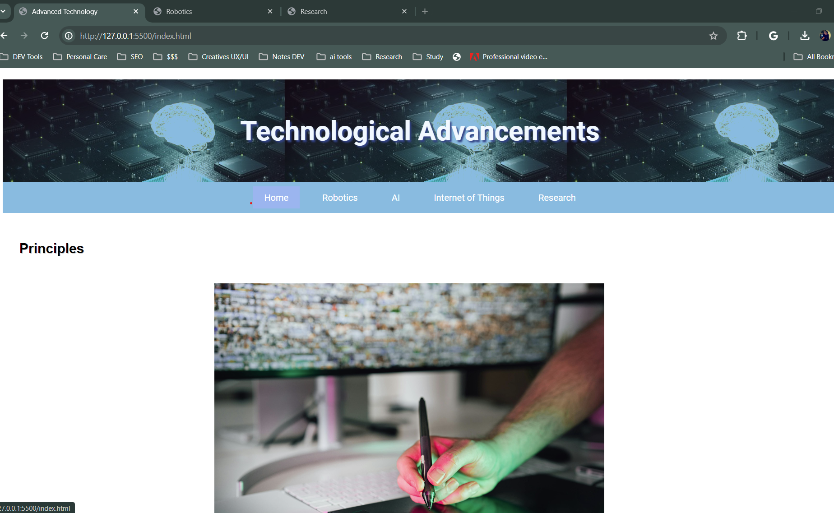
- Add a hero image to the home page for your website. You may use the tech-banner.png.
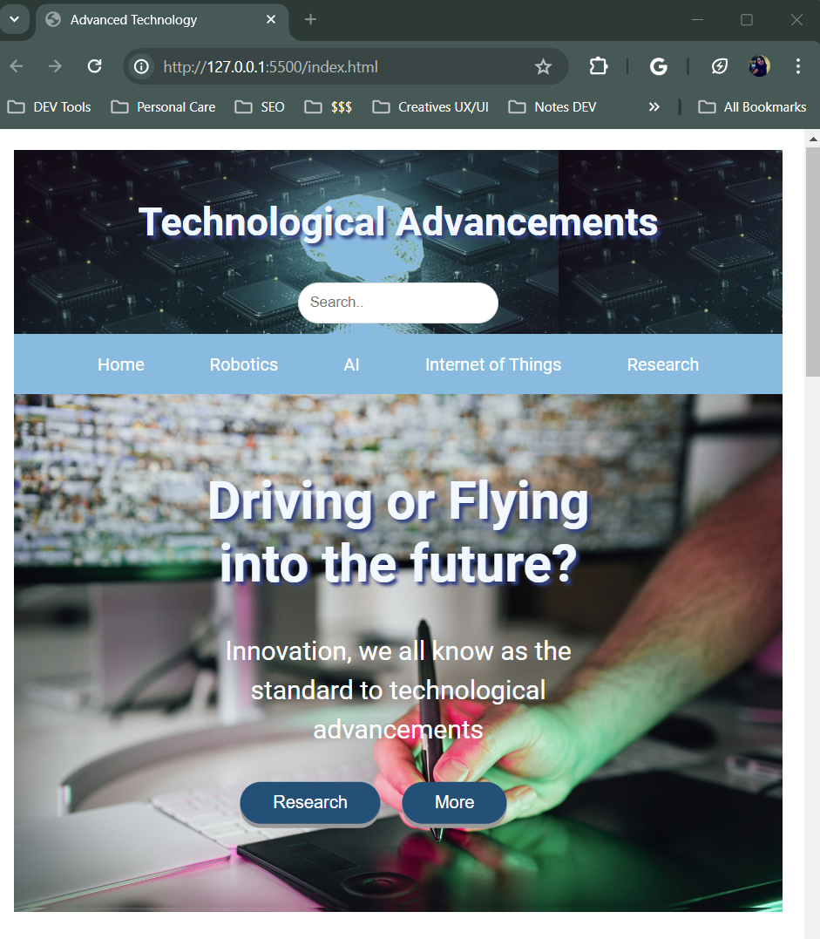
- Add a table to one of your webpages. Use a minimum of four rows and three columns for your table. Use at least one rowspan or colspan within your table.
Added table on Chat GPT page:
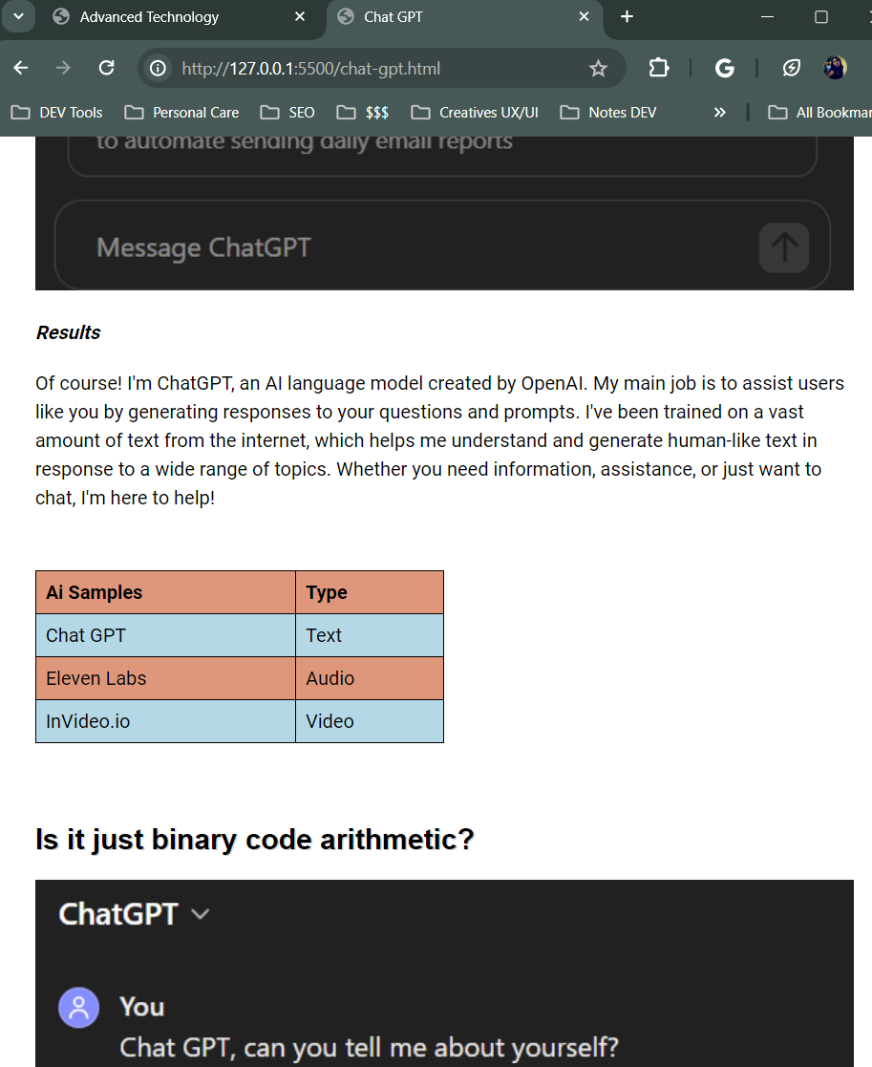
- Add a form to your website. Include a minimum of eight form elements, including a Submit button. Include at least two fieldsets and two legends. Add the required attribute to at least two input elements. The form should uses the method="post" and action=https://webdevbasics.net/scripts/demo.php
Added it to research.html
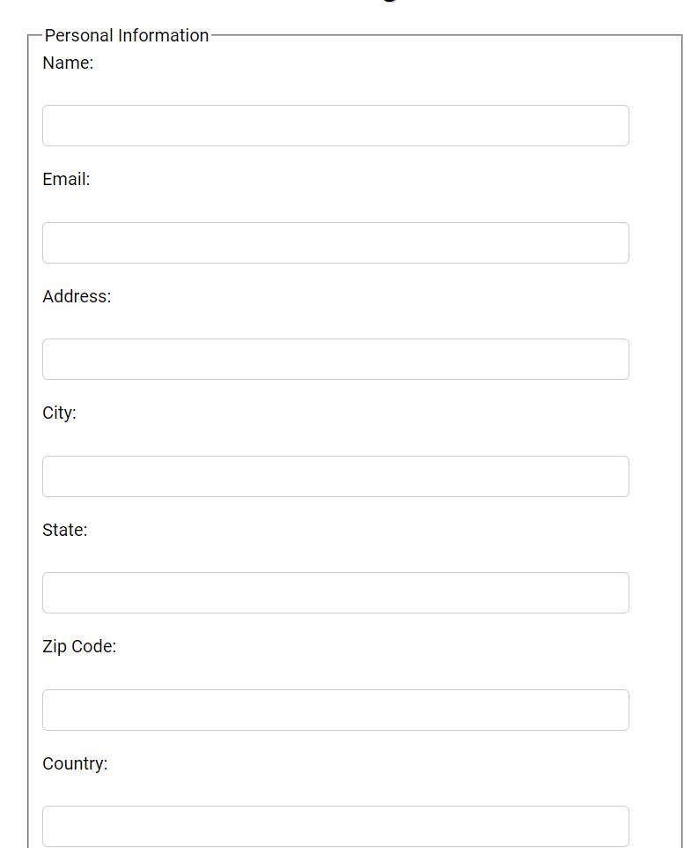
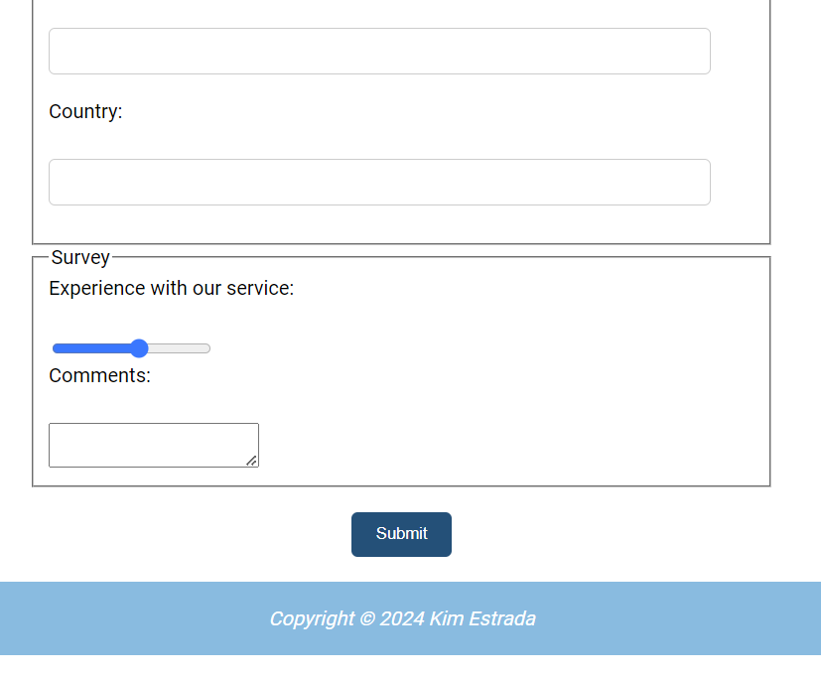
- Add the audio element with controls to a webpage within your website. You may create an audio file or research the Internet for royalty-free audio resources. Create two audio files, using the MP3 and Ogg file formats. And Provide fallback text for legacy browsers that do not support the audio element.
Added Audio to research.html
Fallback code in html:
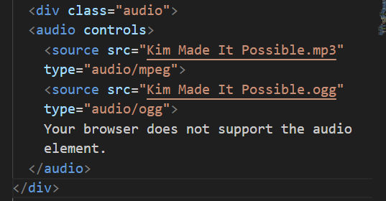
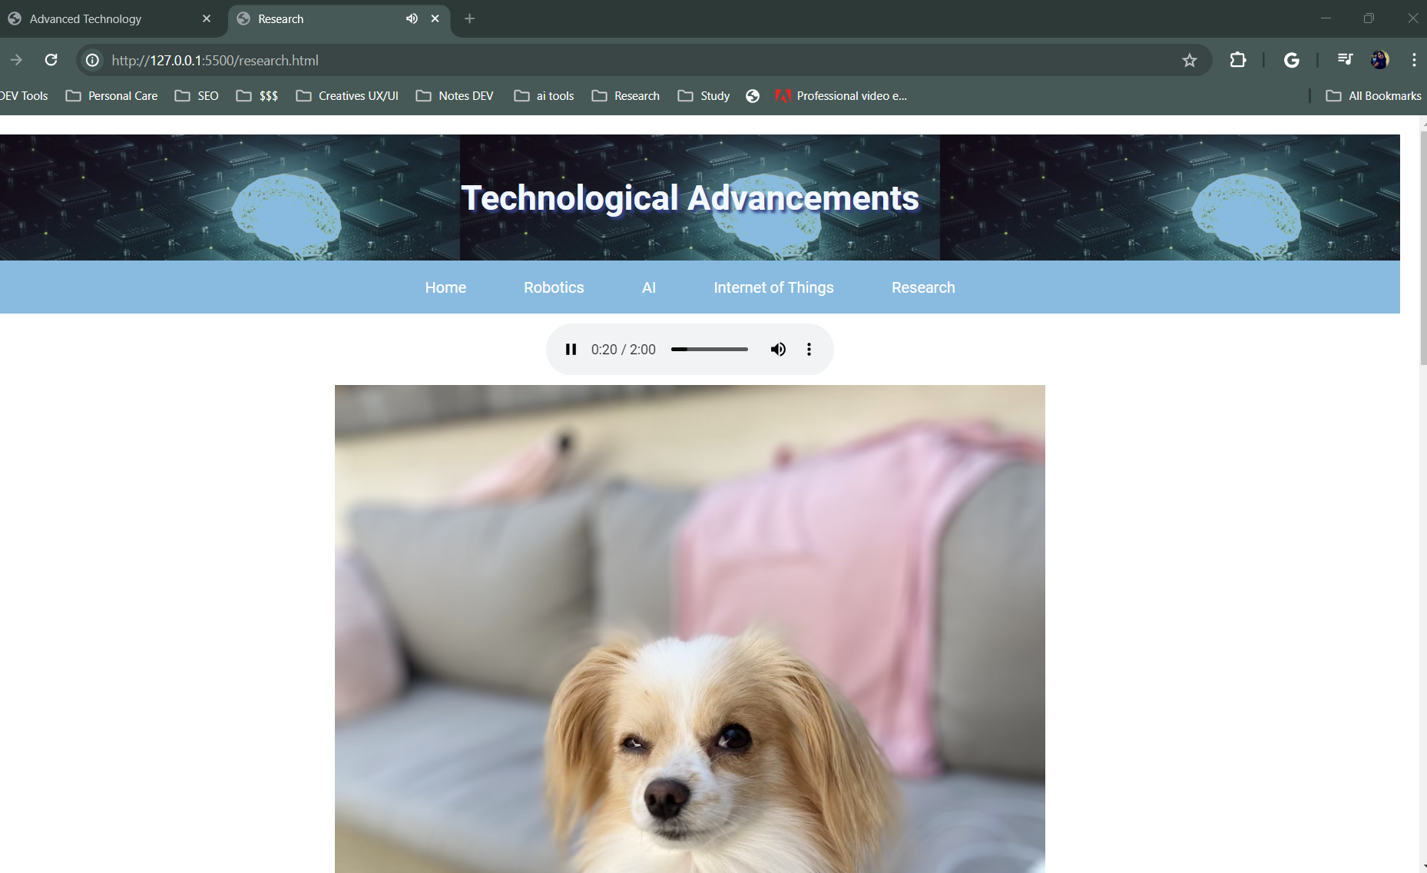
- You now need to use a style sheet to format the website:
  - Add three media queries to your style sheet; one for mobile/cell phone devices, one for tablet, and one for desktop, and determine the design and breakpoint for each viewport.
Added Mobile/Tablet Queries:
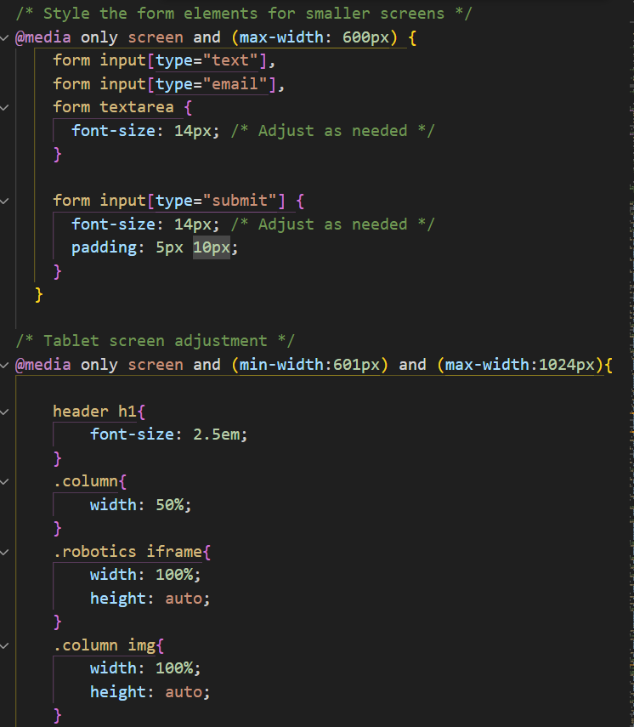
Saved Desktop as default unless needed: Saved as notes-

  - For the mobile/cell phone devices design a mobile-friendly navigation system. 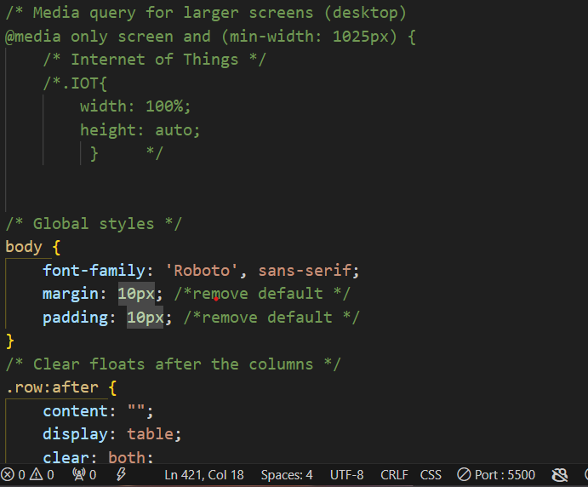
  - Remove any special characters (the bullets) used between navigation links. Make the same change to all HTML files used within your website.
Completed – Q&A
  - Update your HTML files and style sheet to make responsive images. This includes removing height and width attributes from image elements and creating a style rule that sets a max width to 100%. Also display image elements as a block.
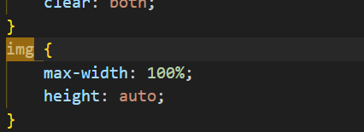
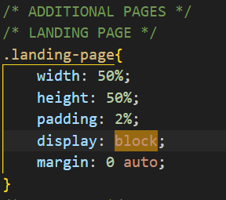
  - Use at least two pseudo-classes (visited to change the color of the text and hover to remove the line under the link) to format the links in the nav area.
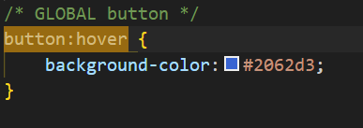
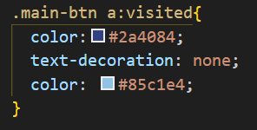
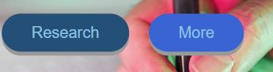
  - Apply rounded corners to at least two elements
Complete – QA
  - Use a gradient.
Iot.html – created CTAs with gradient
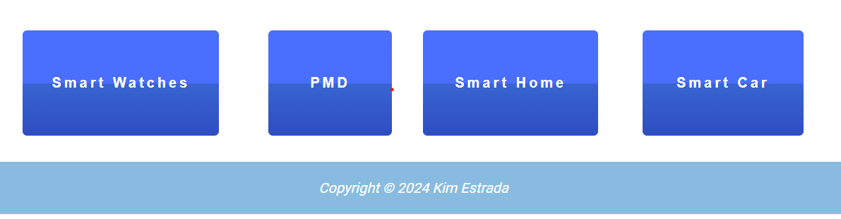
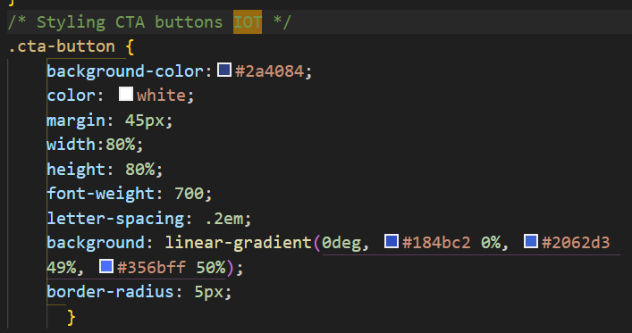

  - Hide the table for a mobile viewport and use a list or other element to display your table data for a mobile viewport.
  - 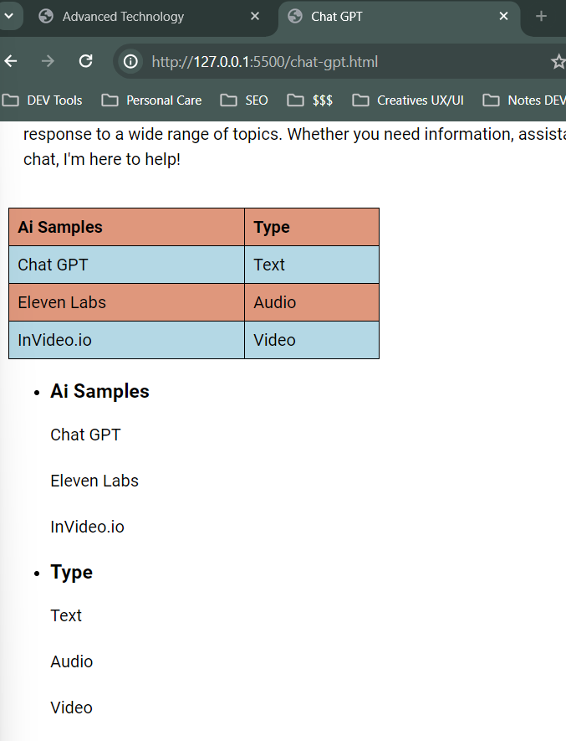
  - 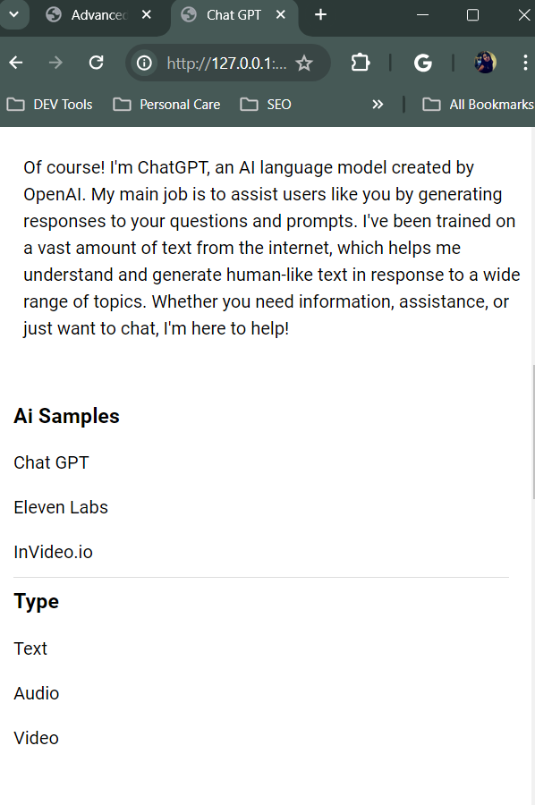
- Validate all HTML and CSS files and correct any errors.

