**Guide to Using musc_threshr**

**Starting the program**

Be sure musc_threshr.m and roi_mov.m are in the data directory, MRI_Reliability_Study\. In Matlab, be sure the current directory is MRI_Reliability_Study\. At the command prompt, type *musc_thresr*, or double-click on the file musc_thresh.m in a directory and then clicking the “Run” button (on the top Matlab command ribbon) or pressing <F5>.

**Selecting a DICOM image file**

First, navigate to the subject folder. Then the visit folder and finally the MRI series folder (e.g. s3401 [usually the last series directory]). There should be just one DICOM image file, i00001.dcm, of the thigh muscles. Select the DICOM file and either 1. Double-click on the file, or 2. Press <Enter>, or 3. Click the “Open” button.

**Selecting left and right subcutaneous fat, femurs and muscles**

(“Christmas Hams” on p. 4 in PDF file with plots (e.g., see mthresh_IM0001.pdf).

Follow the prompts to select a single point in the subcutaneous fat (green band under skin), femurs (red ring within the muscles) and muscles (gray area around the femur and under the subcutaneous fat). It is important to click on the correct color pixel. Do not click on an isolated island of color.

The left thigh is on the right of the image and the right thigh is on the left of the image. (Anterior is towards the top of the image and superior is into the image.)

**Digitizing the polygon region of interest around the flexor muscles**

Digitize the line between the extensor and flexor muscles. It is important to accurately follow the separation between these two groups of muscles. See the Polygon_ROI_Guide.pdf for tips on creating the polygon region of interest.

The Matlab plotting tools in the upper right of the figure (hover cursor near the upper right of the plot) may be used to magnify the image (magnifying glass with plus sign [+]), reducing the magnification (magnifying glass with minus sign [-]), translating the image (hand), or restoring the initial view of the image (house).

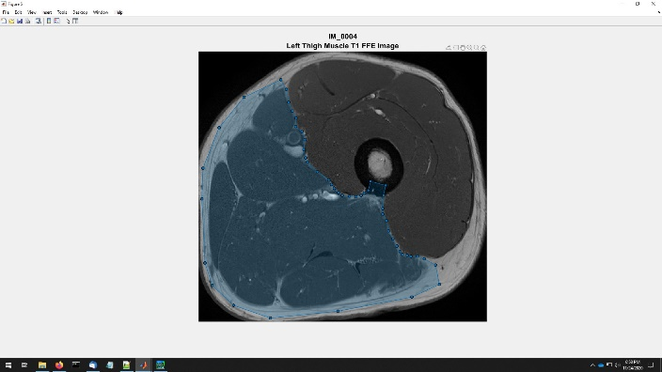

Click on the appropriate plotting tool, use the tool and then be sure to click on the tool again to resume digitizing the polygon region of interest.

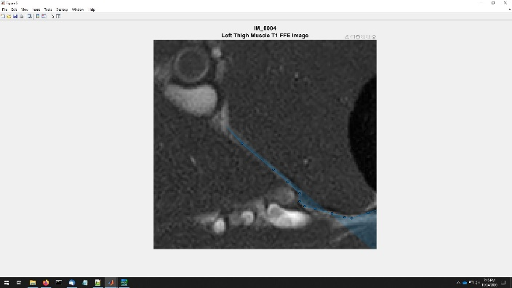Magnified View for Digitizing the Region of Interest

Since the femur and subcutaneous fat are not part of the muscle, digitizing within the femur or around the outside the muscle is not sensitive to the digitization and a coarser polygon is sufficient to define the flexor muscles.

After the polygon region of interest is closed and has been edited by moving, adding and/or deleting vertices, press <Enter> or double-click on the region of interest to continue.

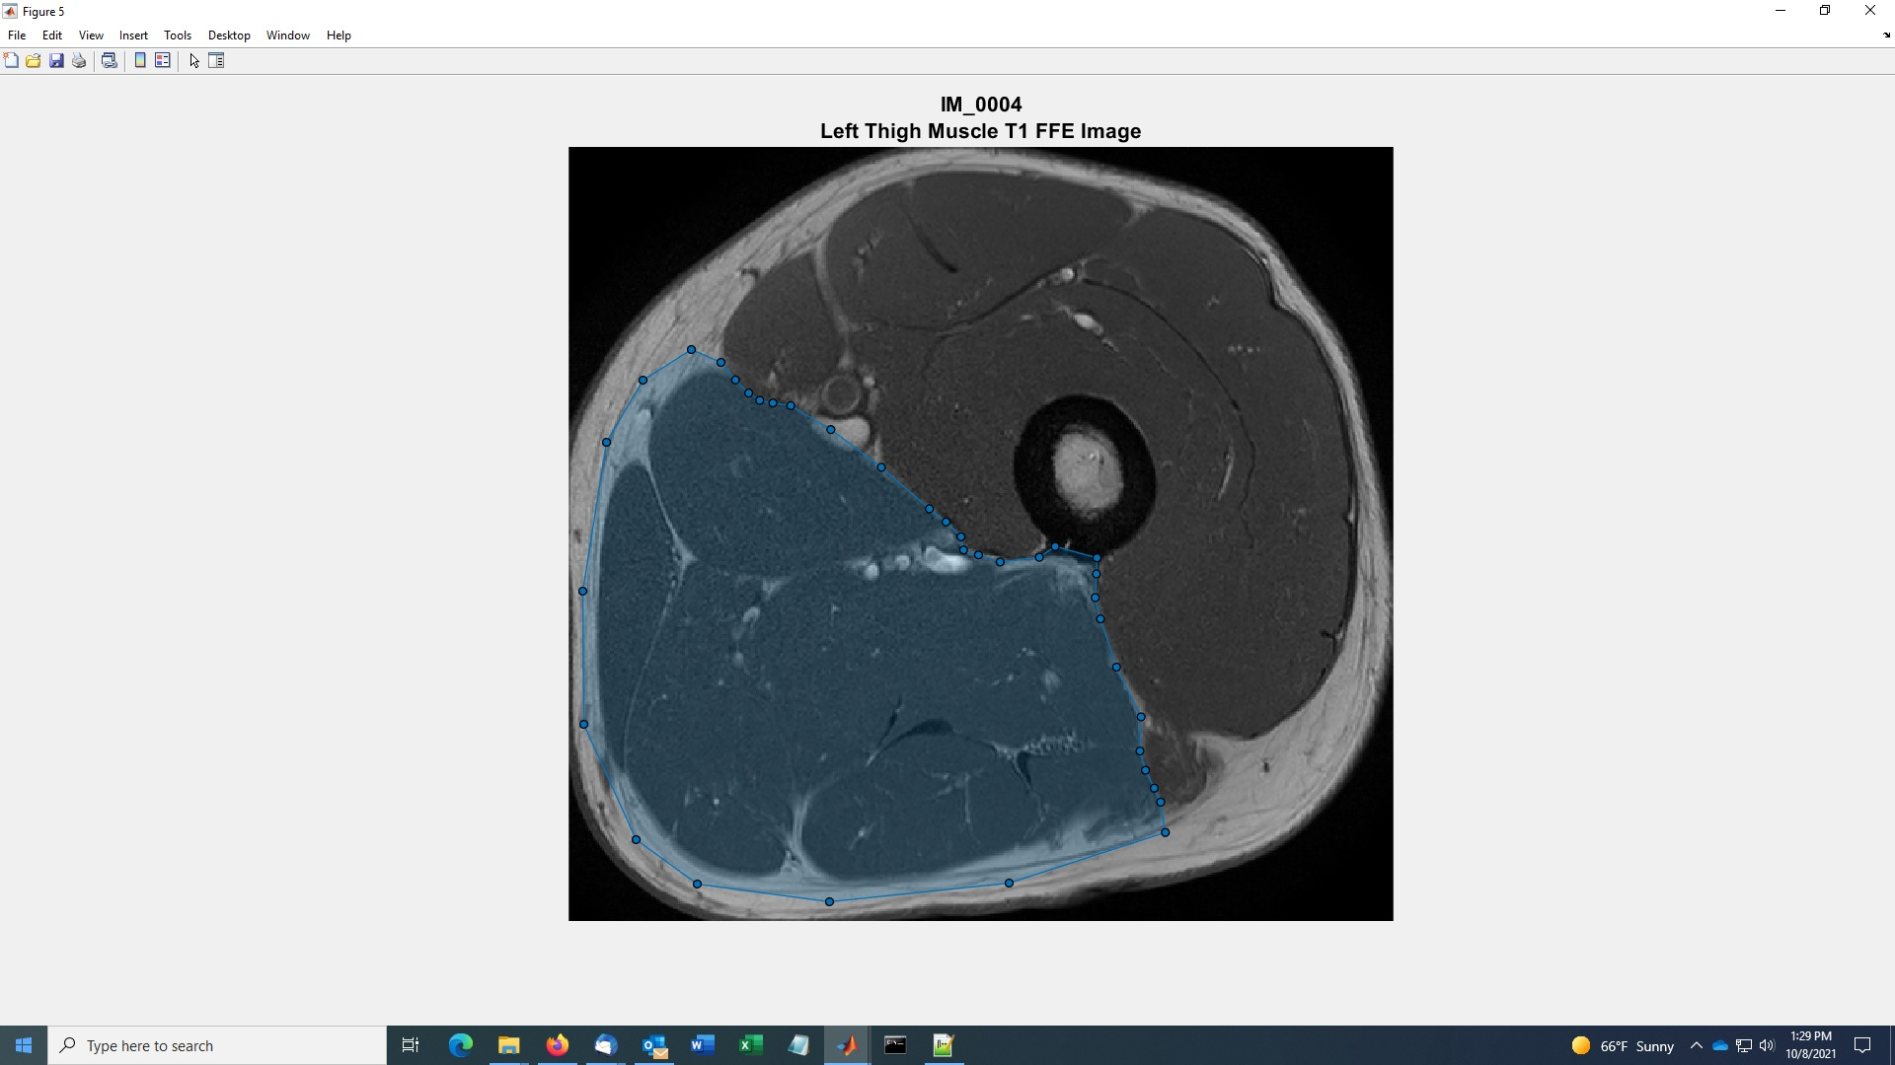

**Verifying the polygon region of interest**

For the moment ignore the menu box and click on the figure of the muscles to bring it to the front. Just the muscles are plotted with the polygon region of interest outlined in red. The figure has a “Muscles” menu in the top menu of the figure. This can be used to view just the extensors, the flexors or the whole thigh muscle by clicking the appropriate muscles. Also the polygon region of interest can be turned on or off by clicking “ROI”.

This figure should be carefully examined to be sure the extensors and flexors are correctly digitized.

To get back to menu box, click on “Window” at the top of the figure menu and select the “MENU” window or click on the Matlab icon on the taskbar and select the “MENU” window. If the extensor and flexor muscles are correct, click “Yes” to continue. Otherwise, click “No” to return to the polygon region of interest. The vertices of the polygon region of interest can be moved to better outline the flexor muscles and additional vertices can be added to better follow the contour of the muscles.

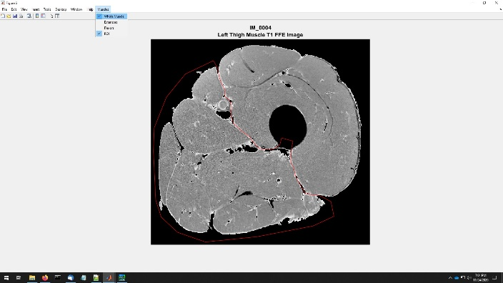**Plots**

Plots of the raw image, threshold histogram, muscles (extensors, flexors and total), subcutaneous fat and noncontractile elements are written to the Postscript file, mthreshr_??_v?.ps, where ?? is the subject number and ? is the visit number (1 or 2) into the MRI_Reliability_Study\MuscleCSA\ directory.

**Cross-sectional areas**

The cross-sectional areas for the muscles (extensors, flexors and total), subcutaneous fat and noncontractile elements are displayed in the command window.

These values are also written to the MS-Excel spreadsheet, mthreshr.xlsx in the MRI_Reliability_Study\MuscleCSA\ directory. The output MS-Excel spreadsheet, mthreshr.xlsx, can NOT be open in another program (e.g. MS-Excel, text editor, etc.) while using this program.

Running the program for the same image will result in duplicate data in the spreadsheet. The spreadsheet should be checked for duplicate data before any statistical analyzes.