**Guide to Using musc_thresh_ptoa M-file**

**Starting the Program**

In MATLAB, be sure **musc_thresh_ptoa.m**, **roi_mov.m**, and the MRI **DICOM files** are in the current directory. At the command prompt, type *musc_thresh_ptoa*, or double-click on the file musc_thresh_ptoa.m in the directory and then click the “Run” button (on the top MATLAB command ribbon) or press <F5>.

**Selecting a DICOM Image File**

First, when prompted, select the folder containing the thigh muscle DICOM files. Next, select the specific DICOM image you want to segment and either (1) Double-click on the file, (2) Press <Enter>, or (3) Click the “Open” button, when prompted.

**Selecting Left and Right Subcutaneous Fat, Femurs and Muscles**

Follow the prompts to select a single point in the subcutaneous fat (green band under skin, **A**), femur (red ring within the muscles, **B**), “bulk” muscle (gray area around the femur and under the subcutaneous fat, **C**) of the **left thigh**. Repeat on the **right thigh**. Note that the gracilis muscle (gray area near the inner thigh; may be surrounded by subcutaneous fat, **D**) and possibly one or two additional isolated muscle areas.

**D**

**D**

**C**

**C**

**B**

**B**

**A**

**A**

It is important to click on the correct color pixel. The left thigh is on the right side of the image and the right thigh is on the left side of the image.

**Digitizing the Polygon Region of Interest (ROI) Around the Flexor Muscles**

Digitize the line between the extensor and flexor muscle groups. It is important to accurately follow the separation between these two groups of muscles. See the Polygon_ROI_Guide.pdf for tips on creating the polygon region of interest.

The MATLAB plotting tools in the upper right of the figure (hover cursor near the upper right of the plot) may be used to magnify the image (magnifying glass with plus sign [+]), reduce the magnification (magnifying glass with minus sign [-]), translate the image (hand), or restore the initial view of the image (house).

Click on the appropriate plotting tool, use the tool, and then be sure to click on the tool again to resume digitizing the polygon region of interest.

Magnified view for digitizing the region of interest.

Since the femur and subcutaneous fat are not part of the muscle, digitizing within the femur or around the outside of the muscle is not sensitive to digitization and a coarser polygon is sufficient to define the flexor muscles.

After the polygon region of interest is closed and has been edited by moving, adding, and/or deleting vertices, press <Enter> or double-click on the region of interest to continue.

Digitizing the region of interest around the flexor (left) and extensor (right) muscles

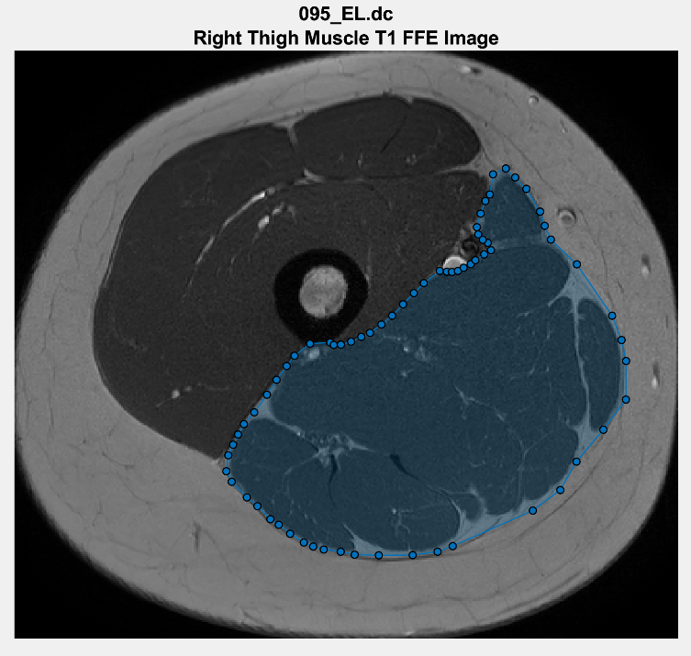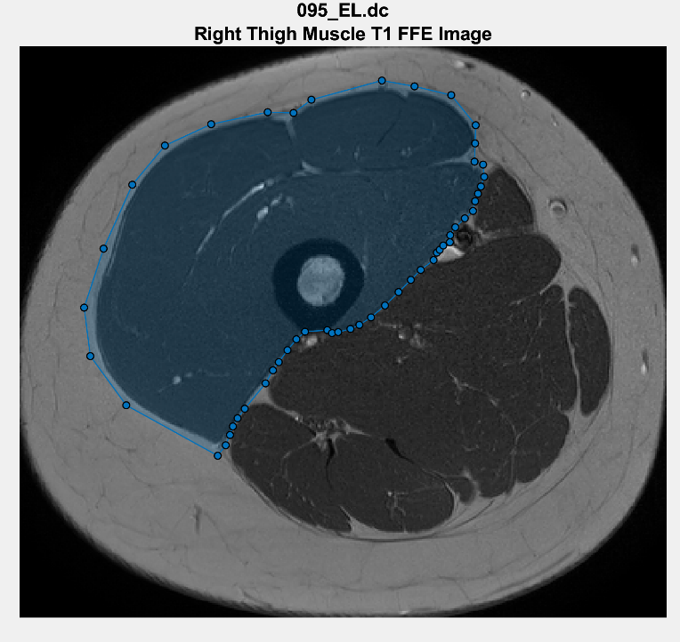

**Verifying the Polygon Region of Interest**

Carefully examine the polygon region of interest outlined in red to be sure the flexor muscles are correctly digitized. Also, verify that the gracilis muscle and other isolated muscles are included in the image.

If the flexor muscles are correct, click “Yes” to continue. Otherwise, click “No” to return to the polygon region of interest. The vertices of the polygon region of interest can be moved to better outline the flexor muscles and additional vertices can be added to better follow the contour of the muscles.

If the gracilis muscle or other isolated muscles are not included in the image or a region that is not muscle is included in the image, stop and note the file. Do not continue to process the file. The file will need to be process separately.

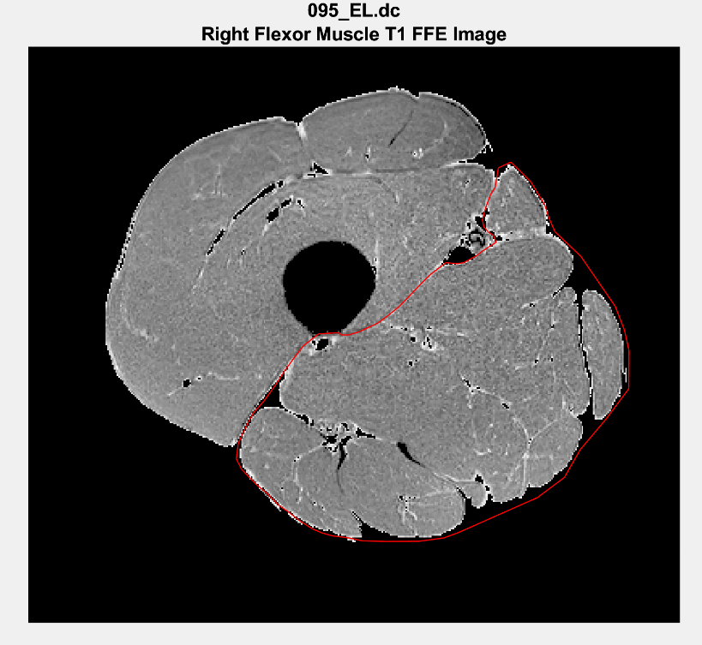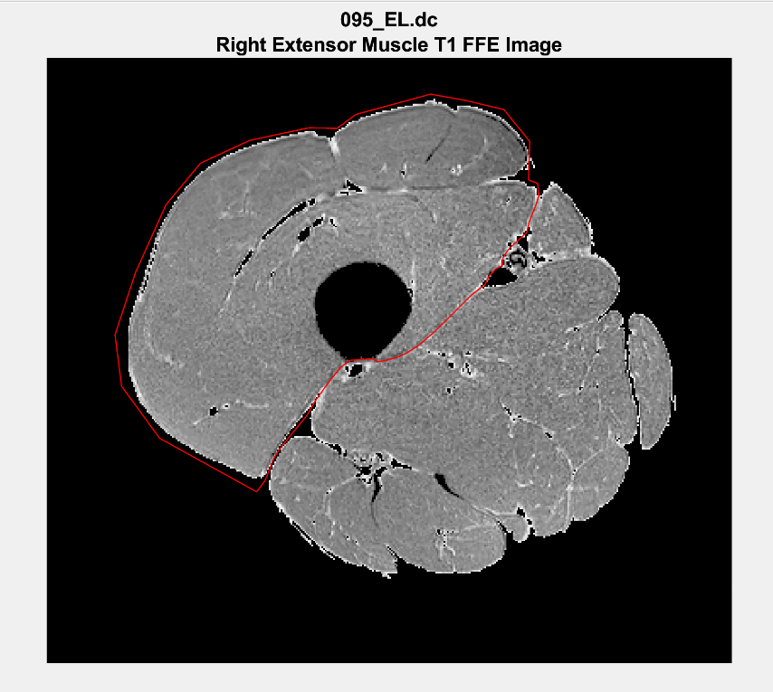

Verifying the polygon region of interest around the flexor (left) and extensor (right) muscles

**Digitizing and Verifying the Polygon Region of Interest Around the Extensor Muscles**

Follow the prompts and repeat the same steps as outlined in the above two sections to digitize the extensor muscles.

**Plots**

Plots of the raw image, threshold histogram, threshold image, and left and right muscle groups, subcutaneous fat and noncontractile elements are written to the Postscript file, **mthresh_*.ps** in the “Muscle CSA” folder, where “*” is the subject number. The Postscript file can be converted to a PDF file by right-clicking the file in Explorer and selecting “Convert to Adobe PDF”.

**Cross-Sectional Areas**

The cross-sectional areas for the muscles (extensors, flexors and total), subcutaneous fat and noncontractile elements (all in cm2) are written to the Excel file, **mthresh.xlsx** in the “Muscle CSA” folder. They are also displayed in the command window.

**Note: If the threshold image contains artifact/shadowing above the muscle within the subcutaneous fat…**

1. …the “**Mus CSA Total**” calculated by MATLAB (and written to Excel) for that leg will be **exaggerated**. It will be more accurate to add the individual CSAs of the flexor and extensor muscle groups of the leg that you segmented, manually in Excel.
2. …the “**SubFat CSA**” calculated by MATLAB (and written to Excel) for that leg will be **undercounted** as MATLAB will not count the portion of subcutaneous fat containing artifact/shadowing as “subcutaneous fat.”
3. …the “**Non Con CSA**” calculated by MATLAB (and written to Excel) for that leg will be **exaggerated** as MATLAB often erroneously includes the surrounding subcutaneous fat and skin in the calculation.