**Error Report**

1. Error running random command.

# uniform random numbers in [0,1]

dataOne = random.rand(5,5)

The error was that the random command was not recognized. The error was due to missing the step to import the random from the numpy module. Ran the command:

import random from numpy

1. Error when running median_low command:

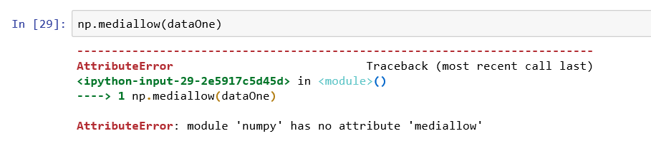

Attempted to fix by adding an underscore to the command np.median_low and it still did not work:

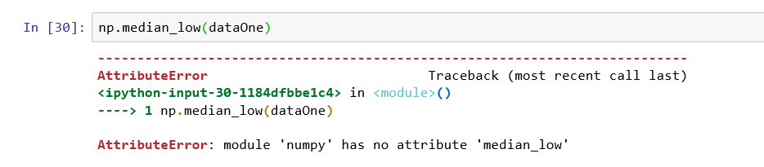

Attempted different commands with no success:

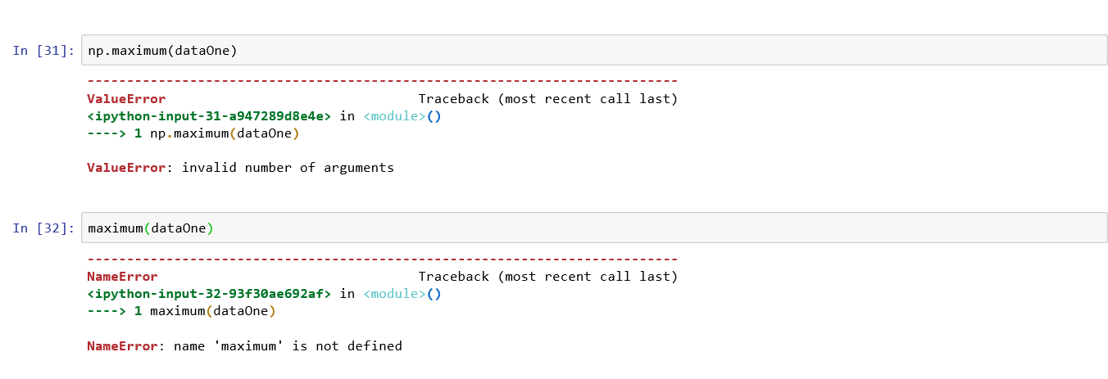

Found the correct commands for Average, Minimum and Maxium for the Array:

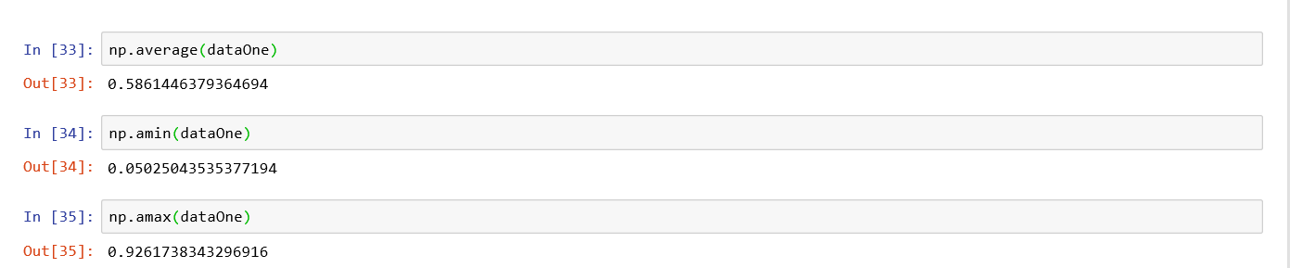

1. Error when adding variables:

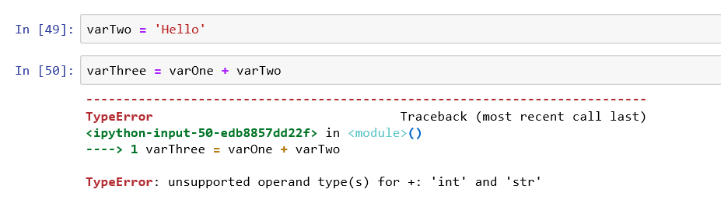

I figured the issue had to do with the variables being different, i.e. numerical vs. textual.

Yes! I landed on the page where everybody lands that as this issue. I fixed by using the following command:



1. Current Date and Time sintax error:

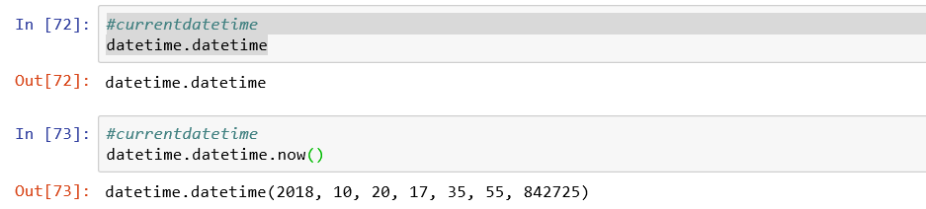

1. Error importing a data set. This was due to parenthesis in Python 2.7 vs. 3.6.

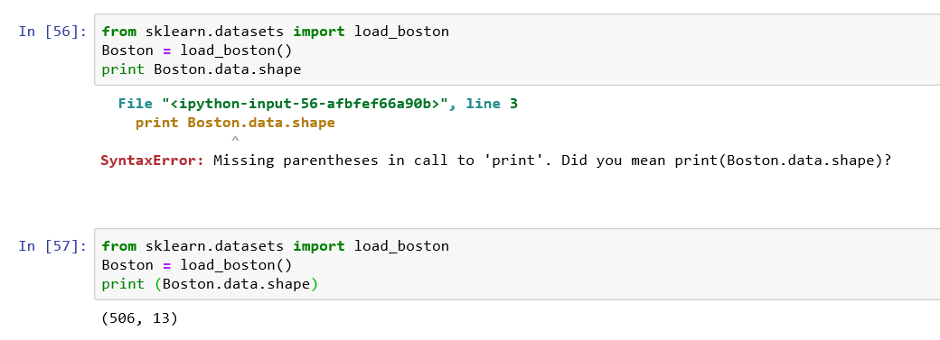

1. Syntax issues with a comma and the command. The book had the Var Args incorrect:

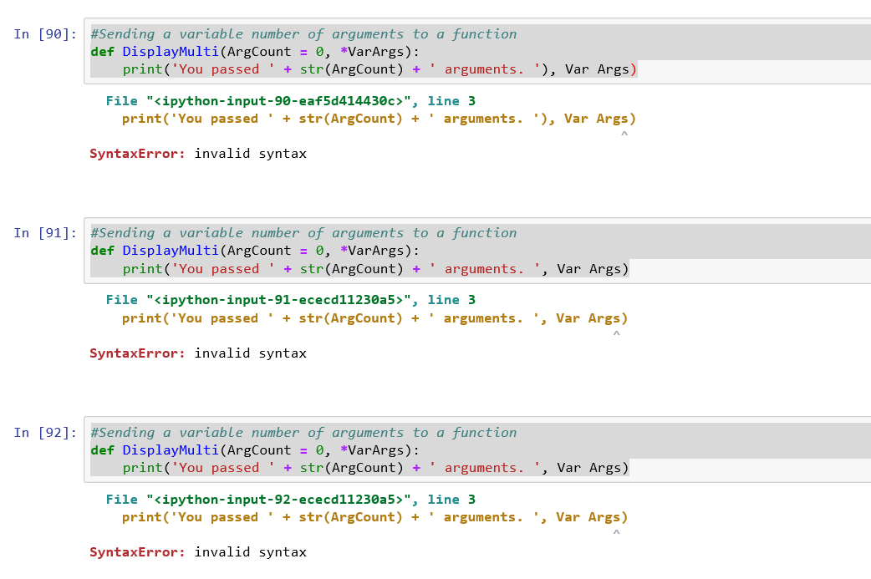

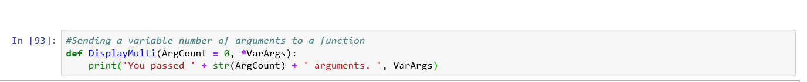

1. Indentation issues when entering the code. I thought the syntax issues had to do with parenthesis and or differences between Python 2.7 and 3.65. It took me about 40 iterations and looking up some code with IF statements on line.

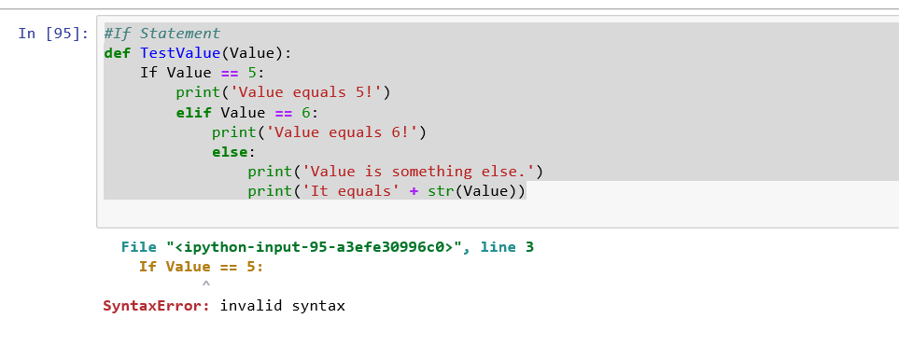

After starting from scratch and looking at the first if statement and made sure that it worked. I started playing with the Else and the Elif. I finally got it to work!!

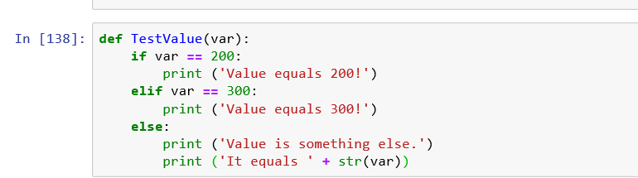

1. Error trying to import “sets” module:

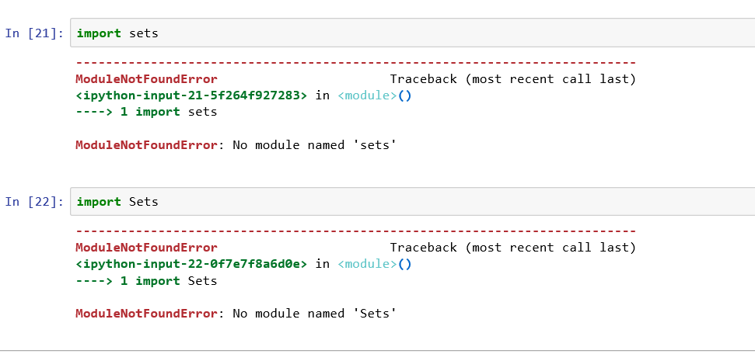

It turns out that this module is already included Python 3.6 version vs. 2.7 where you do have to import it.

1. Syntax issue with set command. The correct spelling of the command is “set” vs. “Set”.

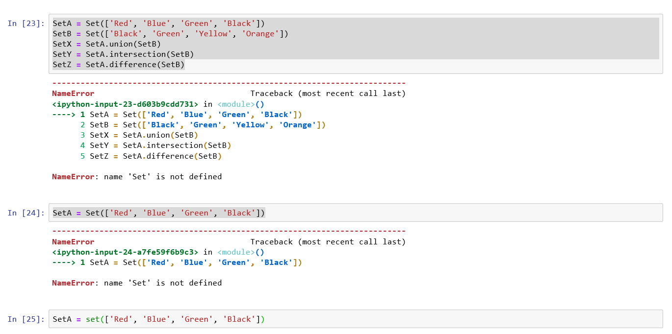

1. Parenthesis with the print comments. I forgot. AGAIN…

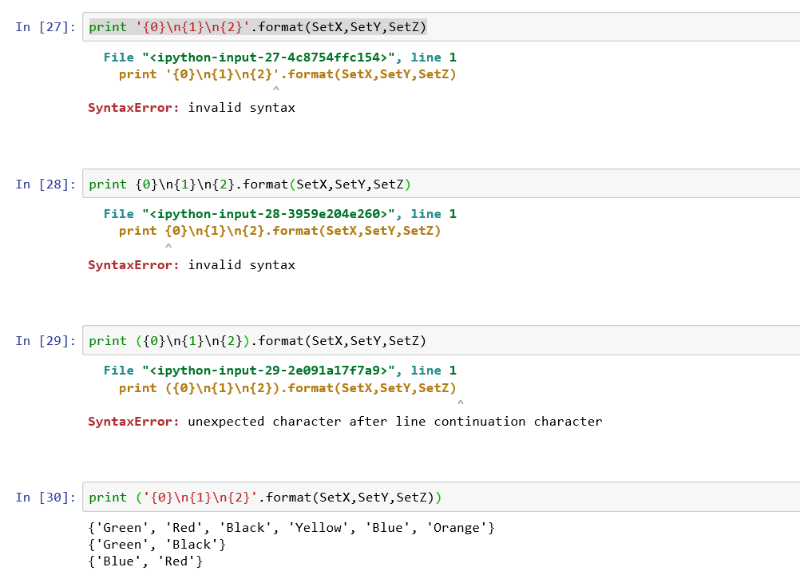

1. Syntax issues with adding values to Tuples. Tuples are supposed to be immutable so the Internet suggests that list should be used instead. The command in the book did not work. I used a different command thought to add values to a tuple which I also had to create new one.

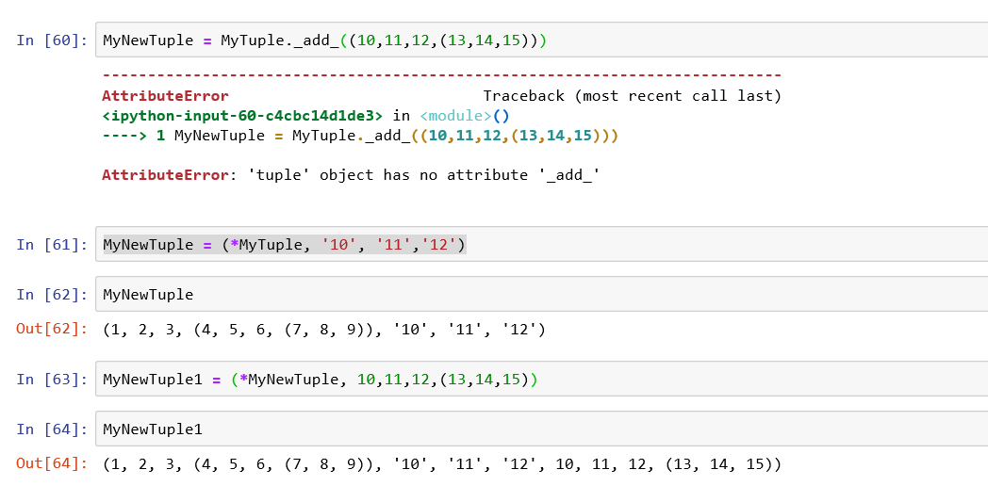

1. Incorrect syntax for Dictionary definition which turns out that there is a difference between Python 2.7 and 3.6:

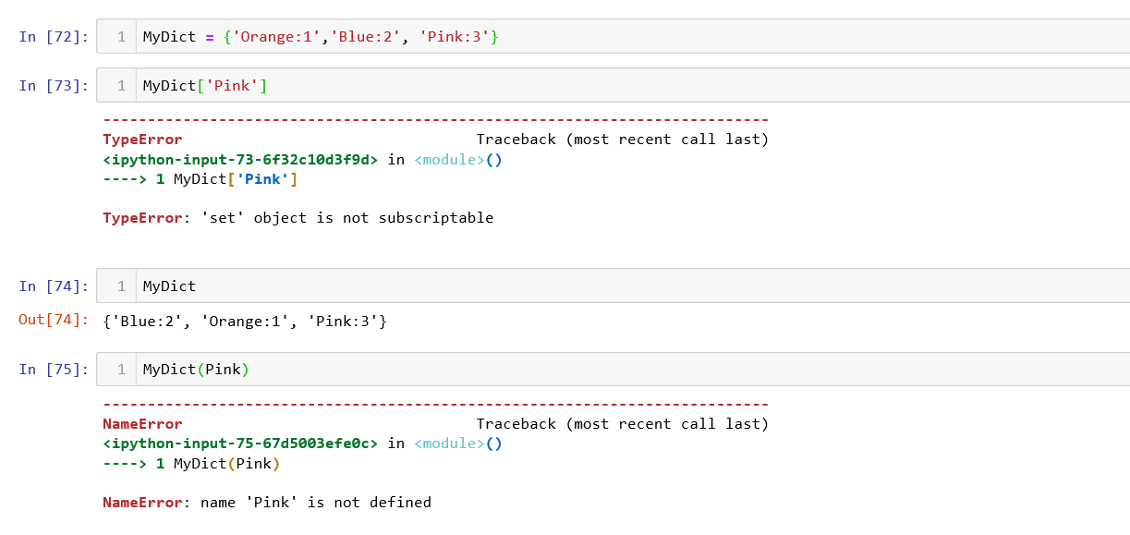

Updated syntax:

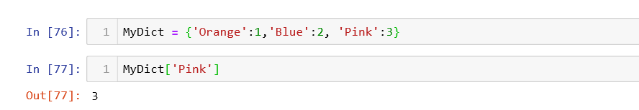

1. Reading error due to differences between 2.7 and 3.6:

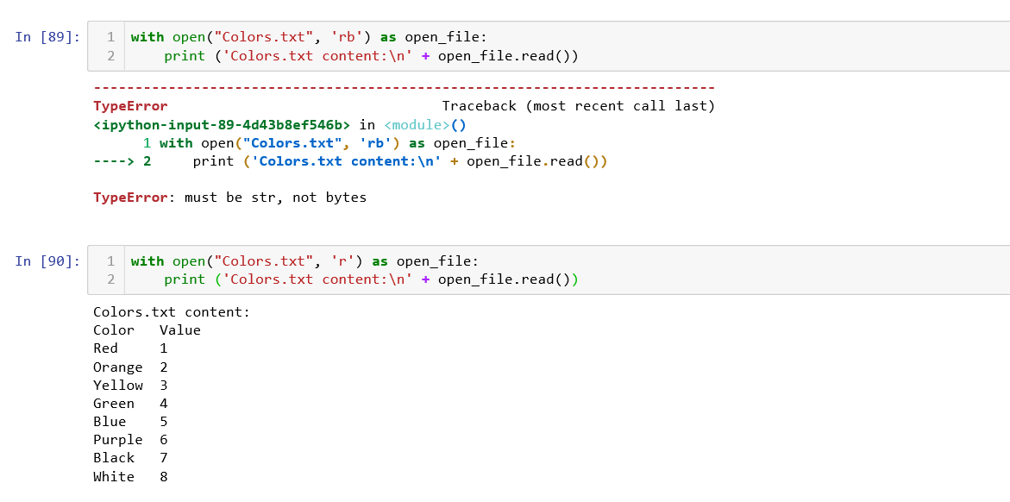

1. Error with resizing image:

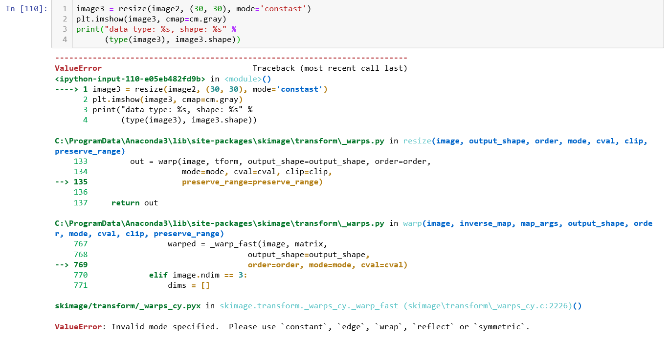

Fixed it by using mode of ‘constant’.

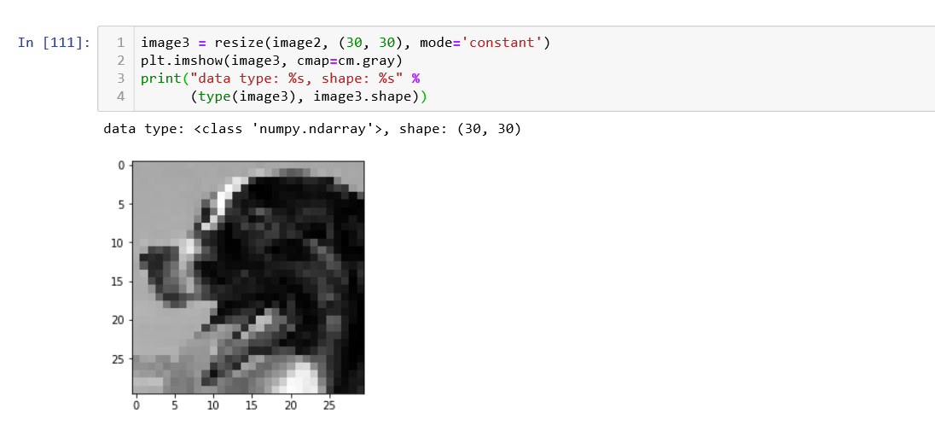

1. Issues with importing CSV file:

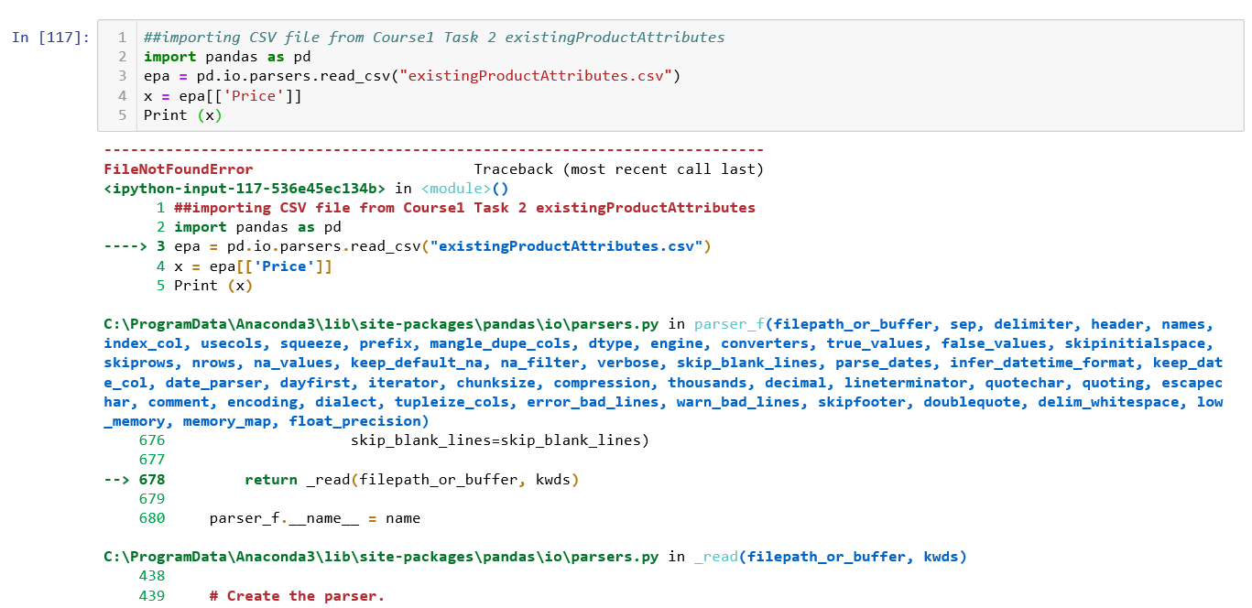

Success! I did not have the csv file at the correct location.

