Parking Management

* **Deployment Details**

GIT URL -> <https://github.com/mggmanik/parking-management>

Heroku Build -> <https://still-scrubland-03010.herokuapp.com/>

* **Running in Local(Assuming Nodejs, npm and angular cli is installed)**

Clone the above GIT URL and run npm install in the root folder and in angular folder.

Run node server.js in the root folder to run the server.

Run ng serve –aot in the angular folder to run the UI code.

* **Authentication**

Email and Password are the **required** fields for Logging In.

Two Users have been created with the roles of Booking Counter Agent and Parking Zone Assistant.

**Credentials**

Booking Counter Agent

Email – [agent@gmail.com](mailto:agent@gmail.com)

Password – agent@123

Parking Zone Assistant

Email – [assistant@gmail.com](mailto:assistant@gmail.com)

Password – assistant@123

* **Dashboard**

**Reset** Button will remove all the vehicle registration numbers from all the records in the **Parking Spaces Table** and remove all the transactional data from the **Vehicle Parking Table.**

Both Booking Counter Agent and Parking Zone Assistant can view the status of the Parking Spaces.

**Green** denotes **vacant** parking space and **Grey** denote **occupied** parking space.

Booking Counter Agent can book parking spaces for vehicles by entering their registration number and same way release the parking spaces.

Registration Number has to be according to the Indian Vehicle Registration Number standards, a regex validation has been provided for that.

* **Reports**

Need to enter the **Booking Date** to fetch reports from the server for the entered date.

Records are sorted as per the booking time in descending order upon clicking the **Booking Time** on the table.

* **Database Schemas**

**USER**

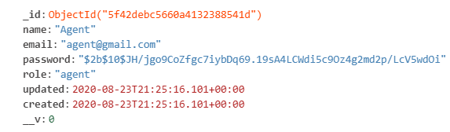

**PARKING ZONE**

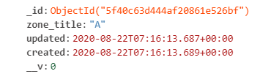

**PARKING SPACE**

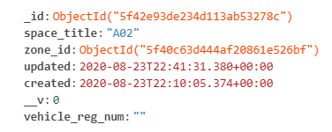

**VEHICLE PARKING**

