FOCUS WORLDWIDE
PROJECT SPECIFICATION
Goal is: Type a country → Press enter → Get a fully structured Excel engine file.
System should be stateless: Each time you run it, it builds a fresh file. It doesn’t rely on stored data.
ECONOMICS FRAMEWORK

1.
name: unemployment_rate
source: IMF
units: percent
time: past_5_years
frequency: annual
geo_level: country
World Economic Outlook (October 2025) - Unemployment rate

2.
name: gdp_current_prices
source: IMF
units: billions_of_dollars
time: past_10_years
frequency: annual
geo_level: country
World Economic Outlook (October 2025) - GDP, current prices
3.
name: gdp_per_capita_current_prices
source: IMF
units: dollars_per_capita
time: past_10_years_and_future_5_years
frequency: annual
geo_level: country
World Economic Outlook (October 2025) - GDP per capita, current prices
4.
name: gross_domestic_product_constant_prices_percent_change
source: IMF
dataset: world_economic_outlook
units: percent
time: past_5_years_and_future_5_years
frequency: annual
geo_level: country
Data Explorer
5.
name: harmonised_index_of_consumer_prices
source: IMF
dataset: consumer_price_index
display_all_by_table: full_list
expenditure_category: all
type_of_transformation: period_average_period_over_period_percent_change
units: percent
time: past_5_years_and_future_5_years
frequency: annual
geo_level: country
Data Explorer

6.
name: consumer_confidence_index
source: OECD
units: index
time: past_5_years
frequency: monthly
geo_level: country
Consumer confidence index (CCI) | OECD
7.
name: income_share_held_by_highest_10%
source: world_bank_group
units: percent
time: last_10_years
frequency: annual
geo_level: country
Income share held by highest 10% | Data
8.
name: income_share_held_by_lowest_10%
source: world_bank_group
units: percent
time: last_10_years
frequency: annual
geo_level: country
Income share held by lowest 10% | Data
9.
name: unemployment_youth_total_%_of_total_labor_force_ages_15-24_modeled_ILO_estimate
source: world_bank_group
units: percent
time: past_10_years
frequency: annual
geo_level: country
Unemployment, youth total (% of total labor force ages 15-24) (modeled ILO estimate) | Data

ECONOMICS PROMPT – EXECUTIVE NARRATIVE
You are a senior macroeconomic strategist and retail expansion advisor preparing a structural economic assessment for a corporate leadership team in the apparel and luxury industry.Base your analysis strictly and exclusively on the structured IMF, World Bank, and OECD data provided below. Do not introduce, estimate, or assume additional data. Use only the listed indicators and ratios directly derived from them (e.g., growth differentials, distribution spreads, forward outlook comparisons).Your objective is not to describe macroeconomic statistics, but to assess structural purchasing power capacity, economic resilience, cyclical exposure, and income distribution quality from a retail and luxury market perspective.Write exactly three clearly separated analytical paragraphs. Maintain a formal, executive, decision-oriented tone. Focus on structural dynamics and forward-looking implications rather than short-term volatility.

DATA PROVIDED:
- Unemployment rate (annual, past 5 years) – IMF
- GDP at current prices (annual, past 10 years) – IMF
- GDP per capita at current prices (annual, past 10 years + next 5 years) – IMF
- GDP growth, constant prices (% change, annual, past 5 years + next 5 years) – IMF
- Harmonised Index of Consumer Prices (annual % change, past 5 years + next 5 years) – IMF
- Consumer Confidence Index (monthly, past 5 years) – OECD
- Income share held by highest 10% (annual, last 10 years) – World Bank
- Income share held by lowest 10% (annual, last 10 years) – World Bank
- Youth unemployment rate (annual, past 10 years) – World Bank
You may calculate:
5-year CAGR where relevant
Income distribution spread (Top 10% vs Bottom 10% differential)

STRUCTURE YOUR RESPONSE AS FOLLOWS:
1. Economic Scale, Growth Trajectory & Forward Momentum (Indicators 2, 3, 4)
Assess the structural size of the economy and its long-term expansion trajectory.
Evaluate GDP growth dynamics over the past five years and the projected five-year outlook.
Determine whether growth is accelerating, stabilizing, or decelerating.
Analyze GDP per capita level and forward trajectory as a proxy for purchasing power depth.
Distinguish structural growth trends from cyclical rebounds.
Conclude whether the economy represents: Expanding high-potential market / Mature but stable consumption base / Slowing growth environment / Structurally constrained macro landscape.
Translate findings into implications for medium-term retail expansion confidence.

2. Stability, Inflation & Cyclical Risk Profile (Indicators 1, 5, 6, 9)
Assess unemployment trends and labor market tightness.
Evaluate youth unemployment as an indicator of generational demand pressure and medium-term consumption risk.
Analyze inflation dynamics and forward projections to determine real income erosion or stabilization.
Interpret consumer confidence trends as a proxy for near-term discretionary spending sentiment.
Determine whether macro conditions support stable real consumption growth or indicate cyclical fragility.
Conclude whether the market environment is: Consumption-supportive and stable / Inflation-constrained / Labor-market fragile / Cyclically exposed.
Translate implications into retail pricing power, margin resilience, and short-term revenue visibility.
3. Income Structure & Luxury Market Depth (Indicators 3, 7, 8)
Prioritize income distribution quality over aggregate size.
Analyze income concentration by comparing top 10% and bottom 10% shares.
Assess whether inequality levels suggest premium-segment concentration or broad middle-class depth.
Interpret GDP per capita in conjunction with income distribution to determine effective luxury purchasing power.
Determine whether the economic structure supports broad-based aspirational consumption, high-end luxury concentration, or polarized demand.
Conclude whether the income architecture structurally favors: Deep premium capture potential / Broad mid-market retail opportunity / Polarized luxury niche / Structurally limited discretionary upside.
Explicitly state implications for assortment positioning, price architecture, and long-term brand scaling
ADDITIONAL ANALYTICAL REQUIREMENTS:
Focus on structural interpretation rather than descriptive reporting.
Distinguish secular trends from post-shock normalization effects.
Avoid restating raw figures without interpretation.
Translate macroeconomic metrics into retail demand and margin implications.
Maintain a C-level, decision-support tone.
Limit total output to approximately 300–350 words.
Deliver exactly three clearly separated paragraphs.
Do not introduce any data not provided.
TOURISM FRAMEWORK
1.
name: UN_Tourism_8_9_1_TDGDP_04_2025
source: UN_tourism
Indicator: Tourism_direct_GDP_as_a_proportion_of_total_GDP_%
units: percent
time: past_10_years
frequency: annual
geo_level: country
2.
name: UN_Tourism_inbound_arrivals_by_region_12_2025
source: UN_tourism
filter: inbound_trips_region_overnight_visitors_tourists_
indicator_partner_area_label:
Africa
Americas
East_Asia_and_the_Pacific
Europe
Middle_East
South_Asia
units: thousand_trips
time: past_10_years
frequency: annual
geo_level: country
3.
name: UN_Tourism_inbound_arrivals_by_purpose_12_2025
source: UN_tourism
indicator:
inbound_trips_by purpose_business_overnight_visitors_tourists)
inbound_trips_by purpose_personal_overnight_visitors_tourists)
units: thousand_trips
time: past_10_years
frequency: annual
geo_level: country
4.
name: UN_Tourism_inbound_arrivals_by_transport_12_2025
source: UN_tourism
indicator:
inbound_trips_transport_air_overnight_visitors_tourists
inbound_trips_transport_by_land_overnight_visitors_tourists
inbound_trips_transport_water_overnight_visitors_tourists
units: thousand_trips
time: past_10_years
frequency: annual
geo_level: country
5.
name: UN_Tourism_inbound_accommodation_12_2025
source: UN_tourism
indicator: inbound_accommodation_short_term_accommodation_hotels_and_similar_ISIC_5510_overnights
units: thousand_overnights
time: past_10_years
frequency: annual
geo_level: country

6.
name: UN_Tourism_inbound_expenditure_12_2025
source: UN_tourism
indicator: inbound_expenditure_balance_of_payments_total_visitors
units: million_US_dollars
time: past_10_years
frequency: annual
geo_level: country

7.
name: UN_Tourism_accommodation_hotels_12_2025
source: UN_tourism
indicator: capacity_accommodation_short_term_accommodation_hotels_and_similar_ISIC_5510_length_of_stay_average
units: overnights
time: past_10_years
frequency: annual
geo_level: country

7.
name: UN_Tourism_domestic_trips_12_2025
source: UN_tourism
indicator: domestic_trips_total_total_visitors
units: thousands_trips
time: past_10_years
frequency: annual
geo_level: country

8.
name: UN_Tourism_domestic_accommodation_12_2025
source: UN_tourism
indicator: domestic_accommodation_short_term_accommodation_hotels_and_similar_ISIC_5510_overnights
units: thousands_overnights
time: past_10_years
frequency: annual
geo_level: country

TOURISM PROMPT – EXECUTIVE NARRATIVE
You are a senior tourism economist and luxury retail strategy advisor preparing a high-level strategic tourism assessment for a corporate leadership team in the apparel and luxury sector. Base your analysis strictly and exclusively on the structured UN Tourism data provided below. Do not introduce, estimate, or assume additional data. Use only the listed indicators and ratios directly derived from them (e.g., CAGR, expenditure per arrival). Your objective is not to describe the data, but to assess the strategic implications of the tourism structure for luxury retail positioning, demand resilience, and revenue quality. Write exactly three clearly separated analytical paragraphs. Maintain a formal, executive, decision-oriented tone.

DATA PROVIDED:

- Tourism direct GDP as % of total GDP (annual, past 10 years)
- Inbound arrivals (total, annual, past 10 years)
- Inbound arrivals by partner region (annual, past 10 years)
- Inbound arrivals by purpose (business vs personal, annual, past 10 years)
- Inbound arrivals by transport mode (air, land, water; annual, past 10 years)
- Inbound tourism expenditure (total, million USD, annual, past 10 years)
- Inbound accommodation overnights (hotels and similar, annual, past 10 years)
- Average length of stay (annual, past 10 years)
- Domestic trips (annual, past 10 years)
- Domestic accommodation overnights (annual, past 10 years)
You may calculate:
Total inbound arrivals
CAGR (5-year or 10-year where relevant)
Expenditure per arrival (total inbound expenditure ÷ inbound arrivals)

STRUCTURE YOUR RESPONSE AS FOLLOWS:
1. Structural Attractiveness & Exposure Profile (Indicators 1, 2, 3, 9)
Assess the structural scale, trajectory, and macroeconomic weight of tourism.
Evaluate whether growth is structurally embedded or cyclical recovery-driven.
Determine geographic diversification versus concentration risk across partner regions.
Compare inbound and domestic demand to assess external exposure.
Conclude on the country’s tourism exposure profile: Diversified global hub / Regionally dependent growth market / Tourism-heavy and externally exposed / Domestically buffered mixed model.
Explicitly state implications for volatility sensitivity and long-term retail expansion confidence.

2. Demand Architecture & Operational Reliability (Indicators 5, 7, 8, 10)
Assess the structural composition of tourism flows rather than their absolute size.
Interpret transport mix as a proxy for premium accessibility and long-haul penetration.
Evaluate length of stay and hotel overnights as indicators of retail interaction time.
Assess domestic accommodation as a stabilizer of demand cycles.
Determine whether the tourism architecture supports predictable retail throughput.
Conclude whether the market offers: High operational visibility / Air-exposed luxury inflow potential / Short-stay transactional tourism / Structurally volatile demand.
Translate findings into implications for store productivity, staffing stability, and network planning.

3. Value Intensity & Luxury Monetization Potential (Indicators 4, 6, 2, 8)
Prioritize value dynamics over volume metrics.
Analyze expenditure per arrival and compare expenditure growth versus arrival growth to assess monetization intensity.
Evaluate business versus personal mix as an indicator of premium positioning potential.
Interpret average length of stay in relation to discretionary spending opportunity.
Determine whether the tourism model is value-accretive or volume-driven.
Conclude whether tourism structurally supports: High-margin luxury capture / Stable aspirational consumption / Transactional mid-market retail / Limited monetization upside.
State the strategic relevance of tourism for long-term apparel and luxury retail positioning.

ADDITIONAL ANALYTICAL REQUIREMENTS:
Focus on structural interpretation rather than descriptive reporting.
Distinguish secular trends from short-term shocks.
Highlight concentration and accessibility risks.
Translate all tourism metrics into strategic retail implications.
Maintain a C-level, decision-support tone.
Limit total output to approximately 300–350 words.
Deliver exactly three clearly separated paragraphs.
Do not introduce any data not provided.

DEMOGRAPHICS FRAMEWORK
FOR THE NEXT INDICATOR DOWNLOAD FILE: Population Division |
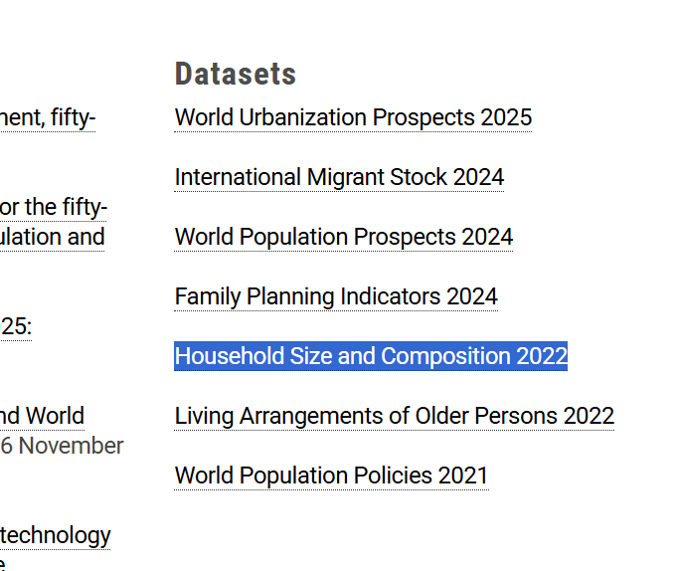

1.
name: household_size_and_composition_2022
indicator: average_household_size_number_of_members
filter_data_source_category: all
source: united_nations
units: persons
time: last_available_year
frequency: annual
geo_level: country
Population Division |
FOR THE NEXT 3 INDICATORS DOWNLOAD FILE / Standard Projections (Estimates and Projection scenarios) / CSV format World Population Prospects
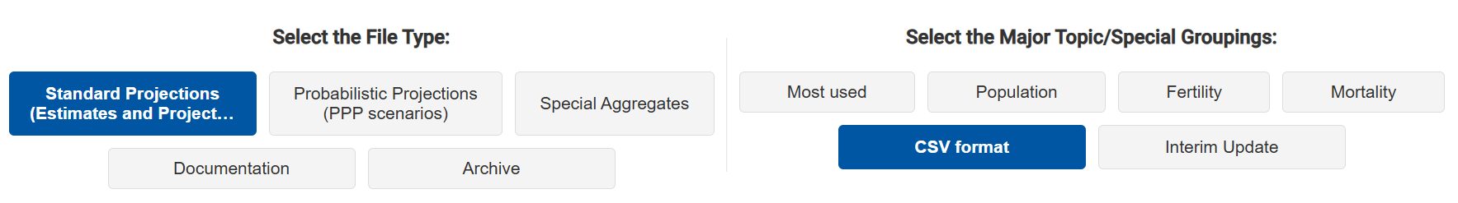
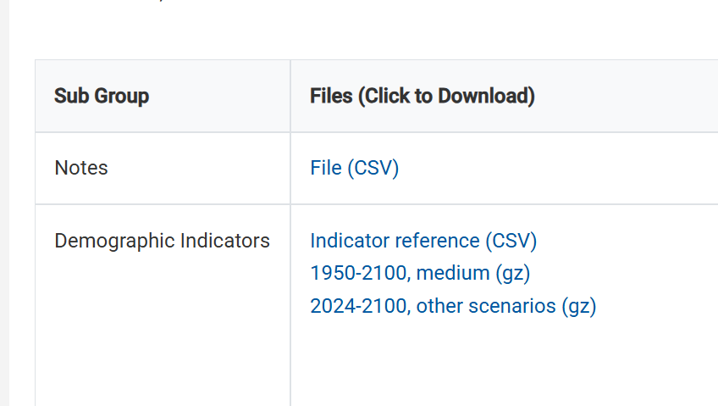
2.
name: TPopulation1Jan
source: united_nations
units: thousands
time: past_10_years_and_future_10_years
frequency: annual
geo_level: country
World Population Prospects
3.
name: NatChange
source: united_nations
units: thousands
time: past_10_years
frequency: annual
geo_level: country
World Population Prospects
4.
name: NetMigrations
source: united_nations
units: thousands
time: past_10_years
frequency: annual
geo_level: country
World Population Prospects
5.
name: TPopulationMale1July
source: united_nations
units: thousands
time: past_10_years
frequency: annual
geo_level: country
World Population Prospects
6.
name: TPopulationFemale1July
source: united_nations
units: thousands
time: past_10_years
frequency: annual
geo_level: country
World Population Prospects
FOR THE NEXT INDICATOR DOWNLOAD FILE: Standard Projections (Estimates and Projection scenarios) / Population World Population Prospects
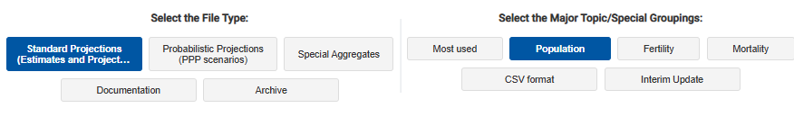

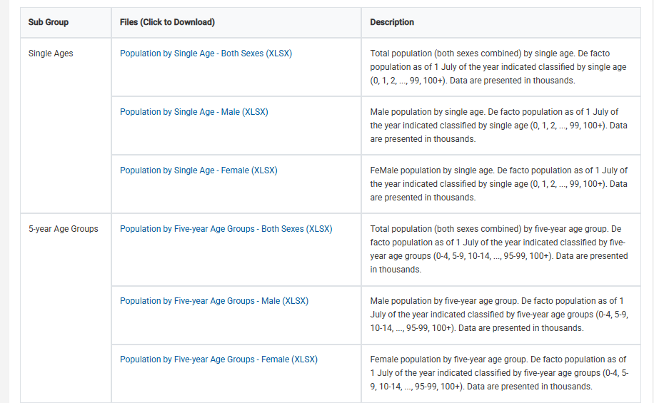
7.
name: population_by_Five_year_Age_Groups_Both_Sexes
source: united_nations
excel_sheet: estimates
indicator:
0-4
5-9
10-14
15-19
20-24
25-29
30-34
35-39
40-44
45-49
50-54
55-59
60-64
65-69
70-74
75-79
80-84
85-89
90-94
95-99
100+
units: thousands
time: past_5_years
frequency: annual
geo_level: country
World Population Prospects
DEMOGRAPHICS PROMPT – EXECUTIVE NARRATIVE
You are a senior demographic economist and strategic retail advisor preparing a structural population assessment for a corporate leadership team in the apparel and luxury industry.Base your analysis strictly and exclusively on the structured United Nations demographic data provided below. Do not introduce, estimate, or assume additional data. Use only the listed indicators and ratios directly derived from them (e.g., cohort shares, growth rates, dependency ratios).Your objective is not to describe demographic statistics, but to assess the structural sustainability, composition, and long-term quality of the consumer base from a retail demand and expansion perspective.
Write exactly two clearly separated analytical paragraphs. Maintain a formal, executive, decision-oriented tone. Focus strictly on medium- to long-term structural implications rather than short-term fluctuations.

DATA PROVIDED:
- Total population (annual, past 10 years)
- Population by 5-year age cohorts (annual, past 10 years)
- Natural population change (annual, past 10 years)
- Net migration (annual, past 10 years)
- Total population projection (next 10 years)
- Average household size (annual, past 10 years)
You may calculate:
Cohort shares (% of total population)
Growth rates (5- or 10-year CAGR where relevant)
Working-age population share (15–64)

STRUCTURE YOUR RESPONSE AS FOLLOWS:
1. Structural Consumer Base & Demographic Momentum (Indicators 1–5)
Assess the long-term trajectory of total population and determine whether the consumer base is expanding, stagnating, or contracting.
Evaluate the age structure with particular attention to the core consumption cohort (25–49/54) and overall working-age population (15–64).
Assess the speed and intensity of ageing dynamics (65+ and 80+ where available).
Interpret natural change versus net migration to determine whether demographic momentum is internally generated or migration-dependent.
Evaluate the 10-year forward projection to assess structural sustainability.
Conclude whether the market presents: Structurally expanding demand capacity / Stable but ageing consumer base / Migration-supported equilibrium / Structurally declining demographic fundamentals.
Translate findings into implications for long-term retail expansion, labor availability, and demand resilience.
2. Household Structure & Consumption Architecture (Indicators 2, 6)
Assess demographic composition in relation to household formation patterns.
Analyze the evolution of average household size and identify whether households are becoming smaller or more concentrated.
Interpret smaller household structures as proxies for individualized consumption and discretionary spending intensity.
Evaluate whether demographic ageing combined with household size trends implies shifting consumption patterns (e.g., smaller, older, more urban households).
Determine whether the demographic structure supports broad-based mass consumption, individualized premium consumption, or structurally constrained demand growth.
Conclude whether the market structurally favors: Individualized consumption expansion / Stable family-driven demand / Ageing and smaller-household rebalancing / Structurally narrowing consumption base.
Translate conclusions into implications for store format strategy, assortment architecture, and long-term brand penetration.
ADDITIONAL ANALYTICAL REQUIREMENTS:
Focus on structural interpretation rather than descriptive reporting.
Distinguish secular demographic shifts from short-term migration fluctuations.
Highlight structural risks (accelerated ageing, shrinking core cohort, migration dependency).
Avoid repeating raw figures without interpretation.
Maintain a C-level, decision-support tone.
Limit total output to approximately 300–350 words.
Deliver exactly two clearly separated paragraphs.
Do not introduce any data not provided. Do not introduce any data not provided.

________________________________________

CONCENTRATED OVERVIEW
CONDENSED PROMPT – EXECUTIVE NARRATIVE

You are a senior macroeconomic and retail strategy advisor preparing a one-slide executive market diagnostic for a corporate leadership team in the apparel and luxury industry.Base your analysis strictly and exclusively on the structured macroeconomic, tourism, and demographic data provided below. Do not introduce, estimate, or assume additional data. Use only the listed indicators and ratios directly derived from them (e.g., expenditure per arrival, working-age share, growth differentials).Your objective is to deliver a highly synthesized structural assessment of the market’s purchasing power, tourism monetization capacity, and long-term consumer sustainability in a single integrated narrative.Write exactly one analytical paragraph of approximately 180–200 words. Maintain a formal, executive, decision-oriented tone suitable for a board-level slide. Prioritize synthesis and strategic interpretation over descriptive reporting.

DATA PROVIDED:
Unemployment rate
GDP at current prices
GDP per capita at current prices
GDP growth (constant prices)
Harmonised Index of Consumer Prices
Consumer Confidence Index
Tourism direct GDP as % of total GDP
Inbound arrivals
Inbound tourism expenditure
Inbound accommodation overnights
Average length of stay
Domestic accommodation overnights
Total population
Population by 5-year age cohorts
Natural population change
Net migration
Total population projection
Average household size

In your paragraph:First assess economic scale and purchasing power dynamics (growth, income level, inflation, labor stability). Then evaluate tourism monetization intensity and external exposure (value per arrival, tourism dependency, stay structure). Then assess demographic momentum and structural consumer sustainability (core age cohorts, migration support, forward projection, household structure). Conclude with a clear strategic positioning of the market (e.g., structurally attractive and scalable / premium-concentrated but cyclical / demographically constrained / externally dependent).Avoid repeating raw figures without interpretation. Distinguish structural positioning from short-term volatility.

NUTS 3 – Focus on CITIES
1.
name: area_by_NUTS_3_region
source: eurostat
units: square_kilometre
time: past_10_years
frequency: annual
geo_level: city
[demo_r_d3area] Area by NUTS 3 region
2.
name: gross_domestic_product_GDP_at_current_market_prices_by_NUTS_3_region
source: eurostat
units:
million_euro
euro_per_inhabitant
time: past_10_years
frequency: annual
geo_level: city
[nama_10r_3gdp] Gross domestic product (GDP) at current market prices by NUTS 3 region
3.
name: population_on_1_january_by_broad_age_group_sex_and_NUTS_3_region
source: eurostat
indicator_sex:
males
females
total
filter_age_class: total
units: number
time: past_10_years
frequency: annual
geo_level: city
[demo_r_pjanaggr3] Population on 1 January by broad age group, sex and NUTS 3 region
4.
name: population_on_1_january_by_broad_age_group_sex_and_NUTS_3_region
source: eurostat
indicator_age_class:
less_than_15_years
from_15_to_64_years
65_years_or_over
total
filter_sex: total
units: number
time: past_10_years
frequency: annual
geo_level: city
[demo_r_pjanaggr3] Population on 1 January by broad age group, sex and NUTS 3 region

5.
name: employment_thousand_persons_by_NUTS_3_region
source: eurostat
indicator: employed_persons
filter_statistical_classification_of_economic_activities_in_the_european_community: total_all_NACE_activities
units: thousand
time: past_10_years
frequency: annual
geo_level: city
[nama_10r_3empers] Employment (thousand persons) by NUTS 3 region

6.
name: nights_spent_at_tourist_accommodation_establishments_by_NUTS_3_region_from_2020_onwards
source: eurostat
indicator_country_of_residence:
domestic_country
foreign_country
total
filter_statistical_classification_of_economic_activities_in_the_european_community: hotels_and_similar_accommodation
units: number
time: past_5_years
frequency: annual
geo_level: city
[tour_occ_nin3] Nights spent at tourist accommodation establishments by NUTS 3 region (from 2020 onwards)

MASTER PROMPT – CITY BENCHMARK (100–120 WORDS)
You are a senior retail strategy consultant preparing a concise comparative city benchmarking summary for a business development case. Base your analysis strictly and exclusively on the structured NUTS 3 data provided. Do not invent or assume additional information. Write one paragraph between 100 and 120 words. Focus on relative positioning between the selected cities. Do not repeat raw figures. Highlight only the most decisive economic, demographic, and tourism differences.
Prioritize:
Relative economic scale (GDP, GDP per capita)
Population size and growth
Employment strength
Tourism intensity and foreign exposure
Identify which city structurally dominates, which shows stronger growth momentum, and whether any city has differentiated demand characteristics. Conclude implicitly on the strategic attractiveness of the focus city versus its regional peers.Maintain a sharp, comparative, executive tone.

