**PROMIS SCHALEN + CODERING (T-scores)**

*2.1.2.4. Psychosocial well-being*

The self-report short forms of the anxiety, depression, anger, social isolation developed by the Patient-Reported Outcomes Measurement Information System (PROMIS®; [www.healthmeasures.net](http://www.healthmeasures.net)) were used to assess psychosocial well-being. Research indicates that these scales are reliable and valid for use in the general population and in populations with chronic health conditions (e.g., Cella et al., 2010).

The *anxiety scale (*PROMIS® Item Bank v1.0-Emotional Distress-Anxiety – Short Form 4a; 4 items; Pilkonis et al., 2011) measured anxiety over the past 7 days and consisted of four items (e.g., “I found it hard to focus on anything other than my anxiety”). The *depression scale (*PROMIS® Item Bank v1.0 – Emotional Distress-Depression – Short Form 4a; 4 items; Pilkonis et al., 2011) measured depression over the past 7 days and contained four items (e.g., “I felt worthless”).The *anger scale (*PROMIS Item Bank v. 1.1 – Emotional Distress - Anger - Short Form 5a; Pilkonis et al., 2011)measured anger over the past 7 days and consisted of five items (e.g., “I felt angry”).The *social isolation scale* (PROMIS Short Form v2.0 – Social Isolation 4a; Hahn et al., 2010) measured perceptions of being avoided, excluded, detached, disconnected from, or unknown by others by means of four items (e.g., “*I feel left out”)*. All PROMIS-items were scored on a 5-point Likert scale (‘never’, ‘rarely’, ‘sometimes’, ‘often’, ‘always’*)*. Raw scale scores (ranging from 4 to 20) were transformed into standardized T‐scores (*M*=50, SD=10). Higher scores respectively indicate greater anxiety, depression. anger perceived social isolation.

Sleep quality was assessed by means of the PROMIS *Sleep Disturbance Scale* (PROMIS Short Form v1.0 – Sleep Disturbance 4a; Buysse et al., 2010) which asks participants to report on their sleep disturbance over the past 7 days. Four items (e.g., “My sleep was refreshing”) were scored on a 5-point Likert scale. Response options were ‘not at all’, ‘a little bit’, ‘somewhat’, ‘quite a bit’, and ‘very much’,except for the sleep quality item where response options range were ‘very poor’, ‘poor’, ‘fair’, ‘good’, and ‘very good’. Raw scale scores (ranging from 4 to 20) were transformed into standardized T‐scores (*M*=50, SD=10). Higher scores indicate greater sleep disturbance.

* gebruik van T-scores in analyses
* Hier vind je voor iedere schaal een uitgebreide handleiding voor hoe de T-scores berekend werde (tabellen zijn nuttig hier) : <http://www.healthmeasures.net/index.php?option=com_content&view=article&id=180&Itemid=994>
* **Bijvoorbeeld voor de “anxiety scale (short form – 4 items)”**

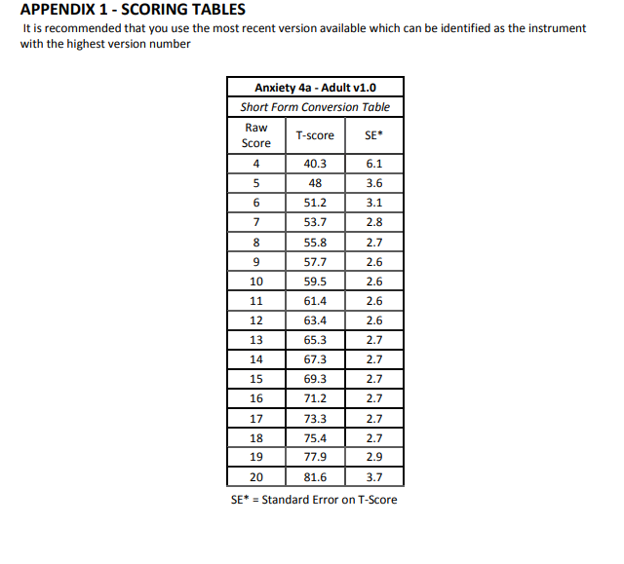

PROMIS measures use scores that have meaning. A PROMIS score of 50 is the average (or mean) score for a specific, relevant group of people (e.g., the U.S. general population, kids with a painful condition). That group is the **reference population**.

Reference Populations

A T-score is a standardized score, like z-scores and IQ scores. All standardized scores have a “middle” score; it is zero for z-scores, 100 for IQ scores, and 50 for T-scores. This middle score is the mean of a large sample that is representative of a relevant population—**a** **reference population**. The large sample used to represent the reference population is called the **Centering Sample**.

For many PROMIS measures, the reference population was the 2000 General US Census. The centering sample was a large sample of individuals who represented the 2000 US General Census.

|  |  |
| --- | --- |
| Emotional Distress - Anger | General population |
| Emotional Distress - Anxiety | General Population |

|  |  |
| --- | --- |
| Emotional Distress - Depression | General population |
| Sleep Disturbance | General population + Clinical sample |
| Social Isolation | General population |

A unique aspect of PROMIS measures is their use of standardized scores that are centered on a relevant reference population. Such scores are called “normative” because their value represents how close or far away they are from a normative population. The word “norm” has different meanings for different contexts. Here, we are not talking about social “norms,” the behaviors we expect from others and ourselves in society. We are also not talking about “normal” per se, even though the term originated from its reference to a standard, bell-shaped distribution curve that labels everything in the vast middle as normal. We use the word norm without applying judgment as to the “normality” of any given score relative to the distribution of scores seen on the same measure in a large group of people. Sometimes we refer to the group as a “reference group” and similarly to “norms” as **reference values** , because they are points of reference from which to understand a given single score.

For example, Jensen et al published **reference values** for eight PROMIS domains for individuals with cancer. The mean Pain Interference score for people with cancer was 52. [**Learn more>>**](https://www.ncbi.nlm.nih.gov/pubmed/28426375)

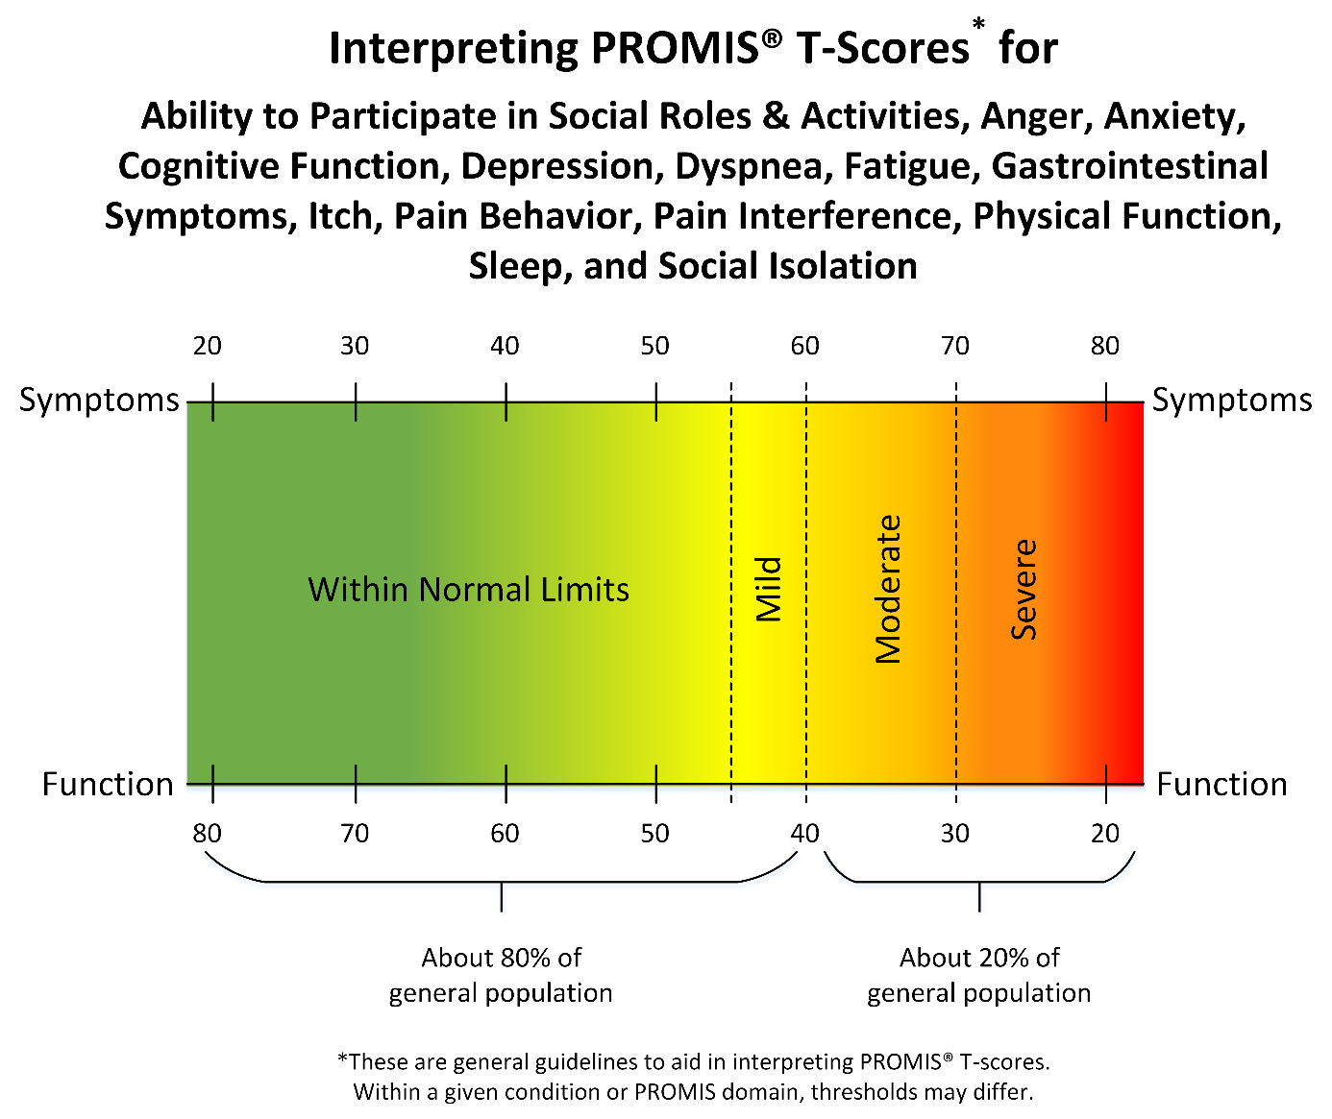

Meer info over PROMIS & T-scores: <http://www.healthmeasures.net/score-and-interpret/interpret-scores/promis/reference-populations>