**The Effect of Vitamin E Diet Supplement on The Growth of Guinea Pigs**

**Maryam Gholami**

**Abstract:** This report is to analyze the effect of vitamin E diet supplement on the growth of guinea pigs, based on an experiment, in which 15 guinea pigs, supposedly at the same age, were divided into three groups. Two treatments were applied to these animals: one is growth-inhibiting substance, applied to all animals in week 1, and the other is different dosages of vitamin E supplement, namely zero, low and high doses, applied for different groups in week 5. The growths of the guinea pigs (in terms of their body weights) were then tracked subsequently. And the main question of interest is then whether vitamin E has any effect on the grow rate of guinea pigs. MANOVA/general linear model (GLM) and linear mixed model (LMM) and repeated measure analysis are employed here answer this question. Based on the information/data provided, it is found that: 1). the time effect in the growth rate is significant; 2). the effect of the vitamin E, either low or high dosage, isn’t significant on the growth rate of guinea pigs; 3). there appears to be a significant interaction between group/dosage and time. However, no firm conclusions can be drawn on the effect of vitamin E and, in particular, on the interaction between treatment and time, as the carryover effect of growth-inhibiting substance at the beginning of the experiment might have distorted the association. Longer observation period is requested to make a firm conclusion on the results.

1. **Introduction**

It’s of great importance to study the effect vitamin E on the growth of guinea pigs, as the knowledge and insight gained from guinea pigs could be generalized to other animals and even human beings. Indeed, this topic has been of great interest decades again [1].

Crowder and Hand [2,3] had described a seven-week study of the effect of a vitamin E diet supplement on the growth of 15 guinea pigs, which were divided into three groups (each with 5 pigs). At the beginning of the study (in week 1) growth inhibiting substance was given to all these pigs, so to slow down their growth and supposedly eliminate potential confounding effects on growth rate. In week 5, each group was applied a different dosage of vitamin E (treatment), namely, zero (control group), low and high doses. Weight (in grams) of each of the guinea pig was then tracked at the end of each week 1, 3, 4, 5, 6, and 7. In terms of statistical language, two treatments were applied to the animals sequentially, once in week 1 with growth inhibiting substance to synchronize the growth of the pigs, the other in week 5 with three dosages of vitamin E, to see the effect of vitamin E on their growth rate.

The questions of interest are 1). Does the growth-inhibiting substance effectively synchronize the growth of the pigs; 2). Does vitamin E supplement have any effect on the growth rate of guinea pigs? 3). Does the growth rate increases while dosage increases?

1. **Data description**

Weights of 15 guinea pigs were tracked in week 1, 3, 4, 5, 6 and 7. No missing values are found in the data [2,3]. The data table is attached in the Appendix I. Fig. 1 shows the growth curves of each individual pig during the study period. It is seen that there is a general upward trend in all the curves and it seems hard to tell the difference in the trend for different groups visually. Fig. 2 depicts the evolution of mean weights in different groups. One observes that right after the application of the growth inhibiting substance, the guinea pigs grew continually for another 3 weeks till week 4, when then the growth in all groups seemed to have stopped. This is clearly reflected in the plateau on the curves between week 4 and 5. Then treatments (vitamin E) were applied to different groups in week 5, and consequently one can see a burst of growth in week 6 and 7 in all the groups. Corresponding summary table is also given in the Appendix for more detailed information.

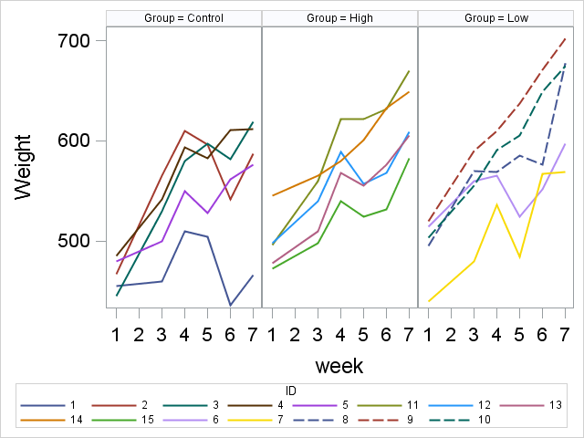

**Fig. 1 The growth curves of each individual pig during the study period**

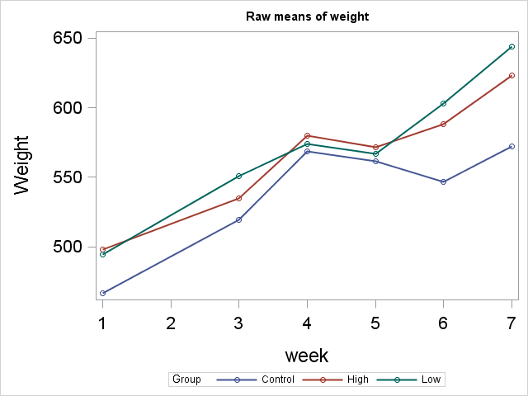

**Fig. 2 The raw means of weight during the study period for control, low and high dosage groups. Note that growth inhibiting substance was applied to all pigs in week 1 and then different doses of vitamin E were applied in week 5.**

1. **Statistical Analysis**

In this section, we carry out more sophisticated analysis to compare the growth rates in different groups, namely control, low and high dosages. Remember that in this experiment there were actually two treatments that were applied to the pigs sequentially. One was growth-inhibiting substance, applied to all animals in week 1, and the other was vitamin E, applied differently to different groups in week 5.

* 1. **Treatment 1: Growth-inhibiting substance**

So for the first treatment, we want to answer the question: is the growth-inhibiting substance effective in slowing down the growth and in synchronizing the growth in different groups? The attention is then placed on the first 5 weeks, namely week 1, 3, 4, and 5, and GLM is used to compare whether there is any difference in the growth rates in different groups. We have employed both R [4] and SAS [5] to analyze the data and both software gave consistent results. Fig. 3 shows the evolution of the estimated means of weights for different groups. It is seen that the guinea pigs continued to grow for another 3 weeks after the treatment in week 1, and before the effect of the growth-inhibiting substance started to take place in week 4. In week 5, the means of different groups are rather close.

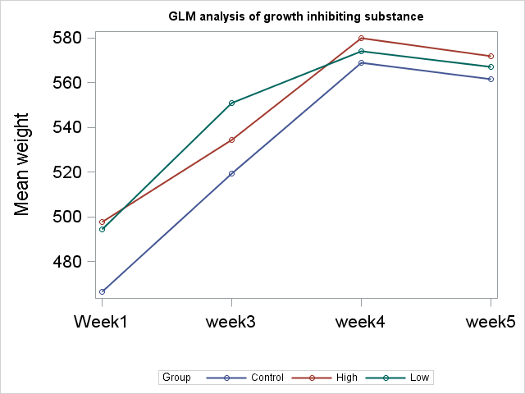

**Fig. 3 The evolution of the estimated means of weights for different groups. It is seen that the guinea pigs continued to grow for another 3 weeks after the treatment in week 1, and before the effect of the growth-inhibiting substance started to take place in week 4. In week 5, the means of different groups are rather close.**

According to GLM test, there is no significant difference in the growth in different groups. Only the effect of “week” is significant, indicating a natural growth in all groups during the period. (The results are summarized in Fig. 4.) This makes sense as the growth-inhibiting substance was applied to all guinea pigs and the treatment was the same for all groups. The most important conclusion of this analysis is that at the beginning of study, i. e., in week 1, the means of weights in different groups were a little different, whereas in week 5, they became much closer, as is shown in Fig. 5. LMM analysis was also used to further study the effect of the growth-inhibiting substance, however, LMM does not bring any new insight to the question.

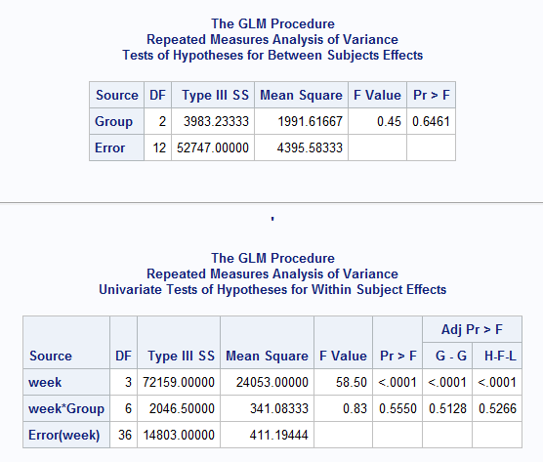

**Fig. 4 Summary results of GLM analysis on the effect of grown-inhibiting substance on guinea pigs in the first 5 weeks of experiment. Note that only the effect of week is significant, indicating the natural growth of guinea pigs. From mean plots, we can see that this was mainly contributed by the growth in the first 3 weeks.**

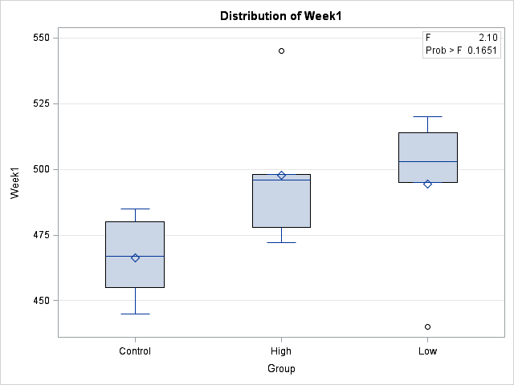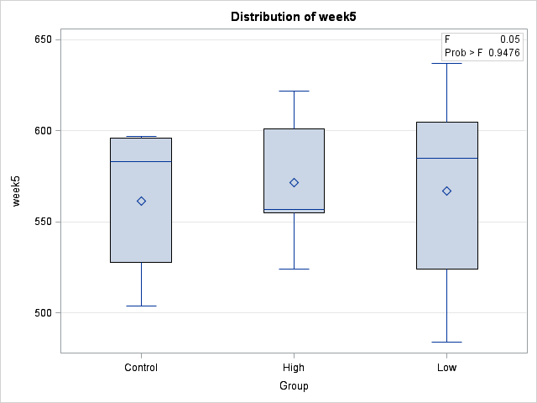

**Fig. 5 A comparison of means for week 1 and week 5.**

* 1. **Treatment 2: vitamin E**

We have seen that up to week 5, weights of guinea pigs in the three groups have been at almost the same baseline, and in week 5, treatments of different dosages of vitamin E were then applied to the three groups. We analyze here the effect of vitamin E on the growth rate in the subsequent weeks by using both GLM and LMM based methods. The question of interest here is then: does vitamin E have any significant effect on the growth of guinea pigs? Or in another words, do the growth rates in the three different groups differ after the treatments? To answer these questions, we have again employed both R and SAS to analyze the data and both software gave consistent results.

**Analysis based on GLM:** Fig. 6 shows the evolution of the estimated means of weights for different groups after the treatment of vitamin E in week 5. It is shown that right after the treatment there is a burst of growth in the two groups with treatment, and the group with low dosage of vitamin E appears to enjoy the fastest growth among the three groups. The control group behaviors a little differently in this time period. It experienced negative growth in week 6, very likely due to the carryover effect of the growth-inhibiting substance, and started to grow in week 7. Also it appears that the three groups have slightly different growth rate.

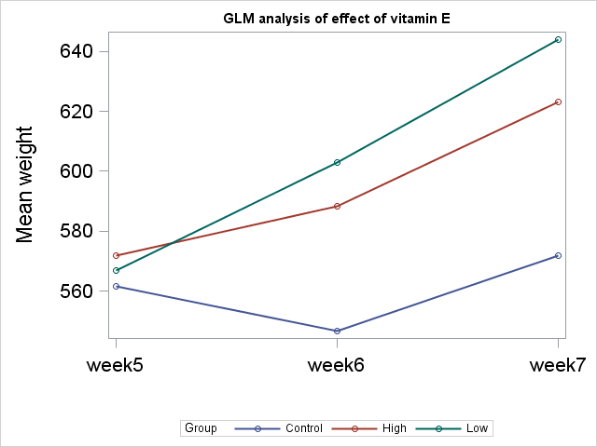

**Fig. 6 The evolution of the estimated means of weights for different groups after the treatment of vitamin E. It is shown that right after the treatment there is a burst of growth in all three groups, and the group with low dosage of vitamin E appears to enjoy the fastest growth among the three groups.**

Although it appears in Fig. 6 that there is significant difference in growth in all three groups, our GLM test says otherwise. Fig. 7 shows summary results of GLM analysis on the effect of vitamin E on guinea pigs in weeks 5-7. Note that while the group effect is insignificant, both the effect of week and week*group interaction are significant. It needs to be cautious here to interpret the significant interaction here, as it might have caused by the carryover effect of the growth-inhibiting substance in week 5 and 6, as from Fig. 6 we have indeed seen some carryover effect in the control group.

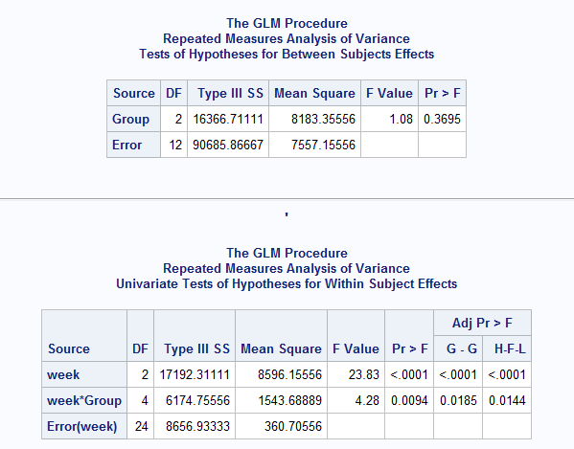

**Fig. 7 Summary results of GLM analysis on the effect of vitamin E on guinea pigs in weeks 5-7. Note that both the effect of week and week*group interaction are significant.**

**Analysis based on LMM:** We next carry out analysis based on LMM [4,5]. Details of the methods can be found in Refs. [4,5]. The following figure (Fig. 8) is to show some basic information about the model we are using, for the purpose of reproduction. In this particular example, unstructured correlation matrix is used for the repeated measurements.

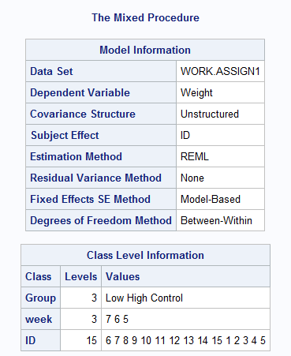

**Fig. 8 Model information of LMM of the effect of vitamin E on the growth rate of guinea pigs. This example is using unstructured correlation matrix for the repeated measurements, and one sees that the estimate is based on REML.**

Fig. 9 shows the solution of the fixed effect in the model of three group (i=1,2 and 3), 5 subject (j=1 to 5) in each group, 6 repeated measurements (k=1 to 6) for each subject:

$$y_{ijk}=μ+α_{i}+γ_{k}+{(αγ)}_{ik}+μ_{ij}+ϵ_{ijk}$$

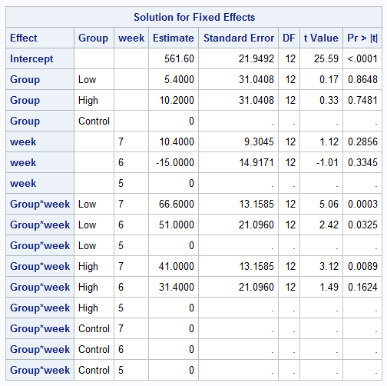

**Fig. 9 Solution for Fixed Effects in the model.**

Fig. 10 shows the Type 3 tests (overall) of fixed effects of the model. We see here again that both the week and week*Group interaction are significant, while group effect not significant. This result is consistent with those shown in Fig. 7, where we have used GLM analysis. Again we need to be very cautious here to interpret the interaction.

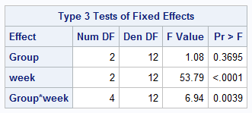

**Fig. 10 Type 3 Tests of Fixed Effects in the model.**

Lastly, it should be mentioned that different correlation structures of repeated measurements have been tested, including compound symmetry (CS), unstructured (UN) and autoregressive (AR(1)). Table 1 shows and compares different information criteria together with log likelihood for models using different correlation matrix. We see that the model with UN correlation matric has the smaller log likelihood, whereas the model based on CS has smaller values in all the other information criteria due to its simplicity. For models based on CS and UN, the fitting results are almost identical.



**Table 1. LMM model comparison. Different models use different correlation matrix for the repeated measurement, all the other setups are the same for all the models.**

1. **Conclusion**

Thus we have employed GLM and LMM method to analyze the experimental data on 15 guinea pigs, to test whether vitamin E has any effect on the growth rate of guinea pigs. Based on the information/data provided, it is found that: 1). the time effect in the growth rate is significant; 2). the effect of the vitamin E, either low or high dosage, isn’t significant on the growth rate of guinea pigs; 3). there appears to be a significant interaction between group/dosage and time. However, no firm conclusions can be drawn on the effect of vitamin E and, in particular, on the interaction between treatment and time, as the carryover effect of growth-inhibiting substance at the beginning of the experiment might have distorted the association. Longer observation period is required to make a firm conclusion on the results.

**References:**

[1] J. E. Wagner (2014), The Biology of the Guinea Pig,.

[2]. M. J. Crowder and D. J. Hand (1990). Analysis of Repeated Measures.

[3] C. S Davis (2002), Statistical methods for the analysis of repeated measurements

[4]. <http://www.ats.ucla.edu/stat/r/seminars/Repeated_Measures/repeated_measures.htm>

[5]. <http://www.ats.ucla.edu/stat/sas/seminars/sas_repeatedmeasures/>

**Appendix I: The data table**



**Appendix II: Summary statistics of the original data**



**Appendix III: Analysis based on R**

* Repeated measure analysis for effect of Growth-inhibiting substance

Error: id

Df Sum Sq Mean Sq F value Pr(>F)

group 2 4214 2107 0.507 0.616

time 1 6842 6842 1.646 0.226

Residuals 11 45716 4156

Error: Within

Df Sum Sq Mean Sq F value Pr(>F)

time 3 72003 24001 57.434 1.34e-13 ***

group:time 6 2059 343 0.821 0.561

Residuals 35 14626 418

---

Signif. codes: 0 ‘***’ 0.001 ‘**’ 0.01 ‘*’ 0.05 ‘.’ 0.1 ‘ ’ 1

* Repeated measure analysis for effect of vitamin E:

Error: id

Df Sum Sq Mean Sq F value Pr(>F)

group 2 16367 8183 1.083 0.37

Residuals 12 90686 7557

Error: Within

Df Sum Sq Mean Sq F value Pr(>F)

time 2 17192 8596 23.83 1.99e-06 ***

group:time 4 6175 1544 4.28 0.00937 **

Residuals 24 8657 361

---

Signif. codes: 0 ‘***’ 0.001 ‘**’ 0.01 ‘*’ 0.05 ‘.’ 0.1 ‘ ’ 1

* Variance-Covariance Structures

summary(fit.cs)

Generalized least squares fit by REML

Model: Wight ~ group * time

Data: longg

AIC BIC logLik

387.125 404.5437 -182.5625

Correlation Structure: Compound symmetry

Formula: ~1 | id

Parameter estimate(s):

Rho

0.8692874

Standardized residuals:

Min Q1 Med Q3 Max

-2.1054152 -0.6853069 0.2855446 0.7233795 1.3325413

Residual standard error: 52.53121

Degrees of freedom: 45 total; 36 residual

> anova(fit.cs)

Denom. DF: 36

numDF F-value p-value

(Intercept) 1 2047.4259 <.0001

group 2 1.0829 0.3494

time 2 23.8315 <.0001

group:time 4 4.2796 0.0062

|  |
| --- |
| summary(fit.un)  Generalized least squares fit by REML  Model: Wight ~ group * time  Data: longg  AIC BIC logLik  389.6992 413.452 -179.8496  Correlation Structure: General  Formula: ~1 | id  Parameter estimate(s):  Correlation:  1 2  2 0.803  3 0.919 0.896  Variance function:  Structure: Different standard deviations per stratum  Formula: ~1 | time  Parameter estimates:  week5 week6 week7  1.000000 1.129815 1.077159  Standardized residuals:  Min Q1 Med Q3 Max  -2.0050385 -0.6845984 0.2777218 0.7566183 1.4262466  Residual standard error: 49.07987  Degrees of freedom: 45 total; 36 residual  > anova(fit.un)  Denom. DF: 36  numDF F-value p-value  (Intercept) 1 1988.2832 <.0001  group 2 0.0398 0.9611  time 2 53.7925 <.0001  group:time 4 6.9432 0.0003 |

> summary(fit.ar1)

Generalized least squares fit by REML

Model: Wight ~ group * time

Data: longg

AIC BIC logLik

393.449 410.8677 -185.7245

Correlation Structure: AR(1)

Formula: ~1 | id

Parameter estimate(s):

Phi

0.8384705

Standardized residuals:

Min Q1 Med Q3 Max

-2.1432278 -0.6976148 0.2906728 0.7363712 1.3564733

Residual standard error: 51.60441

Degrees of freedom: 45 total; 36 residual

> anova(fit.ar1)

Denom. DF: 36

numDF F-value p-value

(Intercept) 1 2298.5481 <.0001

group 2 0.9814 0.3846

time 2 11.9860 0.0001

group:time 4 2.2127 0.0871

|  |  |  |  |
| --- | --- | --- | --- |
| summary(fit.arh1)  Generalized least squares fit by REML  Model: Wight ~ group * time  Data: longg  AIC BIC logLik  396.9177 417.5035 -185.4589  Correlation Structure: AR(1)  Formula: ~1 | id  Parameter estimate(s):  Phi  0.8503497  Variance function:  Structure: Different standard deviations per stratum  Formula: ~1 | time  Parameter estimates:  week5 week6 week7  1.000000 1.094476 1.012751   |  | | --- | | Standardized residuals:  Min Q1 Med Q3 Max  -2.0658480 -0.6631846 0.2777217 0.7500302 1.3816346  Residual standard error: 50.66463  Degrees of freedom: 45 total; 36 residual  > anova(fit.arh1)  Denom. DF: 36  numDF F-value p-value  (Intercept) 1 2407.7961 <.0001  group 2 0.6476 0.5293  time 2 12.8087 0.0001  group:time 4 2.3581 0.0718 | |  | |  |  * Model comparison   anova(fit.cs, fit.un)  Model df AIC BIC logLik Test L.Ratio p-value  fit.cs 1 11 387.1250 404.5437 -182.5625  fit.un 2 15 389.6992 413.4520 -179.8496 1 vs 2 5.425811 0.2463  > anova(fit.cs, fit.ar1)  Model df AIC BIC logLik  fit.cs 1 11 387.125 404.5437 -182.5625  fit.ar1 2 11 393.449 410.8677 -185.7245  > anova(fit.cs, fit.arh1)  Model df AIC BIC logLik Test L.Ratio p-value  fit.cs 1 11 387.1250 404.5437 -182.5625  fit.arh1 2 13 396.9177 417.5035 -185.4589 1 vs 2 5.792712 0.0552 |

* Comparing between weeks:

|  |
| --- |
| Pairwise comparisons using paired t tests  data: Wight and time  week5 week6  week6 0.22189 -  week7 0.00026 0.00025  P value adjustment method: holm |