# Project Basics

For my CRUD Final project, I had decided to create a Weekly Agenda. This application allows for users to input the tasks of their daily lives. To create a new task, users will be asked to input the day the task is taking place, a time, a title that relates, and a description that explains the particular task.

The Weekly Agenda was built using HTML, CSS, jQuery, and Javascript. As per rubric guidelines, the application displays the CRUD function to meet the user’s needs.

## **Add Task**

Users can create tasks by simply inputting the day, time, title and description into the text boxes provided. Using **.push** adds the task to the array, which allows it to be displayed onto the page. **clearInputs()** clears the textboxes after the button to enter has been clicked.

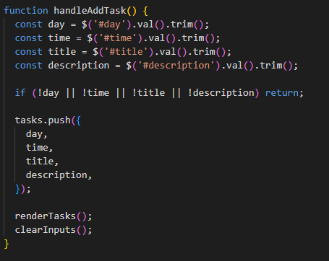

## **View Details**

To view the details of an already-created task, the user will click on the View button. In the JS file, information for the details will be displayed under the **toggleDetails()** function.

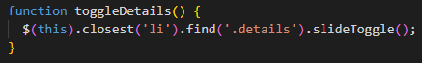

## **Edit Task**

To edit a task, the user will click on the **Edit** button. This button will show the four textboxes (day, time, title, and description), along with a **Save** button.

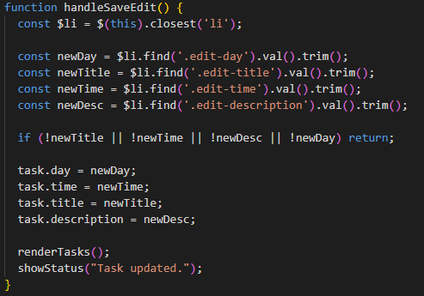

## 

## **Delete Task**

To delete a task, the user will click the delete button. After clicking, text should pop onto the screen, stating the task was deleted.

