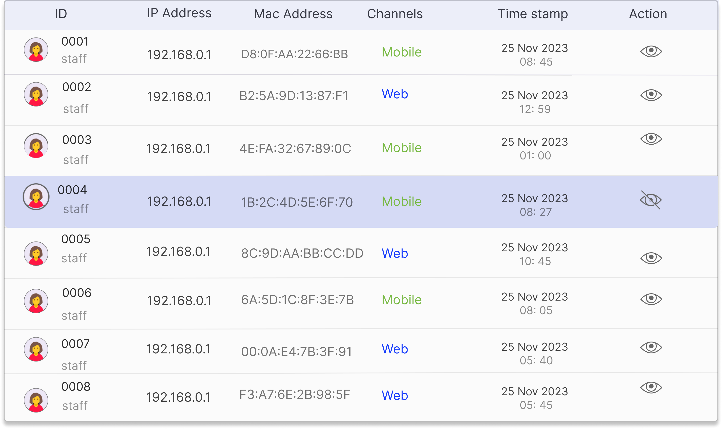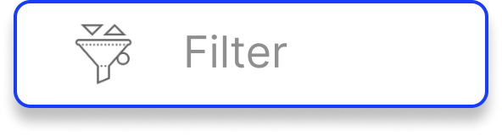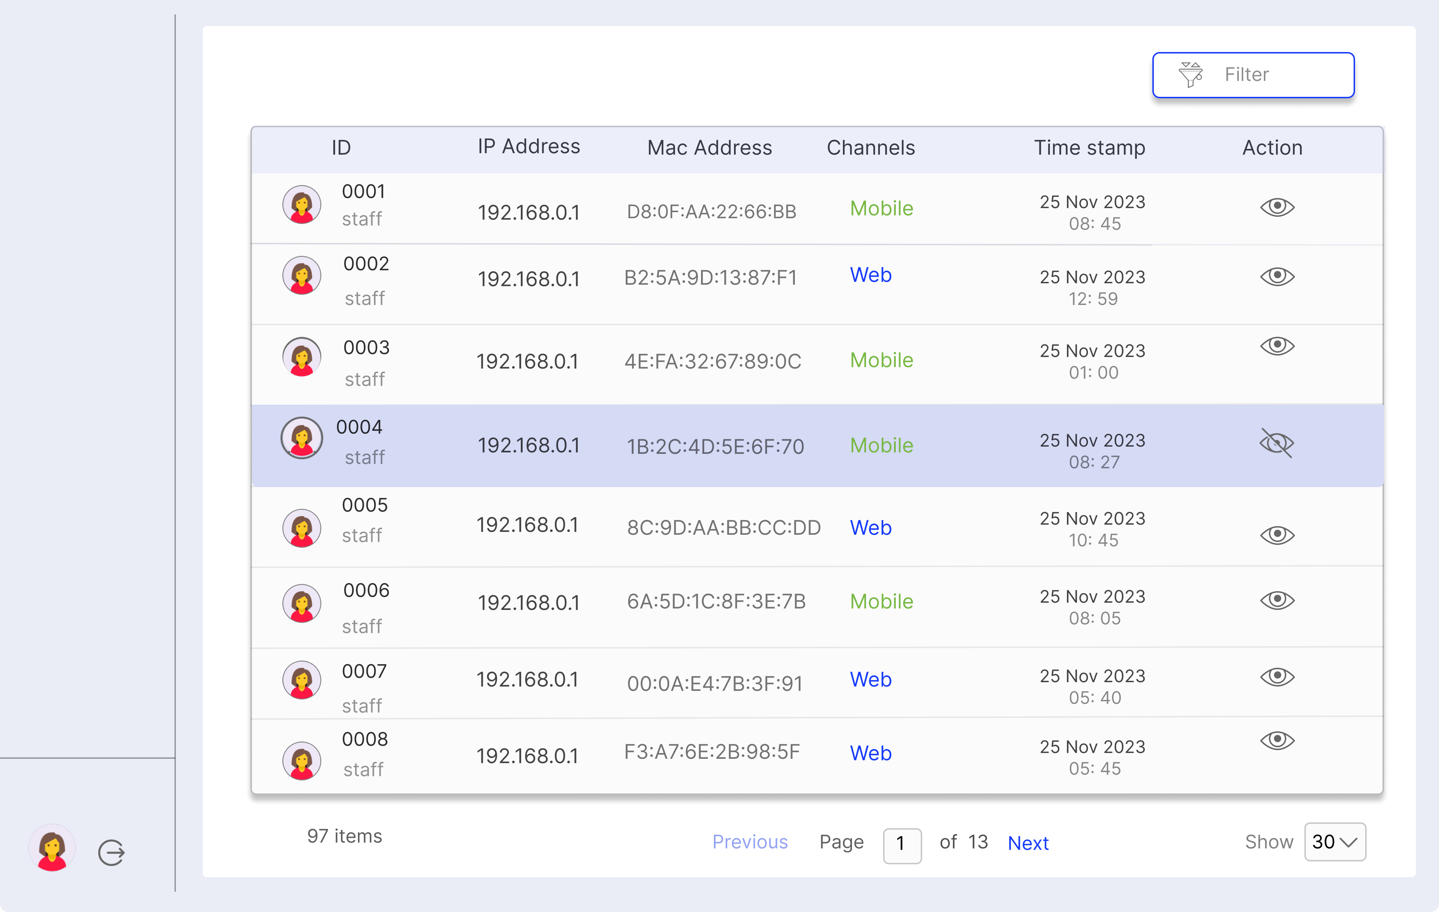

AUDIT LOG USGL

Filter

|  |  |  |  |  |  |  |  |  |
| --- | --- | --- | --- | --- | --- | --- | --- | --- |
| ID | IP Address | Mac Address | Channels | | | of 13 | Time stamp | Action |
| 0001 | 192.168.0.1 | D8:0F:AA:22:66:BB | Mobile | | | Show 30 |
| 25 Nov 2023 |
| staff |
| 08: 45 |
| 0002 | B2:5A:9D:13:87:F1 | Web | | |
| 192.168.0.1 |
| 25 Nov 2023 |
| staff |
| 12: 59 |
| 192.168.0.1 | 4E:FA:32:67:89:0C | Mobile | | |
| 0003 | 25 Nov 2023 |
| staff | 01: 00 |
| 0004 | 192.168.0.1 | 1B:2C:4D:5E:6F:70 | Mobile | | |
| 25 Nov 2023 |
| staff |
| 08: 27 |
| 0005 |
| 192.168.0.1 | 8C:9D:AA:BB:CC:DD | | Web | |
| 25 Nov 2023 |
| staff |
| 10: 45 |
| 0006 | 192.168.0.1 | 6A:5D:1C:8F:3E:7B | Mobile | | |
| 25 Nov 2023 |
| staff | 08: 05 |
| 192.168.0.1 | 00:0A:E4:7B:3F:91 | Web | | |
| 0007 | 25 Nov 2023 |
| staff | 05: 40 |
| 192.168.0.1 | F3:A7:6E:2B:98:5F | Web | | |
| 0008 | 25 Nov 2023 |
| staff |
| 05: 45 |
| Previous | Page | | 1 |
| 97 items | Next |

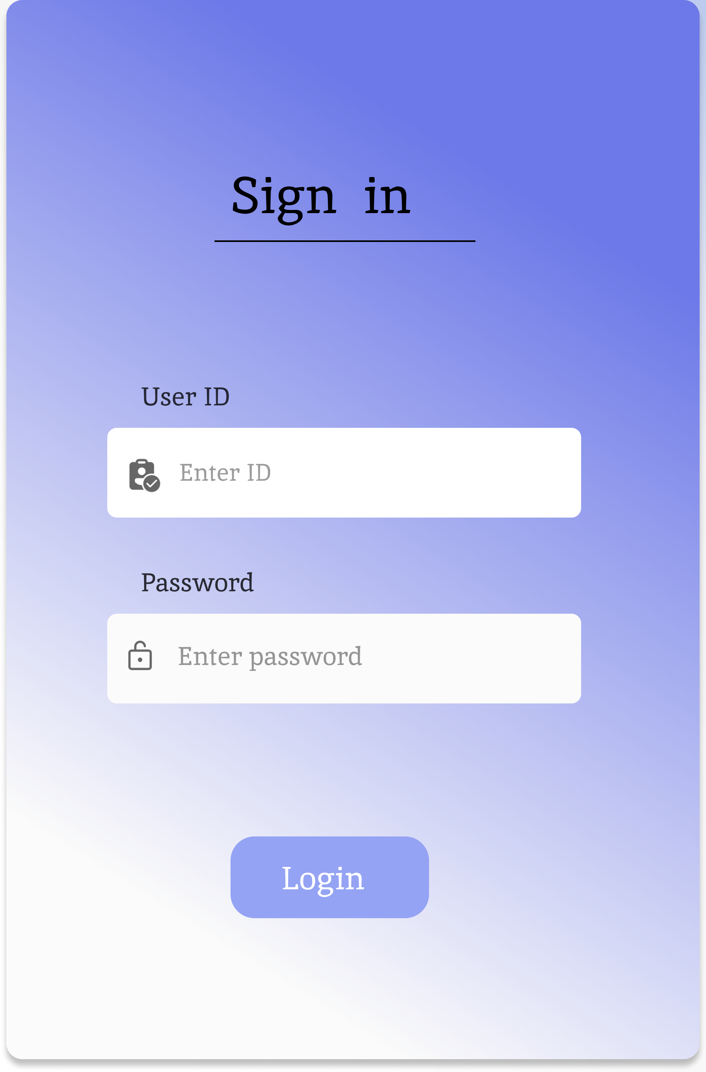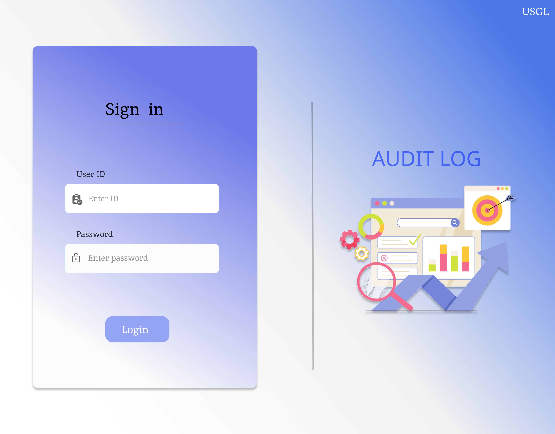

USGL

Sign in

AUDIT LOG

User ID

Enter ID

Password

Enter password

Login