Login: Can use librarian harrischristopher@example.com

Popular books – no input required, just click button

Get libraries – no input required, app will automatically get

Search Book – Can use Amy as author name and Mystery as genre

Available Copy – Can use wizards as book title and Markham library under dropdown

Get reservations – Can use [laurazimmerman@example.org](mailto:laurazimmerman@example.org)

Return Book – Can use cardholder [laurazimmerman@example.org](mailto:laurazimmerman@example.org) and serial number '196831686705'





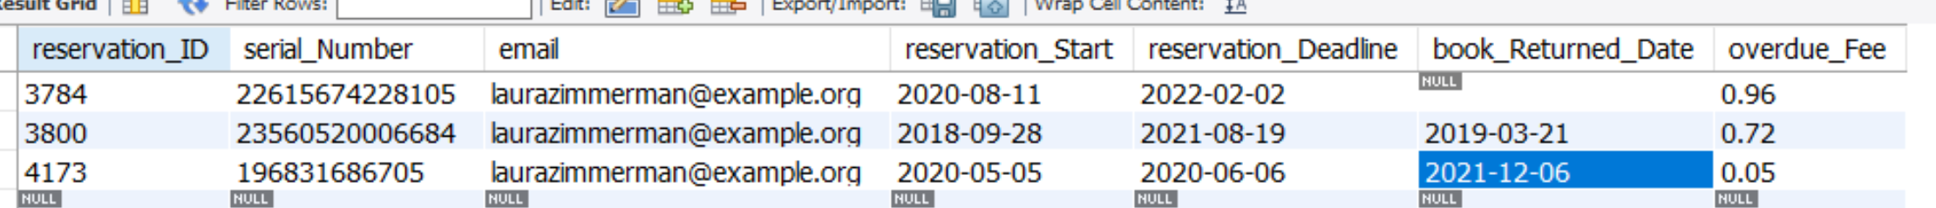

Fee Balance – Can use [laurazimmerman@example.org](mailto:laurazimmerman@example.org)

Make reservation – Can use book serial number '6229517261537' and 'laurazimmerman@example.org'