Discussion_10

MGinorio

10/30/2021

## Example 11.6 pg. 410

In the Dark Ages, Harvard, Dartmouth, and Yale admitted only male students. Assume that, at that time, 80 percent of the sons of Harvard men went to Harvard and the rest went to Yale, 40 percent of the sons of Yale men went to Yale, and the rest split evenly between Harvard and Dartmouth; and of the sons of Dartmouth men, 70 percent went to Dartmouth, 20 percent to Harvard, and 10 percent to Yale. We form a Markov chain with transition matrix.

$$ P =

$$

## Step 1

Create vector College_Admis containing the percentages of college admission for each graduate.

College_Zone <- c("Harv", "Dartm", "Yale")  
College_Zone

## [1] "Harv" "Dartm" "Yale"

## Step 2

Create Matrix with values from probability. convert vector into matrix and add to column and row name

Zone_Transition = matrix(c(0.8,0,0.2,0.20,0.70,0.10,0.30,0.30,0.40),   
 nrow = 3,  
 byrow = TRUE,  
 dimnames = list(College_Zone, College_Zone))  
Zone_Transition

## Harv Dartm Yale  
## Harv 0.8 0.0 0.2  
## Dartm 0.2 0.7 0.1  
## Yale 0.3 0.3 0.4

## Step 3

Install markovchain package

library(markovchain)

## Package: markovchain  
## Version: 0.8.6  
## Date: 2021-05-17  
## BugReport: https://github.com/spedygiorgio/markovchain/issues

## Step 4

Create a markov Chain object state space = to vector in Step 1 and Transition matrix from step 2

mcZone <- new("markovchain", states = College_Zone,  
 byrow = TRUE,  
 transitionMatrix = Zone_Transition,  
 name = "College_Movement")  
mcZone

## College_Movement   
## A 3 - dimensional discrete Markov Chain defined by the following states:   
## Harv, Dartm, Yale   
## The transition matrix (by rows) is defined as follows:   
## Harv Dartm Yale  
## Harv 0.8 0.0 0.2  
## Dartm 0.2 0.7 0.1  
## Yale 0.3 0.3 0.4

class(mcZone)

## [1] "markovchain"  
## attr(,"package")  
## [1] "markovchain"

## Step 5

For Example 11.6, find the probability that the grandson of a man from Harvard went to Harvard

mcZone^2

## College_Movement^2   
## A 3 - dimensional discrete Markov Chain defined by the following states:   
## Harv, Dartm, Yale   
## The transition matrix (by rows) is defined as follows:   
## Harv Dartm Yale  
## Harv 0.70 0.06 0.24  
## Dartm 0.33 0.52 0.15  
## Yale 0.42 0.33 0.25

### Answer

The probability that the grandson of a man from Hardvard went to Harvard is **70%**

## Step 7

Determine the stationary state of

steadyStates(mcZone)

## Harv Dartm Yale  
## [1,] 0.5555556 0.2222222 0.2222222

## Step 8

Display the Markov chain and the transition probabilities.

layout <- Zone_Transition  
plot(mcZone, node.size = 10, layout = layout)

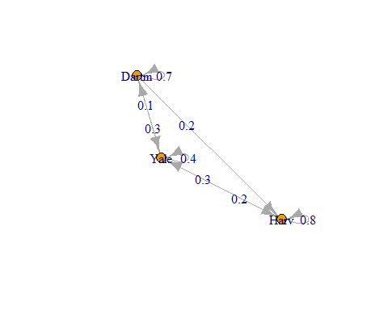

Since we DO NOT have an absorbing Markov chain, we DO NOT calculate the expected time until absorption.