Ginorio_Assignment10

MGinorio

10/31/2021

## Problem

Smith is in jail and has 1 dollar; he can get out on bail if he has 8 dollars. A guard agrees to make a series of bets with him. If Smith bets A dollars, he wins A dollars with probability .4 and loses A dollars with probability .6. Find the probability that he wins 8 dollars before losing all of his money if

1. he bets 1 dollar each time (timid strategy).
2. he bets, each time, as much as possible but not more than necessary to bring his fortune up to 8 dollars (bold strategy).
3. Which strategy gives Smith the better chance of getting out of jail

$q_{z}=\frac{(q/p)^{z}−1}{(q/p)^{M}−1}$

Starting with 1 dollar = $z=1$. $q_{z}$ $p$ = the probability of a win, and $q$ = the probability of a loss. $M$ = reaches the value M or the value 0

### (a)

Find the probability that he reaches M = 8 dollars before losing M = 0

He bets 1 dollar each time (timid strategy)

p <- .4  
q <- 1 - p  
z <- 1  
M <- 8  
  
result_timid <- ((q/p)^z - 1) / ((q/p)^M - 1)  
  
result_timid

## [1] 0.02030135

The probability of winning 8 dollars is 0.02030135

### (b)

he bets, each time, as much as possible but not more than necessary to bring his fortune up to 8 dollars (bold strategy).

In order for Smith to bring his fortune to 8 dollars he needs to double down 3 times

$$1^{2}=2$$

$$2^{2}=4$$

$$2^{3}=8$$

result_bold <- p^3  
  
result_bold

## [1] 0.064

The probability of winning 8 dollars is 0.064

# random walk  
# origin  
x = 1  
y = 0  
no_of_points <- 1000  
  
for (i in 1:no_of_points){  
 # create random number between 1 to 4  
 s = sample(1:4,1)  
 if(s==1){ # right x+1  
 x = c(x,x[length(x) +1])  
 y = c(y,y[length(y)] +0)  
 }  
   
 if(s==2){ # right x+1  
 x = c(x,x[length(x) +2])  
 y = c(y,y[length(y)] +0)  
 }  
   
 if(s==3){ # right x+2  
 x = c(x,x[length(x) +4])  
 y = c(y,y[length(y)] +0)  
 }  
   
}  
  
plot(x,y,col="black", type = "l")

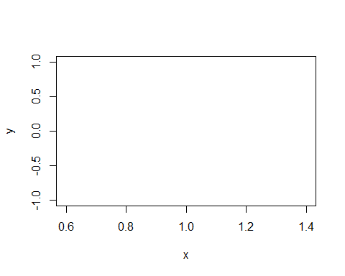

### (c)

Which strategy gives Smith the better chance of getting out of jail?

Based on Smith arrangement the **bold strategy** is the best strategy it gives Smith 6% chance meanwhile the timid strategy gives Smith 2% chance.