**MongoDB and Why NoSQL Databases**

**1. Introduction to NoSQL**

The rise of big data and real-time applications has exposed the limitations of traditional relational databases (RDBMS). NoSQL databases emerged as a solution for high scalability, flexible data modelling, and faster performance on large, distributed systems.

**What is NoSQL?**  
“NoSQL” stands for “Not Only SQL.” These databases don’t follow the rigid table-based model of relational databases. Instead, they offer various flexible data models.

**Types of NoSQL Databases:**

* **Document-based** – e.g., MongoDB (stores JSON-like documents)
* **Key-Value Stores** – e.g., Redis
* **Column-Family Stores** – e.g., Cassandra
* **Graph-Based** – e.g., Neo4j

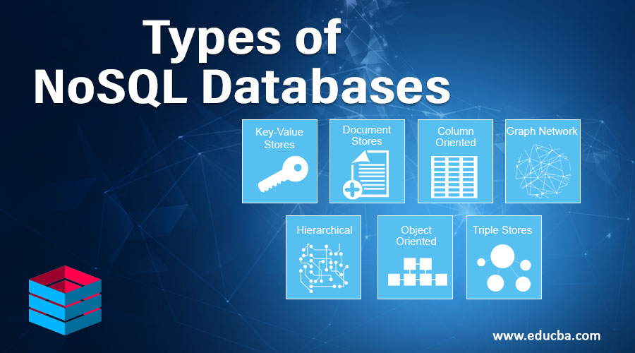

**Key Characteristics:**

* Schema-less (dynamic)
* Horizontal scaling (add more servers)
* High performance for read/write operations
* Designed for unstructured or semi-structured data

Traditional RDBMS systems can't efficiently handle modern demands because they are designed around structured, fixed-schema data and vertical scaling. As data grows in volume, variety, and velocity (especially in cloud and web-scale apps), relational models struggle with performance and flexibility, making NoSQL a better fit in many modern scenarios.

**2. Why NoSQL Over SQL?**

Relational databases use strict schemas and vertical scaling. While reliable, they struggle with rapidly changing data structures or massive scale. NoSQL was built to address this.

| **Feature** | **SQL (Relational)** | **NoSQL (Non-relational)** |
| --- | --- | --- |
| Schema | Fixed, structured | Dynamic, flexible |
| Scaling | Vertical (scale-up) | Horizontal (scale-out) |
| Data Storage | Rows and Tables | JSON, Key-Value, Graph, etc. |
| Consistency | Strong (ACID) | Eventual (BASE) |
| Flexibility | Low | High |

**Use NoSQL When:**

* You expect large volumes of unstructured data.
* Schema is evolving over time.
* You need global scalability.
* You’re building cloud-native or microservices-based apps.

For example, a social media platform may frequently change the structure of user profiles, posts, and activity feeds. With SQL, this requires altering tables and migrations. NoSQL handles such changes naturally.

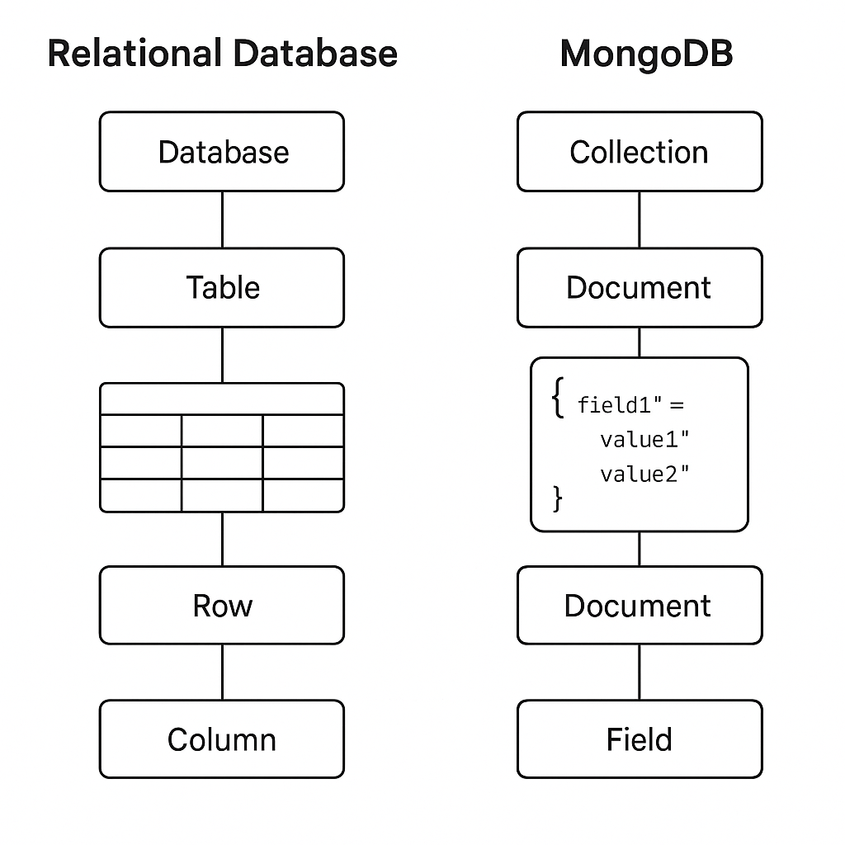

**3. Introduction to MongoDB**

**MongoDB** is a document-oriented NoSQL database. Instead of storing data in tables, it stores data in **documents** (similar to JSON objects) inside **collections**.

**MongoDB Structure:**

* **Database** → Collection of collections
* **Collection** → Group of related documents
* **Document** → Key-value pairs stored in BSON format

**Sample Document:**

{

"_id": "user123",

"name": "Jane Doe",

"email": "jane@example.com",

"orders": [

{"id": 1, "item": "Laptop", "price": 999},

{"id": 2, "item": "Mouse", "price": 25}

]

}

This structure allows storing nested and varying fields easily. Compared to a relational database where orders would be in a separate table linked via foreign keys, MongoDB stores everything together in one place, making reads faster and development more intuitive.

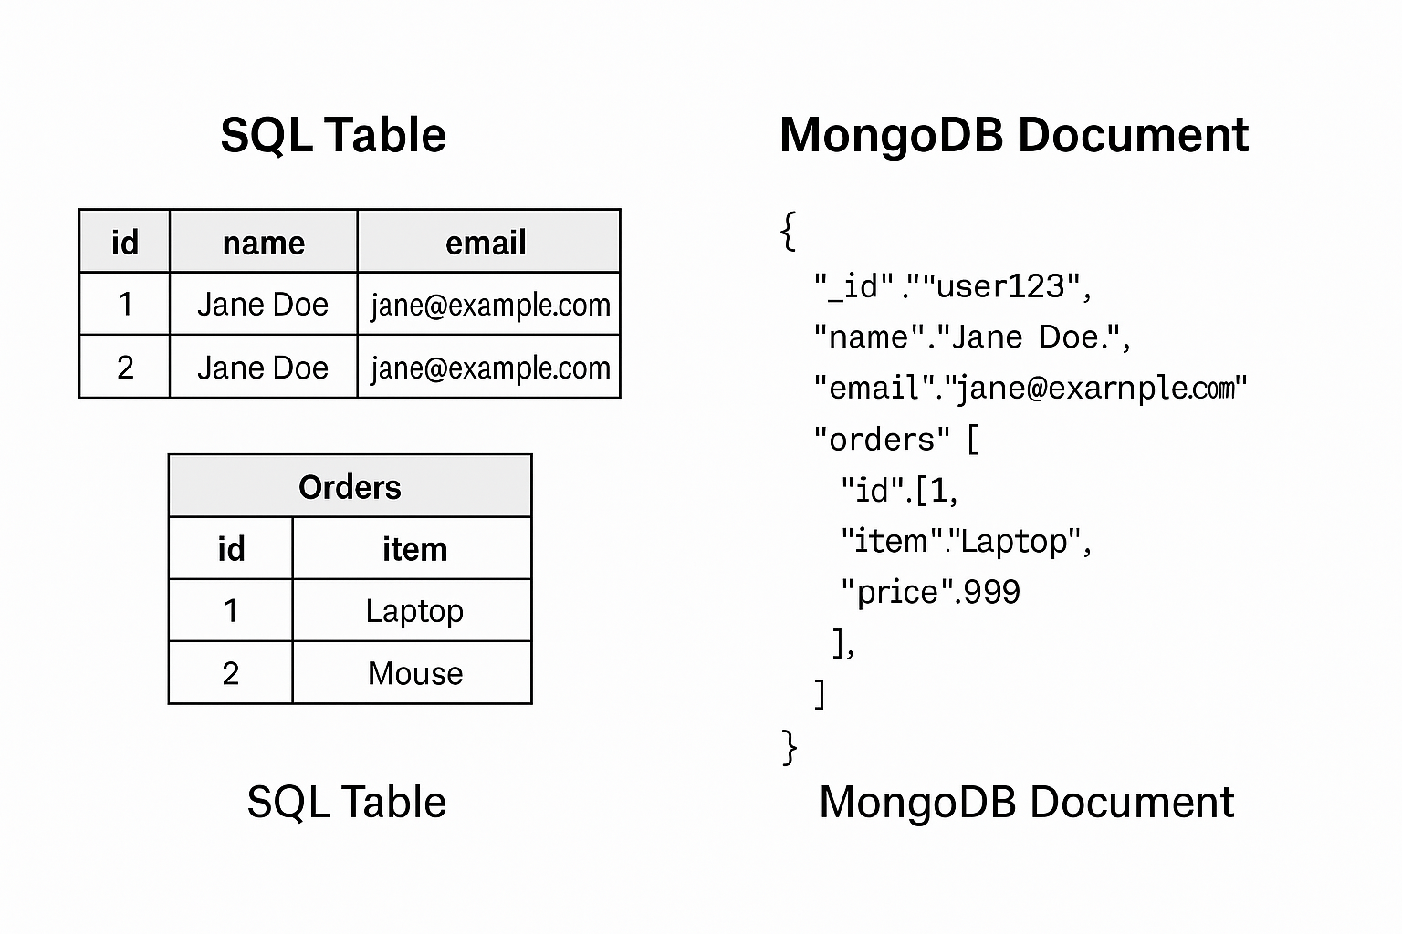

**4. Key Features of MongoDB**

MongoDB is designed to be developer-friendly, performant, and scalable.

**Core Features:**

* **Document-based Storage** – Data is stored as flexible, hierarchical documents.
* **Indexing** – Efficient search using single-field, compound, and geospatial indexes.
* **Aggregation Pipeline** – Perform advanced data transformations and analytics.
* **Sharding** – Automatic horizontal scaling of large datasets.
* **Replication** – High availability using replica sets.
* **Transactions** – Support for multi-document ACID transactions (v4.0+).

The aggregation pipeline in MongoDB allows data to flow through multiple transformation stages, similar to SQL’s GROUP BY, HAVING, and JOIN statements — but all within a flexible document structure. This allows for complex reporting and analytics without relying on traditional joins.

**5. MongoDB Use Cases**

MongoDB shines when flexibility and scale are top priorities.

**Popular Use Cases:**

* **Content Management Systems (CMS)**  
  Pages, blocks, and user content vary widely in structure. MongoDB's schema-less design supports this.
* **E-Commerce Catalogs**  
  Product data changes frequently (e.g., sizes, colors, stock availability). MongoDB handles varying fields in different products with ease.
* **IoT Applications**  
  Sensor data and device logs can be ingested at high volume and vary in structure depending on the device or firmware.
* **Mobile & Social Apps**  
  Schema changes often, users add and remove fields, and scale is a must. MongoDB is ideal for this fast-moving environment.
* **Real-Time Analytics**  
  Aggregation framework allows on-the-fly querying of massive logs, transactions, and user data.

For example, eBay and Uber use MongoDB to store user activity, pricing data, or internal tools that benefit from fast schema iteration and scalable infrastructure.

**6. Pros and Cons of MongoDB**

Every database has trade-offs. Here’s a summary of MongoDB’s strengths and limitations:

**Advantages:**

* Schema flexibility → rapid development without migrations.
* Great for hierarchical/nested data.
* Excellent horizontal scaling with built-in sharding.
* Strong support for indexing, search, and aggregation.
* Integrated cloud platform (MongoDB Atlas).

**Limitations:**

* Lacks native SQL-style JOINs — embedded documents or manual references are needed.
* Eventual consistency in distributed setups — not ideal for systems requiring strict immediate consistency.
* Can consume more memory if indexes aren’t managed well.
* ACID compliance is limited to transactions and not enforced globally across all operations.

To mitigate limitations, MongoDB best practices recommend designing data models based on access patterns, using embedded documents when suitable, avoiding large unbounded arrays, and monitoring performance with Atlas or Compass.