

Meta Ads Performance Audit
Client: Box Divvy
Campaign: Hubster Lead Gen
Period: 5 May 2026 – 11 May 2026

Executive Summary
The Box Divvy campaign is delivering solid results with a blended CPL of $15.23 across 29 leads. Total ad spend for the period was $441.55 with an average CTR of 7.63%. The top performer achieved a CPL of $2.33 (DEC-15-2025 - copy_08771CC1-D4C9-4210-BE). High CTR indicates strong creative-audience fit.

Key Metrics
Period | Spend | Leads | CPL | CTR
This Week | $441.55 | 29 | $15.23 | 7.63%
This Month | $2,069.64 | 182 | $11.37 | 7.67%
Since Starting | $8,319.44 | 882 | $9.43 | 6.69%

Latest Batch — Top Performers
# | Release Lot | CPL | Leads | CTR | Ad ID | Preview
🔥 | May-4 | $6.67 | 16 | 5.14% | ...419360360 | 
2 | May-4 | $13.04 | 5 | 5.12% | ...418000360 | 
⭐ | May-4 | $20.11 | 2 | 5.17% | ...392360360 | 
4 | May-4 | $24.79 | 16 | 7.59% | ...417160360 | 

Top 5 Performers by CPL — All Time
# | Release Lot | CPL | Leads | CTR | Ad ID | Preview
🔥 | Feb-6 | $2.33 | 2 | 2.44% | ...917610360 | 
2 | Feb-6 | $3.18 | 1 | 6.74% | ...917210360 | 
⭐ | Feb-6 | $3.87 | 3 | 4.63% | ...917220360 | 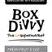
4 | Jan-29 | $4.03 | 11 | 6.22% | ...743430360 | 
5 | Jan-12 | $4.07 | 12 | 6.18% | ...985710360 | 
🔥 = Top performer | ⭐ = Volume star | Sorted by cost per conversion (lowest first)

Release Lot Performance
• DEC-15 Release: 5 conversions from 2 ad(s) – Best cost: $2.33
• DEC-29 Release: 1 conversions from 1 ad(s) – Best cost: $3.18
• Jan-17 Release: 11 conversions from 1 ad(s) – Best cost: $4.03
• Dec-15 Release: 12 conversions from 1 ad(s) – Best cost: $4.07

Creative Insights
Top Performer:
DEC-15-2025 - copy_08771CC1-D4C9-4210-BE7C-B4582E8D0709 - Copy – 2 conversions at $2.33 cost, 2.44% CTR
Runner Up:
DEC-29-2025 - copy_E5D9847D-795E-4D9C-A9E6-1F25D6F4D5D1 - Copy – 1 conversions at $3.18 cost, 6.74% CTR

Demographic Sweet Spot
• Female 35-44: 25 leads, $15.23 CPL, 6.42% CTR
• Female 45-54: 18 leads, $15.39 CPL, 7.57% CTR
• Female 25-34: 11 leads, $20.21 CPL, 5.36% CTR

Key Insights
What's Working:
✓ 29 leads generated from $441.55 spend
✓ CTR of 7.63% indicates strong ad relevance
✓ Cost per lead of $15.23 is within viable range
✓ Top performer "DEC-15-2025 - copy_08771CC1-D4C9-4210-BE7C-B4582E8D0709 - Copy" driving 2 leads

Opportunities:
→ Reduce CPL by pausing ads with CTR below 7.6% average
→ Scale spend on winning ad creatives to increase volume
→ Create new ad variations based on top-performing creative patterns
→ Expand audience targeting based on demographic insights

Recommended Next Steps
▸ Increase budget on top 2 performers by 20-30%
▸ Review underperforming ads and pause or refresh creative
▸ Set up A/B experiment for new headline or creative variation
▸ Monitor frequency caps to avoid ad fatigue

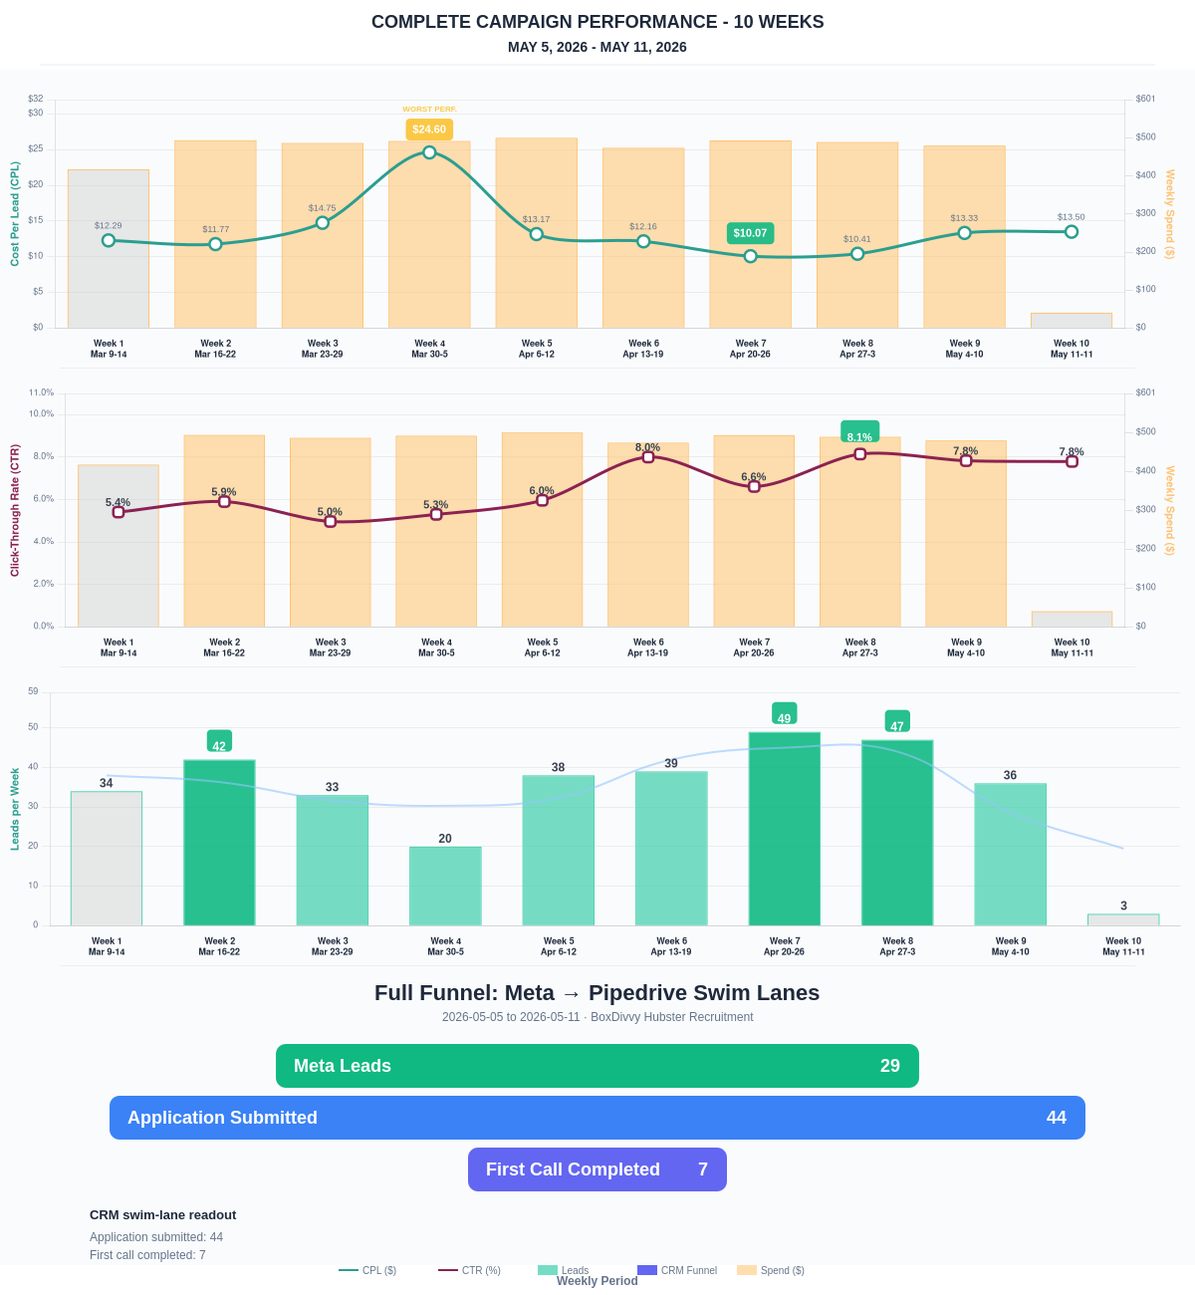

Questions? Let's chat about scaling these results.
Lead → Completed Application Dropoff
Meta lead aliases are not summed. This compares the canonical Meta Lead event against completed applications from complete_registration.
Period | Meta Leads | Completed Applications | Dropoff | Completion Rate | Cost / Completed
This Week | 29 | 20 | 9 | 68.97% | $22.08
Last 30 Days | 182 | 110 | 72 | 60.44% | $18.81
Campaign to Date | 882 | 307 | 575 | 34.81% | $27.10
Full Funnel — Meta → Pipedrive Swim Lanes
Direct Pipedrive pull from BoxDivvy Hubster Recruitment, Hub in Progress, and Hub Handovers. This shows application-stage CRM reality beside Meta attribution.
Funnel Stage | Count | Source | Notes
Meta Leads | 29 | Meta canonical lead | Top-funnel ad-attributed leads
Application Submitted | 44 | Pipedrive swim lane | Deals submitted in Pipedrive during the report period
First Call Completed | 7 | Pipedrive swim lane | Deals that reached the first-call-completed lane
Current open CRM funnel: 254 deals
Open Swim Lane | Open Deals
Application Submitted | 131
First Call Completed | 82
On Hold | 13
Building Members | 6
Joined hub | 5
Hub to be listed | 4
Waiting for delivery day | 4
Hub pack complete | 3

