

Meta Ads Performance Audit
Client: NeedleFree (Comfort-In)
Campaign: PA - Sales - LP - All - CBO - 17.1
Period: 4 May 2026 – 10 May 2026

Executive Summary
NeedleFree (Comfort-In) generated 15 deduped WooCommerce paid kit orders and $8,705.88 in backend revenue for the period. Meta attributed 13 purchase events and $650.00 in purchase value, giving 86.67% purchase capture and 7.47% value capture against Woo truth. Backend CPP was $37.00 with backend ROAS of 15.69x; Meta events remain the attribution lens while Woo order IDs are the business result. Average CTR was 3.84%.

Key Metrics
Period | Spend | Purchases | CPP | CTR
This Week | $554.94 | 13 | $42.69 | 3.84%
This Month | $2,392.67 | 133 | $17.99 | 3.79%
Since Starting | $10,342.94 | 673 | $15.37 | 3.84%

Latest Batch — Top Performers
# | Release Lot | CPP | Purchases | CTR | Ad ID | Preview
🔥 | Apr-28 | $15.85 | 6 | 5.57% | ...512115771 | 

Top 5 Performers by CPP — All Time
# | Release Lot | CPP | Purchases | CTR | Ad ID | Preview
🔥 | Dec-22 | $0.39 | 22 | 2.65% | ...434619171 | 
2 | Jan-20 | $0.76 | 4 | 1.13% | ...245221971 | 
⭐ | Feb-10 | $0.88 | 6 | 0.85% | ...790733771 | 
4 | Feb-18 | $0.89 | 6 | 0.83% | ...620572971 | 
5 | Mar-12 | $1.26 | 4 | 2.70% | ...675335171 | 
🔥 = Top performer | ⭐ = Volume star | Sorted by cost per conversion (lowest first)

Release Lot Performance
• Dec-22 Release: 22 conversions from 1 ad(s) – Best cost: $0.39
• Jan-20 Release: 4 conversions from 1 ad(s) – Best cost: $0.76
• Feb-10 Release: 6 conversions from 1 ad(s) – Best cost: $0.88
• Feb-18 Release: 6 conversions from 1 ad(s) – Best cost: $0.89
• Feb-28 Release: 4 conversions from 1 ad(s) – Best cost: $1.26

Creative Insights
Top Performer:
(22-12-2025) - (5) – 22 conversions at $0.39 cost, 2.65% CTR
Runner Up:
(20-01-2026) - (3) – 4 conversions at $0.76 cost, 1.13% CTR

Demographic Sweet Spot
• Male 25-34: 12 purchases, $14.00 CPP, 3.11% CTR
• Male 35-44: 8 purchases, $26.73 CPP, 3.59% CTR
• Male 45-54: 6 purchases, $17.46 CPP, 5.02% CTR

Key Insights
What's Working:
✓ 13 purchases generated from $554.94 spend
✓ CTR of 3.84% indicates strong ad relevance
✓ Cost per purchase of $42.69 is within viable range
✓ Top performer "(22-12-2025) - (5)" driving 22 purchases

Opportunities:
→ Reduce CPL by pausing ads with CTR below 3.8% average
→ Scale spend on winning ad creatives to increase volume
→ Create new ad variations based on top-performing creative patterns
→ Expand audience targeting based on demographic insights

Recommended Next Steps
▸ Increase budget on top 2 performers by 20-30%
▸ Review underperforming ads and pause or refresh creative
▸ Set up A/B experiment for new headline or creative variation
▸ Monitor frequency caps to avoid ad fatigue

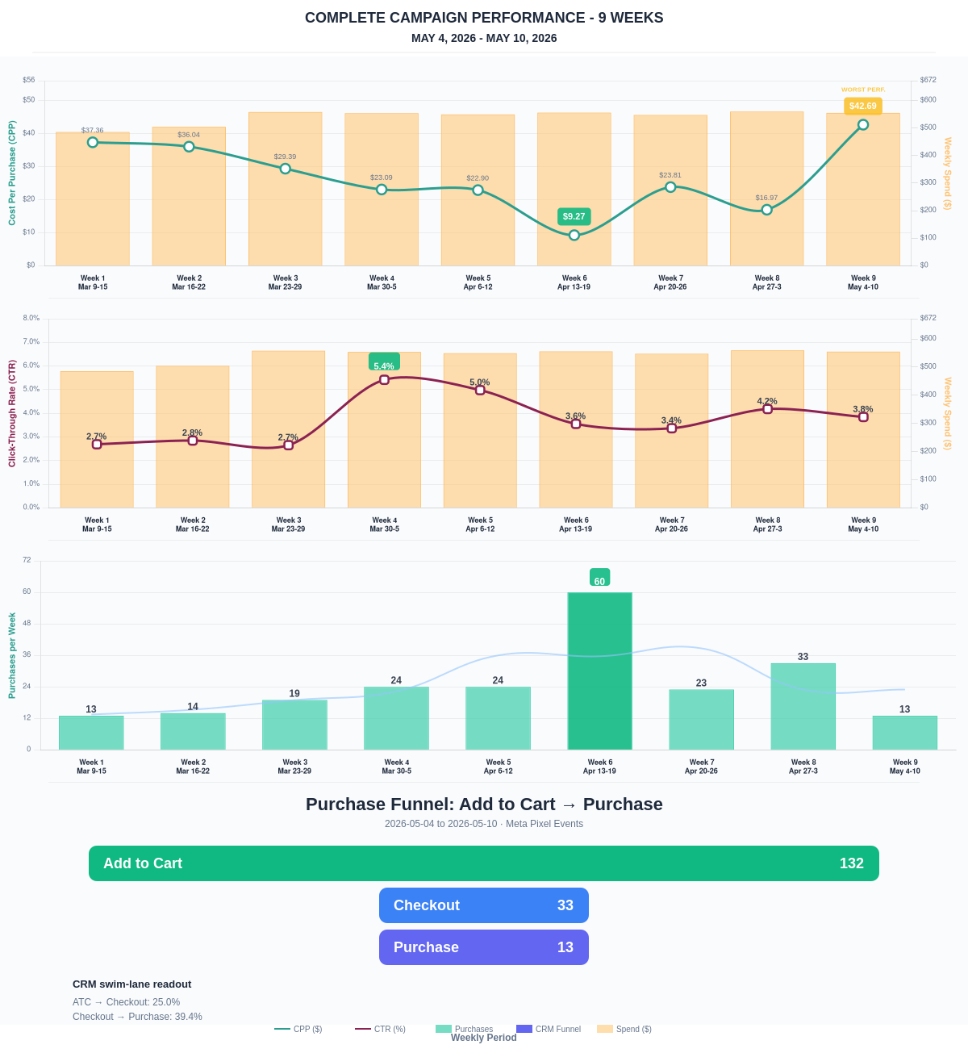

Questions? Let's chat about scaling these results.
E-Commerce Purchase Funnel
Meta Pixel events: Add to Cart → Initiate Checkout → Purchase. Conversion rates show funnel efficiency at each stage.
Period | Add to Cart | Checkout | Purchase | ATC→Chkout | ATC→Purchase
This Week | 132 | 33 | 13 | 25.00% | 9.85%
Last 30 Days | 706 | 152 | 133 | 21.53% | 18.84%
Campaign to Date | 3683 | 932 | 673 | 25.31% | 18.27%
Purchase Funnel — Add to Cart → Checkout → Purchase
Meta Pixel events showing the full e-commerce purchase journey. ATC → Checkout rate and Checkout → Purchase rate indicate funnel health.
Stage | This Week | ATC→Checkout | Checkout→Purchase
Add to Cart | 132 | 25.0% | —
Checkout | 33 | — | 39.4%
Purchase | 13 | — | —
Backend Sales Reconciliation — WooCommerce Source of Truth
WooCommerce paid order IDs are the deduped business result. Meta Ads Manager purchases are the ad-attribution result. They are reconciled side-by-side and never added together.
Period | Woo Paid Kit Orders | Woo Revenue | Meta Purchases | Meta Value | Meta/Woo Ratio | Backend ROAS
This Week | 15 | $8,705.88 | 13 | $650.00 | 86.67% | 15.69x
Last 30 Days | 66 | $33,190.06 | 133 | $6,650.00 | 201.52% | 13.87x
Campaign to Date | 474 | $235,789.01 | 673 | $33,650.00 | 141.98% | 22.80x
This Week Kit Mix
Product | Orders Containing Product | Units | Item Revenue
IM Kit | 8 | 8 | $3,143.01
SubQ Kit | 8 | 10 | $3,543.78
This Week Meta vs Woo Reconciliation
Metric | Value
Woo paid kit orders | 15
Woo paid kit revenue | $8,705.88
Meta Ads Manager purchases | 13
Meta attributed purchase value | $650.00
Woo minus Meta purchase delta | +2 order(s)
Backend ROAS on Meta spend | 15.69x
Important: Woo checkout source/referrer metadata is not used as ad attribution in this report because returning sessions often lose fbclid/_fbc and can show as Direct or Google. Meta Ads Manager remains the source for ad-attributed purchases; WooCommerce remains the source for paid order truth.
Traffic + Revenue Mix — GA4 Pie Graphs
GA4 source/channel revenue mix from property 376212605. Shows the selected report period, matched previous period, and trailing 30 days as separate pie graphs in one row. Unclassified rows are attributed by source/medium where possible and otherwise excluded from the client-facing pie mix. Use WooCommerce above as deduped paid kit order truth.
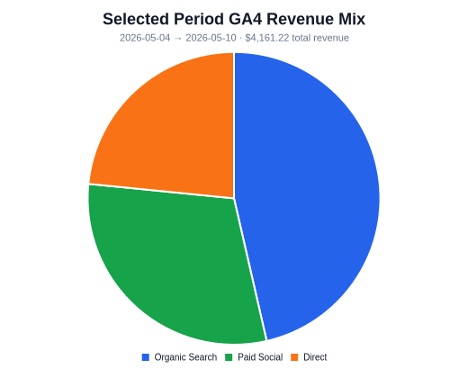 | 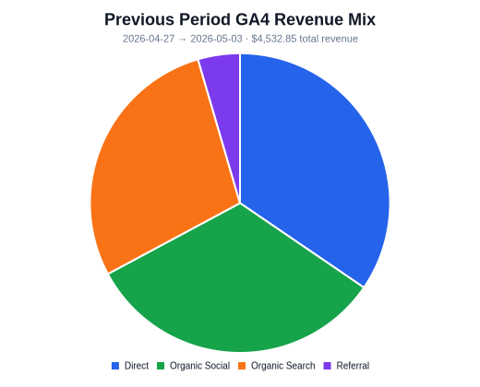 | 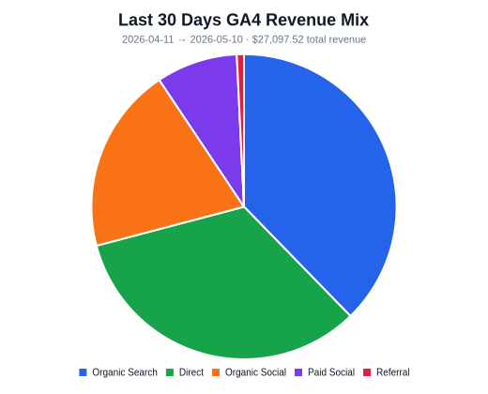
Organic Search this week: 1571 sessions, 5 transaction(s), $1,931.37 revenue (50.4% revenue vs prior week). Paid Social this week: 636 sessions, 2 transaction(s), $1,255.25 revenue (new revenue vs prior week).
Period | Sessions | Transactions | Revenue
Selected Period | 3570 | 9 | $4,161.22
Previous Period | 3545 | 14 | $4,532.85
Last 30 Days | 15183 | 67 | $27,097.52
Attribution note: GA4 channel grouping, Meta ad attribution, and Woo paid-order truth are three different lenses. GA4 can include non-kit purchases and source attribution can move revenue into Direct when return sessions lose campaign identifiers.

