

Meta Ads Performance Audit
Client: Box Divvy
Campaign: Hubster Lead Gen
Period: 30 March 2026 – 5 April 2026

Executive Summary
The Box Divvy campaign is delivering results with a blended CPL of $24.60 across 20 leads. Total ad spend for the period was $492.00 with an average CTR of 5.30%. The top performer achieved a CPL of $2.18 (DEC-15-2025 - copy_08771CC1-D4C9-4210-BE). High CTR indicates strong creative-audience fit.

Key Metrics
Period | Spend | Leads | CPL | CTR
This Week | $492.00 | 20 | $24.60 | 5.30%
This Month | $2,171.46 | 135 | $16.08 | 5.44%
Since Starting | $5,841.32 | 670 | $8.72 | 6.40%

Latest Batch — Top Performers
# | Release Lot | CPL | Leads | CTR | Ad ID | Preview
🔥 | Mar-27 | $2.33 | 1 | 8.93% | ...457220360 | 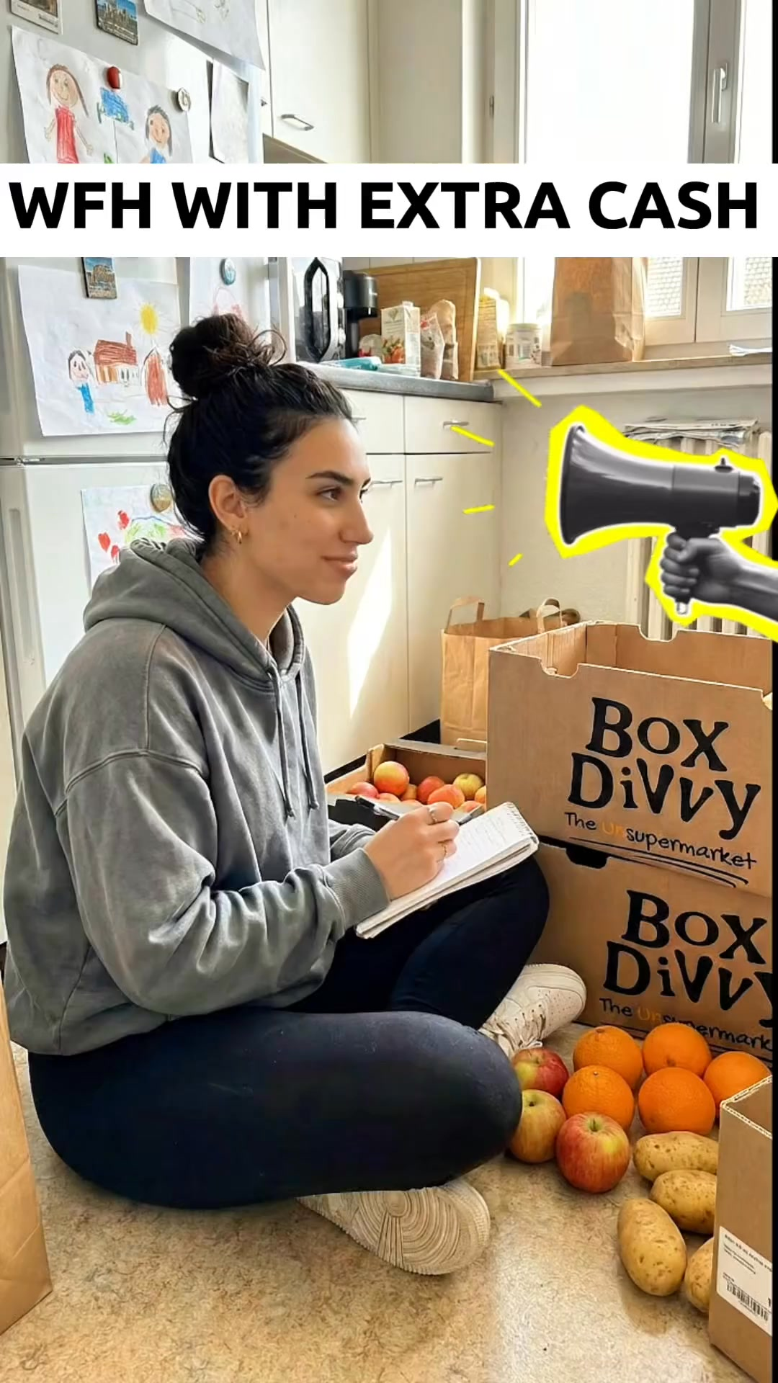
2 | Mar-27 | $12.43 | 3 | 5.67% | ...456990360 | 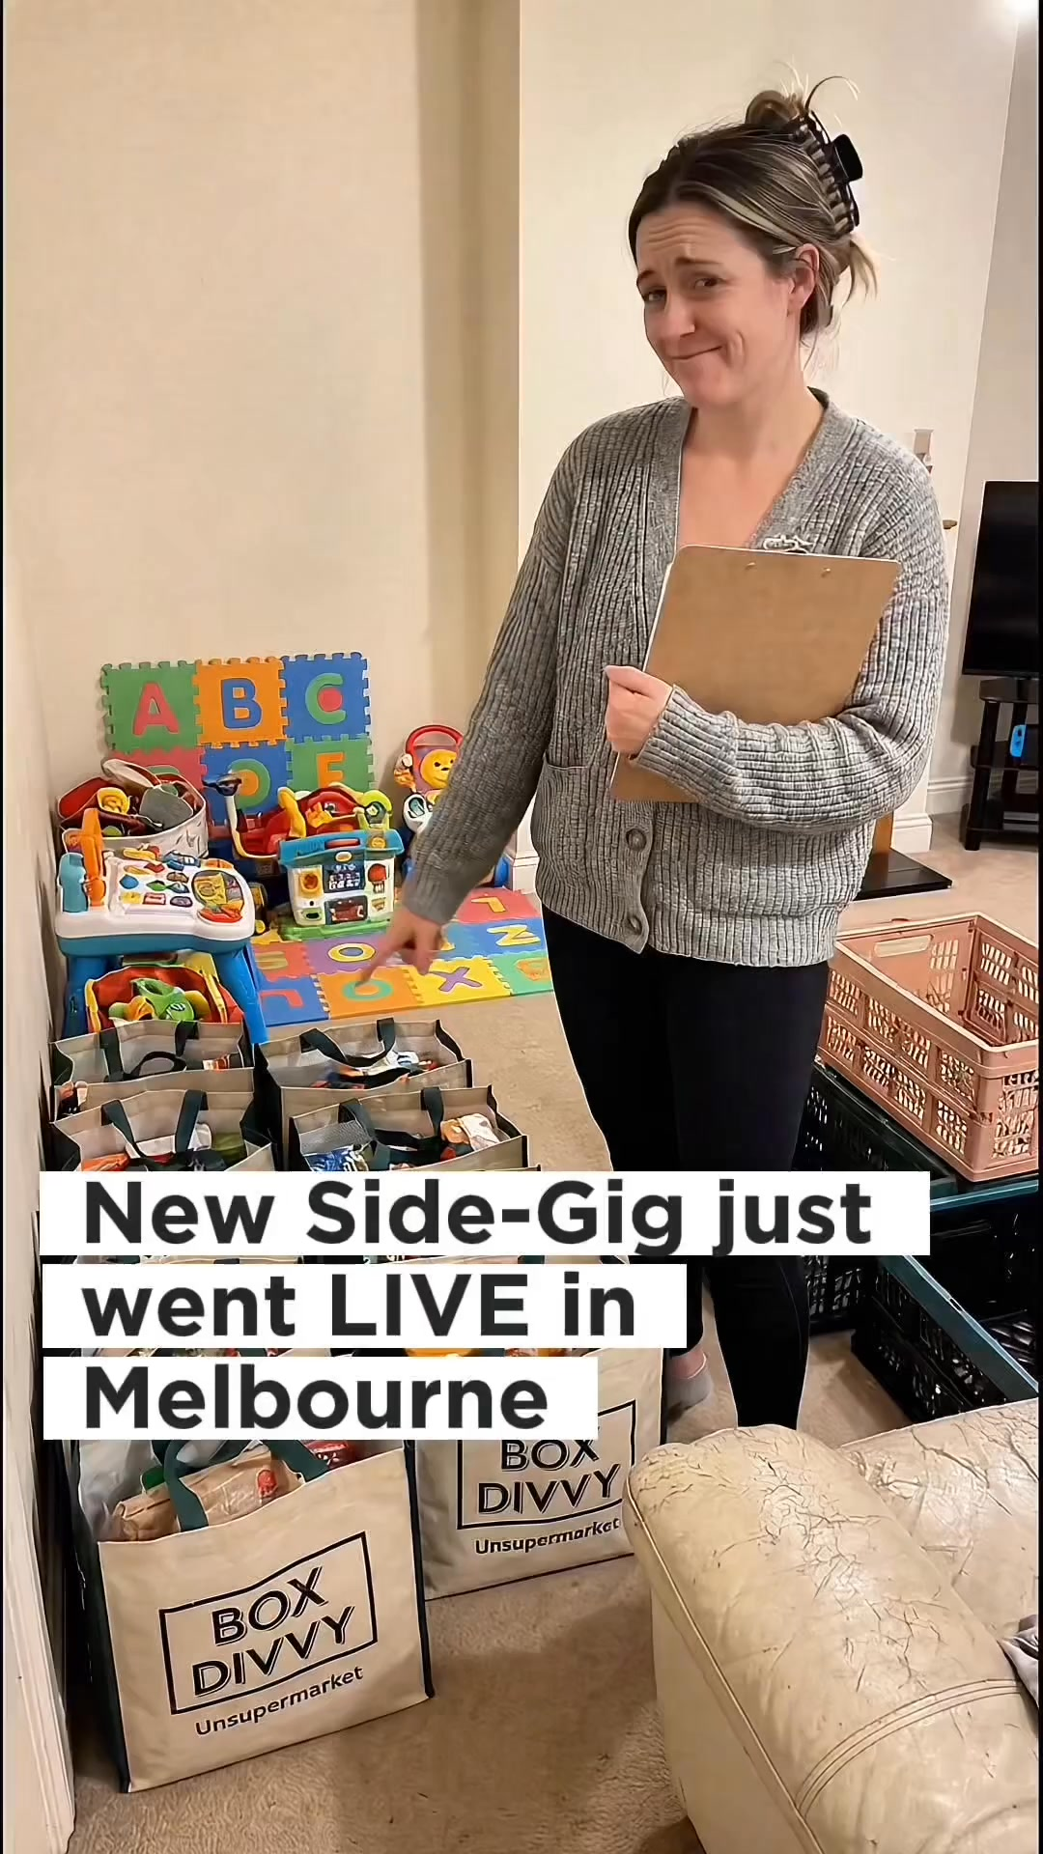
⭐ | Mar-27 | $25.96 | 6 | 3.88% | ...457910360

Top 5 Performers by CPL — All Time
# | Release Lot | CPL | Leads | CTR | Ad ID | Preview
🔥 | Feb-6 | $2.18 | 1 | 2.44% | ...917610360 | 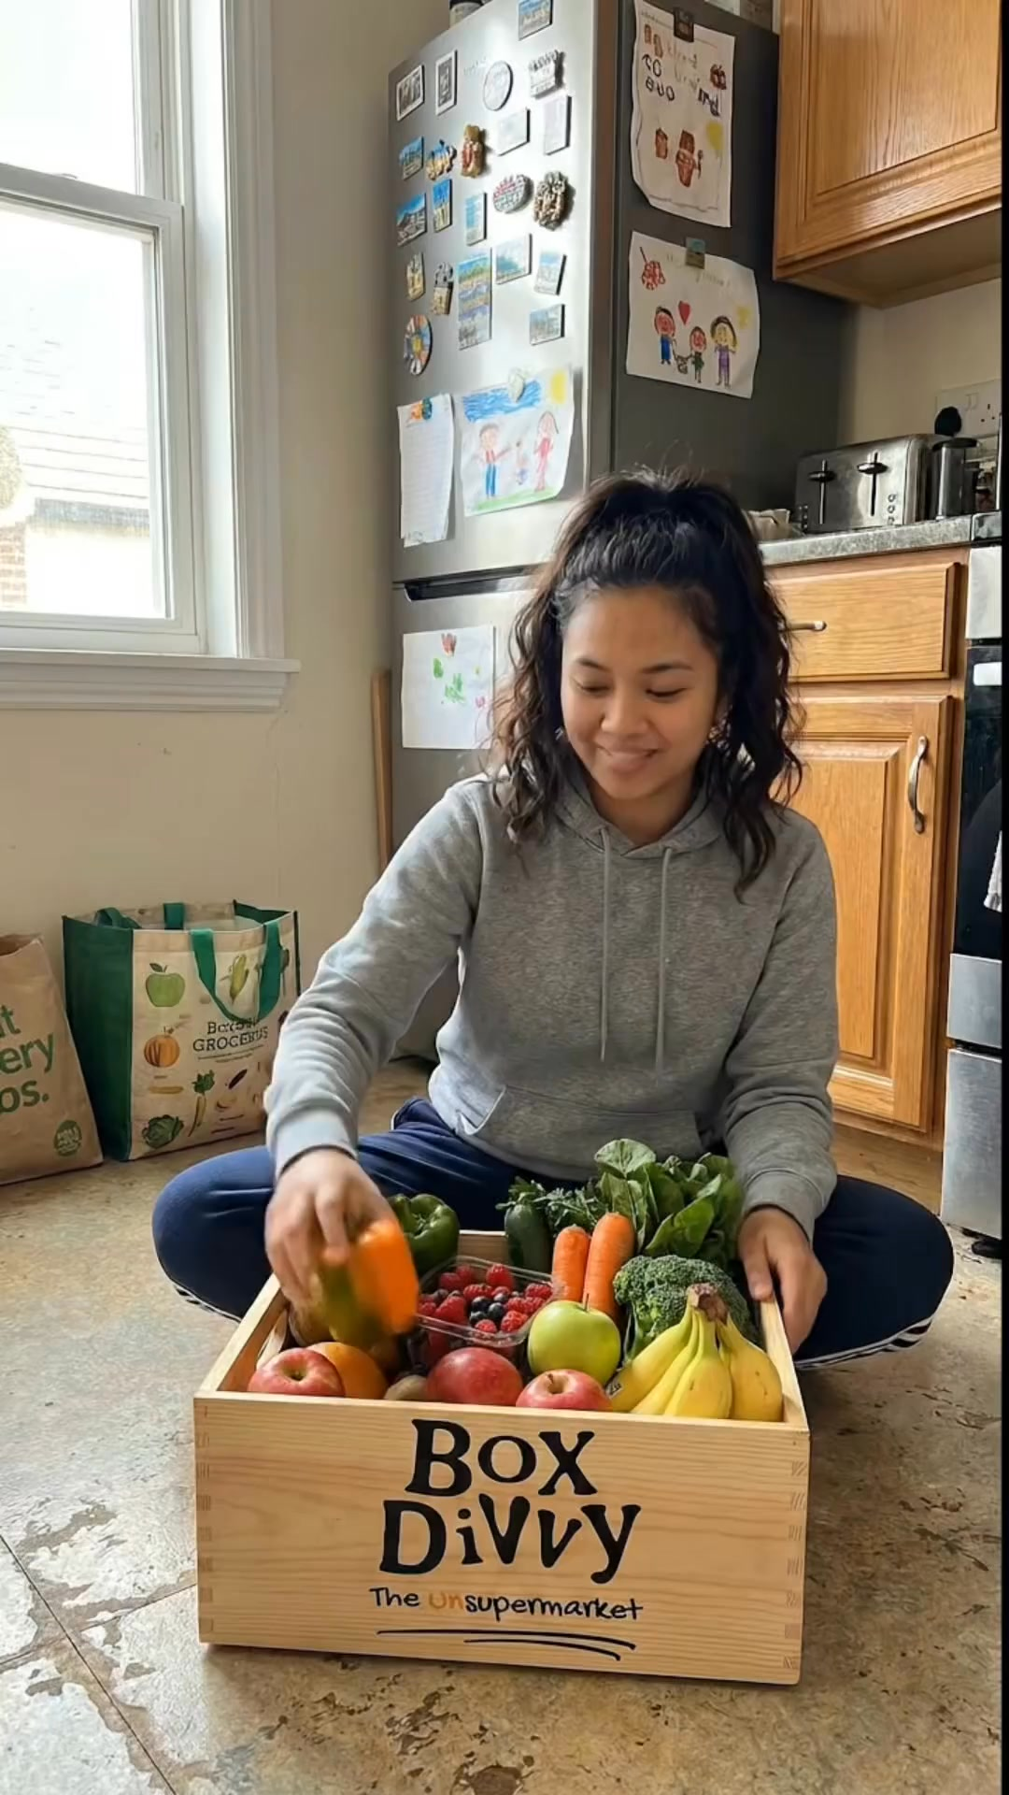
2 | Jan-29 | $4.03 | 11 | 6.22% | ...743430360 | 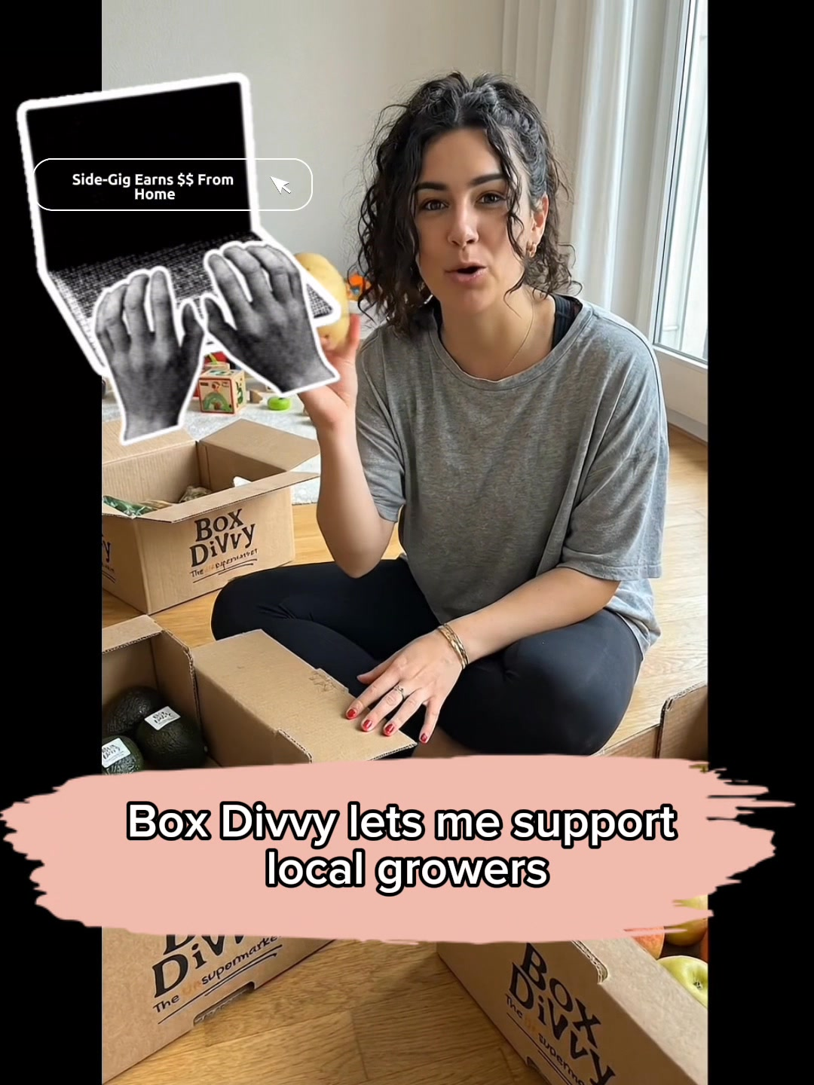
⭐ | Jan-12 | $4.07 | 12 | 6.18% | ...985710360 | 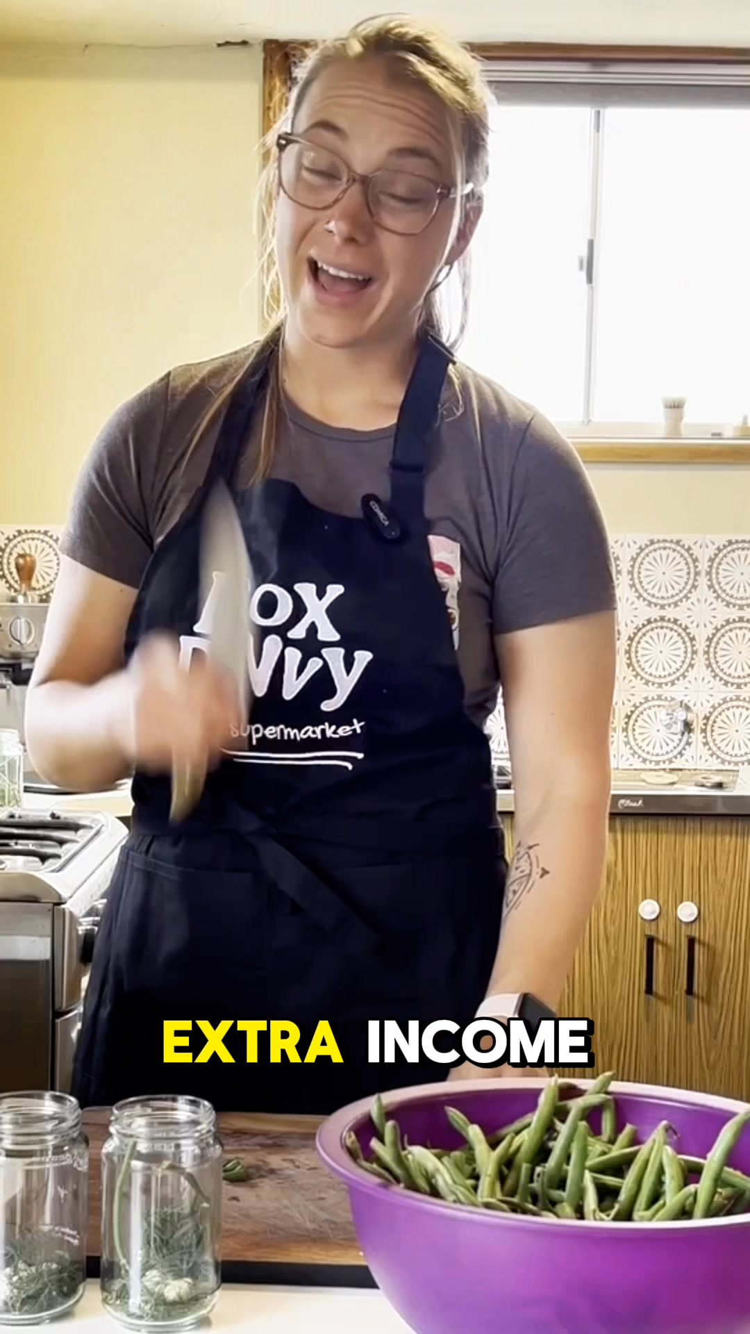
4 | Jan-12 | $4.37 | 104 | 8.66% | ...968670360 | 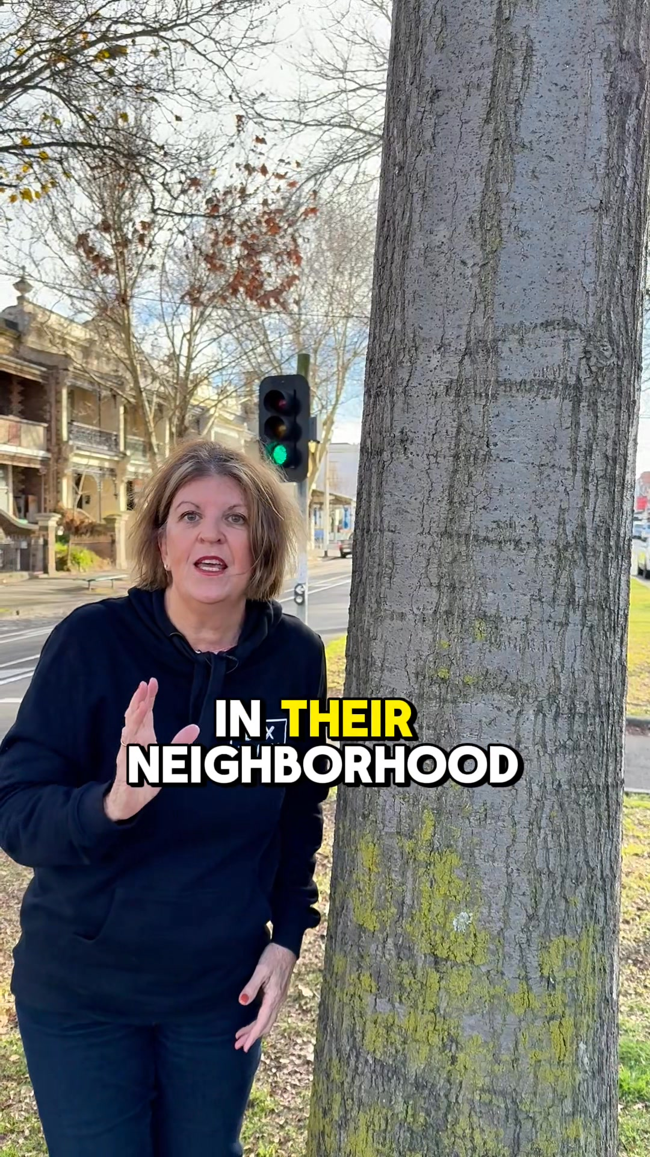
5 | Jan-29 | $4.62 | 92 | 5.89% | ...681010360 | 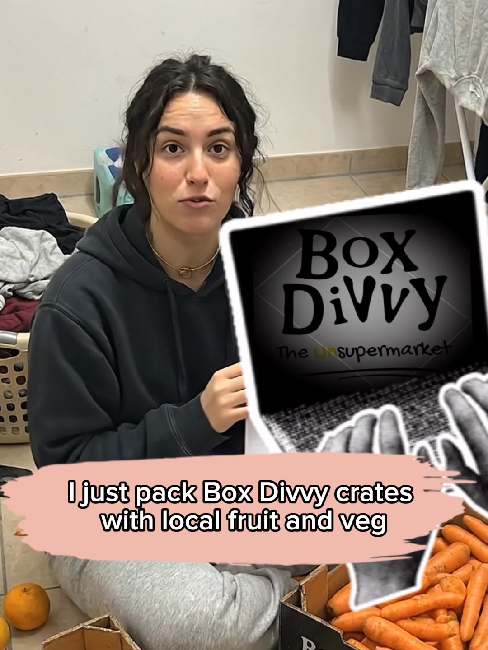
🔥 = Top performer | ⭐ = Volume star | Sorted by cost per conversion (lowest first)

Release Lot Performance
• DEC-15 Release: 1 conversions from 1 ad(s) – Best cost: $2.18
• Jan-17 Release: 103 conversions from 2 ad(s) – Best cost: $4.03
• Dec-15 Release: 116 conversions from 2 ad(s) – Best cost: $4.07

Creative Insights
Top Performer:
DEC-15-2025 - copy_08771CC1-D4C9-4210-BE7C-B4582E8D0709 - Copy – 1 conversions at $2.18 cost, 2.44% CTR
Runner Up:
Jan-17-26 - Copy – 11 conversions at $4.03 cost, 6.22% CTR

Demographic Sweet Spot
• Female 35-44: 14 leads, $15.88 CPL, 5.09% CTR
• Female 45-54: 7 leads, $22.27 CPL, 6.48% CTR
• Female 65+: 3 leads, $6.82 CPL, 10.67% CTR

Key Insights
What's Working:
✓ Campaign is running with 20 conversions

Opportunities:
→ Continue optimising campaign performance

Recommended Next Steps
▸ Monitor performance and adjust as needed

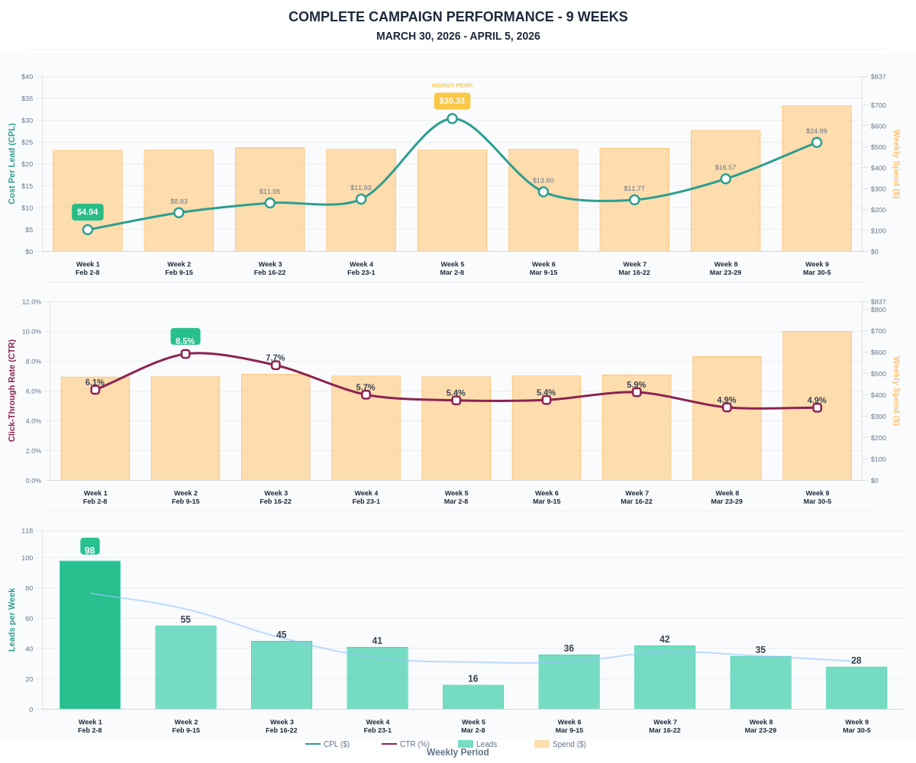

Questions? Let's chat about scaling these results.

