

Meta Ads Performance Audit
Client: Box Divvy
Campaign: Hubster Lead Gen
Period: 5 April 2026 – 11 April 2026

Executive Summary
The Box Divvy campaign is delivering solid results with a blended CPL of $15.30 across 32 leads. Total ad spend for the period was $489.51 with an average CTR of 5.21%. The top performer achieved a CPL of $3.28 (DEC-22-2025 - copy_F3D1B357-B57D-4D8A-80). High CTR indicates strong creative-audience fit.

Key Metrics
Period | Spend | Leads | CPL | CTR
This Week | $489.51 | 32 | $15.30 | 5.21%
This Month | $2,158.86 | 147 | $14.69 | 5.46%
Since Starting | $6,249.80 | 700 | $8.93 | 6.35%

Latest Batch — Top Metrics
# | Release Lot | Spend | CPM | CTR | Ad ID | Preview

Top 5 Performers by CPL — All Time
# | Release Lot | CPL | Leads | CTR | Ad ID | Preview
🔥 | Feb-6 | $3.28 | 1 | 4.41% | ...917330360 | 
2 | Feb-6 | $3.93 | 1 | 2.26% | ...917610360
⭐ | Jan-29 | $4.03 | 11 | 6.22% | ...743430360
4 | Jan-12 | $4.07 | 12 | 6.18% | ...985710360
5 | Feb-6 | $4.12 | 1 | 7.32% | ...917650360
🔥 = Top performer | ⭐ = Volume star | Sorted by cost per conversion (lowest first)

Release Lot Performance
• DEC-22 Release: 1 conversions from 1 ad(s) – Best cost: $3.28
• DEC-15 Release: 1 conversions from 1 ad(s) – Best cost: $3.93
• Jan-17 Release: 11 conversions from 1 ad(s) – Best cost: $4.03
• Dec-15 Release: 12 conversions from 1 ad(s) – Best cost: $4.07
• Jan-12 Release: 1 conversions from 1 ad(s) – Best cost: $4.12

Creative Insights
Top Performer:
DEC-22-2025 - copy_F3D1B357-B57D-4D8A-80E2-8ED18F474963 - Copy – 1 conversions at $3.28 cost, 4.41% CTR
Runner Up:
DEC-15-2025 - copy_08771CC1-D4C9-4210-BE7C-B4582E8D0709 - Copy – 1 conversions at $3.93 cost, 2.26% CTR

Demographic Sweet Spot
• Female 35-44: 15 leads, $15.29 CPL, 4.31% CTR
• Female 45-54: 9 leads, $18.81 CPL, 5.17% CTR
• Female 25-34: 5 leads, $20.55 CPL, 3.04% CTR

Key Insights
What's Working:
✓ Campaign is running with 32 conversions

Opportunities:
→ Continue optimising campaign performance

Recommended Next Steps
▸ Monitor performance and adjust as needed

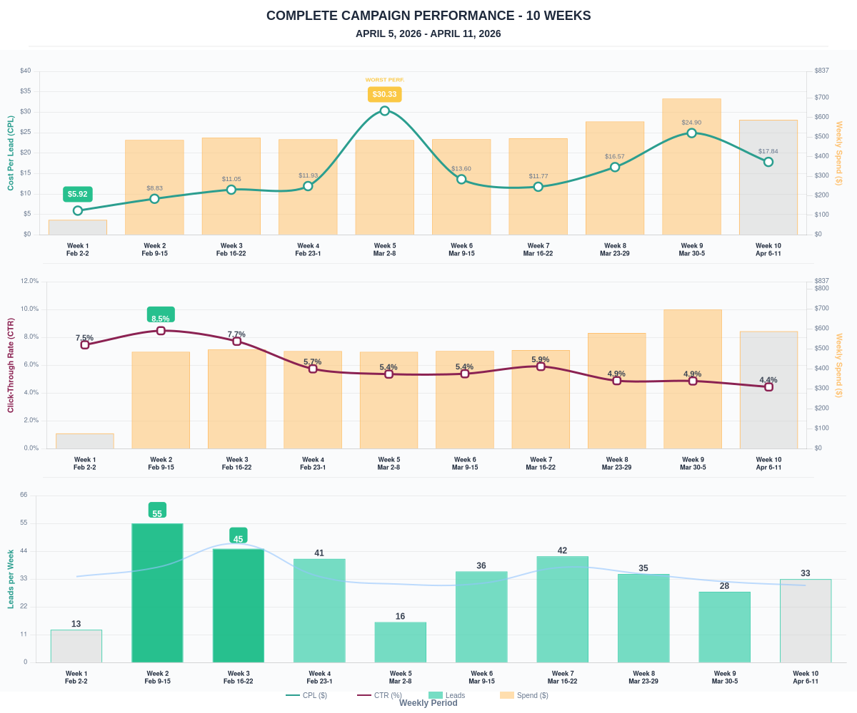

Questions? Let's chat about scaling these results.

