

Meta Ads Performance Audit
Client: Box Divvy
Campaign: Hubster Lead Gen
Period: 6 April 2026 – 12 April 2026

Executive Summary
The Box Divvy campaign is delivering solid results with a blended CPL of $13.17 across 38 leads. Total ad spend for the period was $500.43 with an average CTR of 5.97%. The top performer achieved a CPL of $3.03 (DEC-22-2025 - copy_4F41C52C-D861-43C4-86). High CTR indicates strong creative-audience fit.

Key Metrics
Period | Spend | Leads | CPL | CTR
This Week | $500.43 | 38 | $13.17 | 5.97%
This Month | $2,183.15 | 149 | $14.65 | 5.58%
Since Starting | $6,341.79 | 708 | $8.96 | 6.37%

Latest Batch — Top Performers
# | Release Lot | CPL | Leads | CTR | Ad ID | Preview
🔥 | Mar-5 | $11.14 | 1 | 6.98% | ...609950360 | 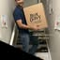
2 | Mar-5 | $23.80 | 1 | 5.70% | ...515360360 | 
⭐ | Mar-5 | $48.20 | 1 | 5.55% | ...136080360 | 

Top 5 Performers by CPL — All Time
# | Release Lot | CPL | Leads | CTR | Ad ID | Preview
🔥 | Feb-6 | $3.03 | 1 | 3.95% | ...917360360 | 
2 | Feb-6 | $3.28 | 1 | 4.41% | ...917330360 | 
⭐ | Feb-6 | $3.93 | 1 | 2.26% | ...917610360 | 
4 | Jan-29 | $4.03 | 11 | 6.22% | ...743430360 | 
5 | Jan-12 | $4.07 | 12 | 6.18% | ...985710360 | 
🔥 = Top performer | ⭐ = Volume star | Sorted by cost per conversion (lowest first)

Release Lot Performance
• DEC-22 Release: 2 conversions from 2 ad(s) – Best cost: $3.03
• DEC-15 Release: 1 conversions from 1 ad(s) – Best cost: $3.93
• Jan-17 Release: 11 conversions from 1 ad(s) – Best cost: $4.03
• Dec-15 Release: 12 conversions from 1 ad(s) – Best cost: $4.07

Creative Insights
Top Performer:
DEC-22-2025 - copy_4F41C52C-D861-43C4-86A3-FA1431C2E2C9 - Copy – 1 conversions at $3.03 cost, 3.95% CTR
Runner Up:
DEC-22-2025 - copy_F3D1B357-B57D-4D8A-80E2-8ED18F474963 - Copy – 1 conversions at $3.28 cost, 4.41% CTR

Demographic Sweet Spot
• Female 35-44: 18 leads, $13.75 CPL, 4.89% CTR
• Female 45-54: 11 leads, $15.85 CPL, 5.75% CTR
• Female 25-34: 6 leads, $18.44 CPL, 3.41% CTR

Key Insights
What's Working:
✓ Exceptional click-through rate of 5.97% indicates highly engaging ad creative and strong audience targeting resonance
✓ Top performing ads are achieving remarkably low cost per lead between $3.03-$3.93, significantly below the campaign average of $13.17
✓ Strong impression volume of 14,362 demonstrates effective audience reach and campaign visibility
✓ December 22nd creative variants are showing particularly strong performance with CTRs above 3.9%

Opportunities:
→ Significant cost per lead variance suggests budget is being allocated to underperforming ads - top performers cost 70% less than average
→ High CTR but relatively low conversion rate indicates potential landing page optimisation opportunities to improve lead capture
→ Limited sample size of top performers (1 lead each) requires scaling successful creative elements to validate performance
→ Performance gap between top ads ($3.03 CPL) and campaign average ($13.17 CPL) suggests poor-performing ads need immediate attention

Recommended Next Steps
▸ Immediately pause underperforming ads and reallocate budget to the three top-performing creative variants to reduce overall cost per lead
▸ Analyse and replicate the creative elements from copy_4F41C52C and copy_F3D1B357 across new ad variations to scale successful messaging
▸ Conduct landing page conversion rate optimisation focusing on form placement, headline alignment with ad copy, and mobile experience
▸ Implement automated rules to pause ads exceeding $15 cost per lead and increase budgets for ads performing below $8 cost per lead

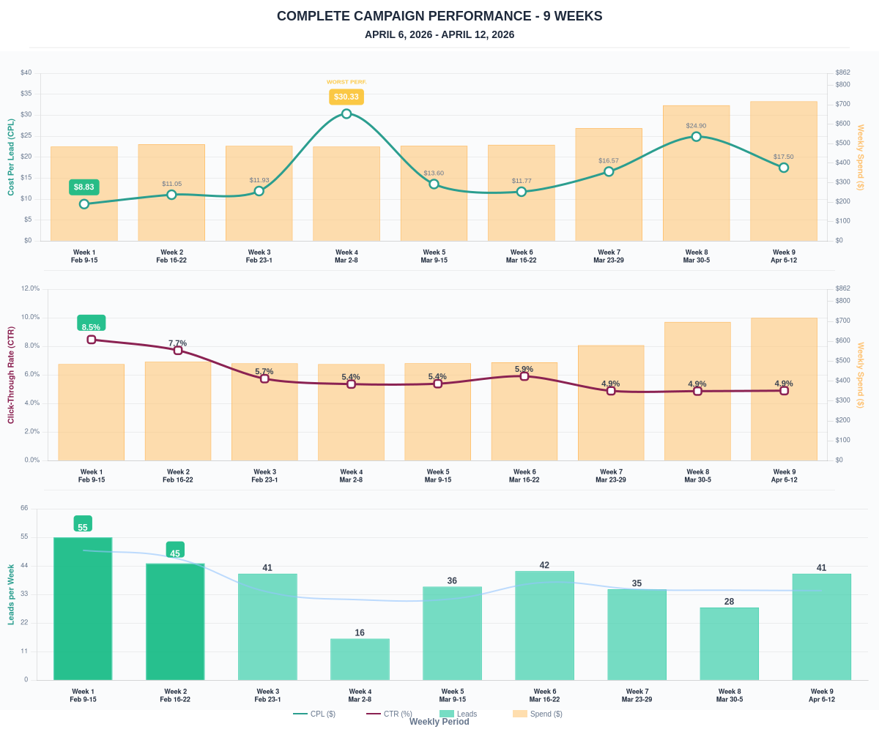

Questions? Let's chat about scaling these results.

