

Meta Ads Performance Audit
Client: Box Divvy
Campaign: Hubster Lead Gen
Period: 13 April 2026 – 19 April 2026

Executive Summary
The Box Divvy campaign is delivering solid results with a blended CPL of $12.16 across 39 leads. Total ad spend for the period was $474.07 with an average CTR of 8.00%. The top performer achieved a CPL of $3.41 (DEC-15-2025 - copy_08771CC1-D4C9-4210-BE). High CTR indicates strong creative-audience fit.

Key Metrics
Period | Spend | Leads | CPL | CTR
This Week | $474.07 | 39 | $12.16 | 8.00%
This Month | $2,167.57 | 144 | $15.05 | 6.18%
Since Starting | $6,815.89 | 747 | $9.12 | 6.50%

Latest Batch — Top Performers
# | Release Lot | CPL | Leads | CTR | Ad ID | Preview
🔥 | Jan-29 | $4.62 | 92 | 5.89% | ...681010360 | 
2 | Jan-29 | $5.84 | 1 | 3.41% | ...696440360 | 
⭐ | Jan-29 | $7.26 | 2 | 4.38% | ...673170360 | 

Top 5 Performers by CPL — All Time
# | Release Lot | CPL | Leads | CTR | Ad ID | Preview
🔥 | Feb-6 | $3.41 | 3 | 5.26% | ...917220360 | 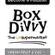
2 | Feb-6 | $3.42 | 1 | 4.76% | ...917330360 | 
⭐ | Feb-6 | $3.56 | 1 | 3.30% | ...917360360 | 
4 | Jan-29 | $4.03 | 11 | 6.22% | ...743430360 | 
5 | Jan-12 | $4.07 | 12 | 6.18% | ...985710360 | 
🔥 = Top performer | ⭐ = Volume star | Sorted by cost per conversion (lowest first)

Release Lot Performance
• DEC-15 Release: 3 conversions from 1 ad(s) – Best cost: $3.41
• DEC-22 Release: 2 conversions from 2 ad(s) – Best cost: $3.42
• Jan-17 Release: 11 conversions from 1 ad(s) – Best cost: $4.03
• Dec-15 Release: 12 conversions from 1 ad(s) – Best cost: $4.07

Creative Insights
Top Performer:
DEC-15-2025 - copy_08771CC1-D4C9-4210-BE7C-B4582E8D0709 - Copy – 3 conversions at $3.41 cost, 5.26% CTR
Runner Up:
DEC-22-2025 - copy_F3D1B357-B57D-4D8A-80E2-8ED18F474963 - Copy – 1 conversions at $3.42 cost, 4.76% CTR

Demographic Sweet Spot
• Female 45-54: 16 leads, $10.18 CPL, 8.54% CTR
• Female 35-44: 13 leads, $18.83 CPL, 7.20% CTR
• Female 25-34: 11 leads, $12.14 CPL, 6.17% CTR

Key Insights
What's Working:
✓ 39 leads generated from $474.07 spend
✓ CTR of 8.00% indicates strong ad relevance
✓ Cost per lead of $12.16 is within viable range
✓ Top performer "DEC-15-2025 - copy_08771CC1-D4C9-4210-BE7C-B4582E8D0709 - Copy" driving 3 leads

Opportunities:
→ Reduce CPL by pausing ads with CTR below 8.0% average
→ Scale spend on winning ad creatives to increase volume
→ Test new ad variations based on top-performing creative patterns
→ Expand audience targeting based on demographic insights

Recommended Next Steps
▸ Increase budget on top 2 performers by 20-30%
▸ Review underperforming ads and pause or refresh creative
▸ Set up A/B test for new headline or creative variation
▸ Monitor frequency caps to avoid ad fatigue

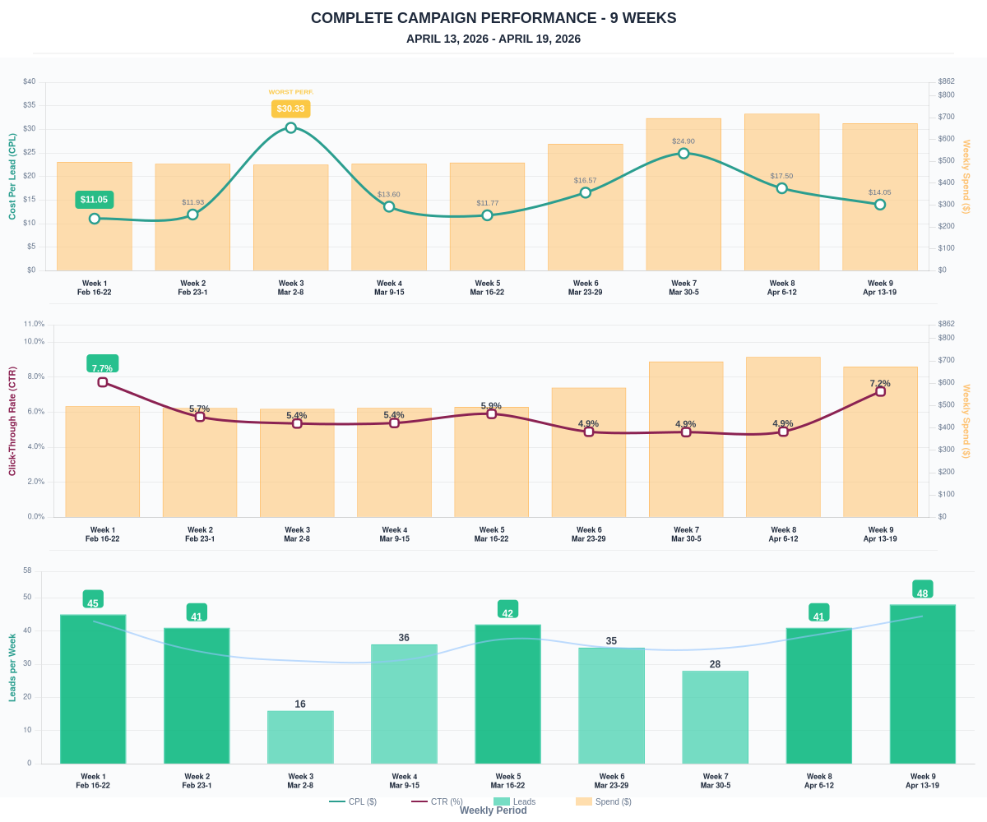

Questions? Let's chat about scaling these results.

