

Meta Ads Performance Audit
Client: Box Divvy
Campaign: Hubster Lead Gen
Period: 20 April 2026 – 26 April 2026

Executive Summary
The Box Divvy campaign is delivering solid results with a blended CPL of $10.07 across 49 leads. Total ad spend for the period was $493.61 with an average CTR of 6.62%. The top performer achieved a CPL of $3.54 (DEC-15-2025 - copy_08771CC1-D4C9-4210-BE). High CTR indicates strong creative-audience fit.

Key Metrics
Period | Spend | Leads | CPL | CTR
This Week | $493.61 | 49 | $10.07 | 6.62%
This Month | $2,169.44 | 163 | $13.31 | 6.54%
Since Starting | $7,309.54 | 796 | $9.18 | 6.51%

Latest Batch — Top Performers
# | Release Lot | CPL | Leads | CTR | Ad ID | Preview
🔥 | Jan-29 | $4.62 | 92 | 5.89% | ...681010360 | 
2 | Jan-29 | $5.84 | 1 | 3.41% | ...696440360 | 
⭐ | Jan-29 | $7.26 | 2 | 4.38% | ...673170360 | 

Top 5 Performers by CPL — All Time
# | Release Lot | CPL | Leads | CTR | Ad ID | Preview
🔥 | Feb-6 | $3.54 | 3 | 5.08% | ...917220360 | 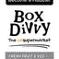
2 | Feb-6 | $3.83 | 1 | 2.91% | ...917360360 | 
⭐ | Jan-29 | $4.03 | 11 | 6.22% | ...743430360 | 
4 | Feb-6 | $4.05 | 1 | 4.73% | ...552480360 | 
5 | Jan-12 | $4.07 | 12 | 6.18% | ...985710360 | 
🔥 = Top performer | ⭐ = Volume star | Sorted by cost per conversion (lowest first)

Release Lot Performance
• DEC-15 Release: 3 conversions from 1 ad(s) – Best cost: $3.54
• DEC-22 Release: 1 conversions from 1 ad(s) – Best cost: $3.83
• Jan-17 Release: 11 conversions from 1 ad(s) – Best cost: $4.03
• Jan-12 Release: 1 conversions from 1 ad(s) – Best cost: $4.05
• Dec-15 Release: 12 conversions from 1 ad(s) – Best cost: $4.07

Creative Insights
Top Performer:
DEC-15-2025 - copy_08771CC1-D4C9-4210-BE7C-B4582E8D0709 - Copy – 3 conversions at $3.54 cost, 5.08% CTR
Runner Up:
DEC-22-2025 - copy_4F41C52C-D861-43C4-86A3-FA1431C2E2C9 - Copy – 1 conversions at $3.83 cost, 2.91% CTR

Demographic Sweet Spot
• Female 25-34: 20 leads, $7.29 CPL, 4.72% CTR
• Female 35-44: 18 leads, $14.08 CPL, 5.75% CTR
• Female 45-54: 15 leads, $10.28 CPL, 6.87% CTR

Key Insights
What's Working:
✓ Strong overall CTR of 6.62% indicates compelling ad creative and targeting resonating well with the audience
✓ Top performing ads achieving exceptional cost efficiency with leads as low as $3.54-$4.03, significantly below the $10.07 average
✓ January 2026 creative delivering strong volume with 11 leads at $4.03 cost per lead and solid 6.22% CTR
✓ High-performing creatives maintaining consistent quality with CTRs ranging from 2.91% to 6.22%

Opportunities:
→ Significant cost per lead variance suggests budget redistribution needed - top performers cost 60-65% less than campaign average
→ Conversion rate optimisation required as 1,215 clicks generated only 49 leads (4.03% conversion rate)
→ Scale successful creative elements from top performers to underperforming ads to improve overall efficiency
→ Audience refinement needed to reduce wasted spend on low-converting segments driving up average CPL

Recommended Next Steps
▸ Immediately increase budget allocation to the three top-performing ad sets whilst pausing or reducing spend on underperformers
▸ Analyse creative elements from the $3.54-$4.03 CPL ads to identify winning copy, imagery, and messaging patterns for replication
▸ Implement conversion tracking review to identify drop-off points in the lead funnel and optimise landing page experience
▸ Create new ad variations based on January 2026 creative success and test similar messaging angles to scale volume

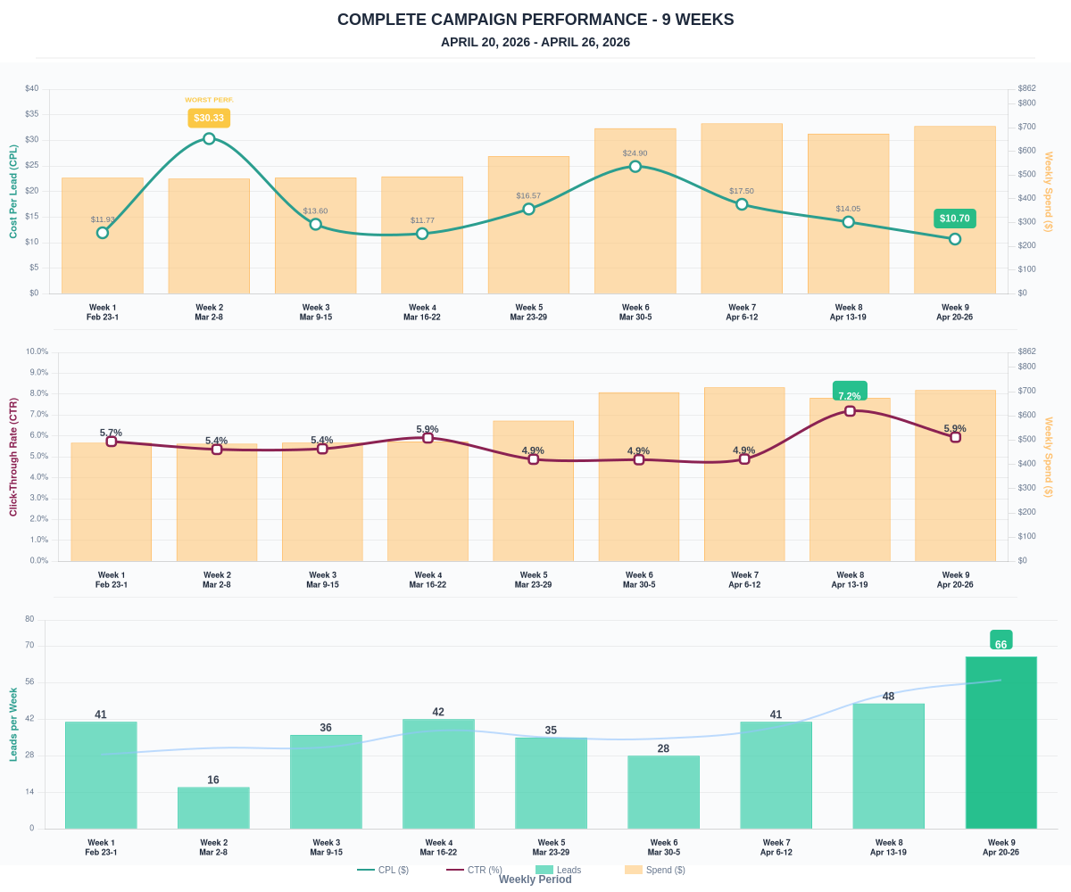

Questions? Let's chat about scaling these results.

