

Meta Ads Performance Audit
Client: Box Divvy
Campaign: Hubster Lead Gen
Period: 27 April 2026 – 3 May 2026

Executive Summary
The Box Divvy campaign is delivering solid results with a blended CPL of $10.40 across 47 leads. Total ad spend for the period was $488.97 with an average CTR of 8.14%. The top performer achieved a CPL of $3.84 (DEC-15-2025 - copy_08771CC1-D4C9-4210-BE). High CTR indicates strong creative-audience fit.

Key Metrics
Period | Spend | Leads | CPL | CTR
This Week | $488.97 | 47 | $10.40 | 8.14%
This Month | $2,168.73 | 180 | $12.05 | 7.12%
Since Starting | $7,798.51 | 843 | $9.25 | 6.61%

Latest Batch — Top Performers
# | Release Lot | CPL | Leads | CTR | Ad ID | Preview
🔥 | Jan-29 | $4.62 | 92 | 5.89% | ...681010360 | 
2 | Jan-29 | $5.84 | 1 | 3.41% | ...696440360 | 
⭐ | Jan-29 | $7.26 | 2 | 4.38% | ...673170360 | 

Top 5 Performers by CPL — All Time
# | Release Lot | CPL | Leads | CTR | Ad ID | Preview
🔥 | Feb-6 | $3.84 | 3 | 4.68% | ...917220360 | 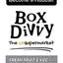
2 | Feb-6 | $3.92 | 1 | 2.83% | ...917360360 | 
⭐ | Jan-29 | $4.03 | 11 | 6.22% | ...743430360 | 
4 | Feb-6 | $4.05 | 1 | 4.73% | ...552480360 | 
5 | Jan-12 | $4.07 | 12 | 6.18% | ...985710360 | 
🔥 = Top performer | ⭐ = Volume star | Sorted by cost per conversion (lowest first)

Release Lot Performance
• DEC-15 Release: 3 conversions from 1 ad(s) – Best cost: $3.84
• DEC-22 Release: 1 conversions from 1 ad(s) – Best cost: $3.92
• Jan-17 Release: 11 conversions from 1 ad(s) – Best cost: $4.03
• Jan-12 Release: 1 conversions from 1 ad(s) – Best cost: $4.05
• Dec-15 Release: 12 conversions from 1 ad(s) – Best cost: $4.07

Creative Insights
Top Performer:
DEC-15-2025 - copy_08771CC1-D4C9-4210-BE7C-B4582E8D0709 - Copy – 3 conversions at $3.84 cost, 4.68% CTR
Runner Up:
DEC-22-2025 - copy_4F41C52C-D861-43C4-86A3-FA1431C2E2C9 - Copy – 1 conversions at $3.92 cost, 2.83% CTR

Demographic Sweet Spot
• Female 35-44: 20 leads, $10.94 CPL, 6.65% CTR
• Female 45-54: 15 leads, $11.62 CPL, 8.23% CTR
• Female 25-34: 8 leads, $15.51 CPL, 5.29% CTR

Key Insights
What's Working:
✓ 47 leads generated from $488.97 spend
✓ CTR of 8.14% indicates strong ad relevance
✓ Cost per lead of $10.40 is within viable range
✓ Top performer "DEC-15-2025 - copy_08771CC1-D4C9-4210-BE7C-B4582E8D0709 - Copy" driving 3 leads

Opportunities:
→ Reduce CPL by pausing ads with CTR below 8.1% average
→ Scale spend on winning ad creatives to increase volume
→ Create new ad variations based on top-performing creative patterns
→ Expand audience targeting based on demographic insights

Recommended Next Steps
▸ Increase budget on top 2 performers by 20-30%
▸ Review underperforming ads and pause or refresh creative
▸ Set up A/B experiment for new headline or creative variation
▸ Monitor frequency caps to avoid ad fatigue

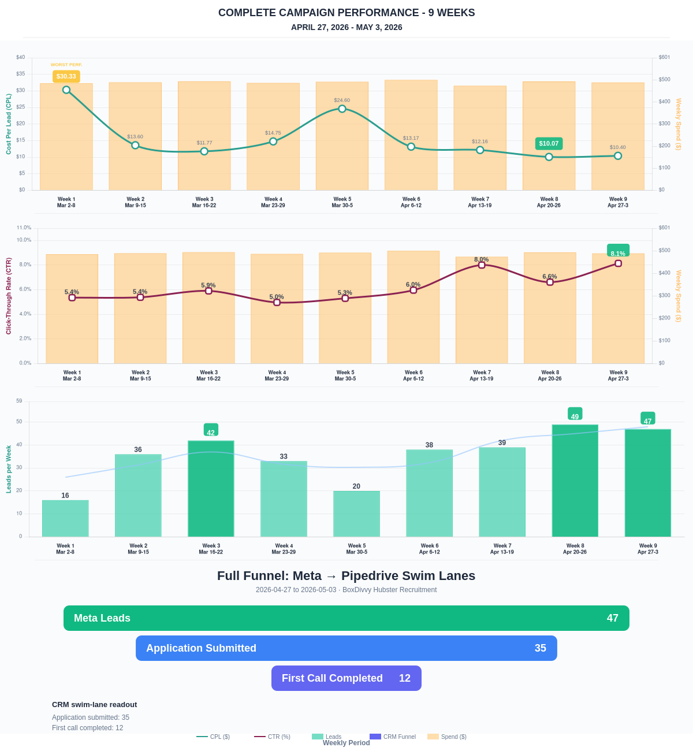

Questions? Let's chat about scaling these results.
Lead → Completed Application Dropoff
Meta lead aliases are not summed. This compares the canonical Meta Lead event against completed applications from complete_registration.
Period | Meta Leads | Completed Applications | Dropoff | Completion Rate | Cost / Completed
This Week | 47 | 25 | 22 | 53.19% | $19.56
Last 30 Days | 180 | 112 | 68 | 62.22% | $19.36
Campaign to Date | 843 | 282 | 561 | 33.45% | $27.65
Full Funnel — Meta → Pipedrive Swim Lanes
Direct Pipedrive pull from BoxDivvy Hubster Recruitment, Hub in Progress, and Hub Handovers. This shows application-stage CRM reality beside Meta attribution.
Funnel Stage | Count | Source | Notes
Meta Leads | 47 | Meta canonical lead | Top-funnel ad-attributed leads
Application Submitted | 35 | Pipedrive swim lane | Deals submitted in Pipedrive during the report period
First Call Completed | 12 | Pipedrive swim lane | Deals that reached the first-call-completed lane
Current open CRM funnel: 229 deals
Open Swim Lane | Open Deals
Application Submitted | 125
First Call Completed | 75
On Hold | 11
Hub to be listed | 7
Waiting for delivery day | 4
Hub pack complete | 3
Joined hub | 3
Hand over confirmation | 1

